Supplementary Material

Supplementary Figures and Tables

Supplementary Figures
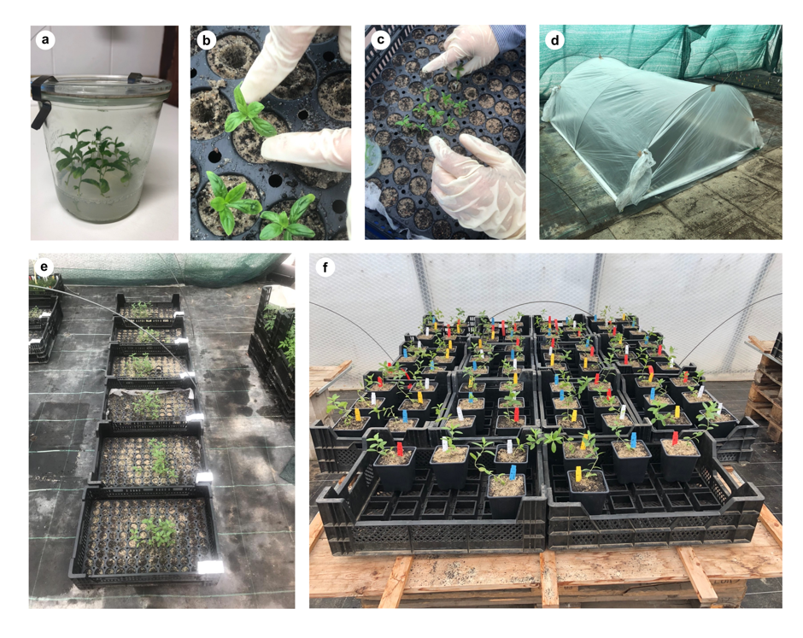

Supplementary Figure 1. Greenhouse experiment. Pictures of the different steps of the set-up. (a) Plants were grown for 10 days in MS^{mod} medium prior to the transfer. (b, c) Transfer of the rooted plants to a tray for acclimatisation. (d) A tent was built over the boxes for acclimatisation. (e) After 3 weeks of acclimation, the plants were left out of the tent for one week prior to the transfer to individual pots. (f) Plants transplanted to 1 L individual pots and randomised for the experiment.

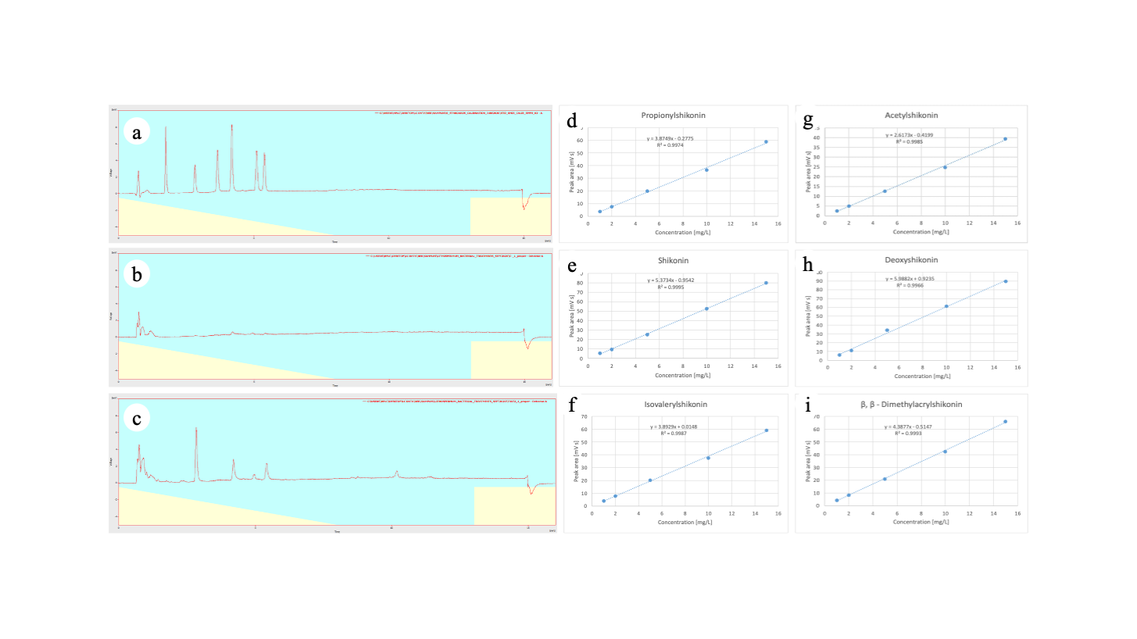
Supplementary Figure 2. Examples of HPLC chromatograms: a) Chromatogram of a mixture containing standards of shikonin (1.7 min), acetylshikonin (2.8 min), propionylshikonin (3.7 min), deoxyshikonin (4.2 min), β, β – dimethylacrylshikonin (5.1 min) and isovalerylshikonin (5.4 min), all compounds are present in a concentration of 5 mg/L. Absorbance measured at 520 nm. b) Chromatogram of a negative control sample, showing no detectable concentration of A/S. c) Chromatogram of a sample of Lithospermum officinale roots inoculated with Chitinophaga sp. R-73072. Panels d to i: Calibration curves of the different standards used for the HPLC-DAD.
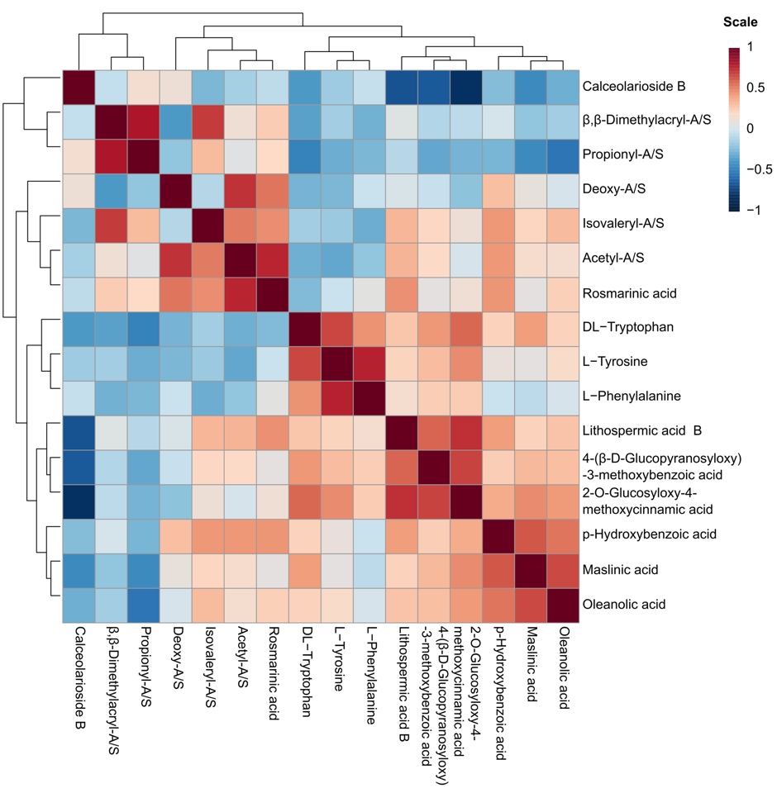Supplementary Figure 3. Correlations of compounds detected and identified by UHPLC-HRMS. Treatments include non-inoculated control and six bacterial treatments (6 biological replicates per treatment). The matrix of normalized peak intensities was analysed with the online server MetaboAnalyst 5 using the module univariate analysis (correlation heatmaps). Spearman rank correlation was used to measure the distance and clustering of features. Metabolite intensity values were auto-scaled using standard settings (range from 1 to -1) for visual representation in the heatmap.

Supplementary Tables
Supplementary Table S1. Nutrient medium composition comparison. MS^{mod}, MS^{mod rooting} and MSR^{mod} against the original MS (Murashige and Skoog, 1962) and MSR media (Declerck et al., 1998) composition.
Chemicals | MS | MS^{mod} | MS^{mod rooting} | MSR | MSR^{mod}
 | (=mg/L Medium)
Macroelements
KNO₃ | 1900 | 1900 | 950 | 76 | 76
Ca(NO₃)₂
NH₄NO₃ | 1650 | 1650 | 825
MgSO₄ x 7 H₂O | 370 | 370 | 185 | 739 | 739
KH₂PO₄ | 170 | 170 | 85 | 4.1 | 4.1
KCl |  |  |  | 65 | 65
CaCl₂ x 2 H₂O | 440 | 440 | 220
Ca(NO3)₂ x 4 H₂O |  |  |  | 359 | 359
Iron
NaFeEDTA | 36.7 | 37.5 | 37.5 | 8.12 | 8.12
Microelements
MnCl₂ x 4 H₂O |  |  |  | 2,45 | 2,45
MnSO₄ x H₂O | 17 | 17 | 17
H₃BO₃ | 6.2 | 6.2 | 6.2 | 1.86 | 1.86
ZnSO₄ x 7 H₂O | 8.6 | 8.6 | 8.6 | 0.29 | 0.29
Na₂MoO₄ x 2 H₂O | 0.25 | 0.25 | 0.25 | 0.0024 | 0.0024
CuSO₄ x 5 H₂O | 0.025 | 0.025 | 0.025 | 0.24 | 0.24
CoCl₂ x 6 H₂O | 0.025 | 0.025 | 0.025
KI | 0.83 | 0.83 | 0.83
(NH₄)₆Mo₇O₂₄ x 4 H₂O |  |  |  | 0.035
Vitamins
Thiamin HCl | 0.1 | 0.1 | 0.1 | 1 | 1
Nicotin acid | 0.5 | 0.5 | 0,5 | 1 | 1
Pyridoxine | 0.5 | 0.5 | 0.5 | 0.9 | 0.9
Glycine | 2 | 2 | 2
CaPanthotenate |  |  |  | 0.9 | 0.9
Biotin |  |  |  | 0.0009 | 0.0009
Cyanocobalamine |  |  |  | 0.4 | 0.4
myo-Inositol | 100 | 100 | 100
Sugars (g/L)
Saccharose | 30 | 10 | 10 | 10
Agar (g/L)
Phytoagar | 6 | 6 | 6
Gelrite |  |  |  | 3 | 3
pH
 | 5.8 | 5.8 | 5.8 | 5.5 | 5.5

Supplementary Table S2. Primers used for qPCR.
Target gene | Primer | Sequence (5′ - 3′) | Reference
Housekeeping gene for Actin-7; ACT7. | LeACT7_Fw | GCCTTTATTGTCTGCATCACC | Ueoka et al., 2020
Housekeeping gene for Actin-7; ACT7. | LeACT7_Rv | GGGGAAAATAGAAAGCCAAAAC | Ueoka et al., 2020
Housekeeping gene for glyceraldehyde 3-phosphate dehydrogenase; GAPDH. | GAPDH_Fw | ACCGTCCACTCCATTACCG | Wu et al., 2009
Housekeeping gene for glyceraldehyde 3-phosphate dehydrogenase; GAPDH. | GAPDH_Rv | ATGAGGCAGCCCTTCCACC | Wu et al., 2009
Expession of 4-hydroxybenzoate geranyltransferase; PGT (A/S precursor) | PGT_Fw | CTCTTAGGCTCCTCTGCT | Wu et al., 2009
Expession of 4-hydroxybenzoate geranyltransferase; PGT (A/S precursor) | PGT_Rv | CGTCGTCCACCTTATCTT | Wu et al., 2009

Supplementary Table S3. The phenotypic effect of bacterial inoculation on the plant roots. Bacteria in bold were selected for further assays.
Controls
Test |  | Effect | Test |  | Effect
Negative control | PBS inoculation | Normal root growth + no pigmentation | Positive  control | MeJA inoculation | Root inhibition + pigmentation (purple)
Group 1: No root growth inhibition + no pigmentation
Strain | Identification | Pigmentation | Strain | Identification | Pigmentation
R-71825 | Roseomonas sp. | None | R-72208 | Neorhizobium sp. | None
R-71842 | Pseudomonas sp. | None | R-72249 | Pedobacter sp. | None
R-71893 | Bacillus sp. | None | R-72369 | Methylopila sp. | None
R-71903 | Rhizobium sp. | None | R-72406 | Stenotrophomonas sp. | None
R-71954 | Rhizobium sp. | None | R-72433 | Rhizobium sp. | None
R-71986 | Pseudoxanthomonas sp. | None | R-72446 | Variovorax sp. | None
R-72066 | Rhizobium sp. | None | R-72456 | Rhizobium sp. | None
R-72074 | Pseudomonas sp. | None | R-72492 | Bacillus sp. | None
R-72135 | Pseudomonas sp. | None | R-72495 | Variovorax sp. | None
R-72139 | Methylobacterium sp. | None | R-72498 | Pantoea sp. | None
R-72151 | Luteibacter sp. | None | R-72500 | Rhizobium sp. | None
R-72153 | Variovorax sp. | None | R-72501 | Inquilinus sp. | None
R-72160 | Rhizobium sp. | None | R-72562 | Kocuria sp. | None
R-72164 | Pseudomonas sp. | None | R-72591 | Sphingobium sp. | None
R-72172 | Pseudomonas sp. | None | R-72597 | Tardiphaga sp. | None
R-72191 | Olivibacter sp. | None | R-73343 | Acidovorax sp. | None
Group 2: No root growth inhibition + pigmentation
Strain | Identification | Pigmentation | Strain | Identification | Pigmentation
R-71838 | Pseudomonas sp. | brownish | R-72599 | Pseudomonas sp. | brownish/black
R-71875 | Brevibacterium sp. | brownish/black | R-72634 | Bacillus sp. | brownish/black
R-72115 | Shinella sp. | brownish/black | R-73072 | Chitinophaga sp. | black
R-72269 | Chitinophaga sp. | brownish/purple | R-73098 | Xanthomonas sp. | brownish/black
R-72393 | Pedobacter sp. | Black | R-73111 | Phyllobacterium sp. | brownish/black
R-72401 | Shinella sp. | brownish/black | R-73117 | Rhizobium sp. | brownish/black/purple
R-72464 | Xanthomonas sp. | brownish/black
Group 3: Root growth inhibition + pigmentation
Strain | Identification | Pigmentation | Strain | Identification | Pigmentation
R-71941 | Tsukamurella sp. | brownish/black | R-72102 | Pseudomonas sp. | brownish
R-72008 | Pseudomonas sp. | brownish | R-72251 | Xanthomonas sp. | brownish/black

Supplementary Table S4. Shoot length of the different treatments of plants grown under polytunnel conditions (10 biological replicates per treatment). Data are expressed in cm and were compared with one-factor ANOVA (p= 0.01669< 0.05) followed by a Newman-Keuls test. Means associated with the same letter are not considered to be significantly different.
Treatments | Means
Chitinophaga sp. R-73072 | 21.97 ± 2.49 a
Pseudomonas sp. R-71838 | 21.02 ± 3.42 a
Rhizobium sp. R-72433 | 20.75 ± 3.32 a
Brevibacterium sp. R-71875 | 20.63 ± 3.92 a
Xanthomonas sp. R-73098 | 20.50 ± 1.97 a
Chitinophaga sp. R-72269 | 20.38 ± 2.62 a
Negative control (MSR^{mod}) | 16.90 ± 1.82 b

Supplementary Table S5. Plant weights (root and shoot) of the different treatments of plants grown under polytunnel conditions (10 biological replicates per treatment). Data of root weight were compared with one-factor ANOVA followed by a Newman-Keuls test. Data of shoot weight were compared with Kruskal-Wallis followed by a Dunn test. Means associated with the same letter are not considered to be significantly different.
Root dry weight (g) |  | Shoot dry weight (g)
p-value 0.0111 |  | p-value 0.005962
Treatments | Means | Treatments | Means
R-72269 | 1.07 ± 0.22 a | R-71838 | 0.55 ± 0.28 a
R-73072 | 1.02 ± 0.26 ab | R-73072 | 0.50 ± 0.10 a
R-71838 | 1.01 ± 0.34 ab | R-71875 | 0.47 ± 0.16 a
R-72433 | 0.86 ± 0.34 ab | R-72269 | 0.47 ± 0.07 a
R-71875 | 0.84 ± 0.38 ab | R-72433 | 0.44 ± 0.15 ab
R-73098 | 0.73 ± 0.22 ab | R-73098 | 0.37 ± 0.10 ab
Negative control | 0.65 ± 0. 20 b | Negative control | 0.32 ± 0.07 b

Supplementary Table S6. Identified metabolites within all plant root samples, inoculated with different bacterial treatments and grown in vitro. Identification of compounds detected by UHPLC-HRMS was performed using the Compound Discoverer software.
Compound Identification | Chemical Class | Molecular Formula | Molecular Weight (g/mol) | MS/MS fragmentation match (%)
Acetyl-A/S | Naphthoquinone | C₁₈H₁₈O₆ | 330.3 | 100.0
Shikonin | Naphthoquinone | C₁₆H₁₆O₅ | 288.29 | 100.0
Isovaleryl-A/S | Naphthoquinone | C₂₁H₂₄O₆ | 372.4 | 100.0
β,β-Dimethylacryl-A/S | Naphthoquinone | C₂₁H₂₂O₆ | 370.4 | 100.0
Deoxy-A/S | Naphthoquinone | C₁₆H₁₆O₄ | 272.29 | 100.0
Propionyl-A/S | Naphthoquinone | C₁₉H₂₀O₆ | 344.4 | 100.0
Rutin | Flavonol glycoside | C₂₇H₃₀O₁₆ | 610.5 | 94.8
4-(β-D-Glucopyranosyloxy)-3-methoxybenzoic acid | Hydroxycinnamic acid | C₁₄H₁₈O₉ | 330.29 | 97.8
Calceolarioside B | Hydroxycinnamic acid | C₂₃H₂₆O₁₁ | 478.4 | 93.5
2-O-Glucosyloxy-4-methoxycinnamic acid | Hydroxycinnamic acid | C₁₆H₂₀O₉ | 356.32 | 46.5
p-Hydroxybenzoic acid | Phenolic acid | C₇H₆O₃ | 138.12 | 53.4
Lithospermic acid B | Polyphenol | C₃₆H₃₀O₁₆ | 718.6 | 92.5
Rosmarinic acid | Polyphenol | C₁₈H₁₆O₈ | 360.3 | 95.2
Adenosine | Ribonucleoside | C₁₀H₁₃N₅O₄ | 267.24 | 99.0
Maslinic acid | Triterpene | C₃₀H₄₈O₄ | 472.7 | 89.6
Oleanolic acid | Triterpene | C₃₀H₄₈O₃ | 456.7 | 95.3
Thiamine | Vitamin | C₁₂H₁₇N₄OS⁺ | 265.36 | 98.0
L-Asparagine | Amino acid | C₄H₈N₂O₃ | 132.12 | 91.1
L-Tyrosine | Amino acid | C₉H₁₁NO₃ | 181.19 | NA
L-Histidine | Amino acid | C₆H₉N₃O₂ | 155.15 | 83.3
L-Phenylalanine | Amino acid | C₉H₁₁NO₂ | 165.19 | 55.9
DL-Glutamine | Amino acid | C₅H₁₀N₂O₃ | 146.14 | 90.7
DL-Tryptophan | Amino acid | C₁₁H₁₂N₂O₂ | 204.22 | 90.7
α-Linolenic acid | Fatty acid | C₁₈H₃₀O₂ | 278.4 | 91.0
12-Oxo-phytodienoic acid | Fatty acid | C₁₈H₂₈O₃ | 292.4 | 86.0

Supplementary Table S7. Expression of key gene PGT (core A/S pathway), as quantified by qPCR. Data were compared with one-factor ANOVA followed by a t-test. Inoculated (bacteria) and non-inoculated plant treatments (3 biological replicates per treatment) were statistically compared (p-value = 0.007) using qbase+ v 3.2.
Comparison | Ratio | Significance
R-72433/Control | 1.78 | Yes
R-73072/Control | 2.41 | Yes
R-73072/R-72433 | 1.35 | No

