Supplement table 1 Genes and corresponding primers
Gene name | Forward/Reverse | Sequence (from 5' to 3')
ctsk | forward | CTTCCAATACGTGCAGCAGA
ctsk | reverse | TCTTCAGGGCTTTCTCGTTC
trap | forward | CACTCCCACCCTGAGATTTGT
trap | reverse | CCCCAGAGACATGATGAAGTCA
mmp9 | forward | CAAAGACCTGAAAACCTCCAA
mmp9 | reverse | GGTACAAGTATGCCTCTGCCA
HIF-1α | forward | GAATGAAGTGCACCCTAACAAG
HIF-1α | reverse | GAGGAATGGGTTCACAAATCAG
β-actin | forward | GAAATCGTGCGTGACATCAAA
β-actin | reverse | TGTAGTTTCATGGATGCCACAG
MSTRG.7566.12 | forward | CCCTCACTGCTCTCTCTGTCCT
MSTRG.7566.12 | reverse | CATGACCATTGCTCATCCCTC
MSTRG.31769.2 | forward | CAGGTGTTGACGCGATGTGA
MSTRG.31769.2 | reverse | TAAGTGGGAAGCCCCAGTG

Supplement table 2 Top ten upregulated and downregulated mRNAs
TOP10 Up mRNA | TOP10 Down mRNA
Gimap4 | Mt3
Ikzf3 | Cyp2s1
Themis | Capn6
Cd7 | Scin
Gimap3 | Slc6a17
Jchain | Edil3
Gm4951 | Rufy4
Ncr1 | Sema7a
Cd3g | Prkcdbp
Cd3e | Kank1

Supplement table 3 Top ten upregulated and downregulated LncRNAs
TOP10 Up LncRNA | TOP10 Down LncRNA
MSTRG.1990.9 | MSTRG.1990.8
MSTRG.1990.13 | MSTRG.41781.2
MSTRG.1990.14 | MSTRG.77697.2
MSTRG.1990.6 | MSTRG.1990.17
MSTRG.46899.2 | MSTRG.1990.21
MSTRG.1990.11 | MSTRG.23904.1
MSTRG.1990.7 | MSTRG.1990.5
MSTRG.1990.4 | MGP_C57BL6NJ_T0001556
MSTRG.1990.15 | MSTRG.1990.16
MSTRG.33517.1 | MSTRG.24308.3

Supplement figure 1 Original Figure of Figure 1B
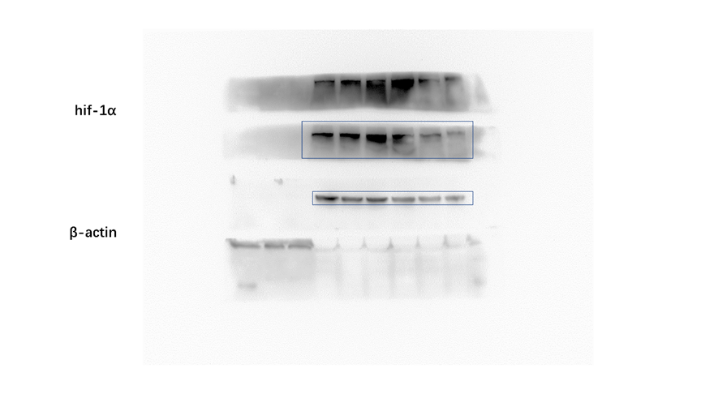

Supplement figure 2 Original Figure of Figure 2B

Supplement figure 3 Original Figure of Figure 5A
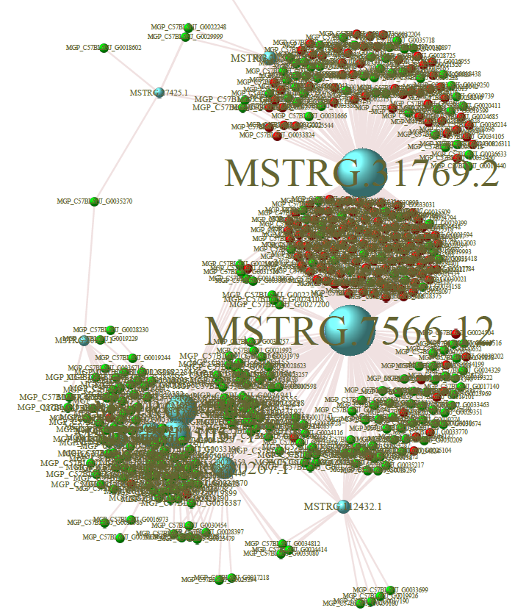

Supplement figure 4 Original Figure of Figure 5C
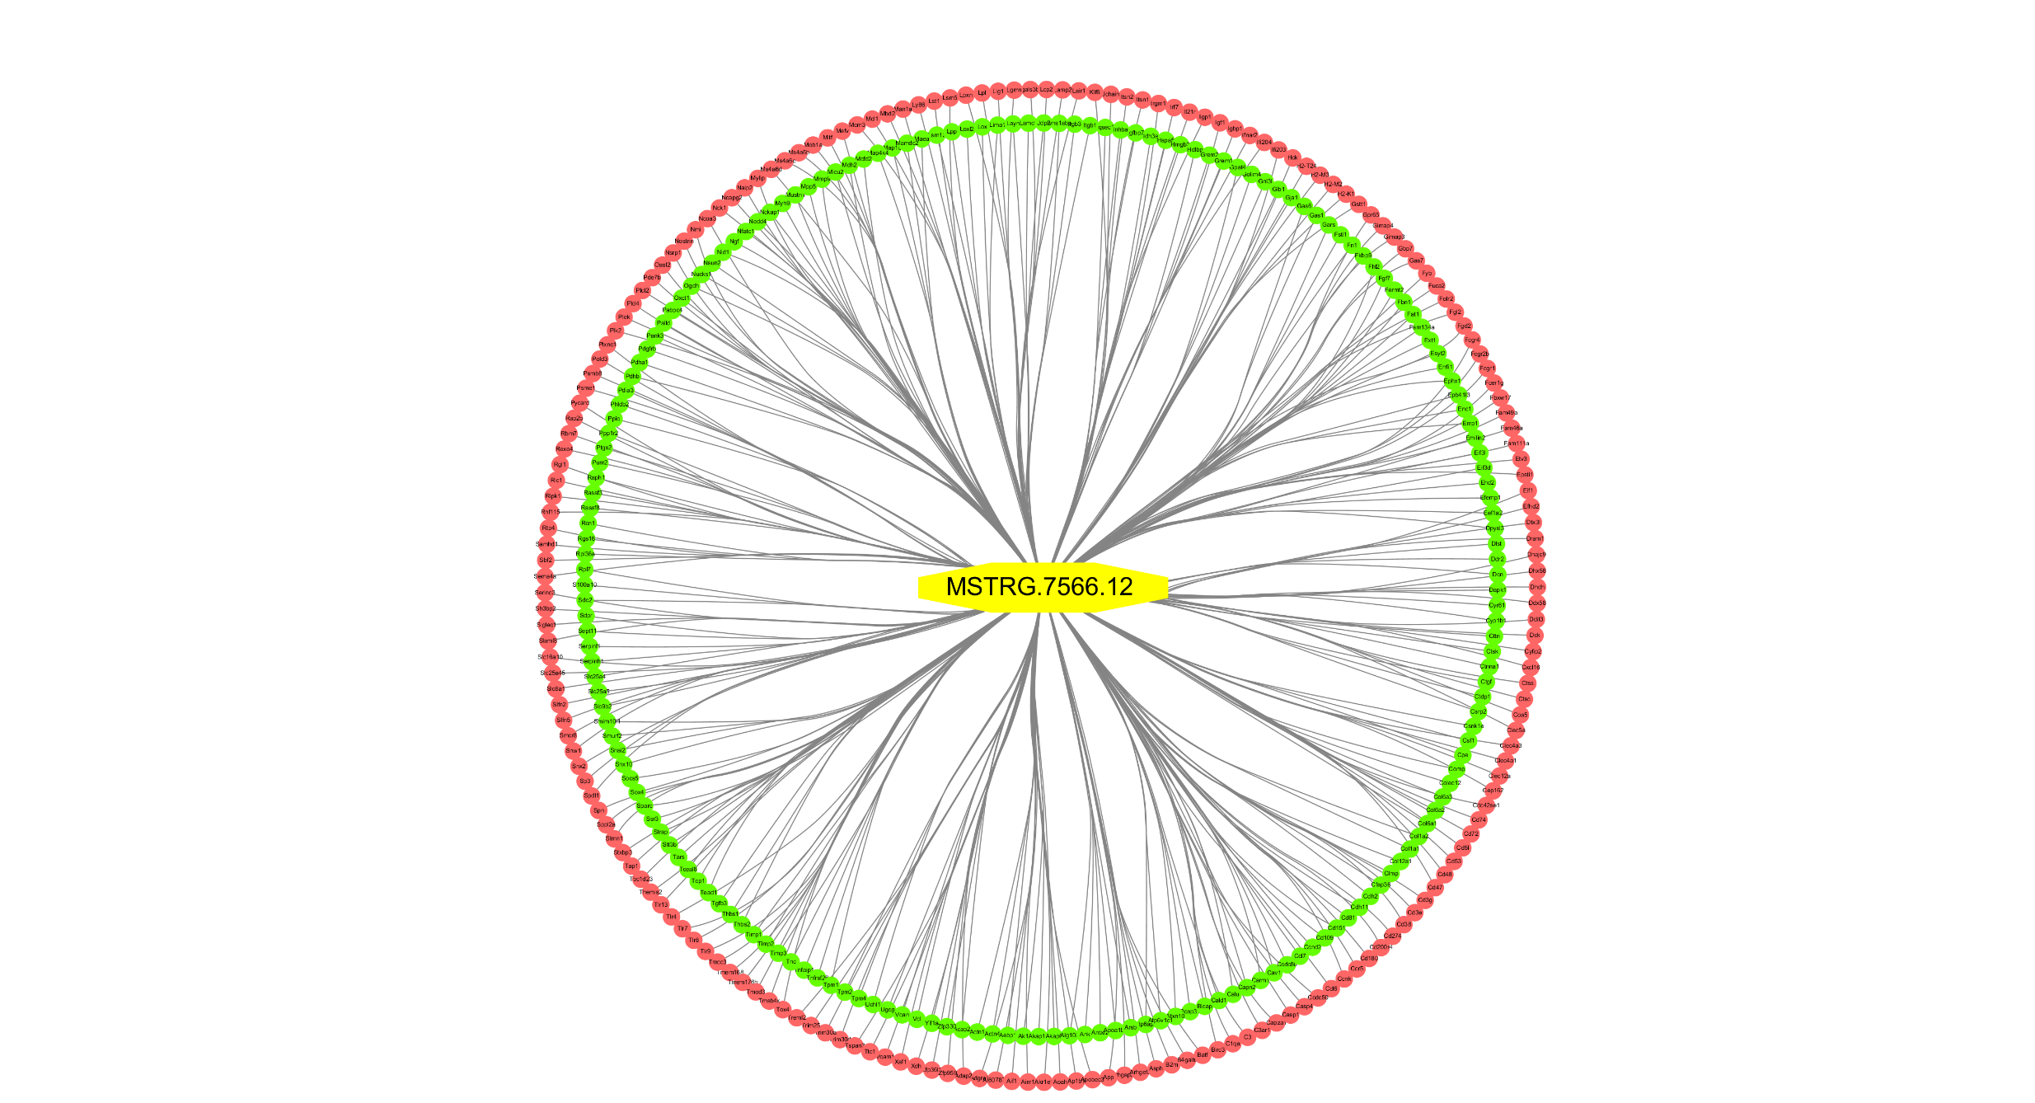

Supplement figure 5 Original Figure of Figure 5F
