**Fig S1**. **The cutoff value of δV1.**

The min (abs(se-sp)) index 0.80 (exact value 0.7985) was used as a threshold for further analysis in δV1≥0.66 subpopulation. The cutoff value was calculated by software R (version 3.6.1) with the package “cutpointr”[1]. Min(abs(se-sp)) index, the minimum value of the absolute value of sensitivity minus specificity.

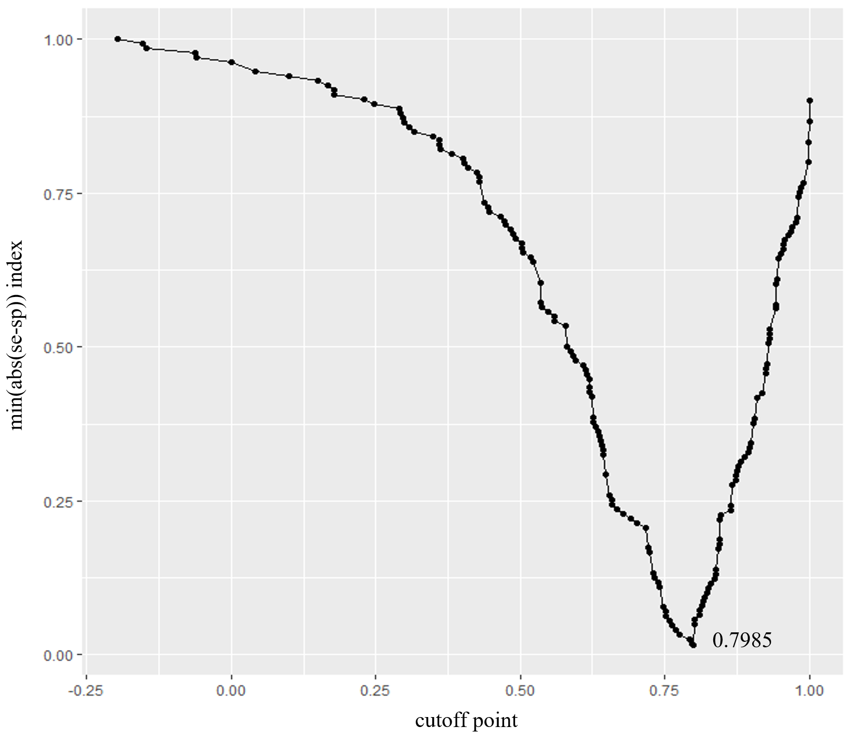

Min, minimum value; abs, absolute value; se, sensitivity; sp, specificity; δV1, the volume change rate of EC treatment.

Reference

1. Thiele C, Hirschfeld G. cutpointr: Improved Estimation and Validation of Optimal Cutpoints in R. 2021 Jun, 98(11).