**Supplementary Figures**



**Figure S1.** Enrichment analysis of miR-10c-5p.

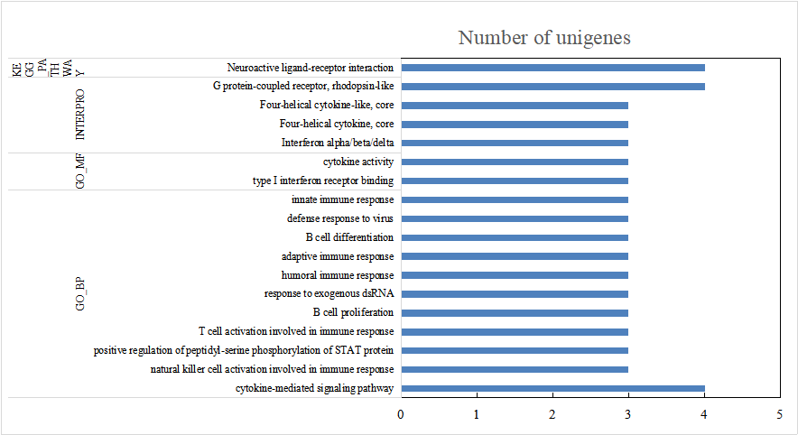

**Figure S2** Functional enrichment analysis of Tibetan chickens relative to lowland chicken specific expression genes.

**Supplementary Tables**

**Table S1** The summary of genome resequencing.

|  |  |  |  |  |  |  |
| --- | --- | --- | --- | --- | --- | --- |
| Breed | Sample name | Clean reads | Mapped reads | Mapped bases (bp) | Mapping ratio (%) | Average depth |
| Peng’xian yellow chicken | LC1 | 123,514,556 | 121,549,598 | 17,835,637,408 | 98.41% | 14.54 |
| LC2 | 129,943,634 | 127,075,609 | 18,621,923,571 | 97.79% | 14.94 |
| LC3 | 121,933,950 | 120,195,056 | 17,634,953,858 | 98.57% | 14.27 |
| LC4 | 114,805,466 | 113,134,152 | 16,568,836,970 | 98.54% | 13.70 |
| LC5 | 133,732,974 | 131,762,298 | 19,334,435,705 | 98.53% | 15.82 |
| LC6 | 124,830,814 | 123,088,068 | 18,072,641,788 | 98.60% | 14.82 |
| Tibetan chicken | TC1 | 132,489,660 | 130,214,243 | 19,091,543,906 | 98.28% | 15.36 |
| TC2 | 137,262,560 | 135,246,978 | 19,842,296,951 | 98.53% | 16.02 |
| TC3 | 114,718,642 | 112,837,400 | 16,549,336,369 | 98.36% | 13.53 |
| TC4 | 155,957,666 | 153,644,772 | 22,545,959,421 | 98.52% | 16.61 |
| TC5 | 134,070,044 | 132,104,611 | 19,384,276,513 | 98.53% | 15.78 |
| TC6 | 142,092,608 | 140,167,508 | 20,557,962,599 | 98.65% | 16.38 |

**Table S3.** The impact of environment and breed factors on the expression level of candidate miRNAs. Two-Way ANOVA were used to calculate the difference based on log2CPM with the tukey method. The significant level is 0.05. PXC and TC represents Peng’xian yellow chicken and Tibetan chicken, respectively.

|  |  |  |  |  |  |
| --- | --- | --- | --- | --- | --- |
| Factor | miRNA | Class | Mean | Std | significance |
| Environment | miR-144-5p | Low altitude | 4.1664 | 0.6292 | B |
| High altitude | 5.6379 | 0.4804 | A |
| miR-144-3p | Low altitude | 8.0245 | 0.6978 | B |
| High altitude | 9.7156 | 0.5769 | A |
| miR-10c-5p | Low altitude | 4.6516 | 1.3207 | A |
| High altitude | 2.9379 | 0.5135 | B |
| miR-499-5p | Low altitude | 4.6943 | 0.5979 | A |
| High altitude | 5.0538 | 1.9890 | A |
| gga-miR-1388a-3p | Low altitude | 7.7985 | 0.5666 | A |
| High altitude | 5.9273 | 1.3345 | B |
| gga-miR-1388b-5p | Low altitude | 8.1000 | 0.6010 | A |
| High altitude | 6.1839 | 1.3985 | B |
| gga-miR-3536 | Low altitude | 0.6302 | 2.0576 | B |
| High altitude | 3.0816 | 1.5962 | A |

|  |  |  |  |  |  |
| --- | --- | --- | --- | --- | --- |
| Breed | miR-144-5p | PXC | 5.0717 | 0.7123 | A |
| TC | 4.7326 | 1.1617 | A |
| miR-144-3p | PXC | 9.0235 | 0.7976 | A |
| TC | 8.7166 | 1.3575 | A |
| miR-10c-5p | PXC | 3.8357 | 1.2542 | A |
| TC | 3.7538 | 1.4808 | A |
| miR-499-5p | PXC | 4.7269 | 2.0095 | A |
| TC | 5.0212 | 0.5487 | A |
| gga_miR_1388a_3p | PXC | 6.4998 | 1.4548 | A |
| TC | 7.2261 | 1.3303 | A |
| gga_miR_1388b_5p | PXC | 6.8366 | 1.5933 | A |
| TC | 7.4472 | 1.3258 | A |
| gga_miR_3536 | PXC | 0.8523 | 2.4799 | A |
| TC | 2.8595 | 1.3490 | A |

|  |  |  |  |  |  |  |
| --- | --- | --- | --- | --- | --- | --- |
| Environment  * Breed | miR-144-5p | PXC | Low altitude | 4.6005 | 0.4199 | AB |
| PXC | High altitude | 5.5429 | 0.6529 | A |
| TC | Low altitude | 3.7323 | 0.4981 | B |
| TC | High altitude | 5.733 | 0.3515 | A |
| miR-144-3p | PXC | Low altitude | 8.521 | 0.3561 | AB |
| PXC | High altitude | 9.5261 | 0.8403 | A |
| TC | Low altitude | 7.528 | 0.5923 | B |
| TC | High altitude | 9.9052 | 0.1353 | A |
| miR-10c-5p | PXC | Low altitude | 4.635 | 1.3145 | A |
| PXC | High altitude | 3.0363 | 0.5366 | A |
| TC | Low altitude | 4.6681 | 1.6223 | A |
| TC | High altitude | 2.8395 | 0.585 | A |
| miR-499-5p | PXC | Low altitude | 4.5644 | 0.8867 | A |
| PXC | High altitude | 4.8894 | 3.0380 | A |
| TC | Low altitude | 4.8241 | 0.2382 | A |
| TC | High altitude | 5.2183 | 0.7612 | A |
| gga_miR_1388a_3p | PXC | Low altitude | 7.7397 | 0.7600 | AB |
| PXC | High altitude | 5.2599 | 0.3181 | B |
| TC | Low altitude | 7.8573 | 0.4632 | A |
| TC | High altitude | 6.5948 | 1.7361 | AB |
| gga_miR_1388b_5p | PXC | Low altitude | 8.1339 | 0.8606 | A |
| PXC | High altitude | 5.5392 | 0.7459 | A |
| TC | Low altitude | 8.0660 | 0.3985 | A |
| TC | High altitude | 6.8285 | 1.7569 | A |
| miR-10c-5p | PXC | Low altitude | -0.8953 | 0.9100 | B |
| PXC | High altitude | 2.6000 | 2.3204 | AB |
| TC | Low altitude | 2.1557 | 1.6656 | AB |
| TC | High altitude | 3.5632 | 0.5380 | A |

**Table S4.** Number of Differentially Expressed Genes and Enrichment of Their Pathways in 48 Samples

|  |  |  |  |  |  |  |  |  |  |  |
| --- | --- | --- | --- | --- | --- | --- | --- | --- | --- | --- |
| **Comparison type** | | **Tissue** | **Number of**  **DEGs** | **Functional category** | | | | **Total**  **pathway** | **Number of Up-regulated DEGs** | **Number of Down-regulated DEGs** |
| **GO-BP** | **GO-MF** | **INTERPRO** | **KEGG** |
| T-test | TC vs LC | Brain | 196 | 19 | 1 | 14 | 1 | 35 | 175 | 21 |
| Heart | 18 | 0 | 0 | 0 | 0 | 0 | 8 | 10 |
| Lung | 137 | 7 | 3 | 7 | 2 | 19 | 39 | 98 |
| Liver | 1017 | 21 | 17 | 46 | 6 | 90 | 169 | 848 |
| HLC vs LTC | Brain | 62 | 0 | 0 | 0 | 0 | 0 | 34 | 28 |
| Heart | 209 | 10 | 0 | 6 | 2 | 18 | 88 | 121 |
| Lung | 467 | 30 | 8 | 16 | 3 | 57 | 150 | 317 |
| Liver | 425 | 9 | 4 | 14 | 12 | 39 | 138 | 287 |
| TC vs LTC | Brain | 107 | 3 | 1 | 2 | 2 | 8 | 84 | 23 |
| Heart | 130 | 2 | 2 | 0 | 0 | 4 | 13 | 117 |
| Lung | 387 | 11 | 3 | 17 | 0 | 31 | 127 | 260 |
| Liver | 1176 | 16 | 12 | 32 | 8 | 68 | 192 | 984 |
| HLC vs LC | Brain | 91 | 3 | 1 | 3 | 1 | 8 | 65 | 26 |
| Heart | 105 | 2 | 0 | 0 | 1 | 3 | 78 | 27 |
| Lung | 185 | 10 | 3 | 8 | 2 | 23 | 65 | 120 |
| Liver | 377 | 7 | 0 | 14 | 10 | 31 | 104 | 273 |
| TC vs HLC | Brain | 47 | 1 | 0 | 1 | 0 | 2 | 25 | 22 |
| Heart | 231 | 3 | 3 | 2 | 4 | 12 | 54 | 177 |
| Lung | 107 | 3 | 0 | 4 | 0 | 7 | 53 | 54 |
| Liver | 421 | 10 | 6 | 12 | 2 | 30 | 98 | 323 |
| LTC vs LC | Brain | 61 | 1 | 1 | 3 | 0 | 5 | 31 | 30 |
| Heart | 68 | 0 | 0 | 0 | 0 | 0 | 53 | 15 |
| Lung | 122 | 3 | 0 | 1 | 0 | 4 | 77 | 45 |
| Liver | 109 | 5 | 0 | 1 | 0 | 6 | 62 | 47 |

**Table S5.** Distribution of SNPs.

|  |  |  |
| --- | --- | --- |
| Category |  | Number |
| intronic |  | 5,055,796 |
| intergenic |  | 3,981,930 |
| ncRNA_intronic | | 1,030,664 |
| upstream |  | 182,660 |
| downstream | | 178,692 |
| exonic | synonymous | 104,003 |
| nonsynonymous | 46,306 |
| stopgain | 504 |
| stoploss | 83 |
| unknown | 1 |
| ncRNA_exonic | | 106,971 |
| UTR3 |  | 89,201 |
| UTR5 |  | 25,684 |
| splicing |  | 17,091 |
| Total | | 10,819,586 |