Supplementary Material For

**Low-frequency dual-band sound absorption by ultrathin planar wall embedded with multiple-cavity resonators**

Note 1 Influences of *r*1 on sound absorption of unit cell................................................2

Note 2 Influences of *l*3 on sound absorption of unit cell................................................2

Note 3 Performances of a room with hard boundaries.................................................. 3

Note 4 Propagation characteristics of sound in free space.............................................4

**Note 1 Influences of *r*1 on sound absorption of unit cell**

**Figures S1A, B** show the simulated sound absorption spectra created by the unit cell with different values of *r*1 around the bands I and II, respectively, in which the other parameters of the unit cell are the same as those in **Figure 1B**. We can see that, with the decrease of *r*1, both working bands move to the low-frequency region with a high-performance sound absorption. Therefore, by changing the value of *r*1, the bands I and II of sound absorption for the planar wall can be modulated.

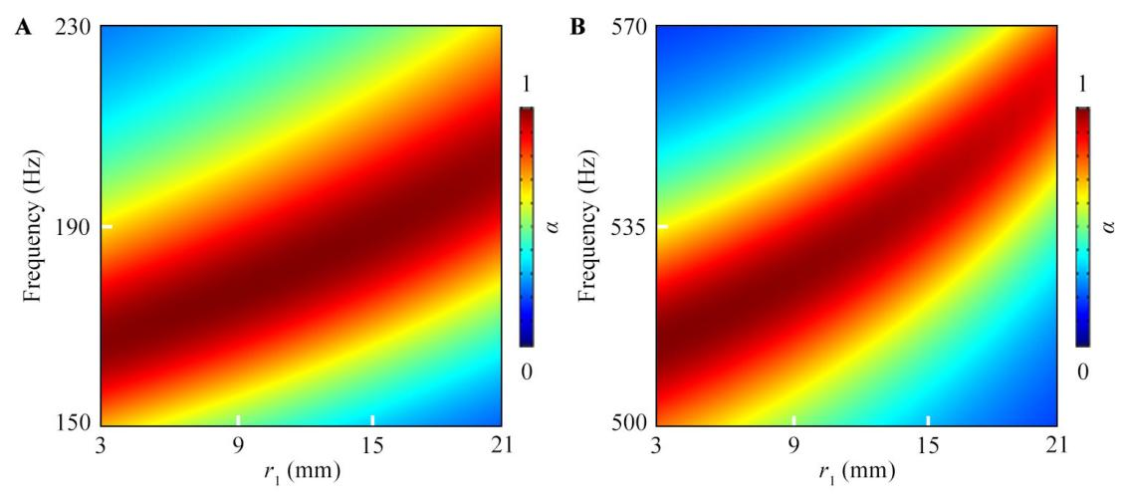

**FIGURE S1 |** Simulated sound absorption spectra created by the unit cell with different values of *r*1 around the bands **(A)** I and **(B)** II.

**Note 2 Influences of *l*3 on sound absorption of unit cell**

**Figures S2A, B** show the simulated sound absorption spectra created by the unit cell with different values of *l*3 around the bands I and II, respectively, in which the other parameters of the unit cell are the same as those in **Figure 1B**. We can see that, with the decrease of *l*3, the absorption peak in the band I almost remains unchanged (**Figure S2A**), while that in the band I moves to the high-frequency region (**Figure S2B**). This is because the band I is closely related to the resonance coupling of both MRs, while the band II is determined by the mutual resonance coupling between the resonators and groove structure. Therefore, the band II of sound absorption can also be modulated by changing the parameter *l*3.

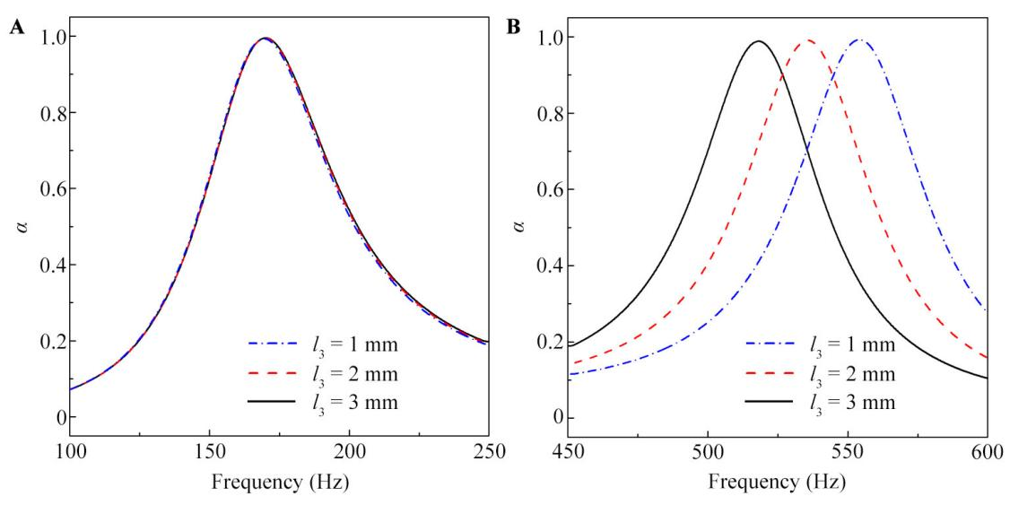

**FIGURE S2 |** Simulated sound absorption spectra created by the unit cell with different values of *l*3 around the bands **(A)** I and **(B)** II.

**Note 3 Performances of a room with hard boundaries**

For comparison, we simulate propagation characteristics of sound in a room with hard boundaries, in which a cylindrical sound source is placed at the center, and the size of the room is same as the barrier-free anechoic room (**Figure 4A**). The total pressure distributions and their corresponding reflected intensity distributions in the room at 173 and 519 Hz are shown in **Figures S3A-D**. We can see that the sound reflections are very strong, which is different from those in the barrier-free anechoic room.

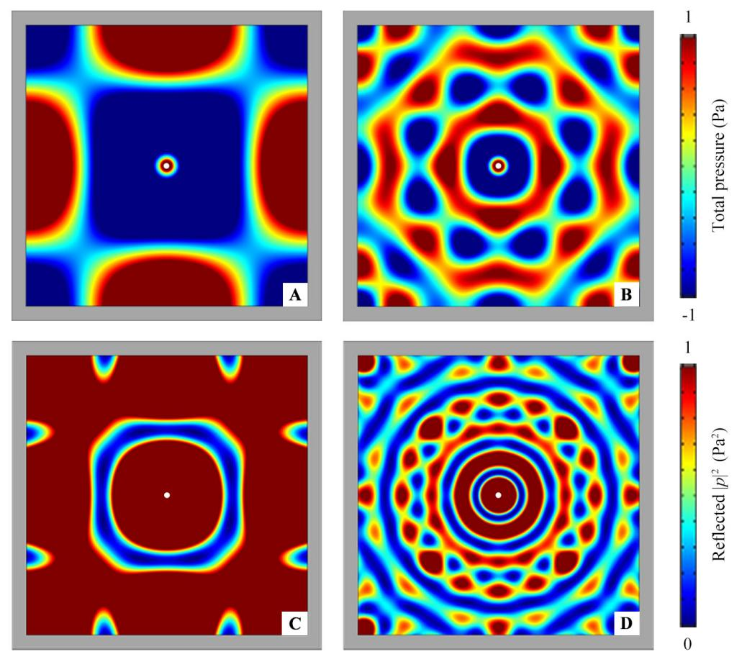

**FIGURE S3 |** Simulated total pressure distributions in a room with hard boundaries at **(A)** 173 Hz and **(B)** 519 Hz, and its corresponding reflected intensity distributions at **(C)** 173 Hz and **(D)** 519 Hz. White solid points at the center represent the positions of cylindrical sound source.

**Note 4 Propagation characteristics of sound in free space**

We also simulate the propagation characteristics of sound in free space, in which a cylindrical sound source is placed at the center. The total pressure distributions at 173 Hz and 519 Hz are shown in **Figures S4A, B**, respectively. We can see that the propagation characteristics of sound in free space at both frequencies are similar to those inside the designed barrier-free anechoic room in **Figures 5A, B**.

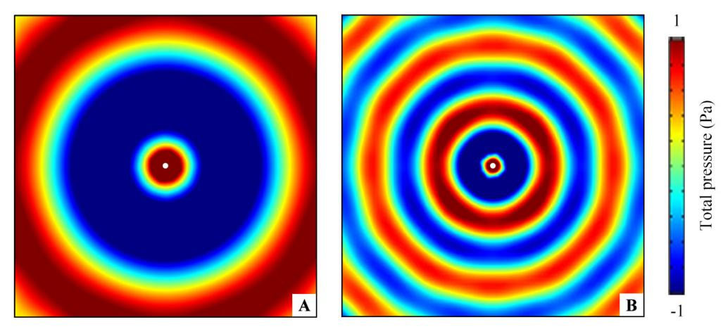

**FIGURE S4 |** Simulated total pressure distributions in free space at **(A)** 173 and **(B)** 519 Hz created by a cylindrical sound source. White solid points at the center represent the positions of cylindrical sound source.