Supplementary Material

## Supplementary Figures

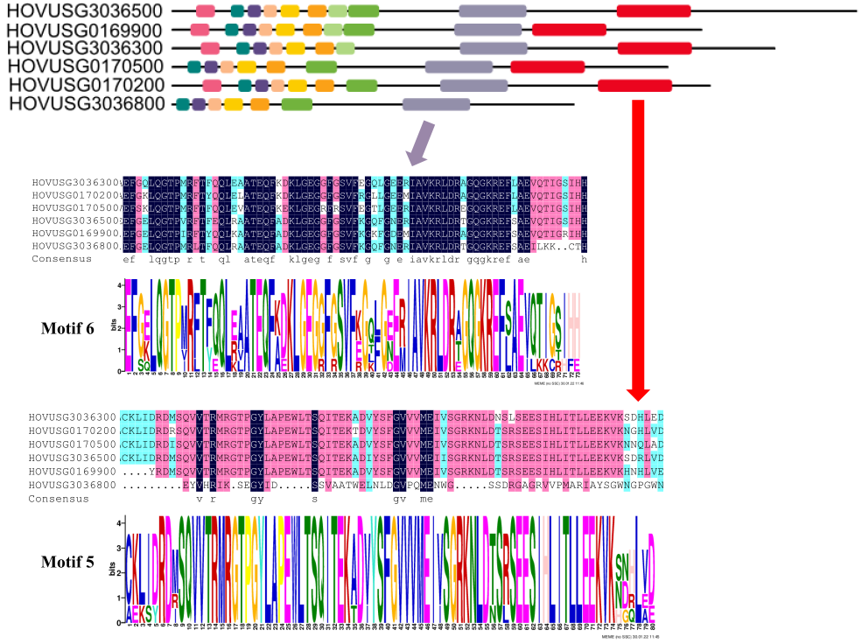

**Figure S2** Motif pattern and corresponding relations of motif 5 and motif 6 to protein sequences of six TLP kinases identified.

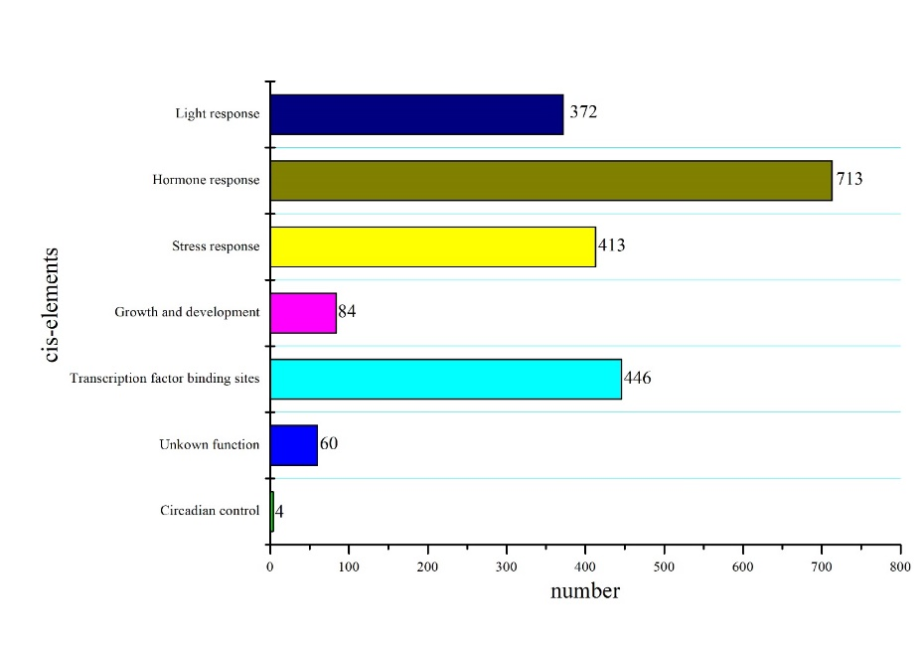

**Figure S3** Total number of cis-elements detected in each of the even categories.

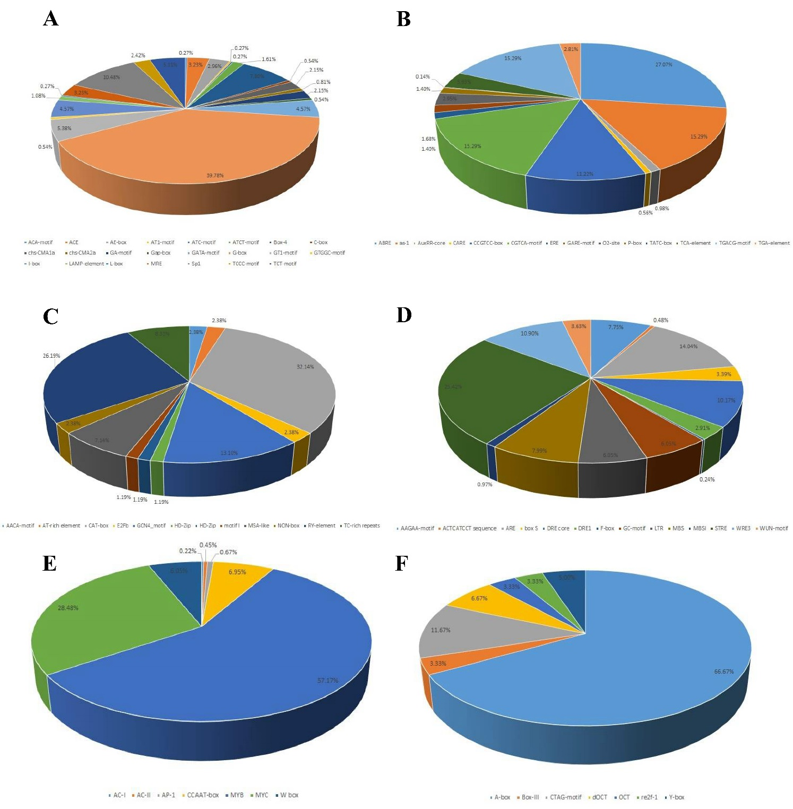

**Figure S4** Statistics of cis-elements found in Qingke *TLP* genes. **(A)** light responsive. **(B)** hormone responsive. **(C)** growth and development. **(D)** Stress responsive. **(E)** Transcription factor binding sites. **(F)** Unknown function.