Supplement Figures

Figure S1 The detection rate of antibiotic resistance genes which are not in layers and broilers. (A) The detection rate of fosfomycin resistance genes. (B) The detection rate of chloramphenicol resistance genes.

(A)

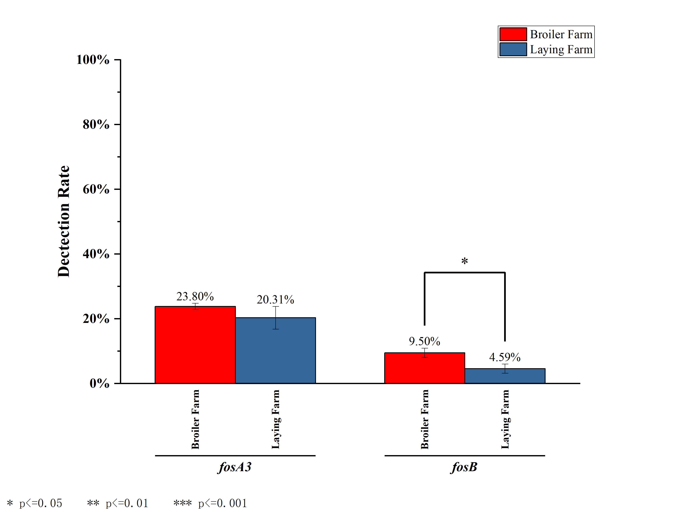(B)

