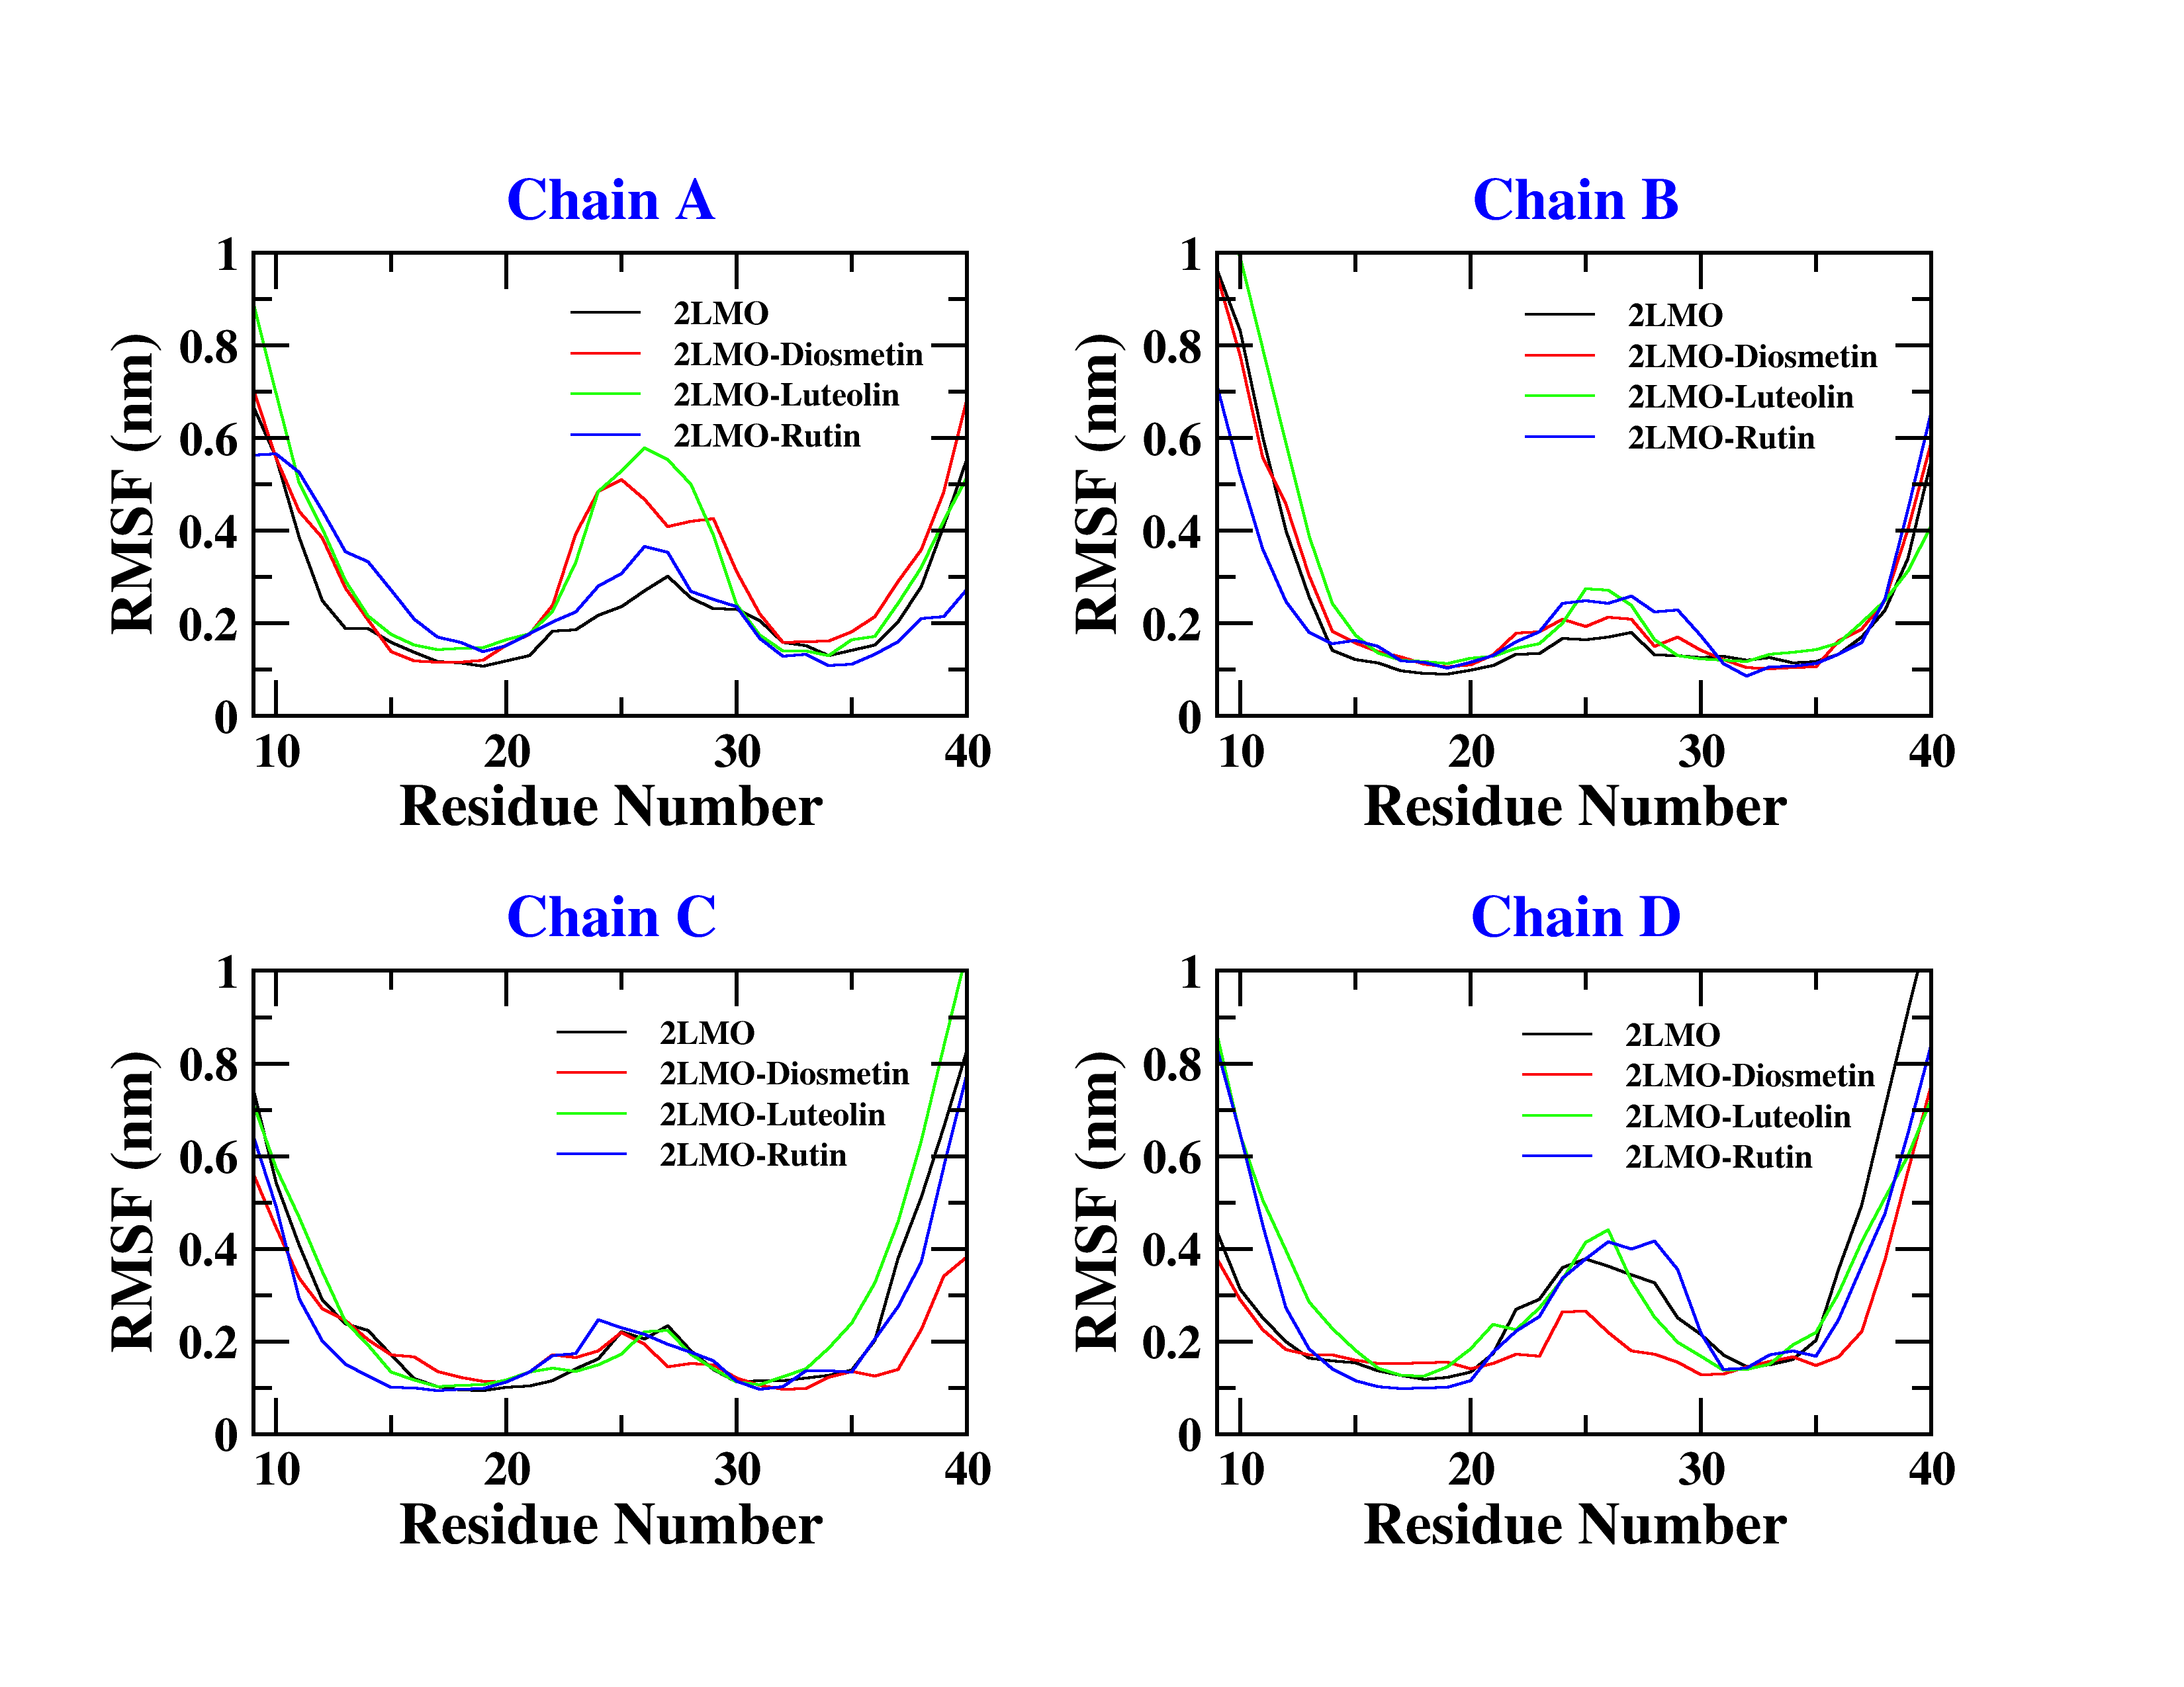

**Supplementary figure S1:** Root mean square fluctuation (RMSF) of backbone atoms of 4 chains (tetramer) of 2LMO and their respective complexes with Diosmetin, Luteolin and Rutin.

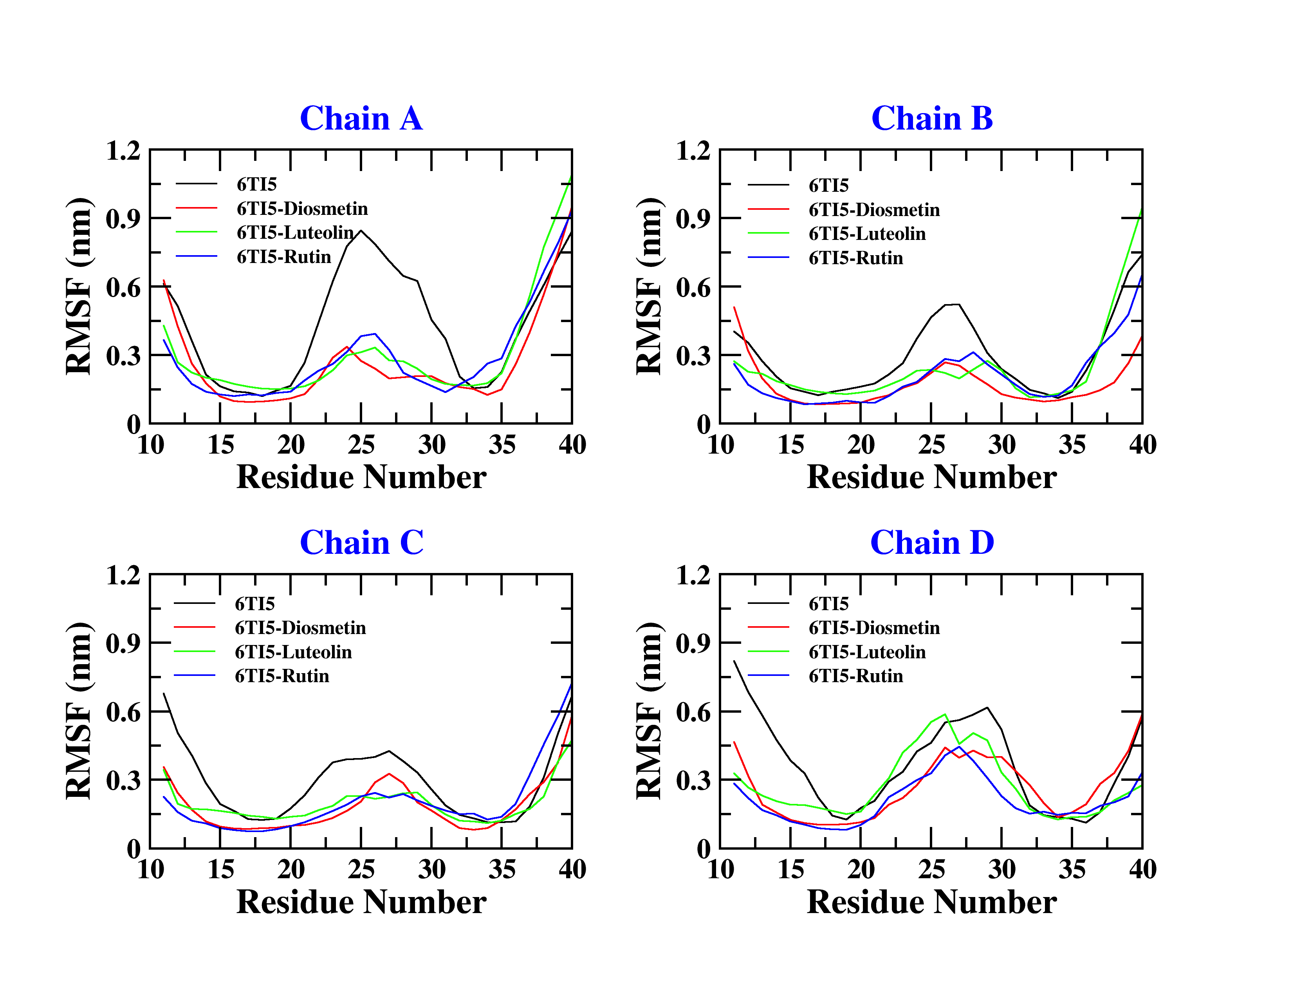

**Supplementary figure S2:** Root mean square fluctuation (RMSF) of backbone atoms of 4 chains (tetramer) of 2LMO and their respective complexes with Diosmetin, Luteolin and Rutin.