Frontiers in Ecology and Evolution
SUPPORTING INFORMATION
Combining geospatial abundance and ecological niche models to identify high-priority areas for conservation: the neglected role of broadscale interspecific competition
Thiago Cavalcante ^{1*}, Marcelo de Moraes Weber ², Adrian A. Barnett ^{3,4}
¹Programa de Pós-Graduação em Ecologia, Instituto Nacional de Pesquisas da Amazônia, INPA, Manaus, Brazil
²Departamento de Zootecnia e Ciências Biológicas, Universidade Federal de Santa Maria, Palmeira das Missões, Brazil
³Departamento de Zoologia, Universidade Federal do Amazonas, Manaus, Brazil
⁴Departamento de Zoologia, Universidade Federal de Pernambuco, Recife, Brazil
* Correspondence:
Thiago Cavalcante
thiagocav.ferreira@gmail.com
Appendix S1 Abundance data, ordinary kriging variograms and summary statistics of generalized linear model (GLM).

Table S1 Geo-referenced abundance records obtained from the literature for gray woolly monkeys (Lagothrix lagotricha cana) and black-faced black spider monkeys (Ateles chamek).
lon | lat | L. l. cana | A. chamek | country | reference
-61.16341 | -11.60808 | 3.12 | 0.55 | Brazil | Monção 2008
-72.78333 | -8.66667 | 0 | 0.2 | Brazil | Peres 1997
-71.86667 | -9.38333 | 0 | 0 | Brazil | Peres 1997
-70.85000 | -6.75000 | 0.3 | 0.3 | Brazil | Peres 1997
-68.90000 | -6.58333 | 1.1 | 0.2 | Brazil | Peres 1997
-68.76667 | -6.46667 | 0.2 | 0.2 | Brazil | Peres 1997
-66.23333 | -3.28333 | 0.2 | 0.4 | Brazil | Peres 1997
-66.01667 | -3.31667 | 0 | 0.4 | Brazil | Peres 1997
-66.90000 | -4.63333 | 0 | 0.2 | Brazil | Peres 1997
-61.35764 | -11.46911 | 0.66 | 0.58 | Brazil | Cavalcante et al 2018
-61.56833 | -11.40944 | 1.6 | 0.8 | Brazil | Iwanaga and Ferrari 2001
-60.85957 | -10.57243 | 0 | 0.21 | Brazil | Ribeiro et al 2015
-59.97117 | -15.03708 | 0 | 5.33 | Brazil | Oliveira 2013
-60.03592 | -14.81694 | 0 | 7.97 | Brazil | Oliveira 2013
-60.35314 | -14.27264 | 0 | 3.95 | Brazil | Oliveira 2013
-60.36697 | -14.16356 | 0 | 5.92 | Brazil | Oliveira 2013
-60.33119 | -14.03158 | 0 | 4.95 | Brazil | Oliveira 2013
-60.45508 | -13.52961 | 1.52 | 6.9 | Brazil | Oliveira 2013
-65.34972 | -4.88528 | 1.03 | 0 | Brazil | Santos and Mendes-Oliveira 2012
-61.07586 | -4.46752 | 0.92 | 0 | Brazil | Bastos 2012
-61.14676 | -4.53037 | 0.73 | 0 | Brazil | Bastos 2012
-61.69339 | -5.09556 | 0.69 | 0 | Brazil | Bastos 2012
-61.82078 | -5.19116 | 1.15 | 0 | Brazil | Bastos 2012
-62.09933 | -5.44899 | 0.94 | 0 | Brazil | Bastos 2012
-62.17386 | -5.57123 | 1.56 | 0 | Brazil | Bastos 2012
-64.91639 | -10.31917 | 0 | 0.6 | Brazil | Iwanaga and Ferrari 2002
-64.13972 | -10.43028 | 0 | 1.1 | Brazil | Iwanaga and Ferrari 2002
-64.57889 | -10.32000 | 0 | 0.8 | Brazil | Iwanaga and Ferrari 2002
-64.61861 | -10.32417 | 0 | 0.2 | Brazil | Iwanaga and Ferrari 2002
-64.11194 | -10.42806 | 0 | 0.8 | Brazil | Iwanaga and Ferrari 2002
-64.80472 | -10.40556 | 0 | 0.2 | Brazil | Iwanaga and Ferrari 2002
-63.78444 | -10.52056 | 0 | 1.1 | Brazil | Iwanaga and Ferrari 2002
-63.66417 | -10.59611 | 0 | 0.4 | Brazil | Iwanaga and Ferrari 2002
-63.31917 | -12.03361 | 0 | 1.9 | Brazil | Iwanaga and Ferrari 2002
-63.98222 | -12.07722 | 0 | 0.4 | Brazil | Iwanaga and Ferrari 2002
-61.19778 | -11.82000 | 0.1 | 0.2 | Brazil | Iwanaga and Ferrari 2002
-61.56833 | -11.40944 | 3.2 | 0.8 | Brazil | Iwanaga and Ferrari 2002
-62.74306 | -10.22694 | 0 | 0.6 | Brazil | Iwanaga and Ferrari 2002
-66.28556 | -9.79639 | 0.6 | 0 | Brazil | Iwanaga and Ferrari 2002
-62.60694 | -9.64139 | 1.2 | 0 | Brazil | Iwanaga and Ferrari 2002
-61.69417 | -9.00528 | 0.2 | 0.3 | Brazil | Iwanaga and Ferrari 2002
-62.04278 | -9.02444 | 0 | 0.7 | Brazil | Iwanaga and Ferrari 2002
-62.16972 | -8.91278 | 0 | 0.4 | Brazil | Iwanaga and Ferrari 2002
-59.99139 | -12.52778 | 0.8 | 0.5 | Brazil | Iwanaga and Ferrari 2002
-61.41056 | -12.20139 | 0 | 2.1 | Brazil | Iwanaga and Ferrari 2002
-64.43778 | -10.83472 | 0 | 0.6 | Brazil | Iwanaga and Ferrari 2002
-64.73361 | -10.76694 | 0 | 0.4 | Brazil | Iwanaga and Ferrari 2002
-64.91639 | -10.84333 | 0 | 0.1 | Brazil | Iwanaga and Ferrari 2002
-64.75389 | -10.30722 | 0 | 1 | Brazil | Iwanaga and Ferrari 2002
-61.42222 | -12.65139 | 0 | 2 | Brazil | Iwanaga and Ferrari 2002
-61.46833 | -13.45861 | 0 | 2.4 | Brazil | Iwanaga and Ferrari 2002
-60.62250 | -12.04417 | 1.9 | 0.5 | Brazil | Iwanaga and Ferrari 2002
-63.54889 | -12.50639 | 0 | 1.5 | Brazil | Alves 2013
-74.83333 | -7.33333 | 0 | 1.1 | Peru | Aquino et al 2005
-73.16667 | -11.56685 | 0.2 | 0.3 | Peru | Aquino et al 2013
-69.92164 | -9.37481 | 0 | 2.4 | Brazil | Borges 2014
-56.93139 | -4.45778 | 0 | 1.4 | Brazil | Branch 1983
-70.08111 | -12.56944 | 0 | 1.4 | Peru | Rosin and Swamy 2013
-69.61639 | -13.11917 | 0 | 6.8 | Peru | Rosin and Swamy 2013
-60.91667 | -13.60000 | 0 | 1.9 | Bolivia | Wallace et al 1998
-62.61667 | -14.63333 | 0 | 0.2 | Bolivia | Wallace et al 2000
-63.51667 | -14.95000 | 0 | 0.1 | Bolivia | Wallace et al 2000
-62.75000 | -15.58333 | 0 | 1.8 | Bolivia | Wallace et al 2000
-62.10000 | -14.50000 | 0 | 0.3 | Bolivia | Wallace et al 2000
-61.80000 | -15.05000 | 0 | 0.1 | Bolivia | Wallace et al 2000
-63.31667 | -15.05000 | 0 | 0.1 | Bolivia | Wallace et al 2000
-57.84667 | -14.59806 | 0 | 1.1 | Brazil | Santos-Filho et al 2017
-57.87694 | -14.56750 | 0 | 1.59 | Brazil | Santos-Filho et al 2017
-57.96778 | -14.62278 | 0 | 1.27 | Brazil | Santos-Filho et al 2017
-57.91500 | -14.67278 | 0 | 1.9 | Brazil | Santos-Filho et al 2017
-57.99222 | -14.70889 | 0 | 2.65 | Brazil | Santos-Filho et al 2017
-58.51139 | -15.32389 | 0 | 1.95 | Brazil | Santos-Filho et al 2017
-58.57639 | -15.33944 | 0 | 1.97 | Brazil | Santos-Filho et al 2017
-58.41278 | -15.38417 | 0 | 5.83 | Brazil | Santos-Filho et al 2017
-58.43472 | -15.37306 | 0 | 6.67 | Brazil | Santos-Filho et al 2017
-58.62472 | -15.54806 | 0 | 2.76 | Brazil | Santos-Filho et al 2017
-58.59056 | -15.44278 | 0 | 4.55 | Brazil | Santos-Filho et al 2017

Table S2 Summary statistics of the generalized linear model (GLM) used to test the broadscale interspecific competition hypothesis between gray woolly monkeys (Lagothrix lagotricha cana) and black-faced black spider monkeys (Ateles chamek).
predictors | estimate | std.error | z.value | significance
Intercept | -0.50707 | 0.07190 | -7053 | ***
Habitat suitability for L. l. cana | 0.61799 | 0.21690 | 2849 | **
A. chamek OK-abundance | -121055 | 0.08482 | -14272 | ***
Habitat suitability for L. l. cana*A. chamek OK-abundance | 134811 | 0.17216 | 7831 | ***
***p < .001
** p < .01
Figure S1 Ordinary kriging [OK]) variograms and fitted models for gray woolly monkeys (Lagothrix lagotricha cana) and black-faced black spider monkeys (Ateles chamek).
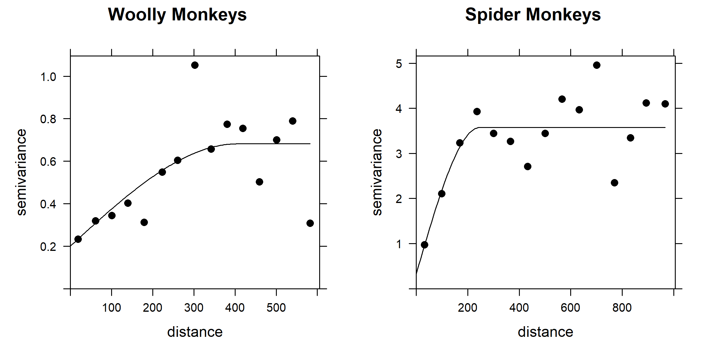

Figure S2 Residual diagnostic plots of the generalized linear model (GLM) used to test the broadscale interspecific competition hypothesis between gray woolly monkeys (Lagothrix lagotricha cana) and black-faced black spider monkeys (Ateles chamek).
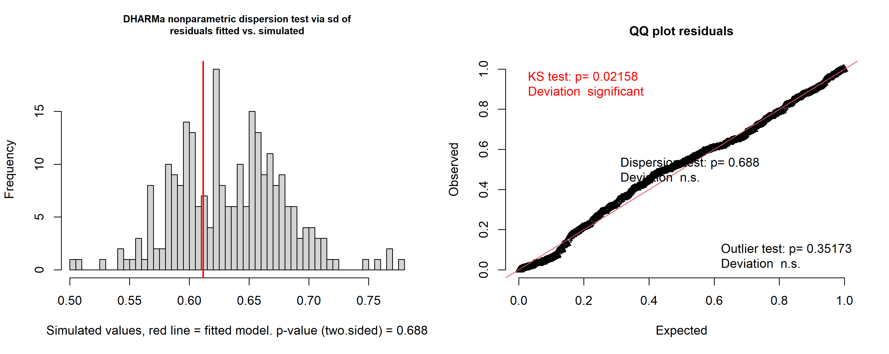
References
Alves SL (2013) Efeitos do tipo de floresta e da estrutura de habitat em assembleias de primatas no sudoeste da Amazônia. Dissertation, Universidade Federal do Pará e Museu Paraense Emílio Goeldi.
Aquino R., Alvarez J., and Mulanovich A. (2005) Diversity and conservation status of primates in the Sierras de Contamana, Peruvian Amazonia. Revista Peruana de Biologia, 12, 427–434.
Aquino R., Cornejo FM., and Heymann EW. (2013) Primate abundance and habitat preferences on the lower Urubamba and Tambo rivers, central-eastern Peruvian Amazonia. Primates, 54, 377–383.
Bastos AN (2012) O efeito da estrutura do habitat na abundância de populações de macaco-barrigudo (Lagothrix cana) no interflúvio Purus-Madeira, Amazônia central. Dissertation, Instituto Nacional de Pesquisas da Amazônia.
Borges LHM. (2014) Abundância de mamíferos de médio e grande porte em resposta ao grau de distanciamento do rio Chandless, Parque Estadual Chandless, Acre, Brasil. Dissertation, Universidade Federal do Acre.
Branch LC. (1983) Seasonal and habitat differences in the abundances of primates in the Amazon (Tapajos) National Park, Brazil. Primates, 24, 424–431.
Cavalcante T., Gusmão AC., and Ferrari SF. (2018). Unexpected diversity: the potential role of privately-owned forest remnants in the conservation of the primates of the highly-impacted Rondônia center of endemism, southwestern Brazilian Amazonia. Neotropical Primates, 24, 82-85.
Iwanaga S., and Ferrari SF. (2001). Party size and diet of syntopic atelids (Ateles chamek and Lagothrix cana) in southwestern Brazilian Amazonia. Folia Primatologica, 72, 217-227.
Iwanaga S, Ferrari SF (2002) Geographic distribution and abundance of woolly (Lagothrix cana) and spider (Ateles chamek) monkeys in southwestern Brazilian Amazonia. Am J Primatol 56:57-64
Monção GR (2008) Estimativa populacional e abundância de primatas em um fragmento no município de Pimenta Bueno, Rondônia, Brasil. Undergraduate thesis, Faculdade de Ciências Biomédicas de Cacoal
Oliveira RF (2013) Beta diversidade de mamíferos na bacia do rio Guaporé, Amazônia, sudoeste de Mato Grosso, Brasil. Dissertation, Universidade do Estado do Mato Grosso
Peres CA (1997) Primate community structure at twenty western Amazonian flooded and unflooded forests. J Trop Ecol 13:381-405
Ribeiro TM, Vale Jr. IC, Cardozo IB, Zoró TK (2015) Diagnóstico etnoambiental participativo, etnozoneamento e plano de gestão em terras indígenas - Vol. 3 Terra Indígena Zoró. Kanindé, Porto Velho.
Rosin C., and Swamy V. (2013) Variable density responses of primate communities to hunting pressure in a Western Amazonian River Basin. Neotropical Primates, 20, 25–31.
Santos FS., and Mendes-Oliveira, AC. (2012). Diversidade de mamíferos de médio e grande porte da região do rio Urucu, Amazonas, Brasil. Biota Neotropica, 12, 282-291.
Santos-Filho M., São Bernardo CS., Van der Laan Barbosa, HW., Gusmão AC., Jerusalinsky L., and Canale, GR. (2017). A new distribution range of Ateles chamek (Humboldt 1812) in an ecotone of three biomes in the Paraguay River Basin. Primates, 58, 441-448.
Wallace RB., Painter RLE., and Taber AB. (1998) Primate diversity, habitat preferences, and population density estimates in Noel Kempff Mercado National Park, Santa Cruz Department, Bolivia. American Journal of Primatology, 46, 197–211.
Wallace RB., Painter RLE., Rumiz D., and Taber AB. (2000) Primate diversity, distribution and relative abundance in the Rios Blanco y Negro Wildlife Reserve, Santa Cruz Department, Bolivia. Neotropical Primates, 8, 24–28.

