Supplementary Material

# Supplementary Figures and Tables

## Supplementary Figures

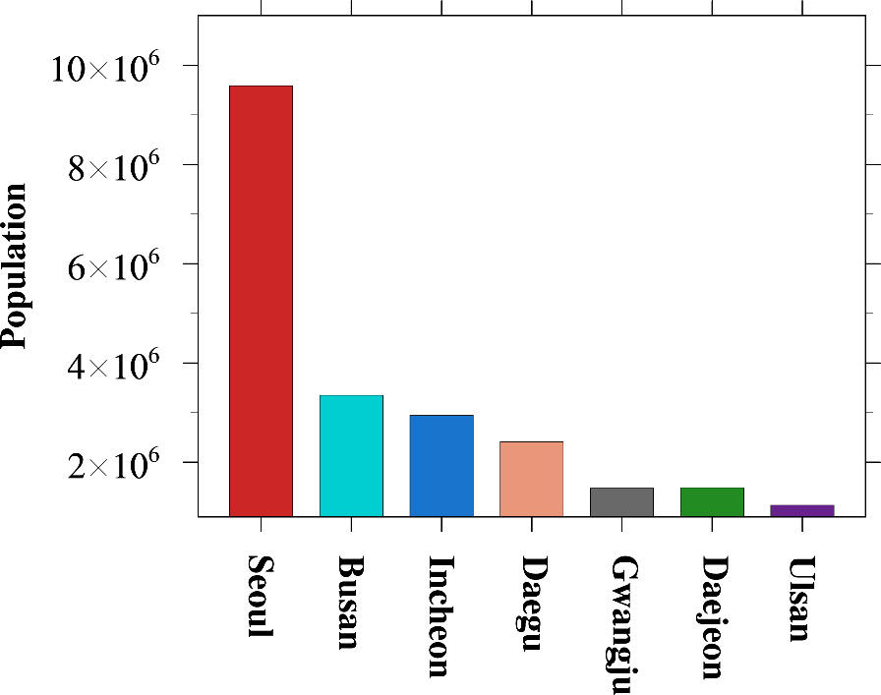

**Supplementary Figure S1.** Population of seven megacities, South Korea in 2020. This information is obtained from the population census data from Korean Statistical Information Service (KOSIS).

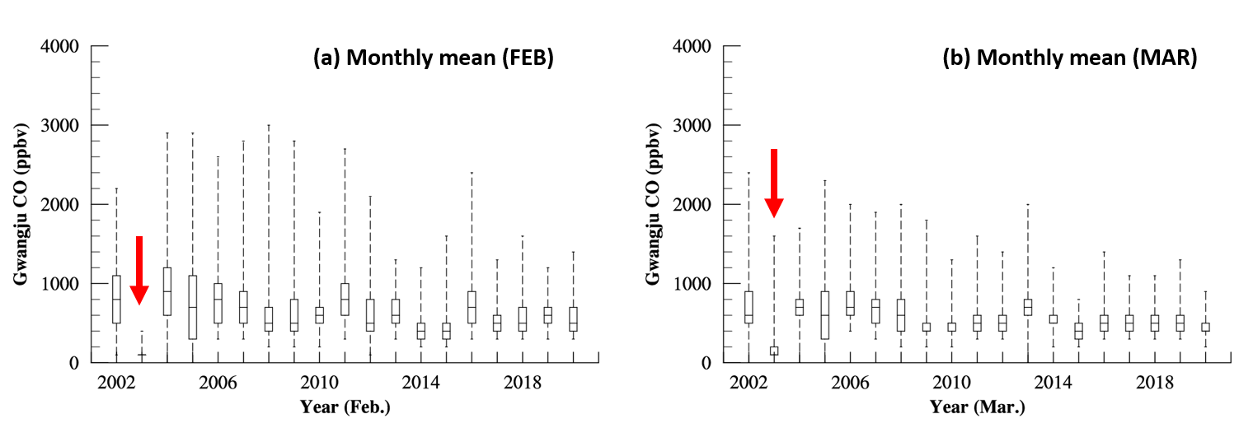

**Supplementary Figure S2.** AIRKOREA CO data time series at station No. 324133 in Gwangju: (a) Monthly mean in February (FEB) and (b) March (MAR). CO values in FEB and MAR (Red arrow) looks strange while the quality-confirmed dataset was used. Similar patterns were found at other stations in Gwangju during the same period. These data were not included in the analysis of this study.

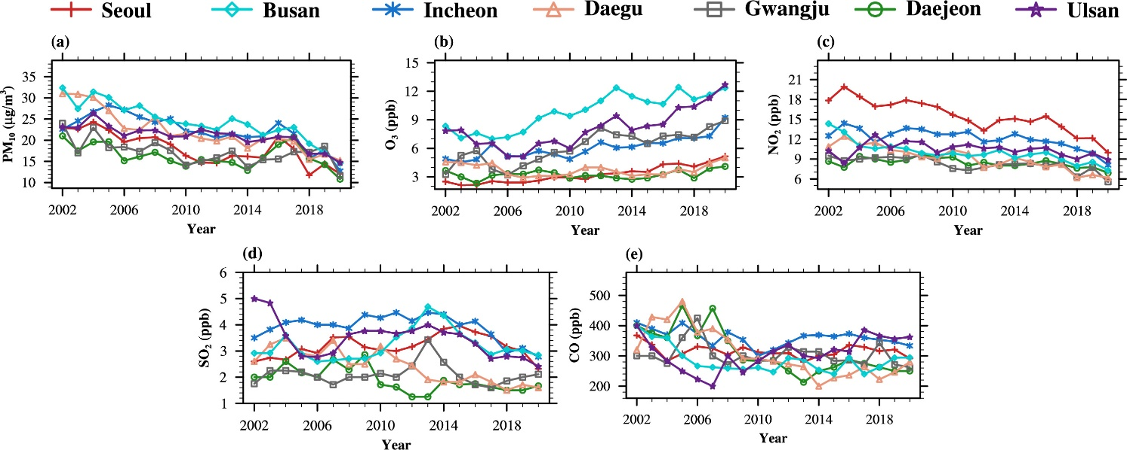

**Supplementary Figure S3.** Annual 10th percentile concentrations of (a) PM10 (μg/m3), (b) O3 (ppb), (c) NO2 (ppb), (d) SO2 (ppb), and (e) CO (ppb) in study regions (2002-2020).

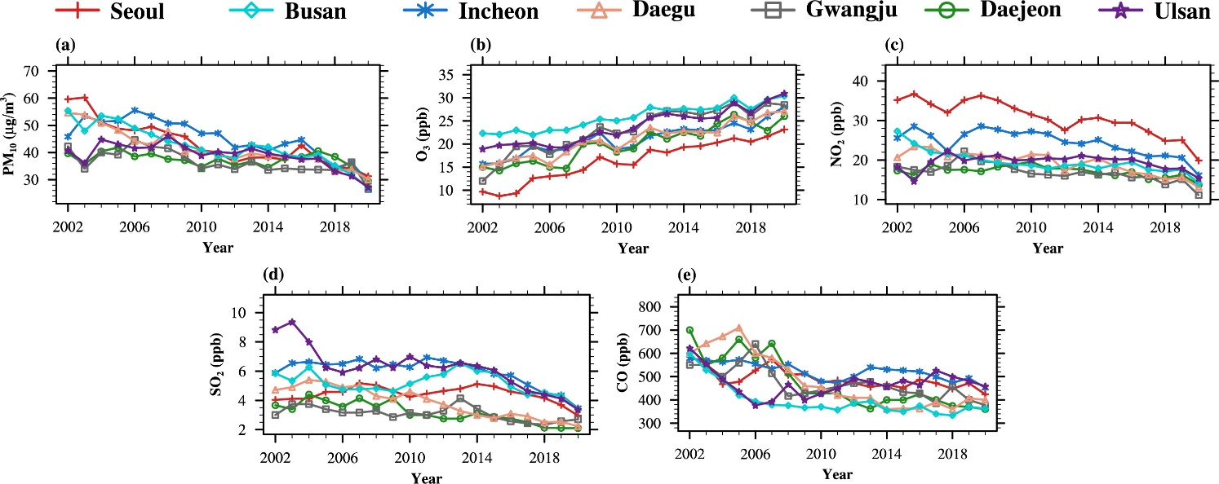

**Supplementary Figure S4.** Annual median concentrations of (a) PM10 (μg/m3), (b) O3 (ppb), (c) NO2 (ppb), (d) SO2 (ppb), and (e) CO (ppb) in study regions (2002-2020).

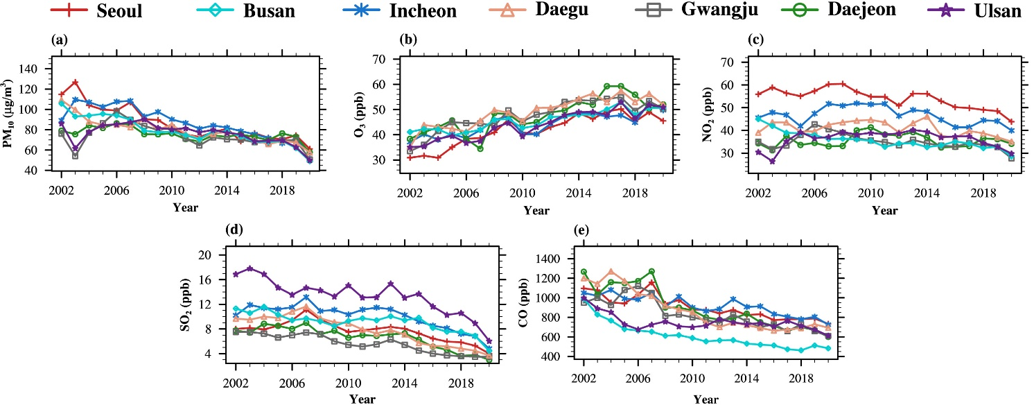

**Supplementary Figure S5.** Annual 90th percentile concentrations of (a) PM10 (μg/m3), (b) O3 (ppb), (c) NO2 (ppb), (d) SO2 (ppb), and (e) CO (ppb) in study regions (2002-2020).

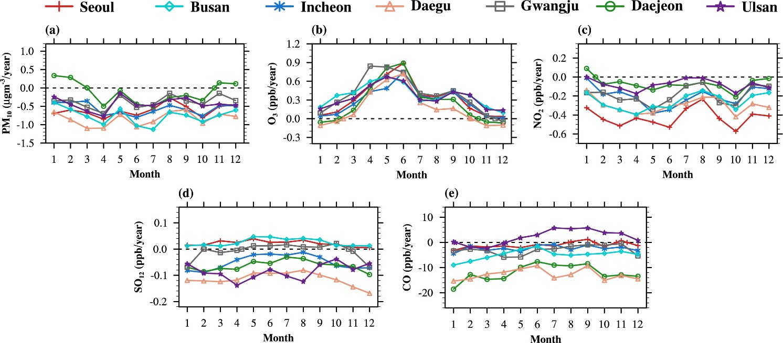

**Supplementary Figure S6.** Monthly 10th percentile concentrations of (a) PM10 (μgm-3/year), (b) O3 (ppb/year), (c) NO2 (ppb/year), (d) SO2 (ppb/year), and (e) CO (ppb/year) in study regions (2002-2020).

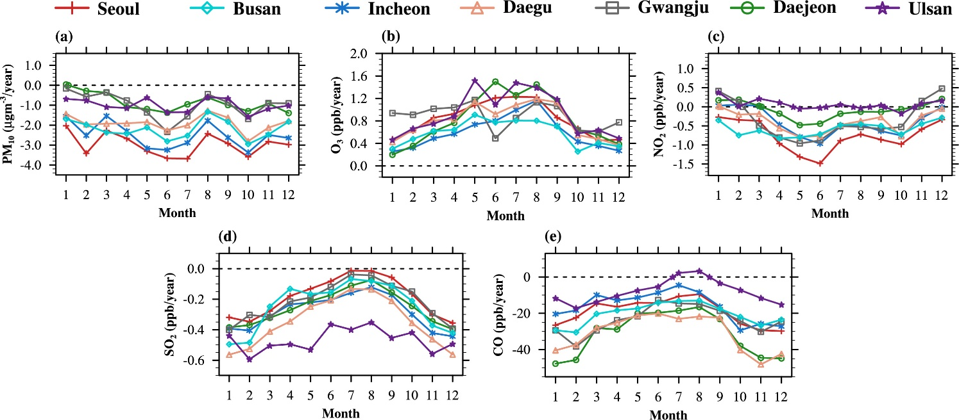

**Supplementary Figure S7.** Monthly 90th percentile concentrations of (a) PM10 (μgm-3/year), (b) O3 (ppb/year), (c) NO2 (ppb/year), (d) SO2 (ppb/year), and (e) CO (ppb/year) in study regions (2002-2020).

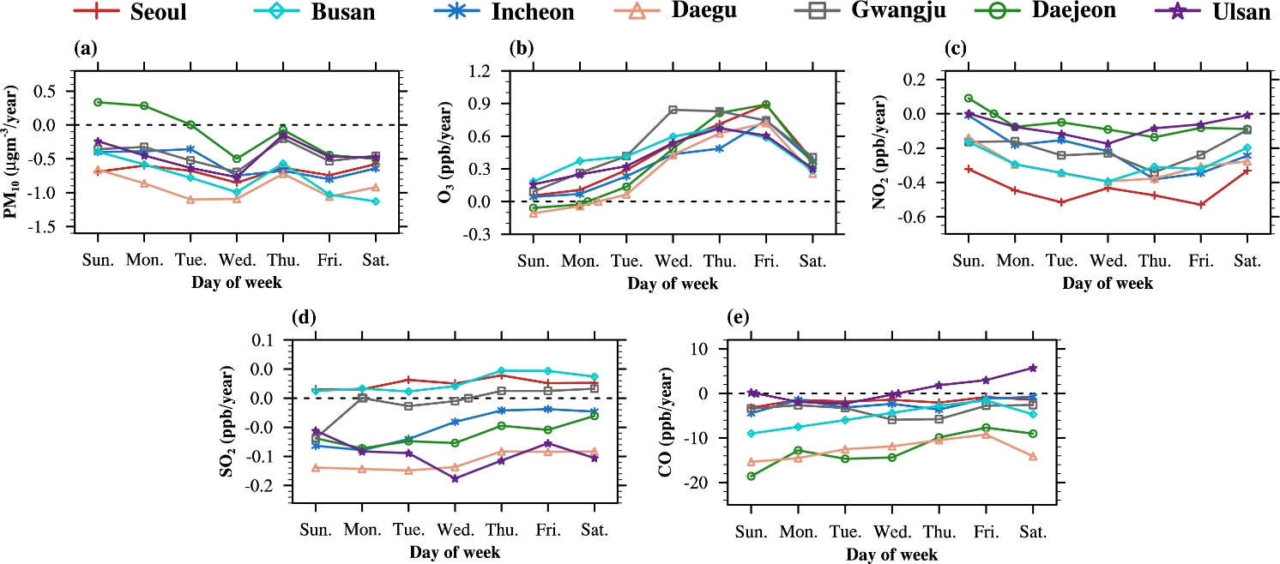

**Supplementary Figure S8.** 10th percentile concentration trend for each day of week. Weekly 10th percentile concentrations trends of (a) PM10 (μgm-3/year), (b) O3 (ppb/year), (c) NO2 (ppb/year), (d) SO2 (ppb/year), and (e) CO (ppb/year) in study regions (2002-2020).

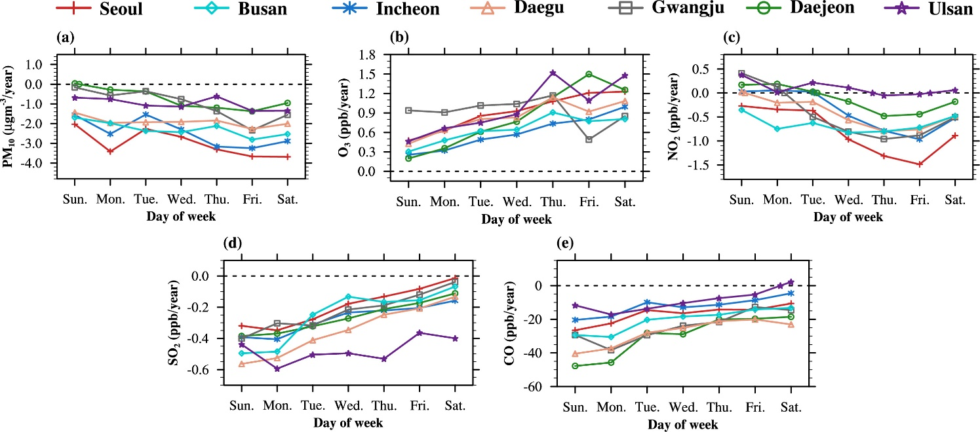

**Supplementary Figure S9.** 90th percentile concentration trend for each day of week. Weekly 90th percentile concentrations trends of (a) PM10 (μgm-3/year), (b) O3 (ppb/year), (c) NO2 (ppb/year), (d) SO2 (ppb/year), and (e) CO (ppb/year) in study regions (2002-2020).

## Supplementary Tables

**Supplementary Table S1.** Number of Asian dust occurrence days in seven megacities (2002-2020).

|  |  |  |  |  |  |  |  |
| --- | --- | --- | --- | --- | --- | --- | --- |
| Year | Seoul | Busan | Incheon | Daegu | Gwangju | Daejeon | Ulsan |
| 2002 | 16 | 12 | 17 | 12 | 14 | 15 | 11 |
| 2003 | 3 | · | 3 | 2 | 1 | 2 | 3 |
| 2004 | 6 | 5 | 6 | 6 | 8 | 10 | 4 |
| 2005 | 12 | 2 | 12 | 5 | 9 | 7 | 2 |
| 2006 | 11 | 10 | 11 | 11 | 13 | 8 | 11 |
| 2007 | 12 | 5 | 13 | 9 | 10 | 11 | 5 |
| 2008 | 11 | 5 | 9 | 6 | 8 | 8 | 5 |
| 2009 | 9 | 8 | 9 | 9 | 7 | 6 | 8 |
| 2010 | 15 | 9 | 14 | 15 | 15 | 15 | 10 |
| 2011 | 9 | 6 | 8 | 12 | 8 | 9 | 9 |
| 2012 | 1 | 1 | 2 | 2 | 2 | 2 | 1 |
| 2013 | 3 | 1 | 3 | 1 | 3 | · | 1 |
| 2014 | 10 | 8 | 8 | 4 | 7 | 6 | 8 |
| 2015 | 15 | 5 | 16 | 9 | 9 | 10 | 6 |
| 2016 | 7 | 7 | 8 | 6 | 6 | 3 | 6 |
| 2017 | 10 | 4 | 8 | 5 | 6 | 6 | 4 |
| 2018 | 5 | 6 | 3 | 5 | 5 | 3 | 6 |
| 2019 | 3 | 2 | 6 | 3 | 3 | 2 | 2 |
| 2020 | 6 | 1 | 5 | 1 | 3 | 2 | · |
| Total | 164 | 97 | 161 | 123 | 137 | 125 | 102 |

**Supplementary Table S2.** Long-term (2002-2020) trends of PM10 (μg m-3/year), O3 (ppb/year), NO2 (ppb/year), SO2 (ppb/year), and CO (ppb/year) using 10th, 50th (median), and 90th percentile levels in seven megacities, South Korea, as shown in Figure 4, Supplementary Figure S3, Supplementary Figure S4, and Supplementary Figure S5. P-values less than 0.01, 0.05, and 0.1 are marked with **, *, and +, respectively.

|  |  |  |  |  |  |  |  |  |
| --- | --- | --- | --- | --- | --- | --- | --- | --- |
|  |  | Seoul | Busan | Incheon | Daegu | Gwangju | Daejeon | Ulsan |
| PM10 | **10th** | -0.55 ** | -0.75 ** | -0.55 | -0.78 ** | -0.32 ** | -0.23 * | -0.39 ** |
| **50th (median)** | -1.35 ** | -1.20 ** | -1.10 ** | -1.14 ** | -0.55 ** | -0.24 * | -0.57 ** |
| **90th** | -2.86 ** | -2.29 ** | -2.48 ** | -2.00 * | -1.01 ** | -0.81 ** | -1.13 ** |
|  |  | **Seoul** | **Busan** | **Incheon** | **Daegu** | **Gwangju** | **Daejeon** | **Ulsan** |
| O3 | **10th** | 0.15 ** | 0.30 ** | 0.17 ** | 0.00 | 0.26 ** | 0.02 | 0.29 ** |
| **50th (median)** | 0.77 ** | 0.48 ** | 0.56 ** | 0.64 ** | 0.81 ** | 0.67 ** | 0.65 ** |
| **90th** | 1.00 ** | 0.62 ** | 0.68 ** | 0.94 ** | 0.93 ** | 0.99 ** | 0.95 ** |
|  |  | **Seoul** | **Busan** | **Incheon** | **Daegu** | **Gwangju** | **Daejeon** | **Ulsan** |
| NO2 | **10th** | -0.40 ** | -0.24 ** | -0.29 ** | -0.29 ** | -0.14 ** | -0.07 ** | -0.07 |
| **50th (median)** | -0.71 ** | -0.43 ** | -0.44 ** | -0.45 ** | -0.31 ** | -0.15 ** | -0.06 |
| **90th** | -0.63 ** | -0.59 ** | -0.31 + | -0.27 * | -0.30 * | 0.04 | 0.07 |
|  |  | **Seoul** | **Busan** | **Incheon** | **Daegu** | **Gwangju** | **Daejeon** | **Ulsan** |
| SO2 | **10th** | 0.02 | 0.02 | -0.04 + | -0.10 ** | 0.00 | -0.05 ** | -0.07 * |
| **50th (median)** | -0.02 | -0.06 + | -0.12 ** | -0.18 ** | -0.05 ** | -0.11 ** | -0.23 ** |
| **90th** | -0.22 ** | -0.24 ** | -0.30 ** | -0.39 ** | -0.25 ** | -0.28 ** | -0.45 ** |
|  |  | **Seoul** | **Busan** | **Incheon** | **Daegu** | **Gwangju** | **Daejeon** | **Ulsan** |
| CO | **10th** | -1.10 | -4.25 * | -2.24 + | -11.22 ** | -2.08 | -10.24 ** | 4.16 + |
| **50th (median)** | -5.67 ** | -9.04 ** | -5.25 ** | -18.43 ** | -9.17 ** | -17.12 ** | -0.78 |
| **90th** | -19.19 ** | -21.25 ** | -16.19 ** | -33.59 ** | -23.32 ** | -34.98 ** | -9.97 ** |

**Supplementary Table S3.** Long-term (2002-2020) trends of monthly median PM10 (μg m−3/year), O3 (ppb/year), NO2 (ppb/year), SO2 (ppb/year), and (e) CO (ppb/year) levels in seven megacities, South Korea, as shown in Figure 5. P-values less than 0.01, 0.05, and 0.1 are marked with **, *, and +, respectively.

|  |  |  |  |  |  |  |  |  |  |  |  |  |
| --- | --- | --- | --- | --- | --- | --- | --- | --- | --- | --- | --- | --- |
| PM10 | Jan. | Feb. | Mar. | Apr. | May | Jun. | Jul. | Aug. | Sep. | Oct. | Nov. | Dec. |
| Seoul | -0.98 ** | -1.35 ** | -1.65 ** | -1.54 ** | -1.67 ** | -1.99 ** | -1.35 ** | -0.65 ** | -1.05 ** | -1.59 ** | -1.11 ** | -1.28 ** |
| Busan | -0.52 * | -0.97 ** | -1.49 ** | -1.36 ** | -1.13 ** | -1.82 ** | -1.66 ** | -1.02 ** | -1.04 ** | -1.57 ** | -1.12 ** | -0.94 ** |
| Incheon | -0.68 * | -0.85 + | -0.96 ** | -1.26 ** | -1.32 ** | -1.69 ** | -1.36 ** | -0.53 * | -1.09 ** | -1.32 ** | -0.88 ** | -0.97 ** |
| Daegu | -0.66 * | -1.16 ** | -1.61 ** | -1.34 ** | -1.19 ** | -1.52 ** | -1.34 ** | -0.88 ** | -0.75 ** | -1.60 ** | -0.93 * | -0.91 ** |
| Gwangju | -0.24 | -0.46 | -0.68 + | -0.78 * | -0.68 * | -0.94 ** | -0.89 ** | -0.17 | -0.43 + | -0.83 ** | -0.30 | -0.46 * |
| Daejeon | 0.58 * | 0.16 | -0.30 | -0.62 * | -0.53 * | -0.69 * | -0.72 * | -0.19 | -0.30 | -0.67 ** | -0.06 | -0.18 |
| Ulsan | -0.15 | -0.52 + | -0.94 * | -0.71 + | -0.38 | -1.04 ** | -0.86 * | -0.49 + | -0.38 * | -0.81 ** | -0.57 | -0.56 * |

|  |  |  |  |  |  |  |  |  |  |  |  |  |
| --- | --- | --- | --- | --- | --- | --- | --- | --- | --- | --- | --- | --- |
| O3 | Jan. | Feb. | Mar. | Apr. | May | Jun. | Jul. | Aug. | Sep. | Oct. | Nov. | Dec. |
| Seoul | 0.37 ** | 0.66 ** | 0.82 ** | 0.94 ** | 1.10 ** | 1.28 ** | 0.82 ** | 0.78 ** | 0.91 ** | 0.75 ** | 0.35 ** | 0.33 ** |
| Busan | 0.26 ** | 0.48 ** | 0.55 ** | 0.55 ** | 0.69 ** | 0.72 ** | 0.48 ** | 0.40 * | 0.51 ** | 0.47 ** | 0.32 ** | 0.23 * |
| Incheon | 0.29 ** | 0.47 ** | 0.50 ** | 0.56 ** | 0.72 ** | 0.93 ** | 0.66 ** | 0.81 ** | 0.77 ** | 0.51 ** | 0.34 ** | 0.27 ** |
| Daegu | 0.30 * | 0.69 ** | 0.65 ** | 0.76 ** | 0.92 ** | 0.95 ** | 0.69 ** | 0.62 ** | 0.65 ** | 0.67 ** | 0.20 | 0.29 * |
| Gwangju | 0.76 ** | 0.97 ** | 0.80 ** | 0.89 ** | 1.00 ** | 0.86 ** | 0.53 ** | 0.77 ** | 0.83 ** | 0.78 ** | 0.50 ** | 0.53 ** |
| Daejeon | 0.09 | 0.47 * | 0.55 ** | 0.63 ** | 0.96 ** | 1.21 ** | 0.79 ** | 0.87 ** | 0.80 ** | 0.62 ** | 0.26 + | 0.18 * |
| Ulsan | 0.40 ** | 0.61 ** | 0.62 ** | 0.79 ** | 1.00 ** | 0.81 ** | 0.73 ** | 0.61 ** | 0.77 ** | 0.70 ** | 0.42 ** | 0.40 ** |

|  |  |  |  |  |  |  |  |  |  |  |  |  |
| --- | --- | --- | --- | --- | --- | --- | --- | --- | --- | --- | --- | --- |
| NO2 | Jan. | Feb. | Mar. | Apr. | May | Jun. | Jul. | Aug. | Sep. | Oct. | Nov. | Dec. |
| Seoul | -0.42 + | -0.60 ** | -0.59 * | -0.76 ** | -0.91 ** | -0.87 ** | -0.57 ** | -0.41 ** | -0.62 ** | -0.85 ** | -0.46 ** | -0.37 + |
| Busan | -0.29 ** | -0.58 ** | -0.5 ** | -0.58 ** | -0.52 ** | -0.52 ** | -0.37 ** | -0.29 ** | -0.33 ** | -0.59 ** | -0.38 ** | -0.22 + |
| Incheon | -0.14 | -0.41 + | -0.15 | -0.43 * | -0.67 ** | -0.62 ** | -0.43 ** | -0.33 ** | -0.49 ** | -0.56 ** | -0.25 | -0.06 |
| Daegu | -0.11 | -0.48 * | -0.44 ** | -0.52 ** | -0.59 ** | -0.45 ** | -0.39 ** | -0.30 ** | -0.25 ** | -0.62 ** | -0.28 | -0.25 |
| Gwangju | -0.01 | -0.21 | -0.35 ** | -0.47 ** | -0.53 ** | -0.48 ** | -0.24 ** | -0.20 * | -0.40 ** | -0.47 ** | 0.09 | 0.07 |
| Daejeon | 0.09 | -0.07 | -0.08 | -0.19 * | -0.29 ** | -0.20 ** | -0.15 ** | -0.10 * | -0.10 | -0.19 | 0.04 | 0.13 |
| Ulsan | 0.08 | -0.15 | -0.04 | -0.12 | -0.08 | 0.01 | -0.04 | -0.05 | -0.05 | -0.19 | -0.01 | -0.01 |

|  |  |  |  |  |  |  |  |  |  |  |  |  |
| --- | --- | --- | --- | --- | --- | --- | --- | --- | --- | --- | --- | --- |
| SO2 | Jan. | Feb. | Mar. | Apr. | May | Jun. | Jul. | Aug. | Sep. | Oct. | Nov. | Dec. |
| Seoul | -0.10 + | -0.11 * | -0.05 | -0.03 | 0.00 | -0.01 | 0.01 | 0.01 | 0.00 | -0.04 * | -0.09 ** | -0.14 ** |
| Busan | -0.09 + | -0.12 * | -0.05 | -0.02 | -0.03 | -0.04 | 0.00 | 0.00 | -0.04 | -0.08 ** | -0.10 * | 0.12 ** |
| Incheon | -0.17 * | -0.2 ** | -0.12 ** | -0.10 ** | -0.10 * | -0.08 * | -0.07 * | -0.05 | -0.08 ** | -0.15 ** | -0.19 ** | -0.20 ** |
| Daegu | -0.23 ** | -0.25 ** | -0.22 ** | -0.20 ** | -0.15 ** | -0.14 ** | -0.12 ** | -0.12 ** | -0.15 ** | -0.20 ** | -0.26 ** | -0.33 ** |
| Gwangju | -0.15 ** | -0.10 ** | -0.11 ** | -0.07 ** | -0.05 * | -0.03 | -0.02 | -0.01 | -0.03 | -0.03 | -0.09 ** | -0.18 ** |
| Daejeon | -0.13 + | -0.15 ** | -0.14 ** | -0.13 ** | -0.09 ** | -0.10 ** | -0.06 ** | -0.05 * | -0.09 ** | -0.11 ** | -0.15 ** | -0.20 ** |
| Ulsan | -0.16 ** | -0.27 ** | -0.23 ** | -0.26 ** | -0.23 ** | -0.20 ** | -0.22 ** | -0.25 ** | -0.25 ** | -0.15 ** | -0.24 ** | -0.20 ** |

|  |  |  |  |  |  |  |  |  |  |  |  |  |
| --- | --- | --- | --- | --- | --- | --- | --- | --- | --- | --- | --- | --- |
| CO | Jan. | Feb. | Mar. | Apr. | May | Jun. | Jul. | Aug. | Sep. | Oct. | Nov. | Dec. |
| Seoul | -8.7 * | -7.82 + | -4.5 + | -5.84 ** | -5.68 ** | -3.85 * | -5.00 ** | -2.14 | -4.09 * | -9.86 ** | -5.87 ** | -8.01 + |
| Busan | -13.09 ** | -13.89 ** | -9.51 ** | -8.06 ** | -8.6 ** | -7.33 ** | -8.41 ** | -8.58 ** | -7.41 * | -9.04 ** | -9.53 ** | -9.53 ++ |
| Incheon | -8.00 + | -6.52 * | -5.11 + | -5.71 ** | -5.39 ** | -3.24 * | 3.74 * | -2.96 | -4.08 + | -8.83 ** | -5.38 | -6.19 |
| Daegu | -20.53 ** | -19.74 ** | -17.72 ** | -16.25 ** | -15.29 ** | -13.39 ** | -18.71 ** | -16.49 ** | -15.12 ** | -24.29 ** | -21.90 ** | -24.75 ** |
| Gwangju | -10.45 * | -6.85 | -4.10 | -16.97 ** | -13.02 ** | -7.49 ** | -7.76 ** | -5.43 + | -7.43 * | -9.52 ** | -8.88 + | -9.65 ** |
| Daejeon | -26.75 ** | -21.59 ** | -17.47 ** | -18.96 ** | -14.41 ** | -13.2 ** | -13.59 ** | -12.54 ** | -12.73 ** | -22.5 ** | -22.21 ** | -21.77 ** |
| Ulsan | -2.61 | -6.82 | -6.82 | -4.17 | -0.94 | 0.77 | 3.55 | 4.34 | 3.41 | 1.25 | -1.18 | -3.19 + |

**Supplementary Table S4.** For each day of week, long-term (2002-2020) trends of median (a) PM10 (μgm-3/year), (b) O3 (ppb/year), (c) NO2 (ppb/year), (d) SO2 (ppb/year), and (e) CO (ppb/year) levels in seven megacities, South Korea, as shown Figure 6. P-values less than 0.01, 0.05, and 0.1 are marked with **, *, and +, respectively.

|  |  |  |  |  |  |  |  |
| --- | --- | --- | --- | --- | --- | --- | --- |
| PM10 | Sun. | Mon. | Tue. | Wed. | Thu. | Fri. | Sat. |
| Seoul | -1.16 ** | -1.37 ** | -1.47 ** | -1.59 ** | -1.34 ** | -1.42 ** | -1.11 ** |
| Busan | -0.97 ** | -1.14 ** | -1.24 ** | -1.35 ** | -1.25 ** | -1.28 ** | -1.18 ** |
| Incheon | -0.88 ** | -1.1 ** | -1.26 ** | -1.30 ** | -1.15 ** | -1.25 ** | -0.88 ** |
| Daegu | -0.97 ** | -0.97 ** | -1.13 ** | -1.27 ** | -1.27 ** | -1.32 ** | -1.04 ** |
| Gwangju | -0.46 ** | -0.52 ** | -0.47 * | -0.79 ** | -0.55 ** | -0.54 ** | -0.46 ** |
| Daejeon | -0.15 | -0.21 | -0.32 + | -0.44 ** | -0.31 * | -0.20 | -0.07 |
| Ulsan | -0.41 * | -0.50 ** | 0.55 ** | -0.67 ** | -0.67 ** | -0.69 ** | -0.56 ** |

|  |  |  |  |  |  |  |  |
| --- | --- | --- | --- | --- | --- | --- | --- |
| O3 | Sun. | Mon. | Tue. | Wed. | Thu. | Fri. | Sat. |
| Seoul | 0.79 ** | 0.76 ** | 0.72 ** | 0.69 ** | 0.75 ** | 0.82 ** | 0.80 ** |
| Busan | 0.51 ** | 0.48 ** | 0.48 ** | 0.43 ** | 0.48 ** | 0.50 ** | 0.52 ** |
| Incheon | 0.55 ** | 0.57 ** | 0.48 ** | 0.51 ** | 0.55 ** | 0.61 ** | 0.62 ** |
| Daegu | 0.64 ** | 0.70 ** | 0.68 ** | 0.57 ** | 0.64 ** | 0.68 ** | 0.62 ** |
| Gwangju | 0.87 ** | 0.83 ** | 0.80 ** | 0.72 ** | 0.78 ** | 0.85 ** | 0.81 ** |
| Daejeon | 0.64 ** | 0.66 ** | 0.63 ** | 0.59 ** | 0.63 ** | 0.77 ** | 0.69 ** |
| Ulsan | 0.65 ** | 0.65 ** | 0.66 ** | 0.65 ** | 0.64 ** | 0.66 ** | 0.67 ** |

|  |  |  |  |  |  |  |  |
| --- | --- | --- | --- | --- | --- | --- | --- |
| NO2 | Sun. | Mon. | Tue. | Wed. | Thu. | Fri. | Sat. |
| Seoul | -0.68 ** | -0.69 ** | -0.75 ** | -0.75 ** | -0.77 ** | -0.71 ** | -0.66 ** |
| Busan | -0.35 ** | -0.42 ** | -0.47 ** | -0.40 ** | -0.44 ** | -0.48 ** | -0.47 ** |
| Incheon | -0.37 ** | -0.45 ** | -0.44 ** | -0.51 ** | -0.47 ** | -0.41 ** | -0.39 ** |
| Daegu | -0.42 ** | -0.42 ** | -0.41 ** | -0.43 ** | -0.48 ** | -0.5 ** | -0.48 ** |
| Gwangju | -0.38 ** | -0.28 ** | -0.28 ** | -0.35 ** | -0.30 ** | -0.27 ** | -0.35 ** |
| Daejeon | -0.15 * | -0.10 + | 0.11 | -0.20 ** | -0.20 * | -0.17 * | -0.16 * |
| Ulsan | -0.08 | -0.03 | 0.00 | -0.05 | -0.05 | -0.10 | -0.10 |

|  |  |  |  |  |  |  |  |
| --- | --- | --- | --- | --- | --- | --- | --- |
| SO2 | Sun. | Mon. | Tue. | Wed. | Thu. | Fri. | Sat. |
| Seoul | -0.01 | -0.02 | -0.03 | -0.04 | -0.03 | -0.03 | -0.01 |
| Busan | -0.01 | -0.04 | -0.07 * | -0.07 * | -0.07 * | -0.07 * | -0.06 |
| Incheon | -0.10 ** | -0.13 ** | -0.14 ** | -0.14 ** | -0.13 ** | -0.12 ** | -0.10 ** |
| Daegu | -0.13 ** | -0.16 ** | -0.19 ** | -0.19 ** | -0.20 ** | -0.20 ** | -0.17 ** |
| Gwangju | -0.04 * | -0.05 ** | -0.05 * | -0.06 ** | -0.06 ** | -0.06 ** | -0.05 * |
| Daejeon | -0.08 ** | -0.10 ** | -0.11 ** | -0.12 ** | -0.13 ** | -0.12 ** | -0.10 ** |
| Ulsan | -0.21 ** | -0.23 ** | -0.22 ** | -0.23 ** | -0.24 ** | -0.24 ** | -0.24 ** |

|  |  |  |  |  |  |  |  |
| --- | --- | --- | --- | --- | --- | --- | --- |
| CO | Sun. | Mon. | Tue. | Wed. | Thu. | Fri. | Sat. |
| Seoul | -3.66 * | -5.81 ** | -6.70 ** | -7.22 ** | -6.10 ** | -6.25 ** | -4.79 ** |
| Busan | -8.18 ** | -9.34 ** | -10.07 ** | -9.73 ** | -8.95 ** | -8.91 ** | -8.84 ** |
| Incheon | -4.01 ** | -5.44 ** | -5.69 ** | -6.85 ** | -5.30 ** | -5.47 ** | -4.11 ** |
| Daegu | -16.23 ** | -17.90 ** | -18.72 ** | -19.64 ** | -19.42 ** | -19.54 ** | -18.03 ** |
| Gwangju | -7.83 ** | -9.04 ** | -9.28 ** | -10.76 ** | -9.65 ** | -9.34 ** | -8.29 ** |
| Daejeon | -15.82 ** | -17.73 ** | -18.01 ** | -19.06 ** | -17.67 ** | -16.40 ** | -14.73 ** |
| Ulsan | 0.27 | -0.82 | -1.39 | -1.64 | -0.47 | -1.68 | -0.30 |

**Supplementary Table S5.** Monthly 10th percentile concentrations of (a) PM10 (μgm-3/year), (b) O3 (ppb/year), (c) NO2 (ppb/year), (d) SO2 (ppb/year), and (e) CO (ppb/year) in study regions (2002-2020), as shown in Supplementary Figure S6. P-values less than 0.01, 0.05, and 0.1 are marked with **, *, and +, respectively.

|  |  |  |  |  |  |  |  |  |  |  |  |  |
| --- | --- | --- | --- | --- | --- | --- | --- | --- | --- | --- | --- | --- |
| PM10 | Jan. | Feb. | Mar. | Apr. | May | Jun. | Jul. | Aug. | Sep. | Oct. | Nov. | Dec. |
| Seoul | -0.69 ** | -0.60 * | -0.68 * | -0.85 * | -0.63 * | -0.74 * | -0.58 ** | -0.27 * | -0.51 ** | -0.81 ** | -0.50 + | -0.47 ** |
| Busan | -0.39 * | -0.58 * | -0.78 ** | -0.99 ** | -0.57 * | -1.03 ** | -1.13 ** | -0.66 ** | -0.74 ** | -0.92 ** | -0.74 ** | -0.6 ** |
| Incheon | -0.40 | -0.39 | -0.36 | -0.75 * | -0.68 + | -0.80 ** | -0.64 ** | -0.47 ** | -0.59 ** | -0.76 ** | -0.48 * | -0.48 * |
| Daegu | -0.66 ** | -0.86 ** | -1.10 | -1.09 ** | -0.72 ** | -1.06 ** | -0.92 ** | -0.64 ** | -0.59 ** | -0.96 ** | -0.71 ** | -0.78 ** |
| Gwangju | -0.36 * | -0.33 | -0.52 + | -0.69 * | -0.20 | -0.53 * | -0.46 ** | -0.15 | -0.35 + | -0.45 ** | -0.15 | -0.34 ** |
| Daejeon | 0.34 + | 0.28 | 0.01 | -0.50 + | -0.07 | -0.44 * | -0.50 ** | -0.26 * | -0.20 + | -0.34 ** | 0.14 | 0.11 |
| Ulsan | -0.24 | -0.45 * | -0.63 * | -0.77 ** | -0.15 | -0.47 ** | -0.47 + | -0.32 + | -0.27 ** | -0.49 ** | -0.44 + | -0.47 ** |

|  |  |  |  |  |  |  |  |  |  |  |  |  |
| --- | --- | --- | --- | --- | --- | --- | --- | --- | --- | --- | --- | --- |
| O3 | Jan. | Feb. | Mar. | Apr. | May | Jun. | Jul. | Aug. | Sep. | Oct. | Nov. | Dec. |
| Seoul | 0.05 ** | 0.11 ** | 0.29 ** | 0.53 ** | 0.71 ** | 0.89 ** | 0.38 ** | 0.35 ** | 0.44 ** | 0.17 ** | 0.04 * | 0.03 ** |
| Busan | 0.18 * | 0.37 ** | 0.42 ** | 0.60 ** | 0.68 ** | 0.59 ** | 0.29 ** | 0.30 ** | 0.44 ** | 0.37 ** | 0.18 ** | 0.10 + |
| Incheon | 0.04 | 0.07 | 0.23 * | 0.43 ** | 0.49 ** | 0.75 ** | 0.37 ** | 0.31 ** | 0.42 ** | 0.23 ** | 0.04 | 0.01 |
| Daegu | -0.11 * | -0.04 | 0.06 | 0.43 ** | 0.63 ** | 0.72 ** | 0.26 ** | 0.14 * | 0.16 ** | 0.01 | -0.11 ** | -0.10 ** |
| Gwangju | 0.09 + | 0.26 ** | 0.42 ** | 0.84 ** | 0.83 ** | 0.74 ** | 0.41 ** | 0.37 ** | 0.45 ** | 0.26 ** | 0.05 | -0.04 |
| Daejeon | -0.06 * | -0.03 | 0.14 + | 0.49 ** | 0.81 ** | 0.89 ** | 0.35 ** | 0.31 ** | 0.31 ** | 0.06 * | -0.05 * | -0.07 ** |
| Ulsan | 0.16 + | 0.25 * | 0.33 ** | 0.54 ** | 0.67 ** | 0.61 ** | 0.30 ** | 0.28 ** | 0.43 ** | 0.38 ** | 0.14 * | 0.14 * |

|  |  |  |  |  |  |  |  |  |  |  |  |  |
| --- | --- | --- | --- | --- | --- | --- | --- | --- | --- | --- | --- | --- |
| NO2 | Jan. | Feb. | Mar. | Apr. | May | Jun. | Jul. | Aug. | Sep. | Oct. | Nov. | Dec. |
| Seoul | -0.32 ** | -0.45 ** | -0.52 ** | -0.43 ** | -0.48 ** | -0.53 ** | -0.33 ** | -0.23 ** | -0.44 ** | -0.57 ** | -0.39 ** | -0.41 ** |
| Busan | -0.16 * | -0.29 ** | -0.35 ** | -0.40 ** | -0.31 ** | -0.32 ** | -0.20 ** | -0.14 * | -0.21 ** | -0.34 ** | -0.19 ** | -0.17 ** |
| Incheon | -0.01 | -0.18 | -0.15 + | -0.22 * | -0.38 ** | -0.35 ** | -0.24 ** | -0.15 * | -0.23 ** | -0.28 ** | -0.11 | -0.12 |
| Daegu | -0.14 + | -0.29 ** | -0.34 ** | -0.39 ** | -0.38 ** | -0.31 ** | -0.28 ** | -0.21 ** | -0.21 ** | -0.42 ** | -0.28 ** | -0.32 ** |
| Gwangju | -0.16 + | -0.16 * | -0.24 ** | -0.23 ** | -0.34 ** | -0.24 ** | -0.09 ** | -0.06 | -0.27 * | -0.30 ** | -0.08 | -0.10 |
| Daejeon | 0.09 | -0.08 | -0.05 | -0.09 + | -0.14 ** | -0.08 + | -0.09 ** | -0.06 | -0.09 | -0.21 ** | -0.04 | -0.02 |
| Ulsan | 0 | -0.08 | -0.12 * | -0.17 ** | -0.08 | -0.06 | -0.01 | -0.01 | -0.06 | -0.17 + | -0.06 | -0.11 * |

|  |  |  |  |  |  |  |  |  |  |  |  |  |
| --- | --- | --- | --- | --- | --- | --- | --- | --- | --- | --- | --- | --- |
| SO2 | Jan. | Feb. | Mar. | Apr. | May | Jun. | Jul. | Aug. | Sep. | Oct. | Nov. | Dec. |
| Seoul | 0.01 | 0.02 | 0.03 | 0.03 | 0.04 | 0.03 | 0.03 | 0.03 + | 0.02 | 0.02 | 0.01 | 0.01 |
| Busan | 0.01 | 0.02 | 0.01 | 0.02 | 0.05 | 0.05 | 0.04 | 0.04 | 0.04 | 0.01 | 0.01 | 0.01 |
| Incheon | -0.08 * | -0.09 * | -0.07 ** | -0.04 | -0.02 | -0.02 | -0.02 | -0.01 | -0.03 | -0.06 * | -0.07 ** | -0.07 + |
| Daegu | -0.12 ** | -0.12 ** | -0.12 ** | -0.12 ** | -0.09 ** | -0.09 ** | -0.09 ** | -0.08 ** | -0.10 ** | -0.12 ** | -0.14 ** | -0.17 ** |
| Gwangju | -0.07 | 0 | -0.01 | -0.01 | 0.01 | 0.01 | 0.02 | 0.01 | 0.01 | 0.02 | -0.01 | -0.07 * |
| Daejeon | -0.07 + | -0.09 ** | -0.07 ** | -0.08 ** | -0.05 + | -0.05 ** | -0.03 + | -0.04 * | -0.06 ** | -0.06 ** | -0.07 ** | -0.10 ** |
| Ulsan | -0.06 + | -0.09 * | -0.09 ** | -0.14 ** | -0.11 ** | -0.08 * | -0.1 * | -0.12 ** | -0.06 + | -0.04 | -0.08 ** | -0.05 + |

|  |  |  |  |  |  |  |  |  |  |  |  |  |
| --- | --- | --- | --- | --- | --- | --- | --- | --- | --- | --- | --- | --- |
| CO | Jan. | Feb. | Mar. | Apr. | May | Jun. | Jul. | Aug. | Sep. | Oct. | Nov. | Dec. |
| Seoul | -3.21 + | -1.46 | -1.79 | -1.43 | -2.07 | -0.82 | -1.42 | 0.24 | 1.24 | -1.71 | 0.69 | -1.29 |
| Busan | -8.99 ** | -7.51 * | -6.00 | -4.37 | -2.77 | -1.58 | -4.69 | -5.09 | -4.69 | -4.35 | -3.56 | -4.74 |
| Incheon | -4.45 * | -1.48 | -3.15 | -2.35 | -3.64 | -1.17 | -0.79 | -2.9 | -1.02 | -2.52 | -1.84 | -3.29 |
| Daegu | -15.34 ** | -14.53 * | -12.53 | -11.86 | -10.48 | -9.23 | -14.1 | -12.77 | -9.30 | -15.07 | -13.14 | -14.50 |
| Gwangju | -3.39 | -2.64 | -3.29 | -5.90 ** | -5.79 * | -2.75 | -2.61 | -1.53 | -0.93 | -1.17 | -0.46 | -5.36 * |
| Daejeon | -18.58 ** | -12.78 ** | -14.68 ** | -14.38 ** | -9.89 ** | -7.68 ** | -9.03 ** | -9.32 ** | -8.48 ** | -13.51 ** | -12.90 ** | -13.46 ** |
| Ulsan | 0.23 | -1.91 | -2.29 | -0.28 | 1.83 | 2.97 | 5.74 * | 5.43 + | 5.73 * | 3.85 + | 3.67 | 0.81 |

**Supplementary Table S6.** Monthly 90th percentile concentrations of (a) PM10 (μgm-3/year), (b) O3 (ppb/year), (c) NO2 (ppb/year), (d) SO2 (ppb/year), and (e) CO (ppb/year) in study regions (2002-2020), as shown in Supplementary Figure S7. P-values less than 0.01, 0.05, and 0.1 are marked with **, *, and +, respectively.

|  |  |  |  |  |  |  |  |  |  |  |  |  |
| --- | --- | --- | --- | --- | --- | --- | --- | --- | --- | --- | --- | --- |
| PM10 | Jan. | Feb. | Mar. | Apr. | May | Jun. | Jul. | Aug. | Sep. | Oct. | Nov. | Dec. |
| Seoul | -2.03 ** | -3.42 ** | -2.27 * | -2.67 ** | -3.31 ** | -3.66 ** | -3.69 ** | -2.43 ** | -2.92 ** | -3.59 ** | -2.82 ** | -2.98 ** |
| Busan | -1.70 ** | -1.98 ** | -2.37 ** | -2.43 ** | -2.12 ** | -2.81 ** | -2.53 ** | -1.33 ** | -1.83 ** | -2.95 ** | -2.47 ** | -1.82 ** |
| Incheon | -1.56 * | -2.52 ** | -1.54 * | -2.30 ** | -3.16 ** | -3.25 ** | -2.89 ** | -1.77 ** | -2.63 ** | -3.37 ** | -2.49 ** | -2.65 ** |
| Daegu | -1.44 * | -1.96 ** | -1.93 * | -1.91 ** | -1.84 ** | -2.27 ** | -2.01 ** | -1.27 ** | -1.62 ** | -2.81 ** | -2.13 ** | -1.78 ** |
| Gwangju | -0.16 | -0.57 | -0.36 | -0.76 | -1.36 + | -2.34 ** | -1.55 * | -0.45 | -0.86 * | -1.69 * | -0.89 | -0.91 |
| Daejeon | 0.04 | -0.28 | -0.36 | -1.09 + | -1.19 * | -1.38 ** | -0.95 | -0.61 + | -0.99 * | -1.3 * | -0.91 | -1.39 * |
| Ulsan | -0.68 | -0.75 | -1.08 | -1.14 + | -0.62 | -1.36 * | -1.34 + | -0.59 | -0.66 * | -1.58 * | -1.18 + | -1.01 + |

|  |  |  |  |  |  |  |  |  |  |  |  |  |
| --- | --- | --- | --- | --- | --- | --- | --- | --- | --- | --- | --- | --- |
| O3 | Jan. | Feb. | Mar. | Apr. | May | Jun. | Jul. | Aug. | Sep. | Oct. | Nov. | Dec. |
| Seoul | 0.47 ** | 0.63 ** | 0.86 ** | 0.93 ** | 1.08 ** | 1.21 ** | 1.23 ** | 1.22 ** | 0.86 ** | 0.66 ** | 0.45 ** | 0.47 ** |
| Busan | 0.30 ** | 0.48 ** | 0.62 ** | 0.64 ** | 0.91 ** | 0.77 ** | 0.81 ** | 0.80 ** | 0.70 ** | 0.25 | 0.41 ** | 0.35 ** |
| Incheon | 0.25 ** | 0.32 ** | 0.49 ** | 0.57 ** | 0.74 * | 0.8 ** | 1.00 ** | 1.16 ** | 0.71 ** | 0.43 * | 0.36 ** | 0.27 ** |
| Daegu | 0.42 ** | 0.64 ** | 0.81 ** | 0.83 ** | 1.14 ** | 0.92 ** | 1.08 ** | 1.19 ** | 1.13 ** | 0.55 ** | 0.48 ** | 0.37 ** |
| Gwangju | 0.94 ** | 0.91 ** | 1.01 ** | 1.04 ** | 1.17 ** | 0.49 + | 0.85 ** | 1.13 ** | 1.07 ** | 0.63 * | 0.61 ** | 0.77 ** |
| Daejeon | 0.20 | 0.36 * | 0.61 * | 0.77 * | 1.14 ** | 1.50 ** | 1.25 ** | 1.45 ** | 1.14 ** | 0.64 ** | 0.54 ** | 0.38 ** |
| Ulsan | 0.46 ** | 0.66 ** | 0.75 ** | 0.88 ** | 1.52 ** | 1.09 ** | 1.48 ** | 1.39 ** | 1.18 ** | 0.58 ** | 0.63 ** | 0.49 ** |

|  |  |  |  |  |  |  |  |  |  |  |  |  |
| --- | --- | --- | --- | --- | --- | --- | --- | --- | --- | --- | --- | --- |
| NO2 | Jan. | Feb. | Mar. | Apr. | May | Jun. | Jul. | Aug. | Sep. | Oct. | Nov. | Dec. |
| Seoul | -0.27 | -0.34 | -0.37 ** | -0.97 ** | -1.31 ** | -1.49 ** | -0.89 ** | -0.72 ** | -0.86 ** | -0.98 ** | -0.59 ** | -0.34 * |
| Busan | -0.35 * | -0.75 ** | -0.62 ** | -0.83 ** | -0.80 ** | -0.72 ** | -0.48 ** | -0.46 ** | -0.50 ** | -0.72 ** | -0.45 ** | -0.29 * |
| Incheon | 0.03 | 0.06 | 0.02 | -0.47 | -0.79 ** | -0.97 ** | -0.52 ** | -0.47 ** | -0.64 ** | -0.75 ** | -0.30 | -0.01 |
| Daegu | 0.02 | -0.20 | -0.18 | -0.57 * | -0.79 ** | -0.76 ** | -0.47 ** | -0.37 ** | -0.27 + | -0.77 ** | -0.23 | -0.05 |
| Gwangju | 0.41 | 0.13 | -0.50 * | -0.81 ** | -0.96 ** | -0.88 ** | -0.51 ** | -0.53 ** | -0.58 ** | -0.53 * | 0.15 | 0.48 |
| Daejeon | 0.17 | 0.19 | 0.03 | -0.18 | -0.48 ** | -0.44 ** | -0.18 | -0.13 | -0.13 | -0.07 | 0.02 | 0.21 |
| Ulsan | 0.38 * | 0.02 | 0.21 | 0.11 | -0.05 | -0.03 | 0.06 | -0.03 | 0.04 | -0.18 | 0.09 | 0.16 |

|  |  |  |  |  |  |  |  |  |  |  |  |  |
| --- | --- | --- | --- | --- | --- | --- | --- | --- | --- | --- | --- | --- |
| SO2 | Jan. | Feb. | Mar. | Apr. | May | Jun. | Jul. | Aug. | Sep. | Oct. | Nov. | Dec. |
| Seoul | -0.32 ** | -0.35 ** | -0.28 ** | -0.18 * | -0.13 * | -0.08 ** | -0.01 | -0.01 | -0.06 * | -0.17 ** | -0.30 ** | -0.36 ** |
| Busan | -0.50 ** | -0.48 ** | -0.25 ** | -0.13 + | -0.17 * | -0.16 * | -0.07 | -0.08 | -0.11 + | -0.21 ** | -0.37 ** | -0.42 ** |
| Incheon | -0.39 ** | -0.41 ** | -0.31 ** | -0.23 * | -0.22 * | -0.20 ** | -0.16 ** | -0.12 * | -0.17 ** | -0.30 ** | -0.42 ** | -0.44 ** |
| Daegu | -0.56 ** | -0.53 ** | -0.41 ** | -0.35 ** | -0.25 ** | -0.21 ** | -0.13 ** | -0.14 ** | -0.21 ** | -0.36 ** | -0.46 ** | -0.56 ** |
| Gwangju | -0.40 ** | -0.30 ** | -0.32 ** | -0.22 ** | -0.19 ** | -0.12 ** | -0.04 | -0.04 | -0.11 ** | -0.15 ** | -0.29 ** | -0.39 ** |
| Daejeon | -0.39 ** | -0.37 ** | -0.32 ** | -0.27 ** | -0.21 ** | -0.17 ** | -0.11 ** | -0.07 ** | -0.16 ** | -0.24 ** | -0.34 ** | -0.40 ** |
| Ulsan | -0.44 ** | -0.59 ** | -0.50 ** | -0.50 ** | -0.53 ** | -0.36 ** | -0.40 * | -0.35 ** | -0.45 ** | -0.42 ** | -0.56 ** | -0.49 ** |

|  |  |  |  |  |  |  |  |  |  |  |  |  |
| --- | --- | --- | --- | --- | --- | --- | --- | --- | --- | --- | --- | --- |
| CO | Jan. | Feb. | Mar. | Apr. | May | Jun. | Jul. | Aug. | Sep. | Oct. | Nov. | Dec. |
| Seoul | -26.55 ** | -22.44 ** | -14.55 * | -16.44 ** | -14.22 ** | -14.35 ** | -10.64 ** | -9.50 ** | -16.92 ** | -25.77 ** | -29.36 ** | -29.82 ** |
| Busan | -29.39 ** | -30.54 ** | -20.32 ** | -18.39 ** | -17.37 ** | -14.15 ** | -13.26 ** | -12.98 ** | -17.55 ** | -22.05 ** | -26.73 ** | -23.54 ** |
| Incheon | -20.41 ** | -18.43 * | -9.91 * | -12.92 ** | -11.36 ** | -8.66 ** | -4.53 + | -8.40 ** | -16.30 ** | -29.40 ** | -25.76 ** | -27.23 ** |
| Daegu | -40.48 ** | -37.33 ** | -27.98 ** | -25.16 ** | -21.15 ** | -20.12 ** | -23.07 ** | -21.80 ** | -22.38 ** | -40.21 ** | -48.17 ** | -42.40 ** |
| Gwangju | -29.34 ** | -38.34 ** | -29.48 ** | -23.84 ** | -21.63 ** | -12.75 ** | -14.58 ** | -14.87 ** | -18.63 ** | -24.23 ** | -30.24 ** | -24.52 * |
| Daejeon | -47.78 ** | -45.70 ** | -28.18 ** | -28.88 ** | -20.08 ** | -19.74 ** | -18.54 ** | -16.55 ** | -23.17 ** | -38.99 ** | -44.52 ** | -44.85 ** |
| Ulsan | -11.71 * | -17.17 ** | -13.75 * | -10.40 * | -7.44 + | -5.32 + | 2.22 | 3.28 | -3.36 | -7.21 | -11.60 ** | -15.23 ** |

**Supplementary Table S7.** 10th percentile concentration trend for each day of week. Weekly 10th percentile concentrations trends of (a) PM10 (μgm-3/year), (b) O3 (ppb/year), (c) NO2 (ppb/year), (d) SO2 (ppb/year), and (e) CO (ppb/year) in study regions (2002-2020), as shown in Supplementary Figure S8. P-values less than 0.01, 0.05, and 0.1 are marked with **, *, and +, respectively.

|  |  |  |  |  |  |  |  |
| --- | --- | --- | --- | --- | --- | --- | --- |
| PM10 | Sun. | Mon. | Tue. | Wed. | Thu. | Fri. | Sat. |
| Seoul | -0.69 ** | -0.60 * | -0.68 * | -0.85 * | -0.63 * | -0.74 * | -0.58 ** |
| Busan | -0.39 * | -0.58 * | -0.78 ** | -0.99 ** | -0.57 * | -1.03 ** | -1.13 ** |
| Incheon | -0.40 | -0.39 | -0.36 | -0.75 * | -0.68 + | -0.80 ** | -0.64 ** |
| Daegu | -0.66 ** | -0.86 ** | -1.10 ** | -1.09 ** | -0.72 ** | -1.06 ** | -0.92 ** |
| Gwangju | -0.36 * | -0.33 | -0.52 | -0.69 + | -0.20 | -0.53 * | -0.46 ** |
| Daejeon | 0.34 + | 0.28 | 0.01 | -0.50 + | -0.07 | -0.44 * | -0.50 ** |
| Ulsan | -0.24 | -0.45 * | -0.63 * | -0.77 ** | -0.15 | -0.47 ** | -0.47 + |

|  |  |  |  |  |  |  |  |
| --- | --- | --- | --- | --- | --- | --- | --- |
| O3 | Sun. | Mon. | Tue. | Wed. | Thu. | Fri. | Sat. |
| Seoul | 0.05 ** | 0.11 ** | 0.29 ** | 0.53 ** | 0.71 ** | 0.89 ** | 0.38 ** |
| Busan | 0.18 * | 0.37 ** | 0.42 ** | 0.60 ** | 0.68 ** | 0.59 ** | 0.29 ** |
| Incheon | 0.04 | 0.07 | 0.23 * | 0.43 ** | 0.49 ** | 0.75 ** | 0.37 ** |
| Daegu | -0.11 * | -0.04 | 0.06 | 0.43 ** | 0.63 ** | 0.72 ** | 0.26 ** |
| Gwangju | 0.09 + | 0.26 ** | 0.42 ** | 0.84 ** | 0.83 ** | 0.74 ** | 0.41 ** |
| Daejeon | -0.06 * | -0.03 | 0.14 + | 0.49 ** | 0.81 ** | 0.89 ** | 0.35 ** |
| Ulsan | 0.16 + | 0.25 * | 0.33 ** | 0.54 ** | 0.67 ** | 0.61 ** | 0.30 ** |

|  |  |  |  |  |  |  |  |
| --- | --- | --- | --- | --- | --- | --- | --- |
| NO2 | Sun. | Mon. | Tue. | Wed. | Thu. | Fri. | Sat. |
| Seoul | -0.32 ** | -0.45 ** | -0.52 ** | -0.43 ** | -0.48 ** | -0.53 ** | -0.33 ** |
| Busan | -0.16 * | -0.29 ** | -0.35 ** | -0.40 ** | -0.31 ** | -0.32 ** | -0.20 ** |
| Incheon | -0.01 | -0.18 | -0.15 + | -0.22 * | -0.38 ** | -0.35 ** | -0.24 ** |
| Daegu | -0.14 + | -0.29 ** | -0.34 ** | -0.39 ** | -0.38 ** | -0.31 ** | -0.28 ** |
| Gwangju | -0.16 + | -0.16 * | -0.24 ** | -0.23 ** | -0.34 ** | -0.24 ** | -0.09 * |
| Daejeon | 0.09 | -0.08 | -0.05 | -0.09 + | -0.14 ** | -0.08 + | -0.09 ** |
| Ulsan | 0.00 | -0.08 | -0.12 * | -0.17 ** | -0.08 | -0.06 | -0.01 |

|  |  |  |  |  |  |  |  |
| --- | --- | --- | --- | --- | --- | --- | --- |
| SO2 | Sun. | Mon. | Tue. | Wed. | Thu. | Fri. | Sat. |
| Seoul | 0.01 | 0.02 | 0.03 | 0.03 | 0.04 | 0.03 | 0.03 |
| Busan | 0.01 | 0.02 | 0.01 | 0.02 | 0.05 | 0.05 | 0.04 |
| Incheon | -0.08 * | -0.09 * | -0.07 ** | -0.04 + | -0.02 | -0.02 | -0.02 |
| Daegu | -0.12 ** | -0.12 ** | -0.12 ** | -0.12 ** | -0.09 ** | -0.09 ** | -0.09 ** |
| Gwangju | -0.07 | 0.00 | -0.01 | -0.01 | 0.01 | 0.01 | 0.02 |
| Daejeon | -0.07 + | -0.09 ** | -0.07 ** | -0.08 ** | -0.05 + | -0.05 ** | -0.03 + |
| Ulsan | -0.06 + | -0.09 * | -0.09 ** | -0.14 ** | -0.11 ** | -0.08 * | -0.10 * |

|  |  |  |  |  |  |  |  |
| --- | --- | --- | --- | --- | --- | --- | --- |
| CO | Sun. | Mon. | Tue. | Wed. | Thu. | Fri. | Sat. |
| Seoul | -3.21 + | -1.46 | -1.79 | -1.43 | -2.07 | -0.82 | -1.42 |
| Busan | -8.99 ** | -7.51 * | -6.00 * | -4.37 * | -2.77 + | -1.58 | -4.69 * |
| Incheon | -4.45 | -1.48 | -3.15 | -2.35 | -3.64 | -1.17 | -0.79 |
| Daegu | -15.34 ** | -14.53 * | -12.53 ** | -11.86 ** | -10.48 ** | -9.23 ** | -14.10 ** |
| Gwangju | -3.39 | -2.64 | -3.29 | -5.9 ** | -5.79 * | -2.75 | -2.61 |
| Daejeon | -18.58 ** | -12.78 ** | -14.68 ** | -14.38 ** | -9.89 ** | -7.68 ** | -9.03 ** |
| Ulsan | 0.23 | -1.91 | -2.29 | -0.28 | 1.83 | 2.97 | 5.74 * |

**Supplementary Table S8.** 90th percentile concentration trend for each day of week. Weekly 90th percentile concentrations trends of (a) PM10 (μgm-3/year), (b) O3 (ppb/year), (c) NO2 (ppb/year), (d) SO2 (ppb/year), and (e) CO (ppb/year) in study regions (2002-2020), as shown in Supplementary Figure S9. P-values less than 0.01, 0.05, and 0.1 are marked with **, *, and +, respectively.

|  |  |  |  |  |  |  |  |
| --- | --- | --- | --- | --- | --- | --- | --- |
| PM10 | Sun. | Mon. | Tue. | Wed. | Thu. | Fri. | Sat. |
| Seoul | -2.03 ** | -3.42 ** | -2.27 * | -2.67 ** | -3.31 ** | -3.66 ** | -3.69 ** |
| Busan | -1.7 ** | -1.98 ** | -2.37 ** | -2.43 ** | -2.12 ** | -2.81 ** | -2.53 ** |
| Incheon | -1.56 * | -2.52 ** | -1.54 * | -2.3 ** | -3.16 ** | -3.25 ** | -2.89 ** |
| Daegu | -1.44 * | -1.96 ** | -1.93 * | -1.91 ** | -1.84 ** | -2.27 ** | -2.01 ** |
| Gwangju | -0.16 | -0.57 | -0.36 | -0.76 | -1.36 + | -2.34 ** | -1.55 * |
| Daejeon | 0.04 | -0.28 | -0.36 | -1.09 + | -1.19 * | -1.38 ** | -0.95 |
| Ulsan | -0.68 | -0.75 | -1.08 | -1.14 + | -0.62 | -1.36 * | -1.34 + |

|  |  |  |  |  |  |  |  |
| --- | --- | --- | --- | --- | --- | --- | --- |
| O3 | Sun. | Mon. | Tue. | Wed. | Thu. | Fri. | Sat. |
| Seoul | 0.47 ** | 0.63 ** | 0.86 ** | 0.93 ** | 1.08 ** | 1.21 ** | 1.23 ** |
| Busan | 0.30 ** | 0.48 ** | 0.62 ** | 0.64 ** | 0.91 ** | 0.77 ** | 0.81 ** |
| Incheon | 0.25 ** | 0.32 ** | 0.49 ** | 0.57 ** | 0.74 * | 0.8 ** | 1.00 ** |
| Daegu | 0.42 ** | 0.64 ** | 0.81 ** | 0.83 ** | 1.14 ** | 0.92 ** | 1.08 ** |
| Gwangju | 0.94 ** | 0.91 ** | 1.01 ** | 1.04 ** | 1.17 ** | 0.49 + | 0.85 ** |
| Daejeon | 0.20 | 0.36 ** | 0.61 ** | 0.77 ** | 1.14 ** | 1.50 ** | 1.25 ** |
| Ulsan | 0.46 ** | 0.66 ** | 0.75 ** | 0.88 ** | 1.52 ** | 1.09 ** | 1.48 ** |

|  |  |  |  |  |  |  |  |
| --- | --- | --- | --- | --- | --- | --- | --- |
| NO2 | Sun. | Mon. | Tue. | Wed. | Thu. | Fri. | Sat. |
| Seoul | -0.27 | -0.34 | -0.37 | -0.97 ** | -1.31 ** | -1.49 ** | -0.89 ** |
| Busan | -0.35 * | -0.75 ** | -0.62 ** | -0.83 ** | -0.80 ** | -0.72 ** | -0.48 ** |
| Incheon | 0.03 | 0.06 | 0.02 | -0.47 | -0.79 ** | -0.97 ** | -0.52 ** |
| Daegu | 0.02 | -0.2 | -0.18 | -0.57 | -0.79 | -0.76 | -0.47 |
| Gwangju | 0.41 | 0.13 | -0.50 * | -0.81 ** | -0.96 ** | -0.88 ** | -0.51 ** |
| Daejeon | 0.17 | 0.19 | 0.03 | -0.18 | -0.48 ** | -0.44 ** | -0.18 |
| Ulsan | 0.38 * | 0.02 | 0.21 | 0.11 | -0.05 | -0.03 | 0.06 |

|  |  |  |  |  |  |  |  |
| --- | --- | --- | --- | --- | --- | --- | --- |
| SO2 | Sun. | Mon. | Tue. | Wed. | Thu. | Fri. | Sat. |
| Seoul | -0.32 ** | -0.35 ** | -0.28 ** | -0.18 * | -0.13 * | -0.08 ** | -0.01 |
| Busan | -0.50 ** | -0.48 ** | -0.25 ** | -0.13 + | -0.17 * | -0.16 * | -0.07 |
| Incheon | -0.39 ** | -0.41 ** | -0.31 ** | -0.23 * | -0.22 * | -0.20 ** | -0.16 ** |
| Daegu | -0.56 ** | -0.53 ** | -0.41 ** | -0.35 ** | -0.25 ** | -0.21 ** | -0.13 ** |
| Gwangju | -0.40 ** | -0.30 ** | -0.32 ** | -0.22 ** | -0.19 ** | -0.12 ** | -0.04 |
| Daejeon | -0.39 ** | -0.37 ** | -0.32 ** | -0.27 ** | -0.21 ** | -0.17 ** | -0.11 ** |
| Ulsan | -0.44 ** | -0.59 ** | -0.50 ** | -0.50 ** | -0.53 ** | -0.36 ** | -0.40 * |

|  |  |  |  |  |  |  |  |
| --- | --- | --- | --- | --- | --- | --- | --- |
| CO | Sun. | Mon. | Tue. | Wed. | Thu. | Fri. | Sat. |
| Seoul | -26.55 ** | -22.44 ** | -14.55 * | -16.44 ** | -14.22 ** | -14.35 ** | -10.64 ** |
| Busan | -29.39 ** | -30.54 ** | -20.32 ** | -18.39 ** | -17.37 ** | -14.15 ** | -13.26 ** |
| Incheon | -20.41 ** | -18.43 * | -9.91 * | -12.92 ** | -11.36 ** | -8.66 ** | -4.53 + |
| Daegu | -40.48 ** | -37.33 ** | -27.98 ** | -25.16 ** | -21.15 ** | -20.12 ** | -23.07 ** |
| Gwangju | -29.34 ** | -38.34 ** | -29.48 ** | -23.84 ** | -21.63 ** | -12.75 ** | -14.58 ** |
| Daejeon | -47.78 ** | -45.70 ** | -28.18 ** | -28.88 ** | -20.08 ** | -19.74 ** | -18.54 ** |
| Ulsan | -11.71 * | -17.17 ** | -13.75 * | -10.40 * | -7.44 + | -5.32 + | 2.22 |