**Table S1** Paired t test for female attractiveness to males in this study. “#” indicates the ID of each mouse. MC, MT, FC and FT refer to control males, antibiotic-treated males, control females, antibiotic-treated females, respectively. For all statistical tests on the contact times, travel distances and time spent, “df” is 18.

|  |  |  |  |  |  |  |  |
| --- | --- | --- | --- | --- | --- | --- | --- |
| Chooser | Paired female | | Paired t test | Chooser | Paired female | | Paired t test |
| MC♂ | FC♀ | FT♀ |  | MT♂ | FC♀ | FT♀ |  |
| 1# | 1# | 1# | t = 1.830, P = 0.048  t = 3.129, P = 0.003  t = 3.136, P = 0.004 | 1# | 6# | 6# | t = 1.830, P = 0.019  t = 3.129, P = 0.021  t = 3.136, P = 0.013 |
| 2# | 2# | 2# | 2# | 7# | 7# |
| 3# | 3# | 3# | 3# | 8# | 8# |
| 4# | 4# | 4# | 4# | 9# | 9# |
| 5# | 5# | 5# | 5# | 10# | 10# |
| 6# | 1# | 1# | 6# | 6# | 6# |
| 7# | 2# | 2# | 7# | 7# | 7# |
| 8# | 3# | 3# | 8# | 8# | 8# |
| 9# | 4# | 4# | 9# | 9# | 9# |
| 10# | 5# | 5# | 10# | 10# | 10# |

**Fig. S1.** A photo (a) andgraphical presentation (b) of experimental design in this study. One control female (FC) and one antibiotic-treated female (FT) were placed in either of the two cages in each test session. The control males (MC) and antibiotic-treated males (MT) were tested individually.

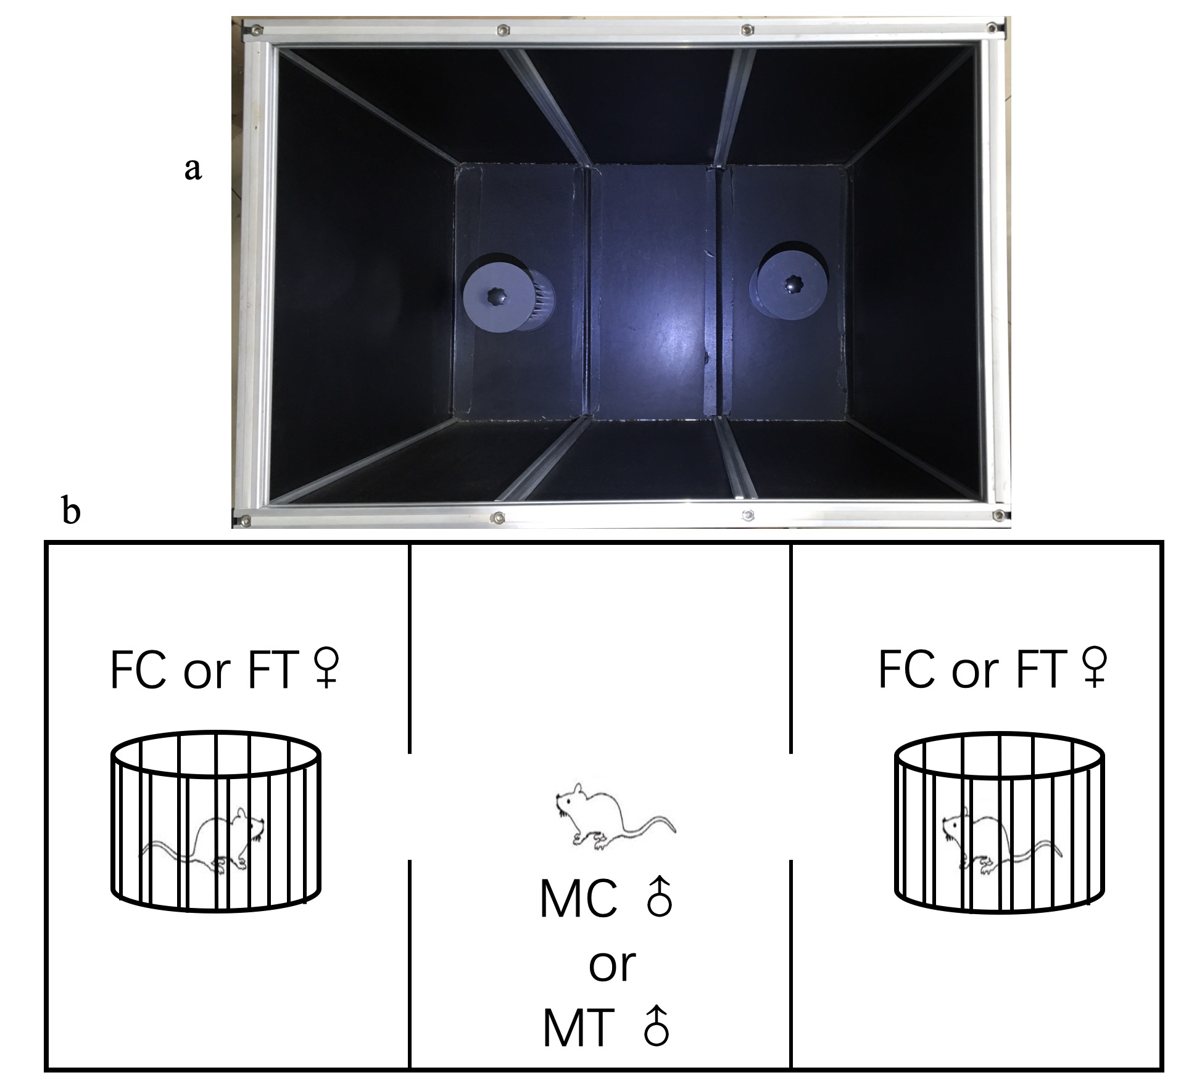

**Fig. S2.** Comparison of the α- diversity indices (a, b, c and d) and -diversity of principal-coordinates analysis (PCoA) based on Bray-Curtis dissimilarities (e) of the gut microbiota of the control males (MC) and antibiotic-treated males (MT). Statistical significance: **, P < 0.01; ***, P < 0.001.

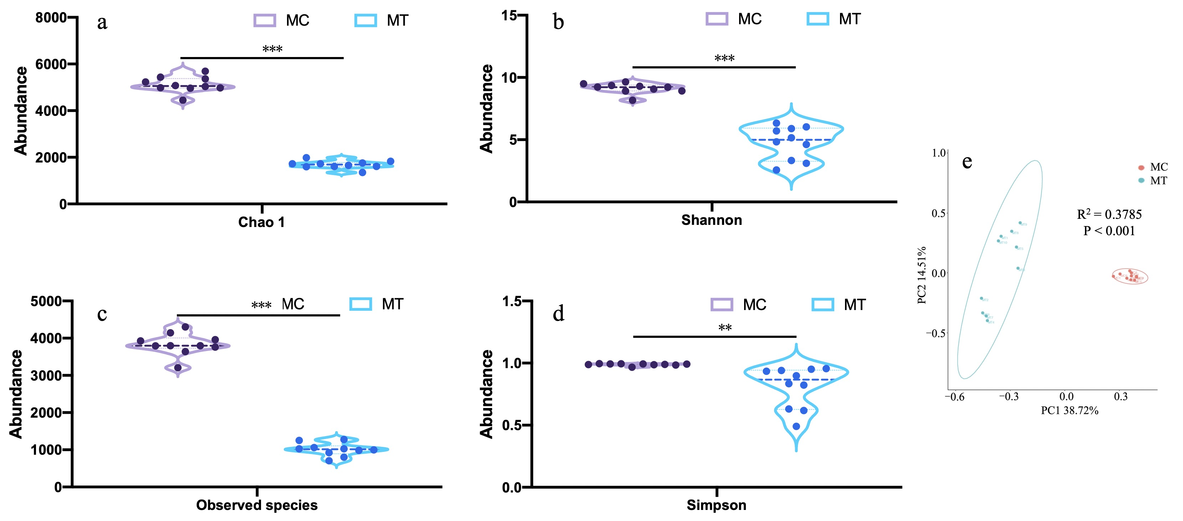

**Fig. S3.** Relative abundance of top 15 phyla (a) and 15 genera (b) that were significantly different between the control females (FC) and antibiotic-treated females (FT).



**Fig. S4.** Relative abundance of top 15 phyla (a) and 15 genera (b) that were significantly different between the control males (MC) and antibiotic-treated males (MT).

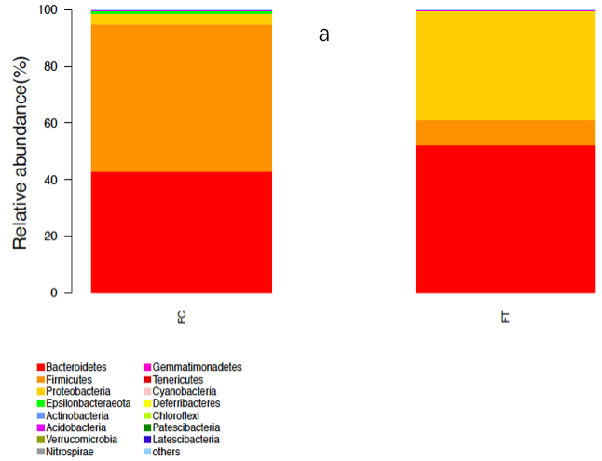

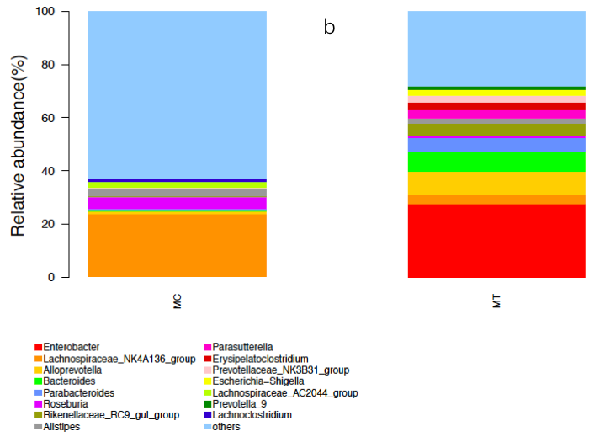

**Fig. S5.** Effects of antibiotic treatments on body weight of males (a) and females (b).

