**Supplementary**

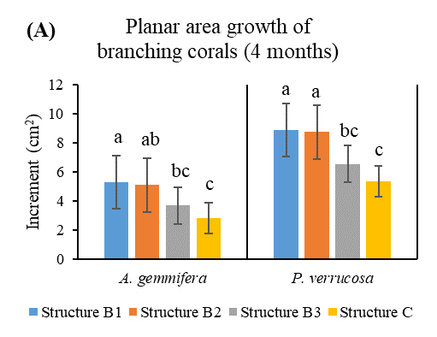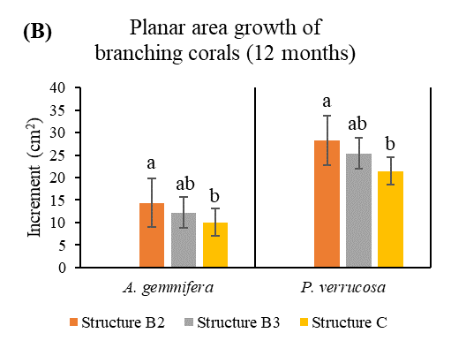

**Figure S1.** (**A**) Mean planar area (mean ± SE) of branching form coral for 4-month increment (T1 period), (**B**) Mean planar area (mean ± SE) of branching form coral for 12-month increment (T2 period); orange, gray, and yellow represent the increments of *A. gemmifera* and *P. verrucosa* on structures B2, B3, and control respectively.

**Table S1.** The comparison between volt (V) and survivorship that using electro-stimulation system on corals.

|  |  |  |
| --- | --- | --- |
| **Volt (V)** | **Survivorship (%)** | **References** |
| 1.2 | 100 | Bakti et al, 2012 |
| 2 | 100 | Stromberg et al, 2010 |
| 2.5 | 98 | Stromberg et al, 2010 |
| 3 | 79 | Stromberg et al, 2010 |
| 3 | 100 | Zamani et al, 2012 |
| 6 | 89 | Jompa et al, 2012 |
| 6 | 100 | Natasasmita et al, 2016 |
| 12 | 100 | Natasasmita et al, 2016 |
| 12 | 100 | Romatzki, 2014 |
| 12 | 95 | Romatzki, 2014 |
| 12 | 100 | Jompa et al, 2012 |
| 12 | 100 | This study |
| 18 | 86 | Sabater and Yap, 2002 |