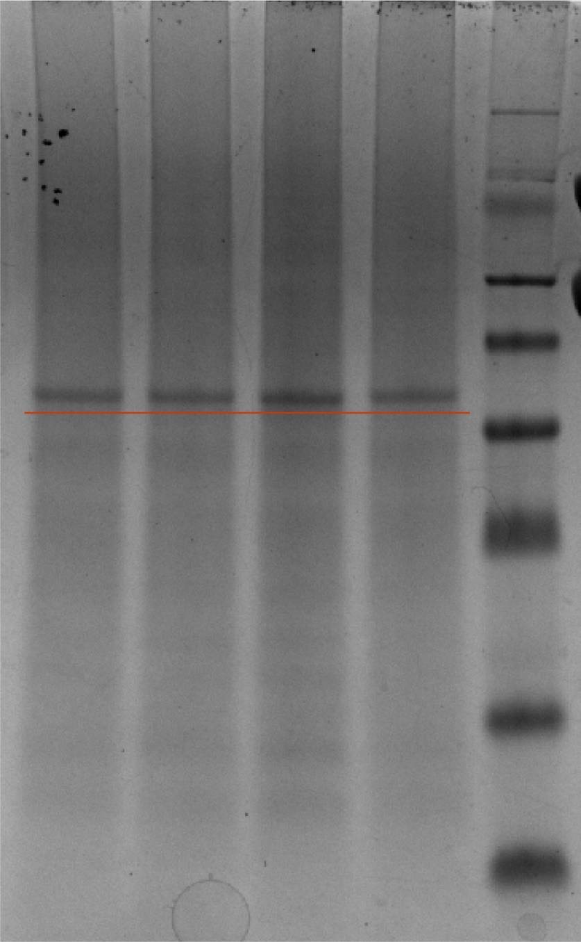

**Figure 1 SDS-Page of 2,5-DKG reductase**

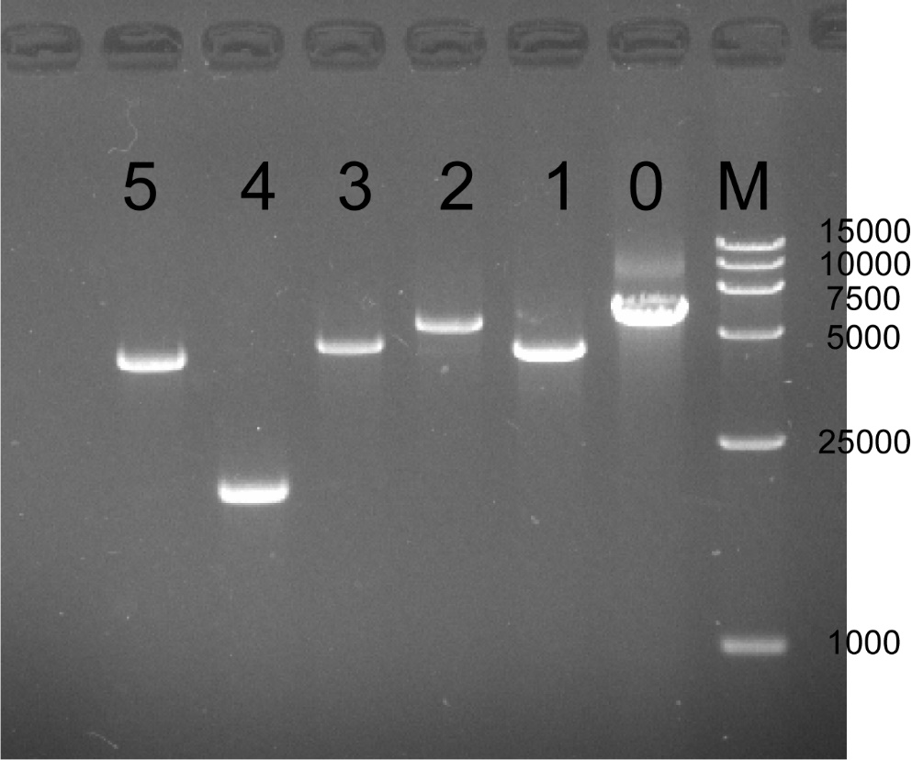

**Figure 2** ***kgdSLC* knockout strain:**

**M: Maker (15000bp); 0: control :1: knockout *kgdL*; 2: knockout *kgdS*; 3: knockout *kgdC*; 4: knockout *kgdSLC*; 5: Overexpression *kgdSLC***