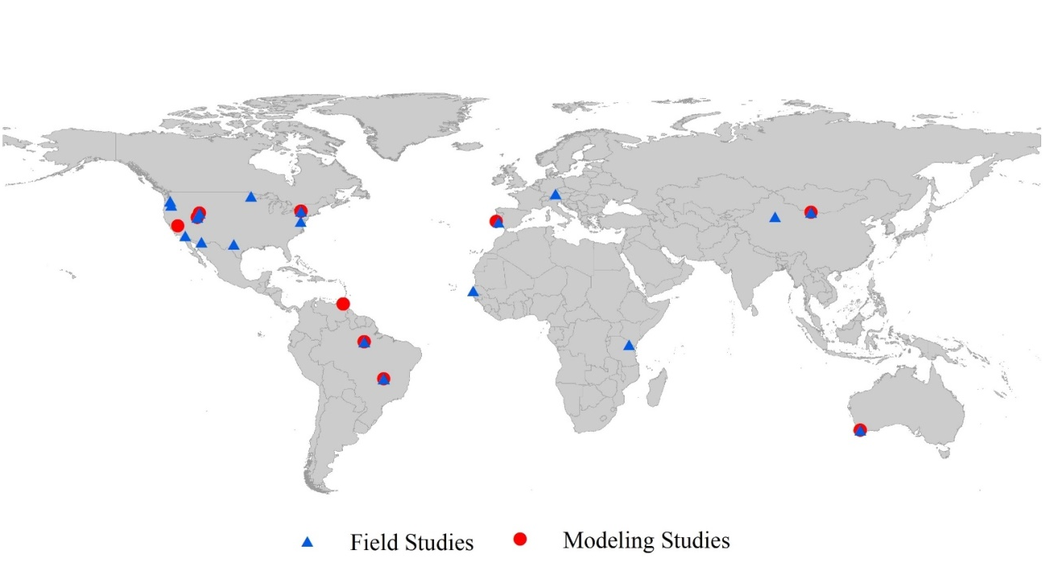
Figure S1 Location map of 47 HR study sites included in the integrated analysis, field studies (blue triangles, n=35), modelling studies (red circles, n=12)

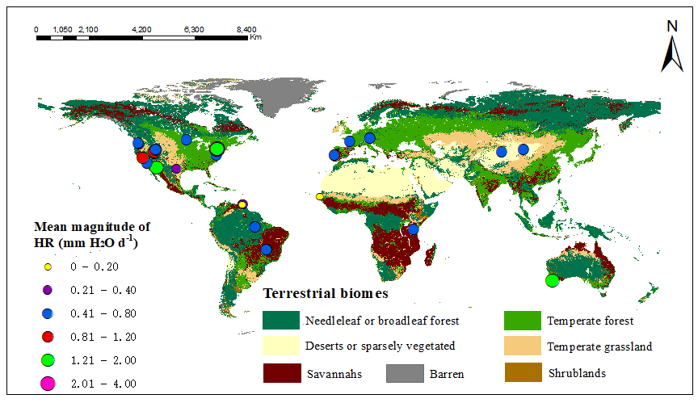
Figure S2: Average distribution range of HR in 47 empirical studies; the size of the dot represents the magnitude of HR. The global database terrestrial biomes from The Nature Conservancy. http://www.nature.org.Map ArcMap10.6. http://www.nature.org.Map

