

*[Frontiers in Earth Science]*

Supporting Information for

**Overriding lithospheric strength affects continental collisional mode selection and subduction transference: Implications for Greater India-Asia convergent system**

Qian Li 1, Zhong-Hai Li 1*, Xinyi Zhong 1

1 Key Laboratory of Computational Geodynamics, College of Earth and Planetary Sciences, University of Chinese Academy of Sciences, Beijing, China.

**Contents of this file**

Text S1

Tables S1 to S2

Figures S1 to S2

**Introduction**

This supporting information includes:

Text S1 summarizes the basic equations and numerical methods of the numerical simulations.

Table S1 shows the viscous flow laws used in the numerical experiments

Table S2 shows the material properties used in the numerical experiments

Figure S1 shows the time-dependent evolution of the averaged overriding crustal thickness during collision for 50 Myrs, with variable plastic friction coefficient of overriding lithospheric mantle.

Figure S2 shows the time-dependent evolution of the averaged overriding crustal thickness during collision for 55 Myrs, with variable plastic friction coefficient of overriding lithospheric mantle.

Text S1.

The numerical models are conducted using the code I2VIS, which combines the 2D finite-difference and the marker-in-cell methods (Gerya, 2010). The basic equations of the numerical model are briefly described here; and please refer to Li et al. (2019) for details.

**1 Governing equations**

The fundamental equations of the numerical model include conservation equations of mass, momentum and energy, as well as the constitutive relationships.

**1.1 Stokes equation**

$\frac{∂{σ_{ij}}^{'}}{∂x_{j}}-\frac{∂P}{∂x_{i}}=ρ\left(C,T,P\right)g_{i}$ (i, j = 1, 2) (1)

Where $σ_{ij}^{'}$ is the deviatoric stress tensor, $x$ the spatial coordinate, and *g* the gravitational acceleration. The density *ρ* depends on composition *C*, dynamic pressure *P* and temperature *T*. The density for a specific rock type is set to be:

$ρ(P,T)=ρ_{0}\left[1-a\left(T-T_{0}\right)\right]\left[1+β\left(P-P_{0}\right)\right]$ (2)

Where $ρ_{0}$ is the density under the reference condition with $P_{0}$ =0.1 MPa and $T_{0}$ =298 K. $α$ and $β$ are the thermal expansion coefficient and the compressibility coefficient, respectively.

**1.2 Conservation of mass**

The mass conservation is approximated by the incompressible continuity equation:

$\frac{∂ν_{i}}{∂x_{i}}=0$ (3)

**1.3 Energy equation**

$ρC_{p}\left(\frac{DT}{Dt}\right)=-\frac{∂q_{i}}{∂x_{i}}+H$ (4)

$q_{i}=-k\left(C,P,T\right)\frac{∂T}{∂x_{i}}$ (5)

$H_{a}=Tαν_{i}\frac{ⅆP}{ⅆx_{i}}$ (6)

$H_{s}={σ_{ij}}^{'}{ε_{ij}}^{'}$ (7)

Where $C_{p}$ is the effective isobaric heat capacity, *DT/Dt* the substantive time derivative of temperature, *q* the thermal heat flux; and *k* is the thermal conductivity, dependent on composition *C*, pressure *P* and temperature *T*. *H* represents all the sources of heat generations, including radioactive heat production (*Hr*), adiabatic heating (*Ha*) and shear heating (*Hs*).

**2 Constitutive relationships**

In the numerical model, the constitutive relationship is combined with visco-plastic-Peierls flow laws (Li et al., 2019).

**2.1 Viscous flow law**

Two different flow laws are applied for the crustal (Ranalli, 1995) and mantle rocks (Karato and Wu, 1993), respectively.

For the crustal rocks (the continental and oceanic crust) follow the flow laws of Ranalli (1995):

$η_{ductile}=\frac{1}{2}A_{R}^{-\frac{1}{n}}{{\dot{ε}}_{II}}^{\frac{1-n}{n}}\exp\left(\frac{E+PV}{nRT}\right)$ (8)

Where $A_{R}$ is the pre-exponential factor, ${\dot{ε}}_{II}$ the second invariant of the strain rate tensor, *E* the activation energy, *V* activation volume, *R* the gas constant and *n* the creep exponent.

For mantle rocks, the viscosity is defined according to Karato and Wu (1993), integrating both diffusion and dislocation creeps:

$η_{diff∕disl}=\frac{1}{2}A_{K}^{-\frac{1}{n}}u{\left(\frac{d}{b}\right)}^{\frac{m}{n}}{\left({\dot{ε}}_{II}\right)}^{\frac{1-n}{n}}\exp\left(\frac{E+PV}{nRT}\right)$ (9)

Where $A_{K}$ is the pre-exponential factor, *u* the shear modulus (*u* = 80 GPa), *d* the grain size (*d* = 1 mm), *b* the length of Burgers vector (*b* = 0.5 nm), *m* the grain size exponent, *E* the activation energy, *V* the activation volume and *n* the creep exponent.

**2.2 Plastic rheology**

The extended Drucker-Prager yield criterion (e.g., Ranallli, 1995) is applied as follows:

$η_{plastic}=\frac{σ_{yield}}{2{\dot{ε}}_{II}}$ (10)

$σ_{yield}=C_{0}+P·λ·sin(φ)$ (11)

Where $σ_{yield}$ is the yield stress, *P* the dynamic pressure, $C_{0}$ the residual rock strength at *P* = 0; and $λ·sin(φ)$ is the effective internal friction coefficient, which includes the possible fluid effects that control the brittle strength of fluid containing porous or fractured media (e.g., Gerya and Meilick, 2011; Li et al., 2016). Strain weakening effect is included in the plastic rheology in some of the numerical models.

**2.3 Peierls mechanism**

The Peierls mechanism is also implemented to the model by (e.g., Kameyama et al., 1999; Karato et al., 2001):

$η_{peierls}=\frac{1}{2A_{peierls}σ_{II}}exp\left(\frac{E+PV}{RT}{\left(1-{\left(\frac{σ_{II}}{σ_{peierls}}\right)}^{p}\right)}^{q}\right)$ (12)

Where $σ_{II}$ is the second invariant of stress tensor, $σ_{peierls}$ the limitation of stress on the material; and $A_{peierls}$, *p* and *q* are experimentally derived material constants.

**2.4 Effective viscosity**

The integrated viscosity of ductile, plastic and Peierls is the minimum value of them (Ranalli, 1995).

$η_{eff}=\min\left(η_{ductile},η_{plastic},η_{peierls}\right)$ (13)

**3. Dehydration and water migration**

Water plays significant roles in the subduction processes, which is thus included in the current numerical models in the forms of both connate water and mineral water. The connate water, present in sediment and oceanic upper crustal basalt, makes up to 1.0 wt% at the surface and decreases to zero at 25 km (Connolly, 2005; Gerya and Meilick, 2011):

$X_{H_{2}O(wt.\%)}=(1-\frac{∆z}{25})X_{H_{2}O(P_{0})}$ (14)

Where $∆z$ is the depth below the surface (0-25 km); and $X_{H_{2}O(P_{0})}$ is the connate water content at the surface (1.0 wt%). For the other rock types, e.g., oceanic lower crust, continental crust and mantle, the connate water content is assumed to be negligible.

For the mineral water, the water capacity is computed with Perple_X (Connolly, 2005, 2009) for four typical rock types in the subduction models, i.e. sediment, basalt (oceanic upper crust), gabbro (oceanic lower crust) and hydrated mantle. The *P-T* range for the water capacity of sediment is *Pmax* = 7 GPa and *Tmax* = 1500 °C, since the sediment generally cannot be subducted to deeper mantle. In contrast, the water capacities in oceanic crust (basalt, gabbro) and mantle are computed with pressures up to 30 GPa, i.e. a depth in the lower mantle, which thus allow the simulation of water activity in the whole upper mantle including the MTZ, and even to the topmost lower mantle (Li et al*.*, 2019).

Expelled water is stored in newly generated water tracers that move independently, with the velocity calculated as:

$$v_{i(water)}= v_{i}-A(\frac{∂P}{∂x_{i}}- g_{i}ρ_{fluid})$$

$A= \frac{v_{percolation}}{g_{2}(ρ_{mantle}- ρ_{fluid})}$ (15)

Where $v_{i(water)}$ is the fluid velocity, $v_{i}$ the local velocity of solid rock, *A* a water percolation constant with a presumed standard value of $v_{percolation}$ = 10 cm/yr (e.g., Peacock, 1990; Gorczyk et al., 2007); and = 9.81 m/s2 is the vertical gravitational acceleration component. When a moving water tracer meets a lithology capable of absorbing water by hydration or partial melting reactions at given *P-T* conditions and rock composition, the water will be consumed.

**4 Phase transition and density structure**

The phase transitions at 410 km and 660 km discontinuities are included in the numerical models with detailed implementation strategies shown in Li et al. (2019).

The phase transitions modify the mantle density structure with the gradual pressure and temperature dependence (Equation 2). In the current study, these phase transitions are only affecting the density, whereas the related variations of latent heat and possible viscosity change are not considered (Li et al., 2019). The resulting density structure of the mantle is consistent with the Preliminary Reference Earth Model (PREM) (Dziewonski and Anderson, 1981). The Clapeyron slopes of 3.0 MPa/K and -1.0 MPa/K are applied for the 410 km and 660 km discontinuities, respectively. Two additional phase transitions are also included, i.e. the oceanic crustal eclogitization (Ito and Kennedy, 1971, 2013) and the metastable olivine in the MTZ (Rubie and Ross, 1994), which could both influence the density structure of the subducting slab and are thus included following Li et al. (2019).

**Table S1.** Viscous flow laws used in the numerical experiments

|  |  |  |  |  |  |  |  |
| --- | --- | --- | --- | --- | --- | --- | --- |
| ID symbol | Flow laws | $$E (kJ∙{mol}^{-1})$$ | $$V (J∙{MPa}^{-1}∙{mol}^{-1})$$ | n | $$A_{R} ({MPa}^{-n}∙s^{-1})$$ | m | $$A_{K} (S^{-1})$$ |
| A | Wet quartzite | 154 | 8 | 2.3 | $$3.2×{10}^{-4}$$ | - | - |
| B | Plagioclase ${An}_{75}$ | 238 | 8 | 3.2 | $$3.3×{10}^{-4}$$ | - | - |
| C | Mafic granulite | 445 | 12 | 4.2 | $$1.4×{10}^{4}$$ | - | - |
| D | Dislocation creep of dry olivine | 540 | 13 | 3.5 | - | 0.0 | $$3.5×{10}^{22}$$ |
| E | Diffusion creep of dry olivine | 300 | 4 | 1.0 | - | 2.5 | $$8.7×{10}^{15}$$ |
| F | Dislocation creep of wet olivine | 430 | 10 | 3.0 | - | 0.0 | $$2.0×{10}^{18}$$ |
| G | Diffusion creep of wet olivine | 240 | 4 | 1.0 | - | 2.5 | $$5.3×{10}^{15}$$ |

References: Kirby, 1983; Kirby and Kronenberg, 1987; Ranalli and Murphy, 1987; Ji and Zhao, 1993; Ranalli, 1995; Karato and Wu, 1993.

**Table S2.** Material properties used in the numerical experiments

|  |  |  |  |  |  |  |  |  |  |  |  |  |
| --- | --- | --- | --- | --- | --- | --- | --- | --- | --- | --- | --- | --- |
| Section | $${Material}^{a}$$ | $$ρ_{0} (kg∙ m^{-3})$$ | | $$α (K^{-1})$$ | $$β ({MPa}^{-1})$$ | $$k^{b}$$ $$(W∙ m^{-1}∙ K^{-1})$$ | $H_{r}$ (μW ${∙m}^{-3}$) | Viscous Flow ${law}^{c}$ | | Plastic $C_{0}$ (Mpa) | | Plastic $$λ·sin(φ)$$ |
| All plates | Sticky air (1) | 1 | 0 | | 0 | 200 | 0 | $${10}^{18} Pa∙s$$ | 0 | | - | |
| Sticky water (2) | 1000 | 0 | | 0 | 200 | 0 | $${10}^{18} Pa∙s$$ | 0 | | - | |
| Sediments (3, 4) | 2600 | $$2×{10}^{-5}$$ | | $$0.75×{10}^{-5}$$ | $$K_{1}$$ | 2 | A | 10 | | 0.1-0.05 | |
| Weak zone mantle (15) | 3300 | $$2×{10}^{-5}$$ | | $$0.75×{10}^{-5}$$ | $$K_{3}$$ | 0.022 | F + G | 1 | | 0.1 | |
| Asthenosphere (14) | 3300 | $$2×{10}^{-5}$$ | | $$0.75×{10}^{-5}$$ | $$K_{3}$$ | 0.022 | D + E | 10 | | 0.6-0.1 | |
| Oceanic Plate | Upper crust (7) | 3000 | $$2×{10}^{-5}$$ | | $$0.75×{10}^{-5}$$ | $$K_{2}$$ | 0.25 | A | 10 | | 0.1-0.05 | |
| Lower crust (8) | 3000 | $$2×{10}^{-5}$$ | | $$0.75×{10}^{-5}$$ | $$K_{2}$$ | 0.25 | B | 10 | | 0.6-0.1 | |
| Lithospheric mantle (12) | 3300 | $$3×{10}^{-5}$$ | | $$1.00×{10}^{-5}$$ | $$K_{3}$$ | 0.022 | D + E | 10 | | 0.6-0.1 | |
| Drifting continental plate | Upper crust (5) | 2700 | $$2×{10}^{-5}$$ | | $$0.75×{10}^{-5}$$ | $$K_{1}$$ | 1 | A | 10 | | 0.1-0.05 | |
| Lower crust (6) | 2900 | $$2×{10}^{-5}$$ | | $$0.75×{10}^{-5}$$ | $$K_{1}$$ | 1 | C | 10 | | 0.1-0.05 | |
| Lithospheric mantle (11) | 3275 | $$3×{10}^{-5}$$ | | $$1.00×{10}^{-5}$$ | $$K_{3}$$ | 0.022 | D + E | 10 | | 0.6-0.1 | |
| Overriding continental plate | Upper crust (9) | 2700 | $$2×{10}^{-5}$$ | | $$0.75×{10}^{-5}$$ | $$K_{1}$$ | 1 | A | 10 | | 0.1-0.05 | |
| Lower crust (10) | 2900 | $$2×{10}^{-5}$$ | | $$0.75×{10}^{-5}$$ | $$K_{1}$$ | 1 | B | 10 | | 0.1-0.05 | |
| Lithospheric mantle (13) | 3300 | $$3×{10}^{-5}$$ | | $$1.00×{10}^{-5}$$ | $$K_{3}$$ | 0.022 | F + G | 10 | | $${varied}^{d}$$ | |
| $${Reference}^{e}$$ | - | 1, 2 | 4 | | 4 | 3 | 1 | 4 | 5 | | 5 | |

a Numbers of materials corresponding to Figure 2.

b; ; .

c Parameters of viscous flow laws are shown in Table S1

d The plastic yielding strength of overriding lithospheric mantle is varied in this study.

e Reference: 1. Turcotte and Schubert, 2002; 2. Bittner and Schmeling, 1995; 3. Clauser and Huenges, 1995; 4. Ranalli, 1995; 5. Li et al., 2019.

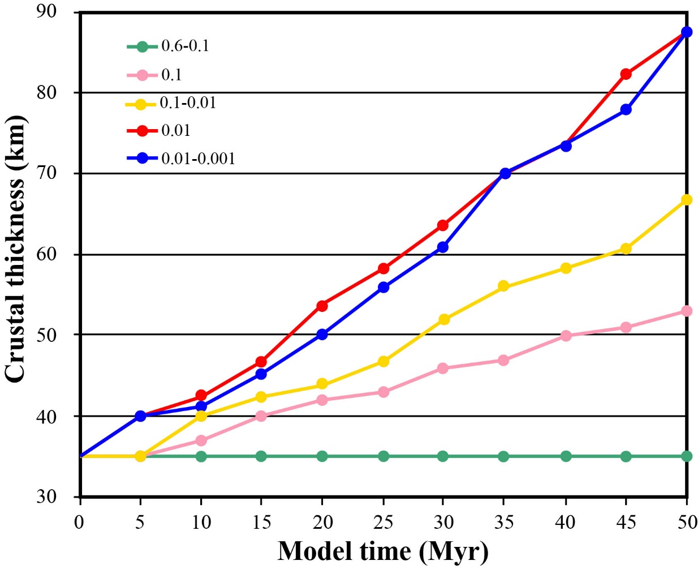

**Figure S1.** Time-dependent evolution of the averaged overriding crustal thickness for the first group of models with continental collision for ~50 Myrs. The colored lines represent the models with different plastic friction coefficients of overriding lithospheric mantle as shown in the figure.

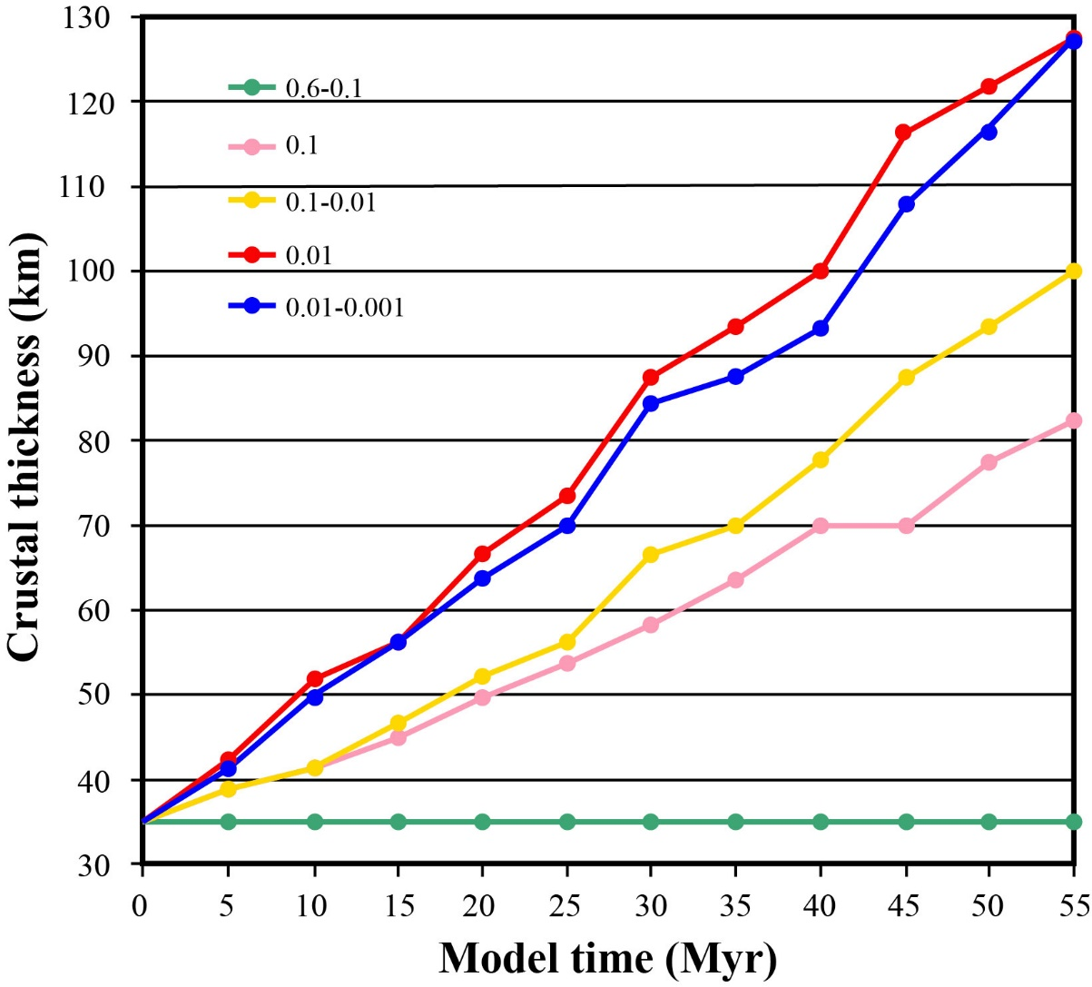

**Figure S2.** Time-dependent evolution of the averaged overriding crustal thickness for the second group of models with continental collision for ~55 Myrs. The colored lines represent the models with different plastic friction coefficients of overriding lithospheric mantle as shown in the figure.

**References:**

Bittner, D., and Schmeling, H. (1995). Numerical Modelling of Melting Processes and Induced Diapirism In the Lower Crust. Geophysical Journal International, 123(1), 59–70.[https://doi.org/10.1111/j.1365-246x.1995.tb06661.x]( https:/doi.org/10.1111/j.1365-246x.1995.tb06661.x%20)

Clauser, C., and Huenges, E. (1995). Thermal conductivity of rocks and minerals. Rock Physics and Phase Relations: A Handbook of Physical Constants, 105–126.[https://doi.org/10.1029/rf003p0105]( https:/doi.org/10.1029/rf003p0105 )

Connolly, J. A. (2005). Computation of phase equilibria by linear programming: A tool for geodynamic modeling and its application to subduction zone decarbonation. Earth and Planetary Science Letters, 236(1 - 2), 524–541. <https://doi.org/10.1016/j.epsl.2005.04.033>

Connolly, J. A. D. (2009). The geodynamic equation of state: What and how. Geochemistry, Geophysics, Geosystems, 10, A10014. <https://doi.org/10.1029/2009GC002540>

Dziewonski, A. M., and Anderson, D. L. (1981). Preliminary reference Earth model. Physics of the Earth and Planetary Interiors, 25(4), 297–356. <https://doi.org/10.1016/0031‐9201(81)90046‐7>

Gerya, T. V., and Meilick, F. I. (2011). Geodynamic regimes of subduction under an active margin: Effects of rheological weakening by fluids and melts. Journal of Metamorphic Geology, 29(1), 7–31. <https://doi.org/10.1111/j.1525-1314.2010.00904.x>

Gerya, T. V. (2010). Introduction to numerical geodynamic modelling. Cambridge, UK: Cambridge University Press. Geological Magazine, 149(01): 174. <http://dx.doi.org/10.1017/S0016756811000604>

Gerya, T. V., and Yuen, D. A. (2007). Robust characteristics method for modelling multiphase visco‐elasto‐platic thermo‐mechanical problems. Physics of the Earth and Planetary Interiors, 163, 83–105. <https://doi.org/10.1016/j.pepi.2007.04.015>

Gorczyk, W., Willner, A. P., Gerya, T. V., Connolly, J. A., and Burg, J. P. (2007). Physical controls of magmatic productivity at Pacifific‐type convergent margins: Numerical modelling. Physics of the Earth and Planetary Interiors, 163(1‐4), 209–232. [https://doi.org/10.1016/j. pepi.2007.05.010](https://doi.org/10.1016/j.%20pepi.2007.05.010)

Ito, E., Akaogi, M., Topor, L., and Navrotsky, A. (1990). Negative pressure‐temperature slopes for reactions forming MgSiO3 perovskite from calorimetry. Science, 249(4974), 1275–1278. <https://doi.org/10.1126/science.249.4974.1275>

Ito, E., and Takahashi, E. (1989). Postspinel transformations in the system Mg2SiO4–Fe2SiO4 and some geophysical implications. Journal of Geophysical Research, 94(B8), 10637–10646. <https://doi.org/10.1029/JB094iB08p10637>

Ito, K., and Kennedy, G. (1971). An experimental study of the basalt‐garnet granulite‐eclogite transition. In J. G. Heacock (Ed.), The Structure and Physical Properties of the Earth's Crust, Geophysical Monograph Series, 14, 303–314. Washington, DC: American Geophysical Union.

Ito, K., and Kennedy, G. (2013). An experimental study of the basalt‐garnet granulite‐eclogite transition. The structure and physical properties of the Earth's crust, 303–314. <https://doi.org/10.1029/gm014p0303>

Ji, S., and Zhao, P. (1993). Flow laws of multiphase rocks calculated from experimental data on the constituent phases. Earth and Planetary Science Letters, 117(1-2), 181–187. <https://doi.org/10.1016/0012-821x(93)90125-s>

Kameyama, M., Yuen, D. A., and Karato, S. I. (1999). Thermal‐mechanical effects of low‐temperature plasticity (the peierls mechanism) on the deformation of viscoelastic shear zone, Earth Planet Science Letters, 168(1‐2), 159–172. [https://doi.org/10.1016/S0012-821X(99)00040-0](https://doi.org/10.1016/S0012-821X%2899%2900040-0)

Karato, S., and Wu, P. (1993). Rheology of the Upper Mantle: A Synthesis. Science, 260(5109), 771–778. <https://doi.org/10.1126/science.260.5109.771>

Karato, S., Riedel, M., and Yuen, D. A. (2001). Rheological structure and deformation of subducted slabs in the mantle transition zone: Implications for mantle circulation and deep earthquakes. Physics of the Earth and Planetary Interiors, 127(1 - 4), 83–108. <https://doi.org/10.1016/S0031-9201(01)00223-0>

Katsura, T., and Ito, E. (1989). The System Mg2SiO4‐Fe2SiO4 at High Pressures and Temperatures: Precise Determination of Stabilities of Olivine, Modifified Spinel, and Spinel. Journal of Geophysical Research, 94(B11), 15,663–15,670. <https://doi.org/10.1029/JB094iB11p15663>

Kirby, S. H. (1983). Rheology of the lithosphere. Reviews of Geophysics, 21(6),1458–1487. [https://doi.org/ 10.1029/RG021i006p01458](https://doi.org/10.1029/RG021i006p01458)

Kirby, S. H., and Kronenberg, A. K. (1987). Rheology of the lithosphere: Selected topics. Reviews of Geophysics, 25(6), 1219. <https://doi.org/10.1029/rg025i006p01219>

Li, Z. H., Liu, M., and Gerya, T. (2016). Lithosphere delamination in continental collisional orogens: A systematic numerical study. Journal of Geophysical Research: Solid Earth, 121(7), 5186–5211. <https://doi.org/10.1002/2016jb013106>

Li, Z. H., Gerya, T. V., and Connolly, J. (2019). Variability of subducting slab morphologies in the mantle transition zone: Insight from petrological‐thermomechanical modeling. Earth‐Science Reviews, 196, 102874. <https://doi.org/10.1016/j.earscirev.2019.05.018>

Peacock, S. M. (1990). Fluid processes in subduction zones. Science, 248(4953), 329–337. <https://doi.org/10.1126/science.248.4953.329>

Ranalli, G., and Murphy, D. C. (1987). Rheological stratification of the lithosphere. Tectonophysics, 132(4), 281–295. [https://doi.org/10.1016/0040-1951(87)90348-9](https://doi.org/10.1016/0040-1951(87)90348-9 )

Ranalli, G. (1995). Rheology of the Earth, Deformation and Flow Processes in Geophysics and Geodynamics, 2nd ed., Chapman and Hall, London.

Rubie, D. C., and Ross, C. R. (1994). Kinetics of the olivine‐spinel transformation in subducting lithosphere: Experimental constraints, and implications for deep slab processes. Physics of the Earth and Planetary Interiors, 86(1-3), 223–241. <https://doi.org/10.1016/0031-9201(94)05070-8>

Turcotte, D. L., and G. Schubert. (2002). Geodynamics, 2nd ed., pp. 456, Cambridge Univ. Press, New York.

Van Mierlo, W. L., Langenhorst, F., Frost, D. J., and Rubie, D. C. (2013). Stagnation of subducting slabs in the transition zone due to slow diffusion in majoritic garnet. Nature Geoscience, 6, 400–403. <https://ui.adsabs.harvard.edu/link_gateway/2013NatGe...6..400V/doi:10.1038/ngeo1772>