Supplementary Material

Text S1 Definition of the spatial correlation between the SATA field at a certain day and its time-lagged ones.
For a given day (noted as t₀), the corresponding spatial field of SATA is focused on and read as $\text{S}\text{(}{\text{t}}_{\text{0}}\text{)}\text{=}\{{\text{s}}_{\text{1}}\text{(}{\text{t}}_{\text{0}}\text{), }{\text{s}}_{\text{2}}\text{(}{\text{t}}_{\text{0}}\text{),… , }{\text{ s}}_{\text{N}}\text{(}{\text{t}}_{\text{0}}\text{)}\}$, in which ${\text{s}}_{\text{1}}\text{(}{\text{t}}_{\text{0}}\text{)}$ represents the SATA value of the first grid in this field at time t_{0,} and there are totally N = 2240 grids in the spatial field in this study. Similarly, for a certain lagged day of t₀, its time can be noted as t₀ + τ (τ denotes the lagged days compared to t₀, and τ is larger than 0), the spatial field of SATA at time t₀ + τ is read as $\text{S}\text{(}\text{t}\text{0 }\text{+ }\text{τ}\text{)}\text{=}\{{\text{s}}_{\text{1}}\text{(}\text{t}\text{0 }\text{+ }\text{τ}\text{), }{\text{s}}_{\text{2}}\text{(}\text{t}\text{0 }\text{+ }\text{τ}\text{),… , }{\text{ s}}_{\text{N}}\text{(}\text{t}\text{0 }\text{+ }\text{τ}\text{)}\}$. Then, the Pearson correlation coefficient (noted as c($\text{τ}$)) between $\text{S}\text{(}{\text{t}}_{\text{0}}\text{)}$ and $\text{S}\text{(}\text{t}\text{0 }\text{+ }\text{τ}\text{) }$can be calculated as follows:
$c\left(τ\right)=\frac{\text{cov}\left[\text{S}\text{(}{\text{t}}_{\text{0}}\text{), }\text{S}\text{(}\text{t}\text{0 }\text{+ }\text{τ}\text{)}\right]}{\text{st}\text{d}\left[\text{S}\text{(}{\text{t}}_{\text{0}}\text{)}\right]\text{st}\text{d}\left[\text{S}\text{(}\text{t}\text{0 }\text{+ }\text{τ}\text{)}\right]},$ (S1)
in which “cov” and “std” denotes the computing processes of covariance and standard deviation respectively. Hence, when τ is taken as different values, $c\left(τ\right)$ can be used to estimate the spatial correlation between the SATA field at a certain day and its time-lagged ones.

Figure S1 (a) Spatial correlation between the SATA field at a certain day and its time-lagged ones. The black line represents the average result for the ${\text{d}}_{\text{Q1}}$ group, red for the ${\text{d}}_{\text{Q2}}$ group. The grey and red shaded areas denote the 90% confidence intervals. (b) Same as (a), but for the comparison between the ${\text{d}}_{\text{Q1}}$ group (black) and the ${\text{d}}_{\text{Q3}}$ group (blue). (c) Same as (a), but for the comparison between the ${\text{d}}_{\text{Q2}}$ group (red) and the ${\text{d}}_{\text{Q3}}$ group (blue).

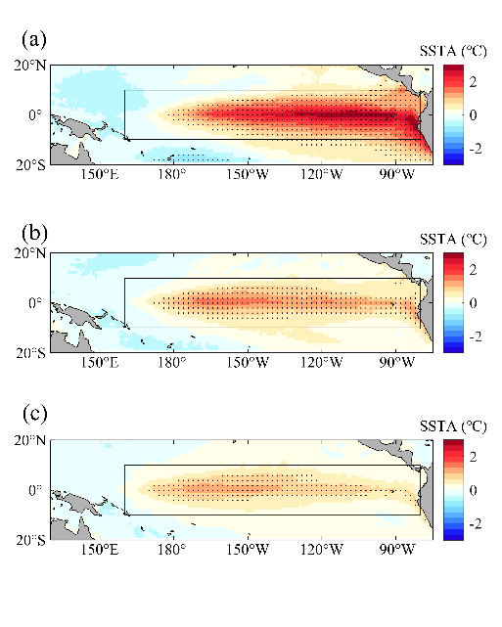
Figure S2. Comparison of SSTA patterns between high and low dimensions (during El Niño episodes). (a) The composite pattern of SSTA corresponding to the ${\text{d}}_{\text{Q1}}$ group. (b) Same as (a), but for the ${\text{d}}_{\text{Q2}}$ group. (c) Same as (a), but for the ${\text{d}}_{\text{Q3}}$ group.

Figure S3. The dynamical evolution of SATA during the 1983 coastal warming event. (a) The SATA are averaged over 5°S-5°N as a function of time and longitude. (b) and (c) show the time series of ${\text{θ}}_{\text{SATA}}$ and ${\text{d}}_{\text{SATA}}$. The black box lines denote this event, and it is consistent with the ones in Figs. 3a and 4a.

