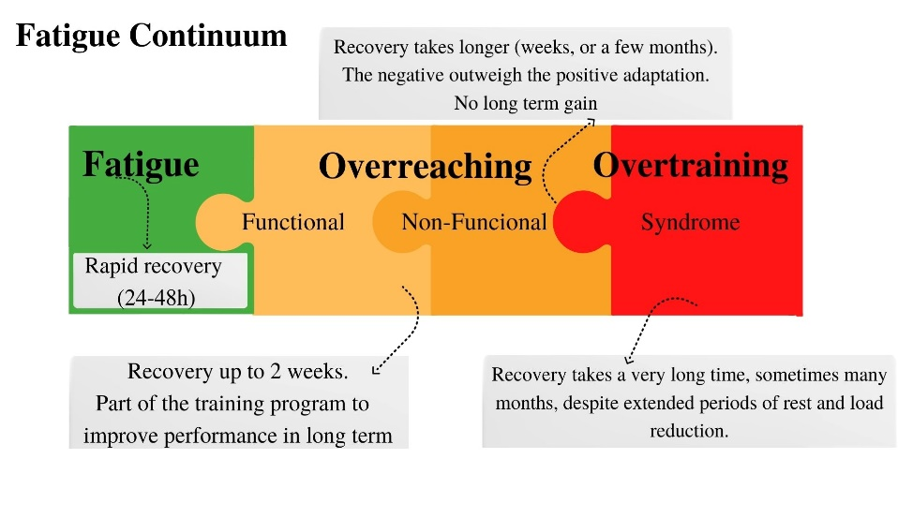

Supplemental material. Figure 1. Fatigue continuum and the classification risk of fatigue, updated from McGuigan, M. (2017).

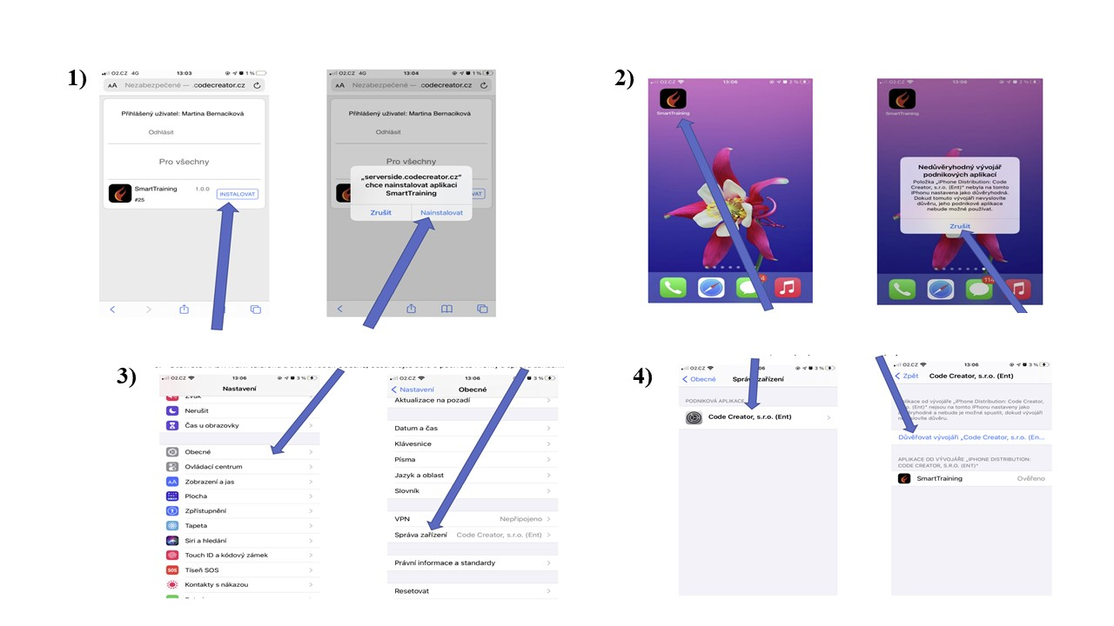
Supplemental material. Figure 2. Smart Training app download and installation process.
Follow these steps to install the iOS application:1) In Safari on your iOS device, open the page: https://serverside.codecreator.cz/aplikace/apks/SmartTraining.apk, click the INSTALL button, and confirm the prompt - select INSTALL. The application will be installed on the desktop of the iOS device. 2)Click the SmartTraining application icon. A message appears stating that the application cannot be started. Confirm Cancel. 3) Open Phone SETTINGS and select the General line, scroll down and confirm Profiles and device management. 4) Click Code Creator, s.r.o. (Ent) and choose Trust Developer. Then start the application by clicking on the SmartTraining icon.

