Supplementary Material

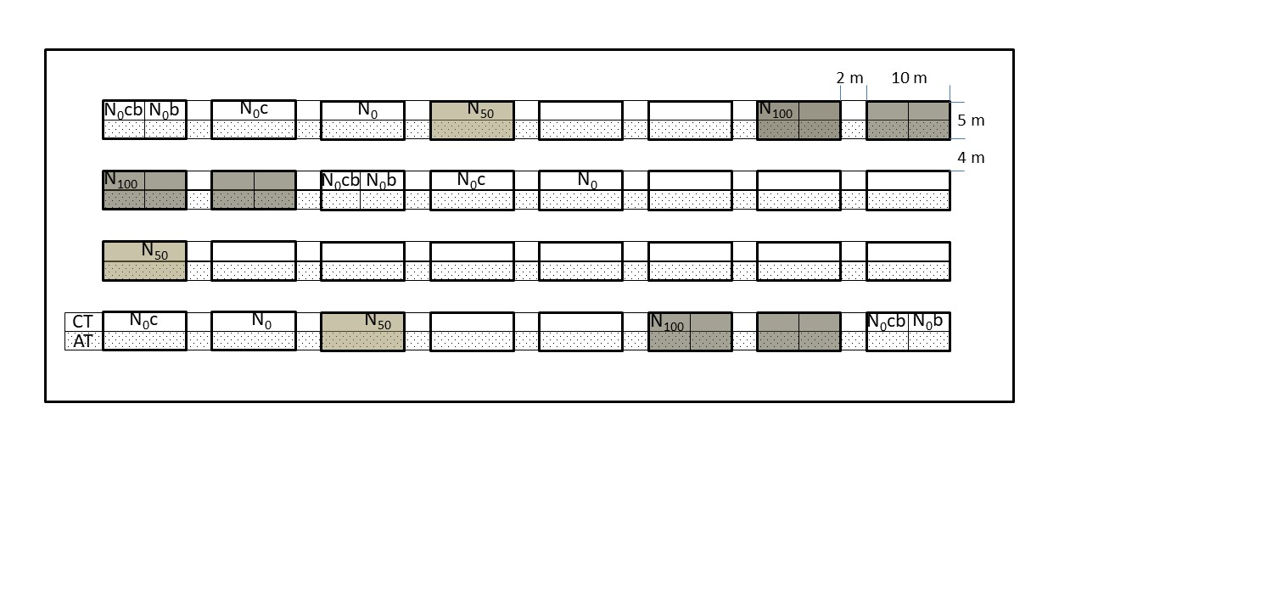

**Supplementary Figure 1.** Field layout of the experiment (same at both experimental sites) showing four blocks with carbon amendment and nitrogen fertilisation plots and split into conventional (CT – ploughing without cover crop) and adaptation (AT – no-till with cover crop) technology. Experimental treatments (N0: no N fertilisation, N50: 50% of maximum of nitrogen fertiliser dose, N100: maximum of nitrogen fertiliser dose; b: biochar; c: compost; cb: composted biochar) used within this study were part of larger experiment (data not shown). Experimental layout was identical for both experimental sites.



**Supplementary Figure 2.** Relative proportion (±SE) of soil CO2 efflux (Rs) on plots treated with compost (c), biochar (b) and composted biochar (cb) to Rs on the untreated plots. The plots were either untreated plots with no added inorganic fertiliser (N0) or with fertiliser containing 100% of maximum nitrogen fertiliser dose (N100).