Supplementary material for

**Synthesis and Photocatalytic Activity of Pt-deposited TiO2 Nanotubes (TNT) for Rhodamine B Degradation**

***Xiaojian Qiu1, Zhenning Wan2, Mengjie Pu2, Xiuru Xu3*, Yuanyao Ye4,Chunhua Hu1\****

*1 School of Resources & Environment, Nanchang University, Nanchang, Jiangxi, 330031, China*

*2 College of Life and Environmental Science, Wenzhou University, Wenzhou 325035, China*

*3 School of Agricultural and Biological Technology, Wenzhou Vocational College of Science & Technology, Zhejiang 325006, China*

*4 School of Environmental Science and Engineering, Huazhong University of Science and Technology, Wuhan 430074, China*

*Corresponding author at \** *Xiuru Xu,* *School of Agricultural and Biological Technology, Wenzhou Vocational College of Science & Technology, Zhejiang 325006, China. E-mail address: [wkyxxr@163.com](mailto:wkyxxr@163.com); Chunhua Hu, School of Resources & Environment, Nanchang University, Nanchang, Jiangxi, 330031, China. E-mail address:* [*chhu@ncu.edu.cn*](mailto:chhu@ncu.edu.cn)*.*



**Figure S1** XRD patterns of different samples with most important planes indicated, ♦ represents the diffraction peak of H2Ti3O7 , ♣ : the typical diffraction peak of anatase, ♥ represents the diffraction peak of brookite, ● : the diffraction peak of rutile.

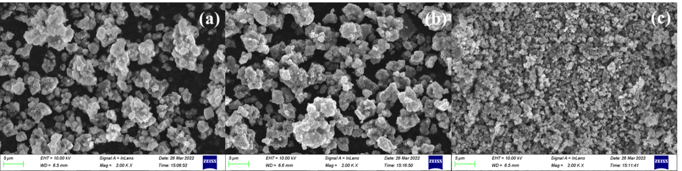

**Figure S2** Under the condition of different calcination temperature of TNT-Pt SEM images.



**Figure S3** The effect of pH on the zeta potential of TNT-400-Pt.