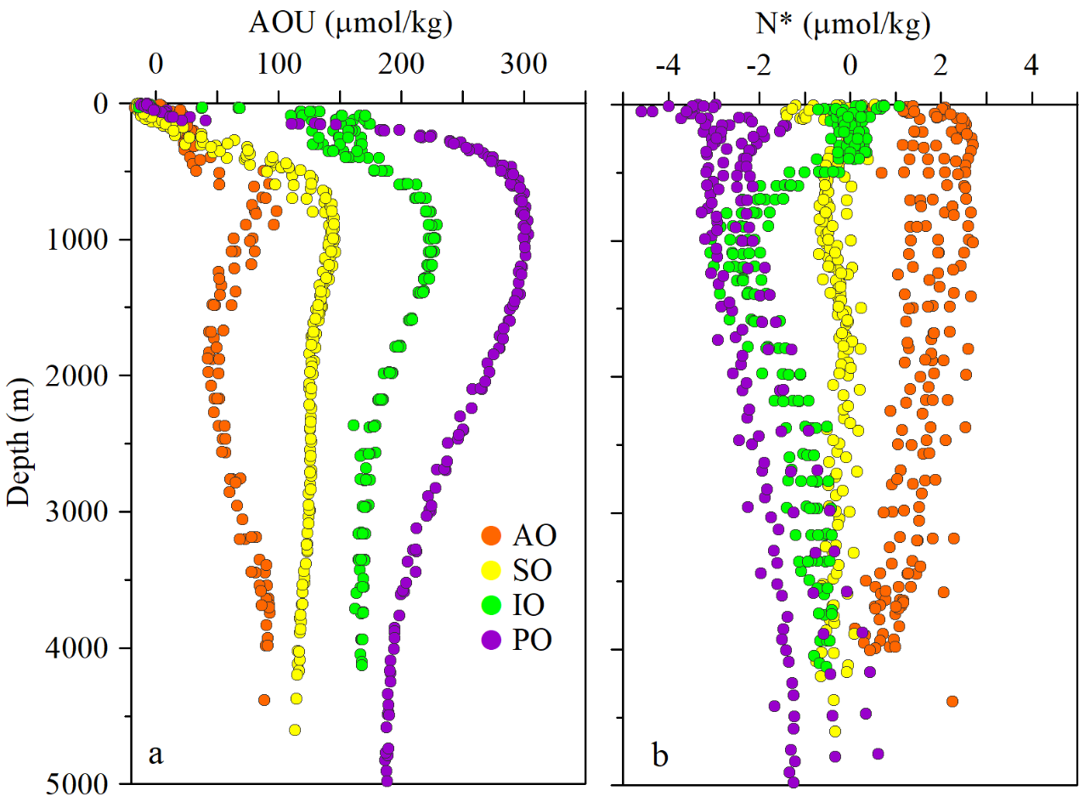

FIGURE S1 Distribution of (a) apparent oxygen utilization (AOU; μmol/kg) and (b) N* (μmol/kg) in the open oceans at different stages of the global ocean conveyor belt. North Atlantic (NA); Southern Ocean (SO); Indian Ocean (IO); North Pacific (NP).

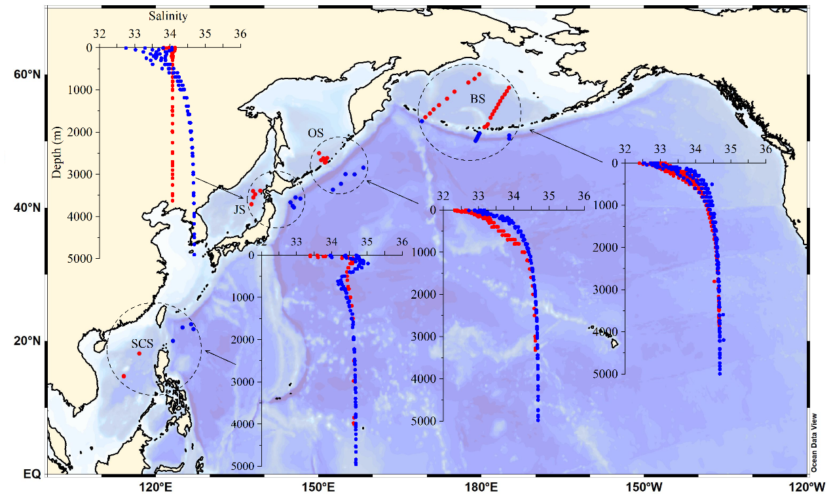

FIGURE S2 Differences in deep-sea salinity concentration in different marginal seas (red dots) and their adjacent Pacific waters (blue dots). The marginal seas include the Bering Sea (BS), Okhotsk Sea (OS), Japan Sea (JS), and South China Sea (SCS).

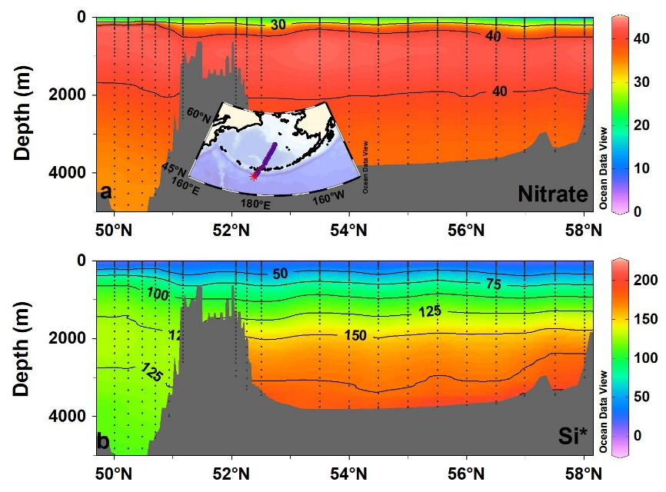

FIGURE S3 Cross-sectional distribution of (a) Nitrate (μmol/kg), and (b) Si* (μmol/kg) in the North Pacific Ocean and Bering Sea. The nutrient tracer Si* indicates an excess/deficit of silicate relative to nitrate.

TABLE S1 Sampling information of data from the World Ocean Database in this study. The study area includes the North Atlantic, Southern, Indian, and North Pacific oceans, which are open ocean waters, and the Bering Sea, Okhotsk Sea, Japan Sea, and South China Sea, which are marginal seas.

|  |  |  |  |  |  |  |
| --- | --- | --- | --- | --- | --- | --- |
| Study area | Cruise | Station | Sampling date | Longitude [ºE] | Latitude [ºN] | Bot. Depth [m] |
| North Atlantic | WOD13_NL | 7134289 | 1990/7/6 | 337.74 | 53.08 | 4019 |
| WOD13_DE | 7867730 | 1991/9/15 | 336.10 | 53.27 | 3718 |
| WOD13_DE | 7867732 | 1991/9/16 | 337.62 | 52.86 | 4005 |
| WOD13_GB | 8080463 | 1991/6/2 | 339.36 | 51.01 | 4412 |
| WOD13_DE | 8084618 | 1997 | 336.54 | 53.23 | 3724 |
| WOD13_DE | 8084620 | 1997 | 337.17 | 53.08 | 4000 |
| WOD13_DE | 8084632 | 1997 | 338.85 | 52.32 | 3770 |
| WOD13_US | 10190706 | 2003/6/26 | 340.00 | 51.00 | 3658 |
| Southern Ocean | WOD13_US | 8082588 | 1994/12/19 | 89.61 | -50.98 | 4200 |
| WOD13_US | 11310614 | 2007/2/26 | 87.02 | -53.53 | 4579 |
| WOD13_US | 11310619 | 2007/2/27 | 89.20 | -51.44 | 3871 |
| WOD13_US | 17991962 | 2016/2/29 | 88.42 | -52.03 | 4240 |
| WOD13_US | 17991963 | 2016/2/29 | 88.88 | -51.54 | 4081 |
| WOD13_US | 17991964 | 2016/2/29 | 89.35 | -51.04 | 4141 |
| Indian Ocean | WOD13_US | 7552702 | 1996/1/3 | 70.00 | -8.00 | 3718 |
| WOD13_US | 7552707 | 1996/1/5 | 66.67 | -8.00 | 4050 |
| WOD13_US | 7552708 | 1996/1/5 | 66.00 | -8.00 | 4128 |
| WOD13_US | 7552710 | 1996/1/5 | 64.65 | -8.00 | 3405 |
| WOD13_US | 7552711 | 1996/1/6 | 64.00 | -8.00 | 4105 |
| WOD13_US | 7552714 | 1996/1/6 | 62.66 | -8.00 | 3435 |
| North Pacific | WOD13_US | 7019854 | 1985/8/25 | 188.46 | 47.01 | 5750 |
| WOD13_US | 855741 | 1985/8/24 | 186.19 | 47.00 | 5658 |
| WOD13_JP | 8206792 | 1999/6/4 | 183.95 | 47.01 | 5627 |
| WOD13_JP | 15559331 | 2007/8/16 | 186.20 | 47.00 | 5724 |
| WOD13_JP | 15559326 | 2007/8/15 | 180.57 | 46.99 | 5721 |
| Bering Sea | WOD13_US | 8081032 | 1993/7/7 | 185.14 | 58.01 | 3020 |
| WOD13_US | 8081033 | 1993/7/7 | 184.75 | 57.50 | 3466 |
| WOD13_US | 8081034 | 1993/7/8 | 184.34 | 56.98 | 3481 |
| WOD13_US | 8081035 | 1993/7/8 | 183.91 | 56.50 | 3676 |
| WOD13_US | 8081036 | 1993/7/8 | 183.50 | 56.00 | 3717 |
| WOD13_US | 8081037 | 1993/7/8 | 183.16 | 55.50 | 3756 |
| WOD13_US | 8081038 | 1993/7/8 | 182.80 | 55.00 | 3777 |
| WOD13_US | 8081039 | 1993/7/9 | 182.44 | 54.49 | 3794 |
| WOD13_US | 8081040 | 1993/7/9 | 182.10 | 54.00 | 3803 |
| WOD13_US | 8081041 | 1993/7/9 | 181.75 | 53.50 | 3771 |
| WOD13_US | 8081043 | 1993/7/10 | 181.23 | 52.50 | 3466 |
| WOD13_US | 8081044 | 1993/7/10 | 181.00 | 52.26 | 3304 |
| WOD13_US | 8081045 | 1993/7/10 | 180.62 | 52.07 | 2907 |
| Okhotsk Sea | WOD13_SU | 11007199 | 2000/6/6 | 151.21 | 46.74 | 3170 |
| WOD13_SU | 11007210 | 2000/6/12 | 151.43 | 46.89 | 3053 |
| WOD13_SU | 15579577 | 1999/9/2 | 151.60 | 47.42 | 3376 |
| WOD13_SU | 15579578 | 1999/9/2 | 151.13 | 47.21 | 3362 |
| WOD13_SU | 15579668 | 2000/6/11 | 150.52 | 47.10 | 2347 |
| WOD13_SU | 15579670 | 2000/6/11 | 150.92 | 47.40 | 3355 |
| WOD13_SU | 15579680 | 2000/6/13 | 150.13 | 48.15 | 3327 |
| Japan Sea | WOD13_JP | 7169768 | 1993/5/25 | 138.35 | 42.00 | 3689 |
| WOD13_JP | 11460726 | 2008/5/13 | 139.32 | 42.53 |  |
| WOD13_JP | 11461152 | 2008/5/22 | 137.68 | 40.50 |  |
| WOD13_JP | 11812641 | 2008/11/16 | 137.67 | 40.50 |  |
| WOD13_JP | 20465378 | 2012/10/29 | 138.02 | 41.51 | 3688 |
| WOD13_JP | 20465380 | 2012/10/30 | 138.00 | 42.47 | 3686 |
| South China Sea | WOD13_JP | 6913363 | 1981/9/26 | 117.00 | 18.10 | 3950 |
| WOD13_JP | 6913612 | 1981/9/29 | 114.17 | 14.68 | 4290 |
| WOD13_JP | 6913636 | 1981/9/29 | 114.16 | 14.67 |  |