Supplementary Material

# Supplementary Figures and Tables

## Supplementary Figures

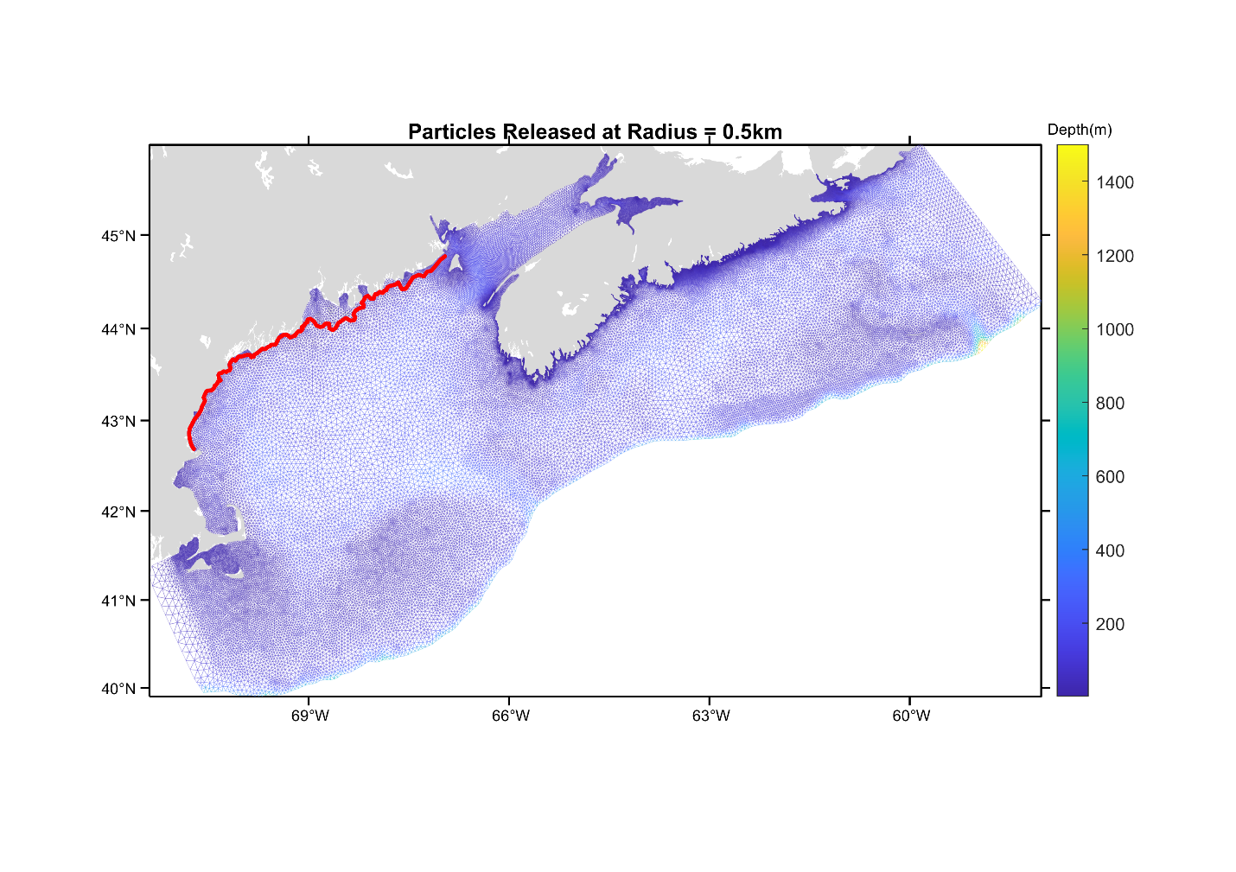

**Figure S1.** Model domain (blue triangular grid) with 0.5 km release band for particles in the Gulf of Maine.

Figure S2. Timing of particle release, as red bands, in relation to tidal velocity in the middle of the Minas Basin.

### Figure S3.

The number of particles settled at each site (panels a. to p.), with the associated release site (x-axis). Bar colour represents the source sub-region, and each panel has a colored horizontal line to indicate settlement sub-region. Results are from the July simulation, with particles assigned sink only (i.e. passive) behavior and a PLD of 33-40 days.

### Figure S4.

The number of particles settled at each site (panels a. to p.), with the associated release site (x-axis). Bar colour represents the source sub-region, and each panel has a colored horizontal line to indicate settlement sub-region. Results are from the July simulation, with particles assigned sink only (i.e. passive) behavior and a PLD of 49-56 days.

### Figure S5.

The number of particles settled at each site (panels a. to p.), with the associated release site (x-axis). Bar colour represents the source sub-region, and each panel has a colored horizontal line to indicate settlement sub-region. Results are from the July simulation, with particles assigned sink and swim behavior and a PLD of 33-40 days.

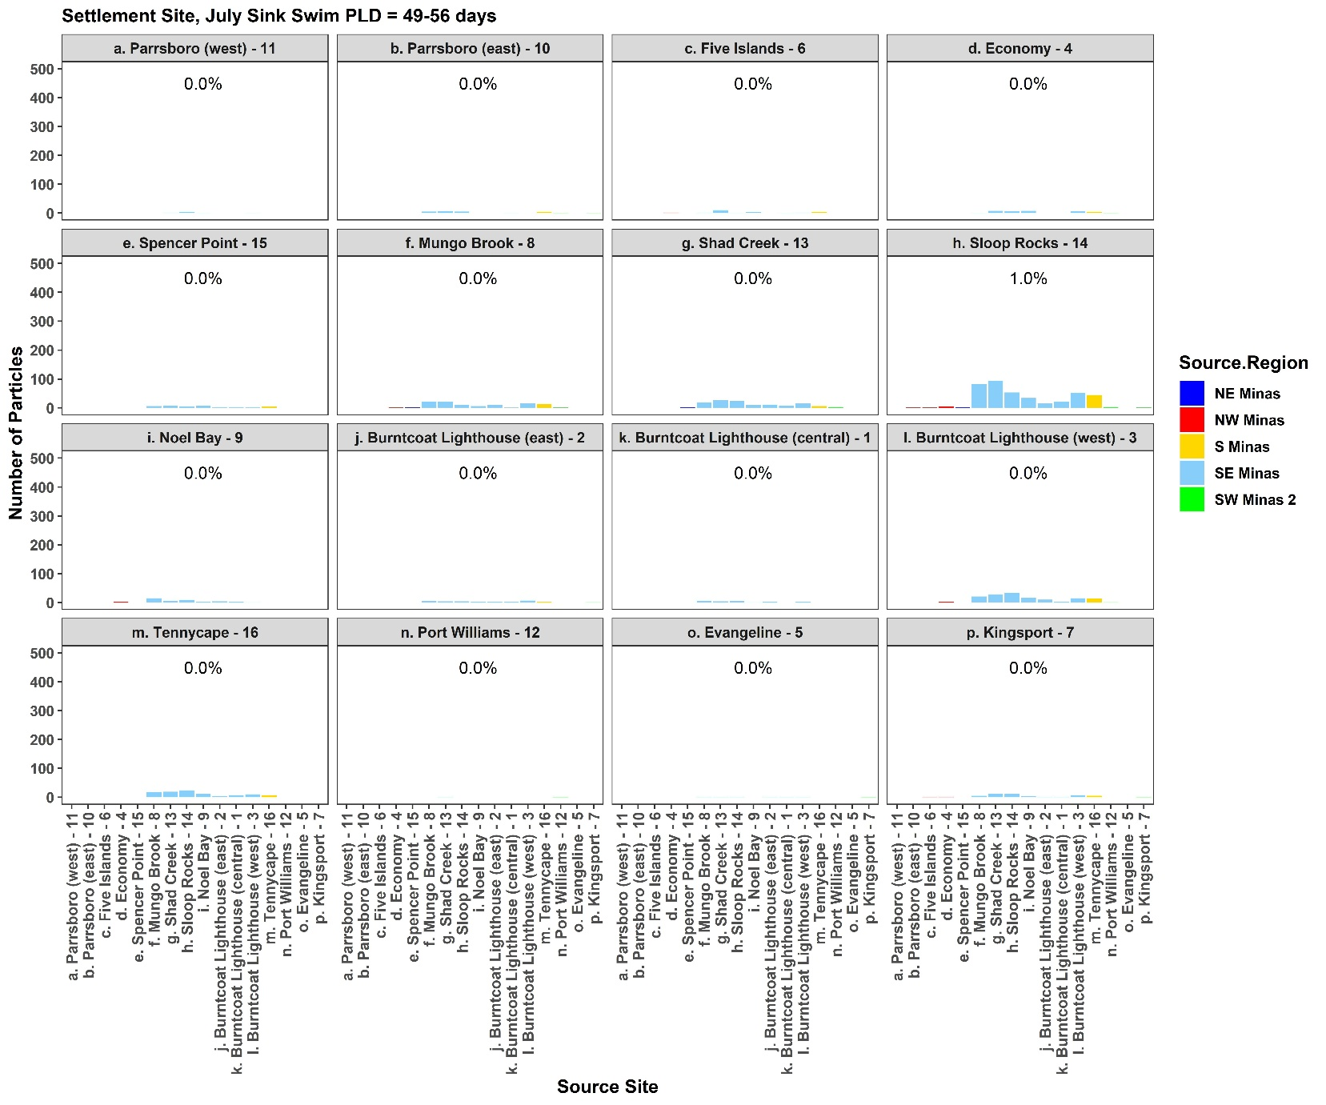

### Figure S6.

The number of particles settled at each site (panels a. to p.), with the associated release site (x-axis). Bar colour represents the source sub-region, and each panel has a colored horizontal line to indicate settlement sub-region. Results are from the July simulation, with particles assigned sink and swim behavior and a PLD of 49-56 days.

### Figure S7.

The number of particles settled at each site (panels a. to p.), with the associated release site (x-axis). Bar colour represents the source sub-region, and each panel has a colored horizontal line to indicate settlement sub-region. Percentages on panels represent the percent of particles settled by site. Results are from the August simulation, with particles assigned sink only (i.e. passive) behavior and a PLD of 33-40 days.

### Figure S8. The number of particles settled at each site (panels a. to p.), with the associated release site (x-axis). Bar colour represents the source sub-region, and each panel has a colored horizontal line to indicate settlement sub-region. Percentages on panels represent the percent of particles settled by site. Results are from the August simulation, with particles assigned sink only (i.e. passive) behavior and a PLD of 49-56 days.

### Figure S9.

The number of particles settled at each site (panels a. to p.), with the associated release site (x-axis). Bar colour represents the source sub-region, and each panel has a colored horizontal line to indicate settlement sub-region. Percentages on panels represent the percent of particles settled by site. Results are from the August simulation, with particles assigned sink and swim behavior and a PLD of 33-40 days.

### Figure S10.

The number of particles settled at each site (panels a. to p.), with the associated release site (x-axis). Bar colour represents the source sub-region, and each panel has a colored horizontal line to indicate settlement sub-region. Percentages on panels represent the percent of particles settled by site. Results are from the August simulation, with particles assigned sink and swim behavior and a PLD of 49-56 days.

**Figure S11.** The total number of particles settling within each sub-region in July simulations within the Minas Basin (rows a-f. m), the Bay of Fundy (rows g-i), and the Gulf of Maine (j-l), separated by source site. Bars are colored by the source sub-region. Percentages in each panel show the percent of total particles settling in each sub-region.

**Figure S12.** The total number of particles settling within each sub-region in August simulations within the Minas Basin (rows a-f. m), the Bay of Fundy (rows g-i), and the Gulf of Maine (j-l), separated by source site. Bars are colored by the source sub-region. Percentages in each panel show the percent of total particles settling in each sub-region.

**Figure S13.** The trajectories of two particles during their simulation runs, with the particle in the top panel assigned sinking only behavior, and the particle in the bottom panel assigned sinking and swimming behavior. Dashed blue line shows the water depth, or bathymetry.

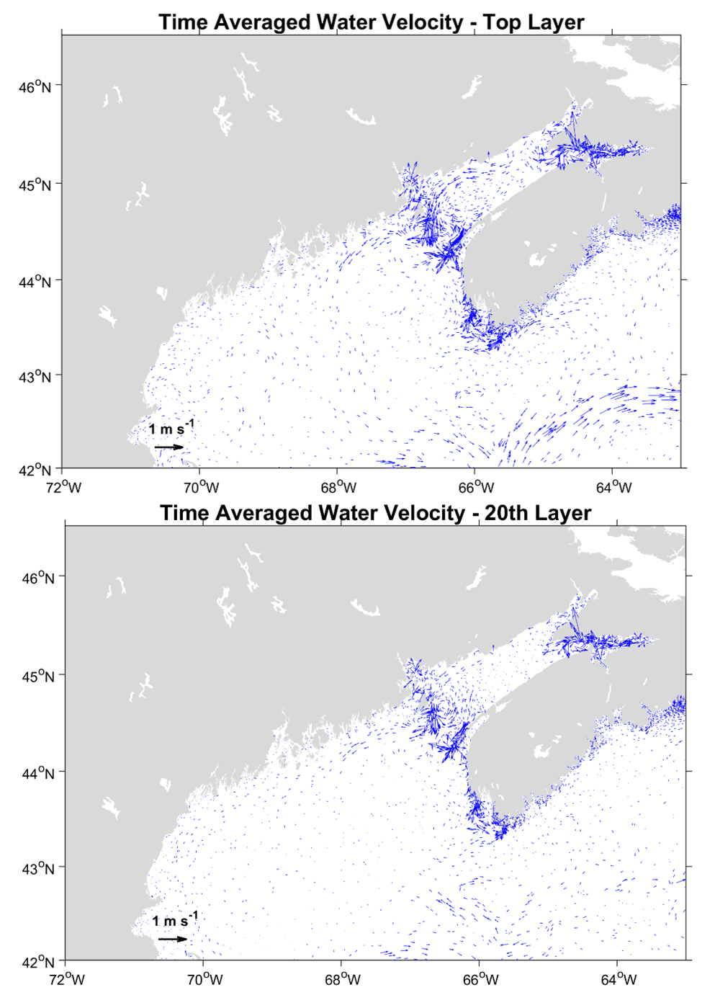

**Figure S14.** Vector plot of time averaged water velocity at the surface of the ocean (Top Layer) and at an intermediate depth (20th Layer, actual depth variable by node with an average of 39.1 m). The length of the arrows indicate relative magnitude of the current while the direction of the arrow indicates the direction of current flow.

## Supplementary Tables

**Table S1.**

List of simulations, including source site, simulation month (spawning seasonality), number of sites, full simulation run time, particle release depth, particle release in relation to the tide, and behavior.

|  |  |  |  |  |  |  |
| --- | --- | --- | --- | --- | --- | --- |
| **Source sites** | **Timing of release** | **No. Sites** | **Simulation run time (days)** | **Part. Rel. Depth** | **Part. Rel. Timing** | **Behavior** |
| **Minas Basin** | July 25 2017 6:00 | 16 | 56 | 1 m | High tide | Swimming |
| **Minas Basin** | July 25 2017 6:00 | 16 | 56 | 1 m | High tide | Passive |
| **Minas Basin** | August 24 2017 18:00 | 16 | 56 | 1 m | High tide | Swimming |
| **Minas Basin** | August 24 2017 18:00 | 16 | 56 | 1 m | High tide | Passive |
| **Coastal Gulf of Maine** | August 24 2017 18:00 | 0.5 and 1.0 km bands | 56 | 1 m | High tide, 1 hr before, 1 hr after | Swimming |

**Table S2.**

Gulf of Maine Simulation results, with indication (yes/no) of whether particles entered the Bay of Fundy by release timing (August 24, 2017, at 17:00, 18:00, or 19:00) and release band width.

|  |  |  |
| --- | --- | --- |
| August 24 | 0.5 km | 1.0 km |
| 17:00 | No | No |
| 18:00 | No | No |
| 19:00 | No | 1/7080 |

**Table S3.**

Detailed results from generalized linear mixed effects models (GLMMs) examining the effects of source sub-region, month, and PLD on the total number of particles settling at suitable habitat sites. Parameters include incidence rate ratios, interpreted as the ratio of the expected change in the number of particles settling at suitable habitat sites of one level of a dependent variable over another level, confidence intervals (CI), and P-value. A higher incidence rate ratio indicates a higher effect of that factor level.

|  |  |  |  |
| --- | --- | --- | --- |
| *Predictors* | *Incidence Rate Ratios* | *CI* | *p* |
| (Intercept) | 2.11 | 0.95 – 4.70 | 0.068 |
| Month [July] | 0.41 | 0.27 – 0.63 | **<0.001** |
| Behavior [Swimming] | 0.33 | 0.22 – 0.51 | **<0.001** |
| PLD49-56 | 1.84 | 1.27 – 2.66 | **0.001** |
| Settle Sub-region [NE Minas] | 2.37 | 0.40 – 13.98 | 0.342 |
| Settle Sub-region [SE Minas] | 7.76 | 2.86 – 21.04 | **<0.001** |
| Settle Sub-region [S Minas] | 62.78 | 10.68 – 369.05 | **<0.001** |
| Settle Sub-region [SW Minas 2] | 3.92 | 1.16 – 13.22 | **0.027** |
| Month [July] * Behavior [Swimming] | 0.81 | 0.60 – 1.09 | 0.160 |
| MonthJuly:PLD49-56 | 1.34 | 0.99 – 1.80 | 0.054 |
| Month [July] * Settle Sub-region [NE Minas] | 1.55 | 0.78 – 3.10 | 0.211 |
| Month [July] * Settle Sub-region [SE Minas] | 1.17 | 0.76 – 1.80 | 0.469 |
| Month [July] * Settle Sub-region [S Minas] | 0.17 | 0.09 – 0.33 | **<0.001** |
| Month [July] * Settle Sub-region [SW Minas 2] | 0.17 | 0.10 – 0.28 | **<0.001** |
| BehaviorSwimming:PLD49-56 | 0.98 | 0.73 – 1.32 | 0.914 |
| PLD49-56:Settle.Sub-region [NE Minas] | 0.71 | 0.36 – 1.38 | 0.308 |
| PLD49-56:Settle.Sub-region [SE Minas] | 0.36 | 0.24 – 0.53 | **<0.001** |
| PLD49-56:Settle.Sub-region [S Minas] | 0.37 | 0.20 – 0.70 | **0.002** |
| PLD49-56:Settle.Sub-region [SW Minas 2] | 0.69 | 0.43 – 1.12 | 0.131 |
| Behavior [Swimming] * Settle Sub-region [NE Minas] | 2.02 | 1.03 – 3.97 | **0.041** |
| Behavior [Swimming] * Settle Sub-region [SE Minas] | 3.72 | 2.44 – 5.69 | **<0.001** |
| Behavior [Swimming] * Settle Sub-region [S Minas] | 3.71 | 1.93 – 7.13 | **<0.001** |
| Behavior [Swimming] * Settle Sub-region [SW Minas 2] | 4.60 | 2.79 – 7.59 | **<0.001** |

**Table S4.**

Detailed results from generalized linear mixed-effects models (GLMMs)examining the effects of settlement sub-region, month, and PLD on the total number of particles settling at suitable habitat sites. Parameters include incidence rate ratios, interpreted as the ratio of the expected change in the number of particles settling at suitable habitat sites of one level of a dependent variable over another level, confidence intervals (CI), and P-value. A higher incidence rate ratio indicates a higher effect of that factor level.

|  |  |  |  |
| --- | --- | --- | --- |
| *Predictors* | *Incidence Rate Ratios* | *CI* | *p* |
| (Intercept) | 3.55 | 1.81 – 6.93 | **<0.001** |
| Month [July] | 0.05 | 0.04 – 0.08 | **<0.001** |
| Behavior [Swimming] | 0.78 | 0.57 – 1.05 | 0.103 |
| PLD49-56 | 1.04 | 0.77 – 1.40 | 0.814 |
| Source Sub-region [NE Minas] | 1.23 | 0.72 – 2.09 | 0.447 |
| Source Sub-region [SE Minas] | 4.79 | 3.57 – 6.43 | **<0.001** |
| Source Sub-region [S Minas] | 3.01 | 1.85 – 4.88 | **<0.001** |
| Source Sub-region [SW Minas 2] | 0.26 | 0.17 – 0.39 | **<0.001** |
| Month [July] * Behavior [Swimming] | 0.67 | 0.52 – 0.86 | **0.002** |
| MonthJuly:PLD49-56 | 1.19 | 0.93 – 1.52 | 0.177 |
| Month [July] * Source Sub-region [NE Minas] | 3.07 | 1.68 – 5.62 | **<0.001** |
| Month [July] * Source Sub-region [SE Minas] | 6.79 | 4.65 – 9.92 | **<0.001** |
| Month [July] * Source Sub-region [S Minas] | 7.18 | 4.19 – 12.31 | **<0.001** |
| Month [July] * Source Sub-region [SW Minas 2] | 3.11 | 1.84 – 5.25 | **<0.001** |
| BehaviorSwimming:PLD49-56 | 0.92 | 0.73 – 1.16 | 0.467 |
| PLD49-56:Source.Sub-regionNE Minas | 0.79 | 0.45 – 1.37 | 0.398 |
| PLD49-56:Source.Sub-regionSE Minas | 1.00 | 0.72 – 1.38 | 0.999 |
| PLD49-56:Source.Sub-regionS Minas | 1.10 | 0.67 – 1.81 | 0.707 |
| PLD49-56:Source.Sub-regionSW Minas 2 | 1.02 | 0.66 – 1.59 | 0.919 |
| Behavior [Swimming] * Source Sub-region [NE Minas] | 1.47 | 0.85 – 2.54 | 0.168 |
| Behavior [Swimming] * Source Sub-region [SE Minas] | 1.48 | 1.07 – 2.05 | **0.016** |
| Behavior [Swimming] * Source Sub-region [S Minas] | 1.68 | 1.02 – 2.77 | **0.040** |
| Behavior [Swimming] * Source Sub-region [SW Minas 2] | 2.13 | 1.36 – 3.32 | **0.001** |

**Table S5.**

Detailed results from generalized linear modelling examining the effects of settlement sub-region, month, and PLD on the total number of particles settling in Minas Basin sub-regions. Parameters include incidence rate ratios, interpreted as the ratio of the expected change in the number of particles settling at suitable habitat sites of one level of a dependent variable over another level, confidence intervals (CI), and P-value. A higher incidence rate ratio indicates a higher effect of that factor level.

|  |  |  |  |
| --- | --- | --- | --- |
| *Predictors* | *Incidence Rate Ratios* | *CI* | *p* |
| (Intercept) | 146.33 | 93.10 – 243.36 | **<0.001** |
| Simulation Month [July] | 0.91 | 0.52 – 1.60 | 0.730 |
| Behavior [Swimming] | 0.62 | 0.35 – 1.09 | 0.086 |
| PLD49-56 days | 1.19 | 0.68 – 2.08 | 0.543 |
| Settle Sub-region [NW Minas Basin] | 0.68 | 0.36 – 1.28 | 0.262 |
| Settle Sub-region [S Minas Basin] | 3.37 | 1.69 – 6.79 | **<0.001** |
| Settle Sub-region [SE Minas Basin] | 0.99 | 0.49 – 2.06 | 0.985 |
| Settle Sub-region [SW Minas 1] | 0.17 | 0.09 – 0.33 | **<0.001** |
| Settle Sub-region [SW Minas 2] | 2.40 | 1.22 – 4.75 | **0.012** |
| Simulation Month [July] * Behavior [Swimming] | 1.10 | 0.73 – 1.66 | 0.630 |
| Simulation_MonthJuly:PLD49-56 days | 1.10 | 0.74 – 1.63 | 0.627 |
| Simulation Month [July] * Settle Sub-region [NW Minas Basin] | 2.62 | 1.26 – 5.42 | **0.005** |
| Simulation Month [July] * Settle Sub-region [S Minas Basin] | 0.09 | 0.04 – 0.18 | **<0.001** |
| Simulation Month [July] * Settle Sub-region [SE Minas Basin] | 1.23 | 0.61 – 2.49 | 0.546 |
| Simulation Month [July] * Settle Sub-region [SW Minas 1] | 0.95 | 0.48 – 1.88 | 0.873 |
| Simulation Month [July] * Settle Sub-region [SW Minas 2] | 0.27 | 0.14 – 0.54 | **<0.001** |
| BehaviorSwimming:PLD49-56 days | 1.28 | 0.86 – 1.90 | 0.217 |
| PLD49-56 days:Settle.Sub-region [NW.Minas.Basin] | 0.89 | 0.45 – 1.75 | 0.727 |
| PLD49-56 days:Settle.Sub-region [S.Minas.Basin] | 0.82 | 0.42 – 1.63 | 0.574 |
| PLD49-56 days:Settle.Sub-region [SE.Minas.Basin] | 0.36 | 0.18 – 0.71 | **0.003** |
| PLD49-56 days:Settle.Sub-region [SW.Minas.1] | 0.87 | 0.44 – 1.74 | 0.700 |
| PLD49-56 days:Settle.Sub-region [SW.Minas.2] | 0.57 | 0.29 – 1.12 | 0.100 |
| Behavior [Swimming] * Settle Sub-region [NW Minas Basin] | 0.69 | 0.33 – 1.44 | 0.292 |
| Behavior [Swimming] * Settle Sub-region [S Minas Basin] | 2.02 | 1.01 – 4.04 | **0.043** |
| Behavior [Swimming] * Settle Sub-region [SE Minas Basin] | 1.83 | 0.90 – 3.71 | 0.081 |
| Behavior [Swimming] * Settle Sub-region [SW Minas 1] | 1.06 | 0.53 – 2.10 | 0.873 |
| Behavior [Swimming] * Settle Sub-region [SW Minas 2] | 1.74 | 0.88 – 3.44 | 0.110 |

**Table S6.**

Detailed results from generalized linear modelling examining the effects of source sub-region, month, and PLD on the total number of particles settling in Minas Basin sub-regions. Parameters include incidence rate ratios, interpreted as the ratio of the expected change in the number of particles settling at suitable habitat sites of one level of a dependent variable over another level, confidence intervals (CI), and P-value. A higher incidence rate ratio indicates a higher effect of that factor level.

|  |  |  |  |
| --- | --- | --- | --- |
| *Predictors* | *Incidence Rate Ratios* | *CI* | *p* |
| (Intercept) | 53.54 | 27.42 – 116.24 | **<0.001** |
| Simulation Month [July] | 0.28 | 0.14 – 0.60 | **0.001** |
| Behavior [Swimming] | 1.04 | 0.50 – 2.19 | 0.909 |
| PLD49-56 days | 0.89 | 0.42 – 1.88 | 0.765 |
| Source Sub-region [NW Minas] | 0.97 | 0.42 – 2.04 | 0.934 |
| Source Sub-region [S Minas] | 5.10 | 1.89 – 13.74 | **0.001** |
| Source Sub-region [SE Minas] | 6.57 | 2.96 – 13.39 | **<0.001** |
| Source Sub-region [SW Minas 2] | 0.49 | 0.21 – 1.07 | 0.079 |
| Simulation Month [July] * Behavior [Swimming] | 0.83 | 0.59 – 1.17 | 0.288 |
| Simulation_MonthJuly:PLD49-56 days | 1.03 | 0.73 – 1.46 | 0.869 |
| Simulation Month [July] * Source Sub-region [NW Minas] | 0.74 | 0.34 – 1.62 | 0.449 |
| Simulation Month [July] * Source Sub-region [S Minas] | 1.86 | 0.70 – 4.96 | 0.214 |
| Simulation Month [July] * Source Sub-region [SE Minas] | 1.86 | 0.88 – 3.92 | 0.102 |
| Simulation Month [July] * Source Sub-region [SW Minas 2] | 1.44 | 0.64 – 3.22 | 0.379 |
| BehaviorSwimming:PLD49-56 days | 1.19 | 0.84 – 1.68 | 0.327 |
| PLD49-56 days:Source.Sub-regionNW Minas | 1.05 | 0.48 – 2.29 | 0.906 |
| PLD49-56 days:Source.Sub-regionS Minas | 0.99 | 0.37 – 2.63 | 0.977 |
| PLD49-56 days:Source.Sub-regionSE Minas | 1.01 | 0.48 – 2.13 | 0.986 |
| PLD49-56 days:Source.Sub-regionSW Minas 2 | 0.79 | 0.35 – 1.78 | 0.572 |
| Behavior [Swimming] * Source Sub-region [NW Minas] | 1.19 | 0.54 – 2.60 | 0.661 |
| Behavior [Swimming] * Source Sub-region [S Minas] | 1.32 | 0.50 – 3.53 | 0.574 |
| Behavior [Swimming] * Source Sub-region [SE Minas] | 1.20 | 0.57 – 2.53 | 0.637 |
| Behavior [Swimming] * Source Sub-region [SW Minas 2] | 1.44 | 0.64 – 3.23 | 0.377 |