Coral bleaching from a nutrient perspective is an understudied area as revealed by a comprehensive bibliometric survey
Tangcheng Li^{1*}, Jiahong Huang¹, Hong Du¹, Xiaojuan Liu¹, Chongming Zhong¹, Senjie Lin^{2*}

¹Biology Department and Institute of Marine Sciences, College of Science, Shantou University, Shantou 515063, China;
²Department of Marine Sciences, University of Connecticut, Groton, CT06405, USA.

Corresponding author：
Tangcheng Li; tchli@stu.edu.cn
Senjie Lin; senjie.lin@uconn.edu;

Running title: bibliometric survey on coral bleaching

Supplementary

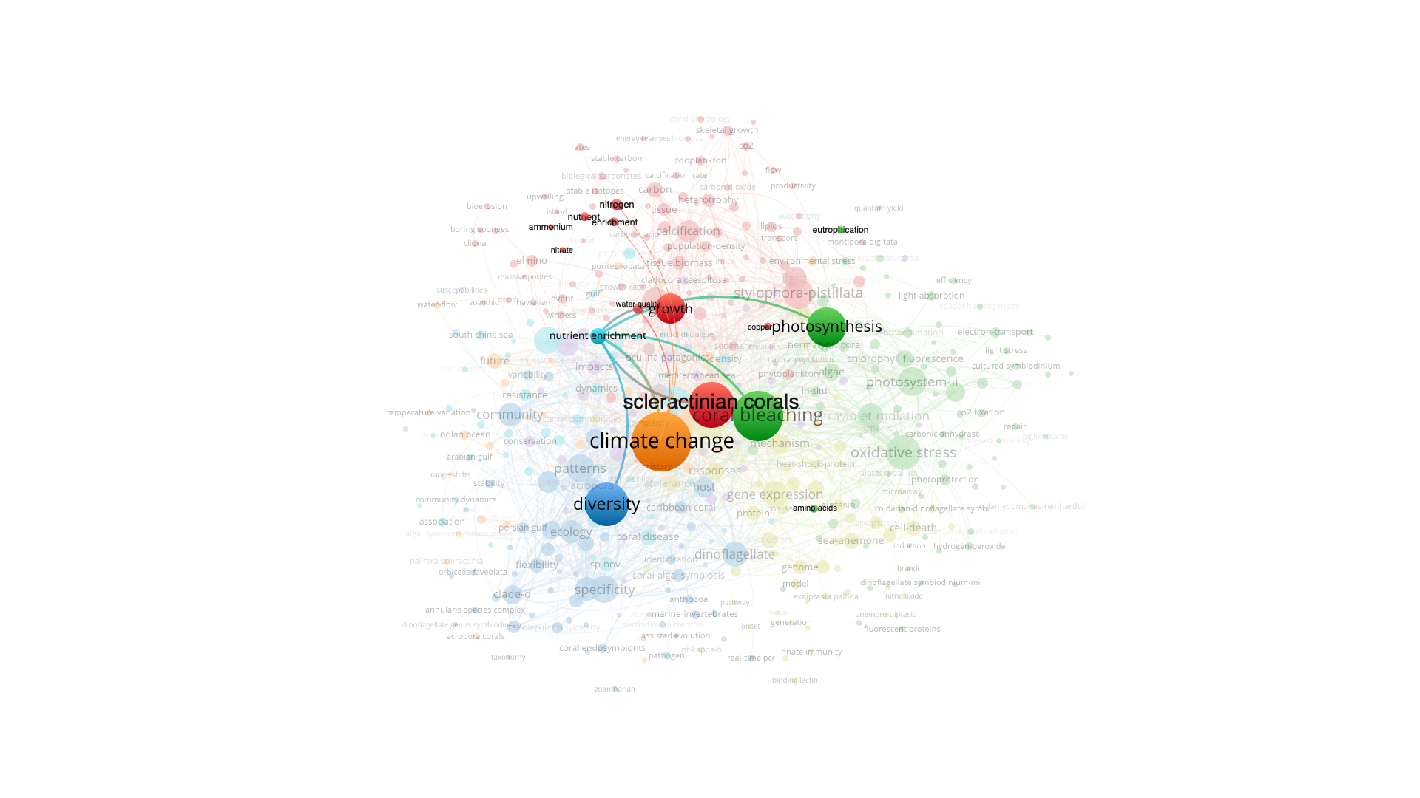
Fig. S1. The highlight co-occurrence map between nutrient and other keywords from combination of coral, Symbiodiniaceae and temperature. Note: The minimum number of the occurrences of a keyword was set at 5.

