Supplementary Material

An endoplasmic reticulum-targeted ratiometric fluorescent molecule reveals Zn2+ micro-dynamics during drug-induced organelle ionic disorder

Hongbao Fang, Yaheng Li, Shankun Yao, Shanshan Geng, Yuncong Chen*, Zijian Guo*, Weijiang He*



**Figure S1** Synthesis route of **ER-Zn**



**Figure S2** 1H NMR of **ER-Zn** (400 MHz, CDCl3)



**Figure S3** 13C NMR of **ER-Zn** (101 MHz, CDCl3)

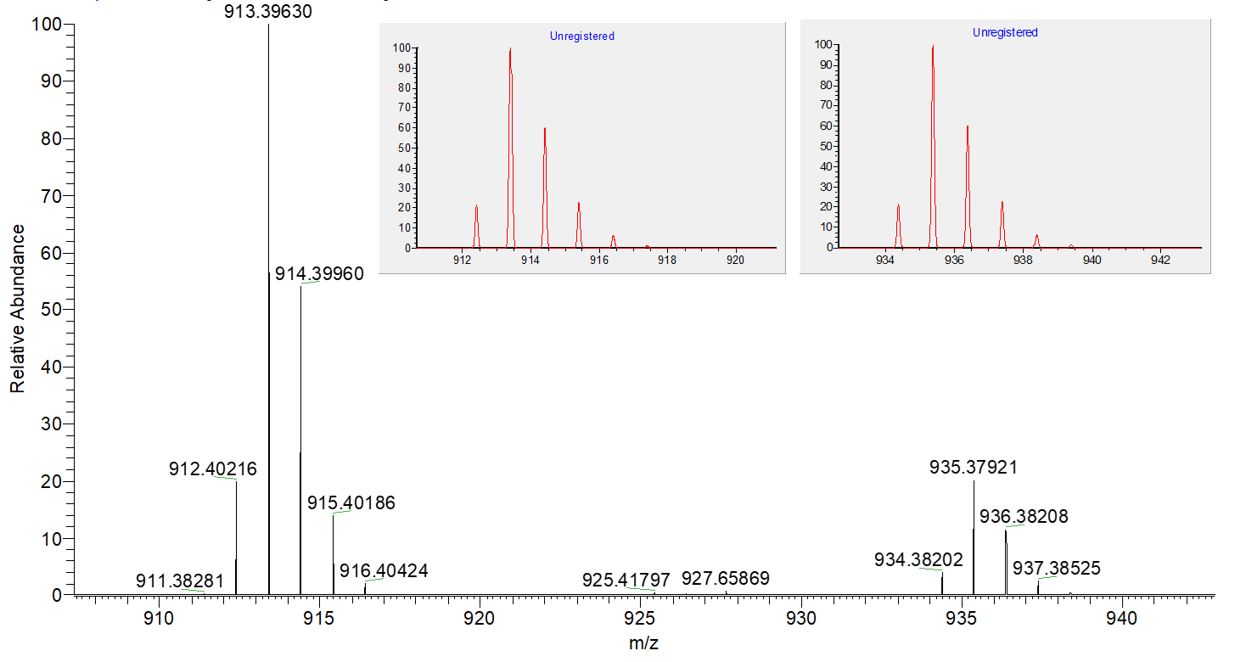

**Figure S4** HRMS of [**ER-Zn+H/Na]+**

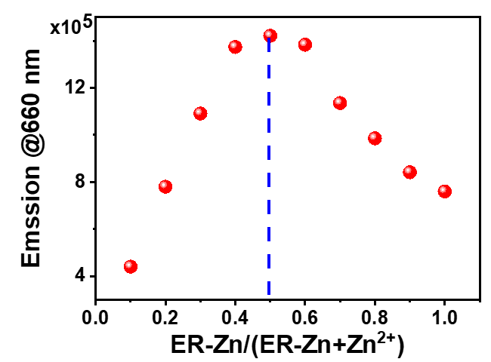

**Figure S5** Work curve of **ER-Zn**

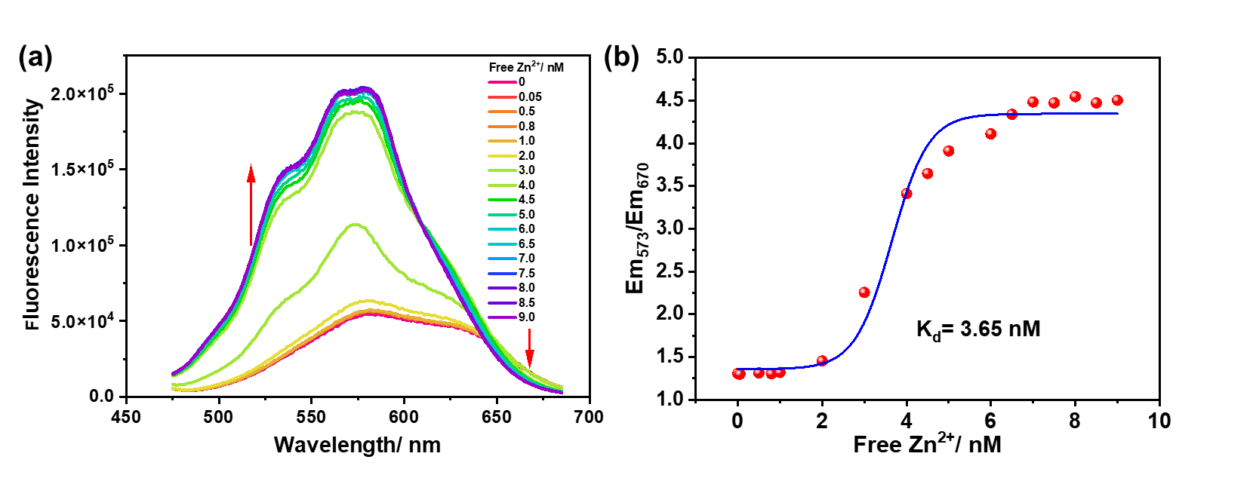

**Figure S6** (a) The excitation spectra of **ER-Zn** (10 μM) with the addition of free Zn2+ in the HEPES buffer (50 mM, 100 mM KNO3, pH 7.2, 10 mM EGTA); (b) Zn2+ binding curve based on emission intensity ratio Em573/Em640 and its fitting for dissociation constant determination.

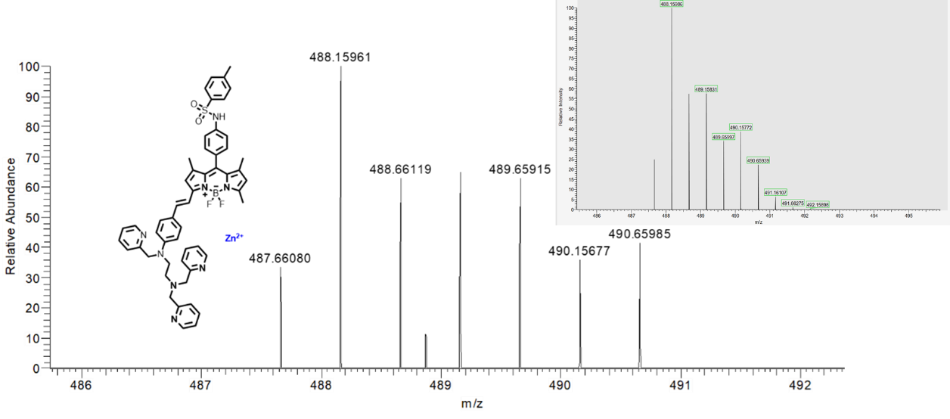

**Figure S7** HRMS of [**ER-Zn**+Zn]2+



**Figure S8** Reversibility of 10 μM **ER-Zn** response to Zn2+



**Figure S9** Cytotoxicity of **ER-Zn** with different concentrations in HeLa cells.

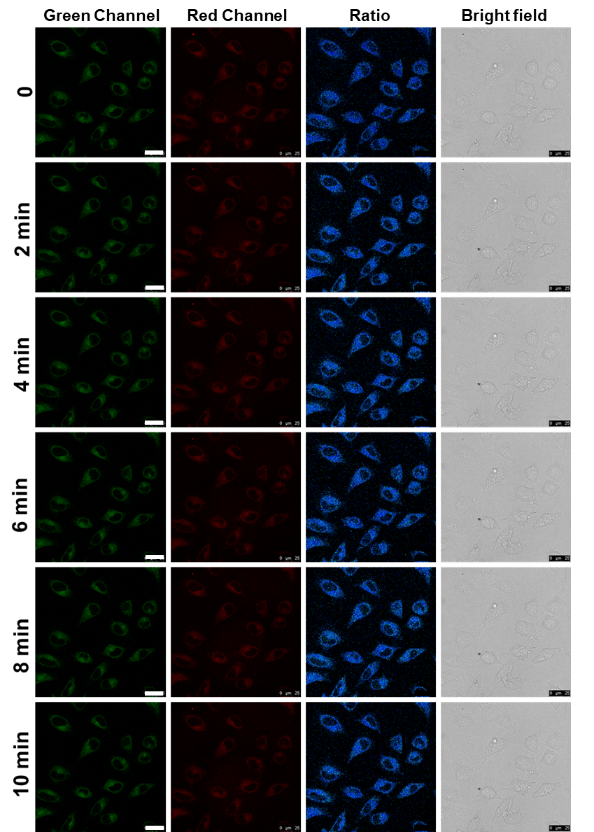

**Figure S10** Photostability experiment of 5 μM **ER-Zn** incubated with cells for2 h. green channel: λex = 570 nm; red channel: λex= 650 nm, λem= 660-720 nm, scale bar: 25 μm.

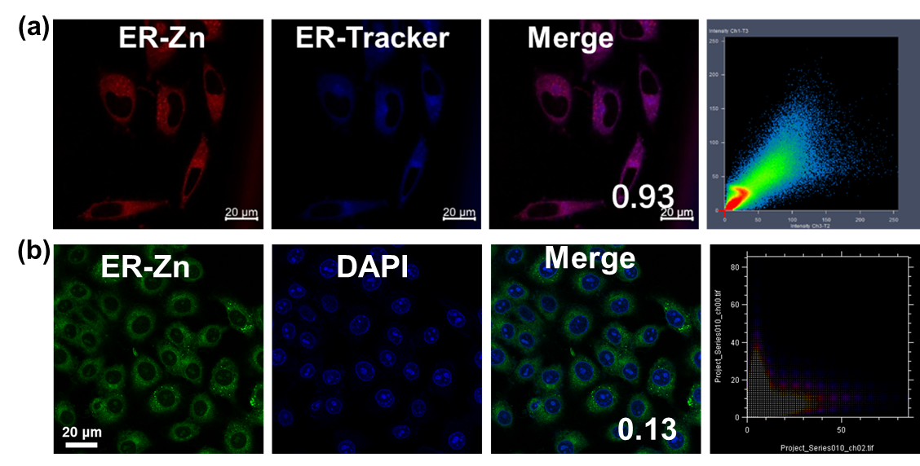

**Figure S11** The colocalization experiment of **ER-Zn** with commercial ER tracker (a) and commercial nuclei tracker(b). Scale bar: 20 μm.