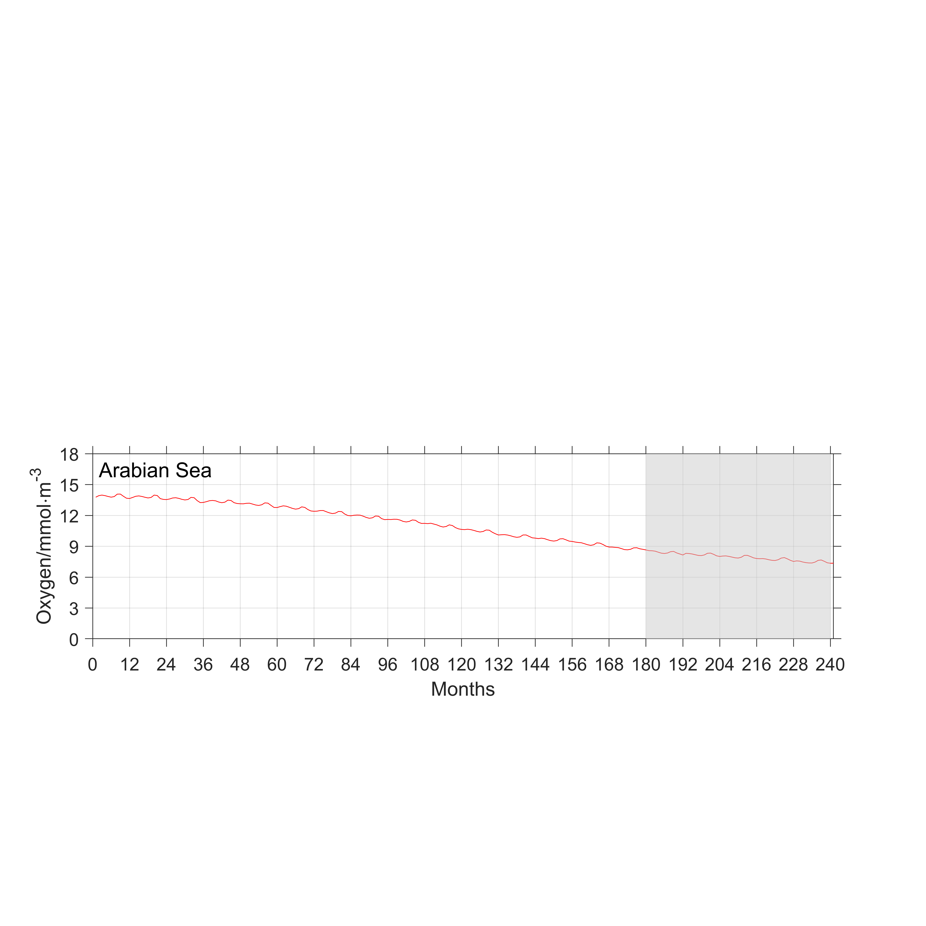
Figure S1. Model simulated oxygen drift in the Arabian Sea, averaged between 200 and 1000 m, as a function of time. The shadowed area represents the period used for analysis.

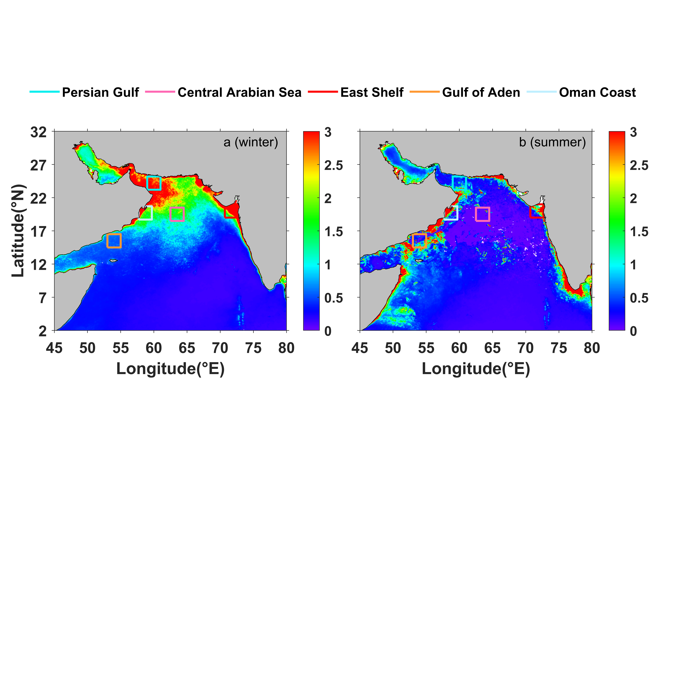
Figure S2. Locations in the idealized experiments to trace the source of detritus during winter and summer monsoons.

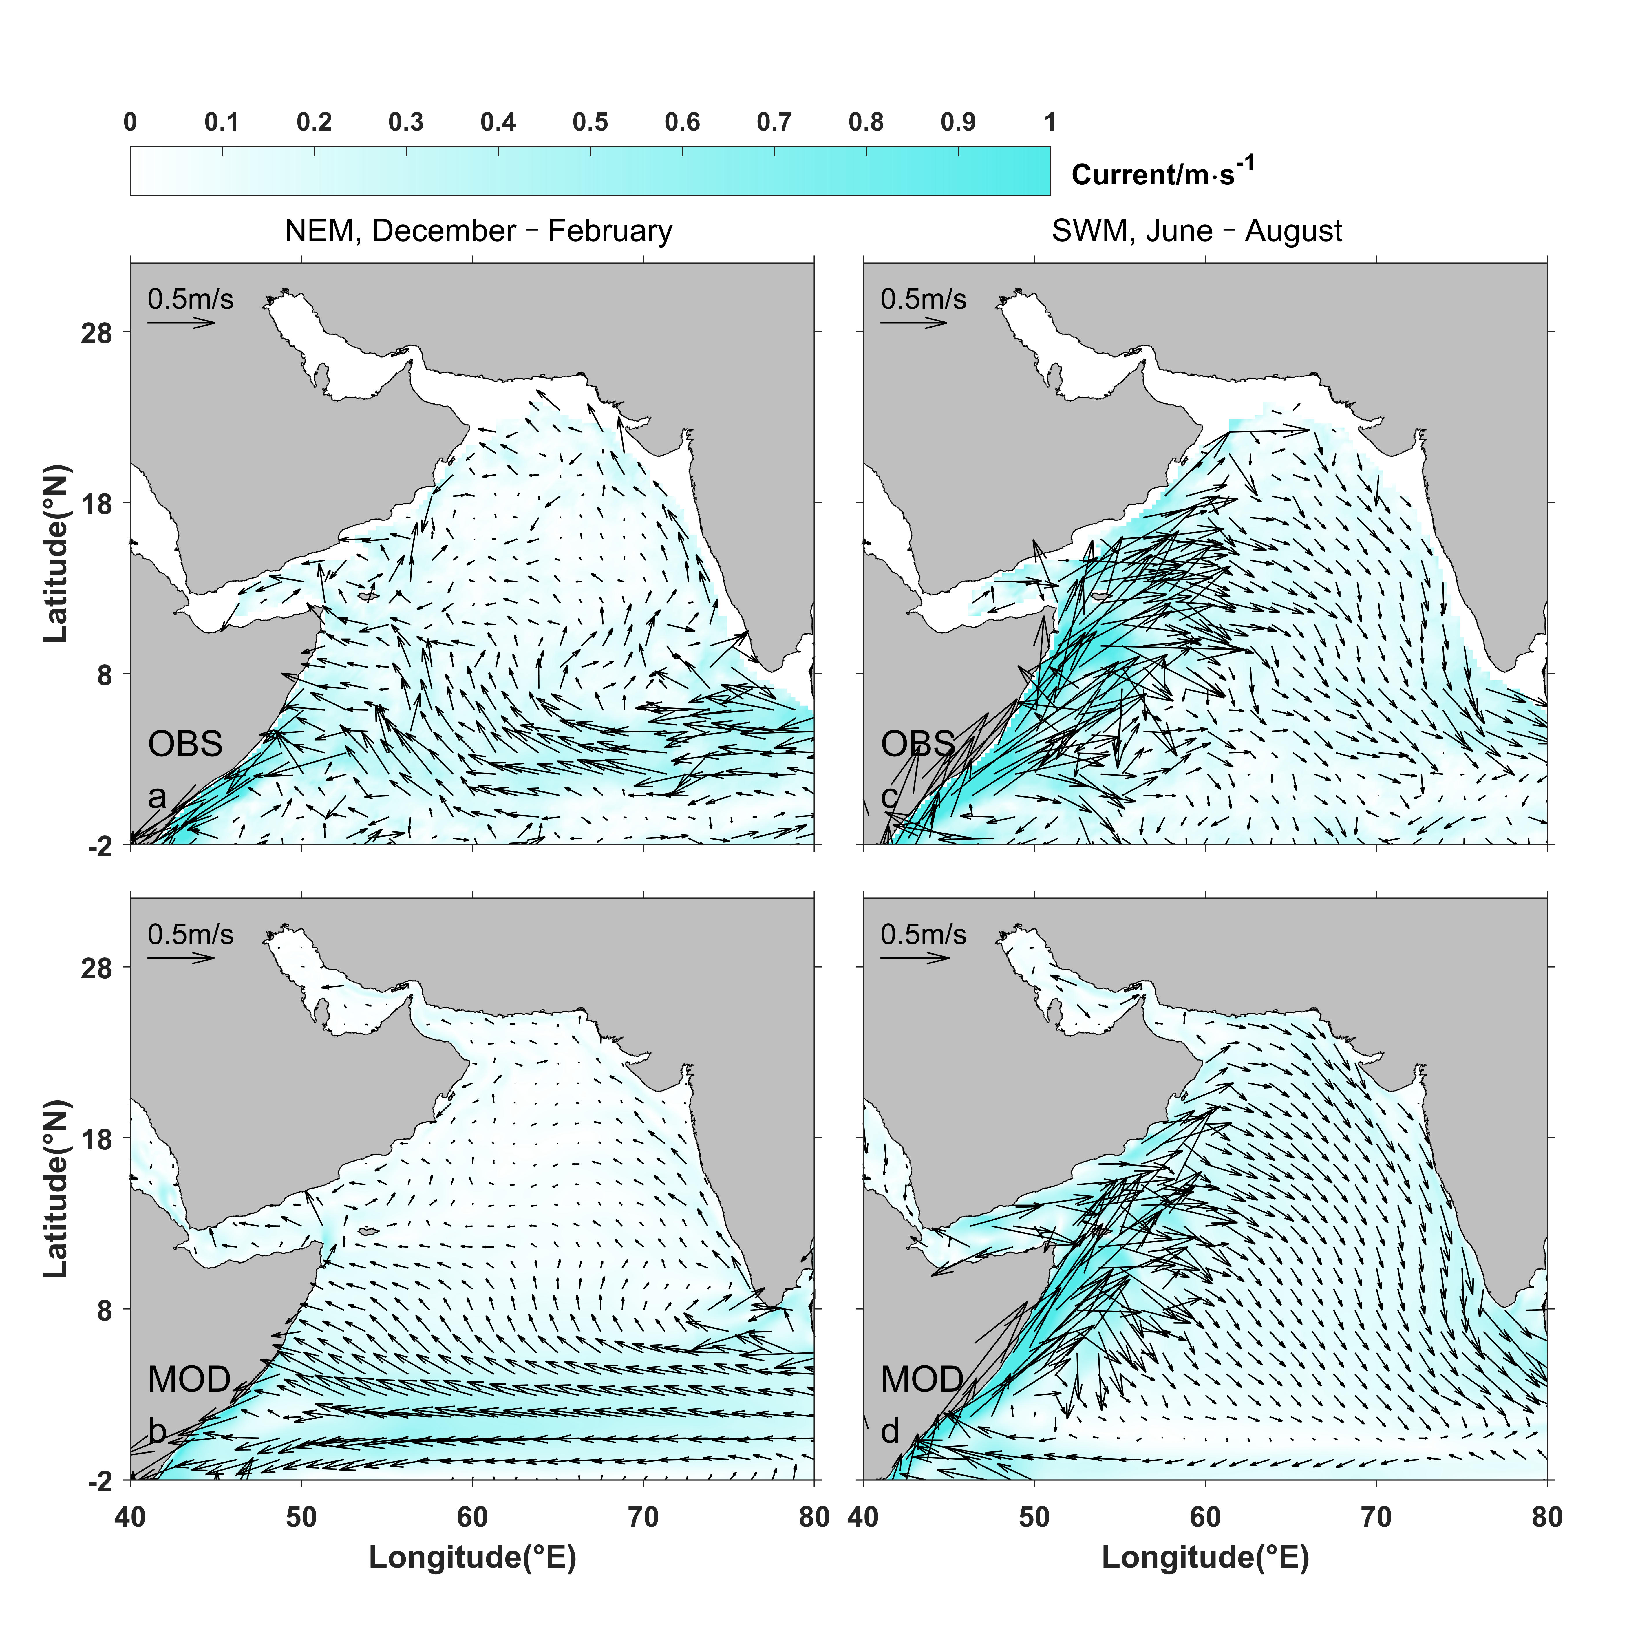
Figure S3. Evaluation of simulated surface current (m·s⁻¹) during winter monsoon (a, b) and summer monsoon (c, d). The observation of surface current is from Laurindo et al. (2017).

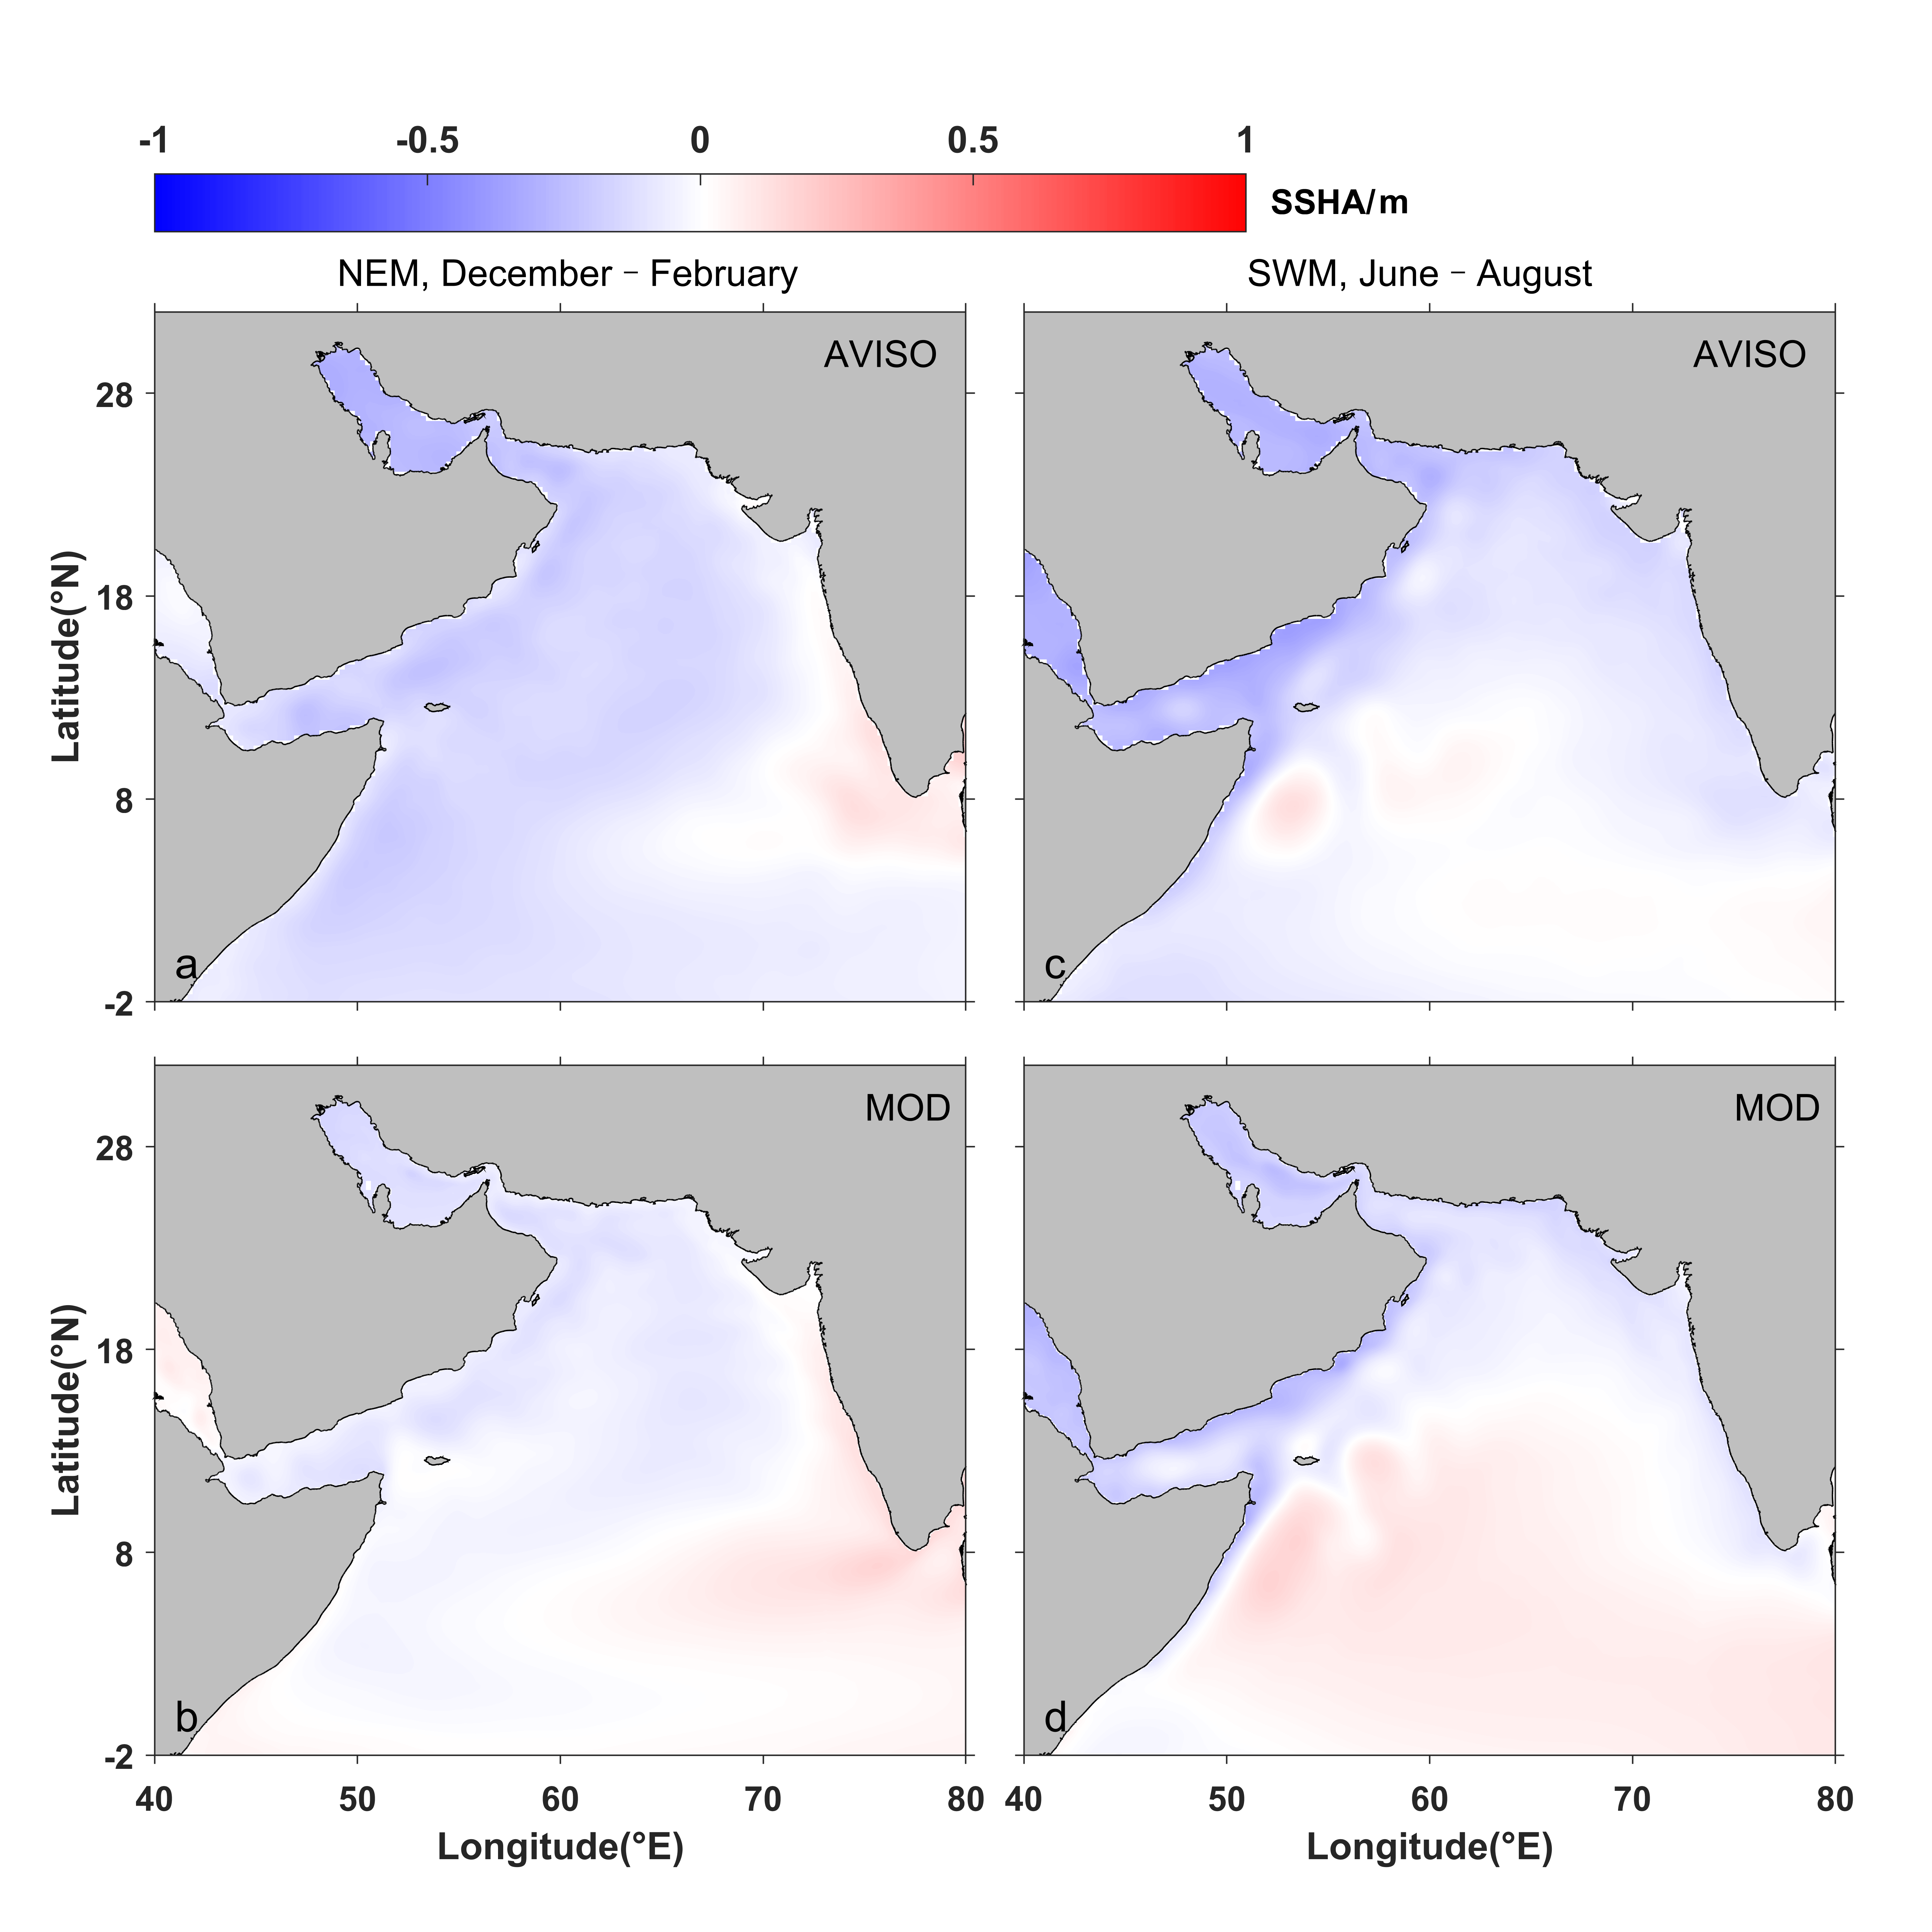
Figure S4. Evaluation of simulated sea-surface height (SSH) anomalies (m) during winter monsoon (a, b) and summer monsoon (c, d). The observation data are from the AVISO.

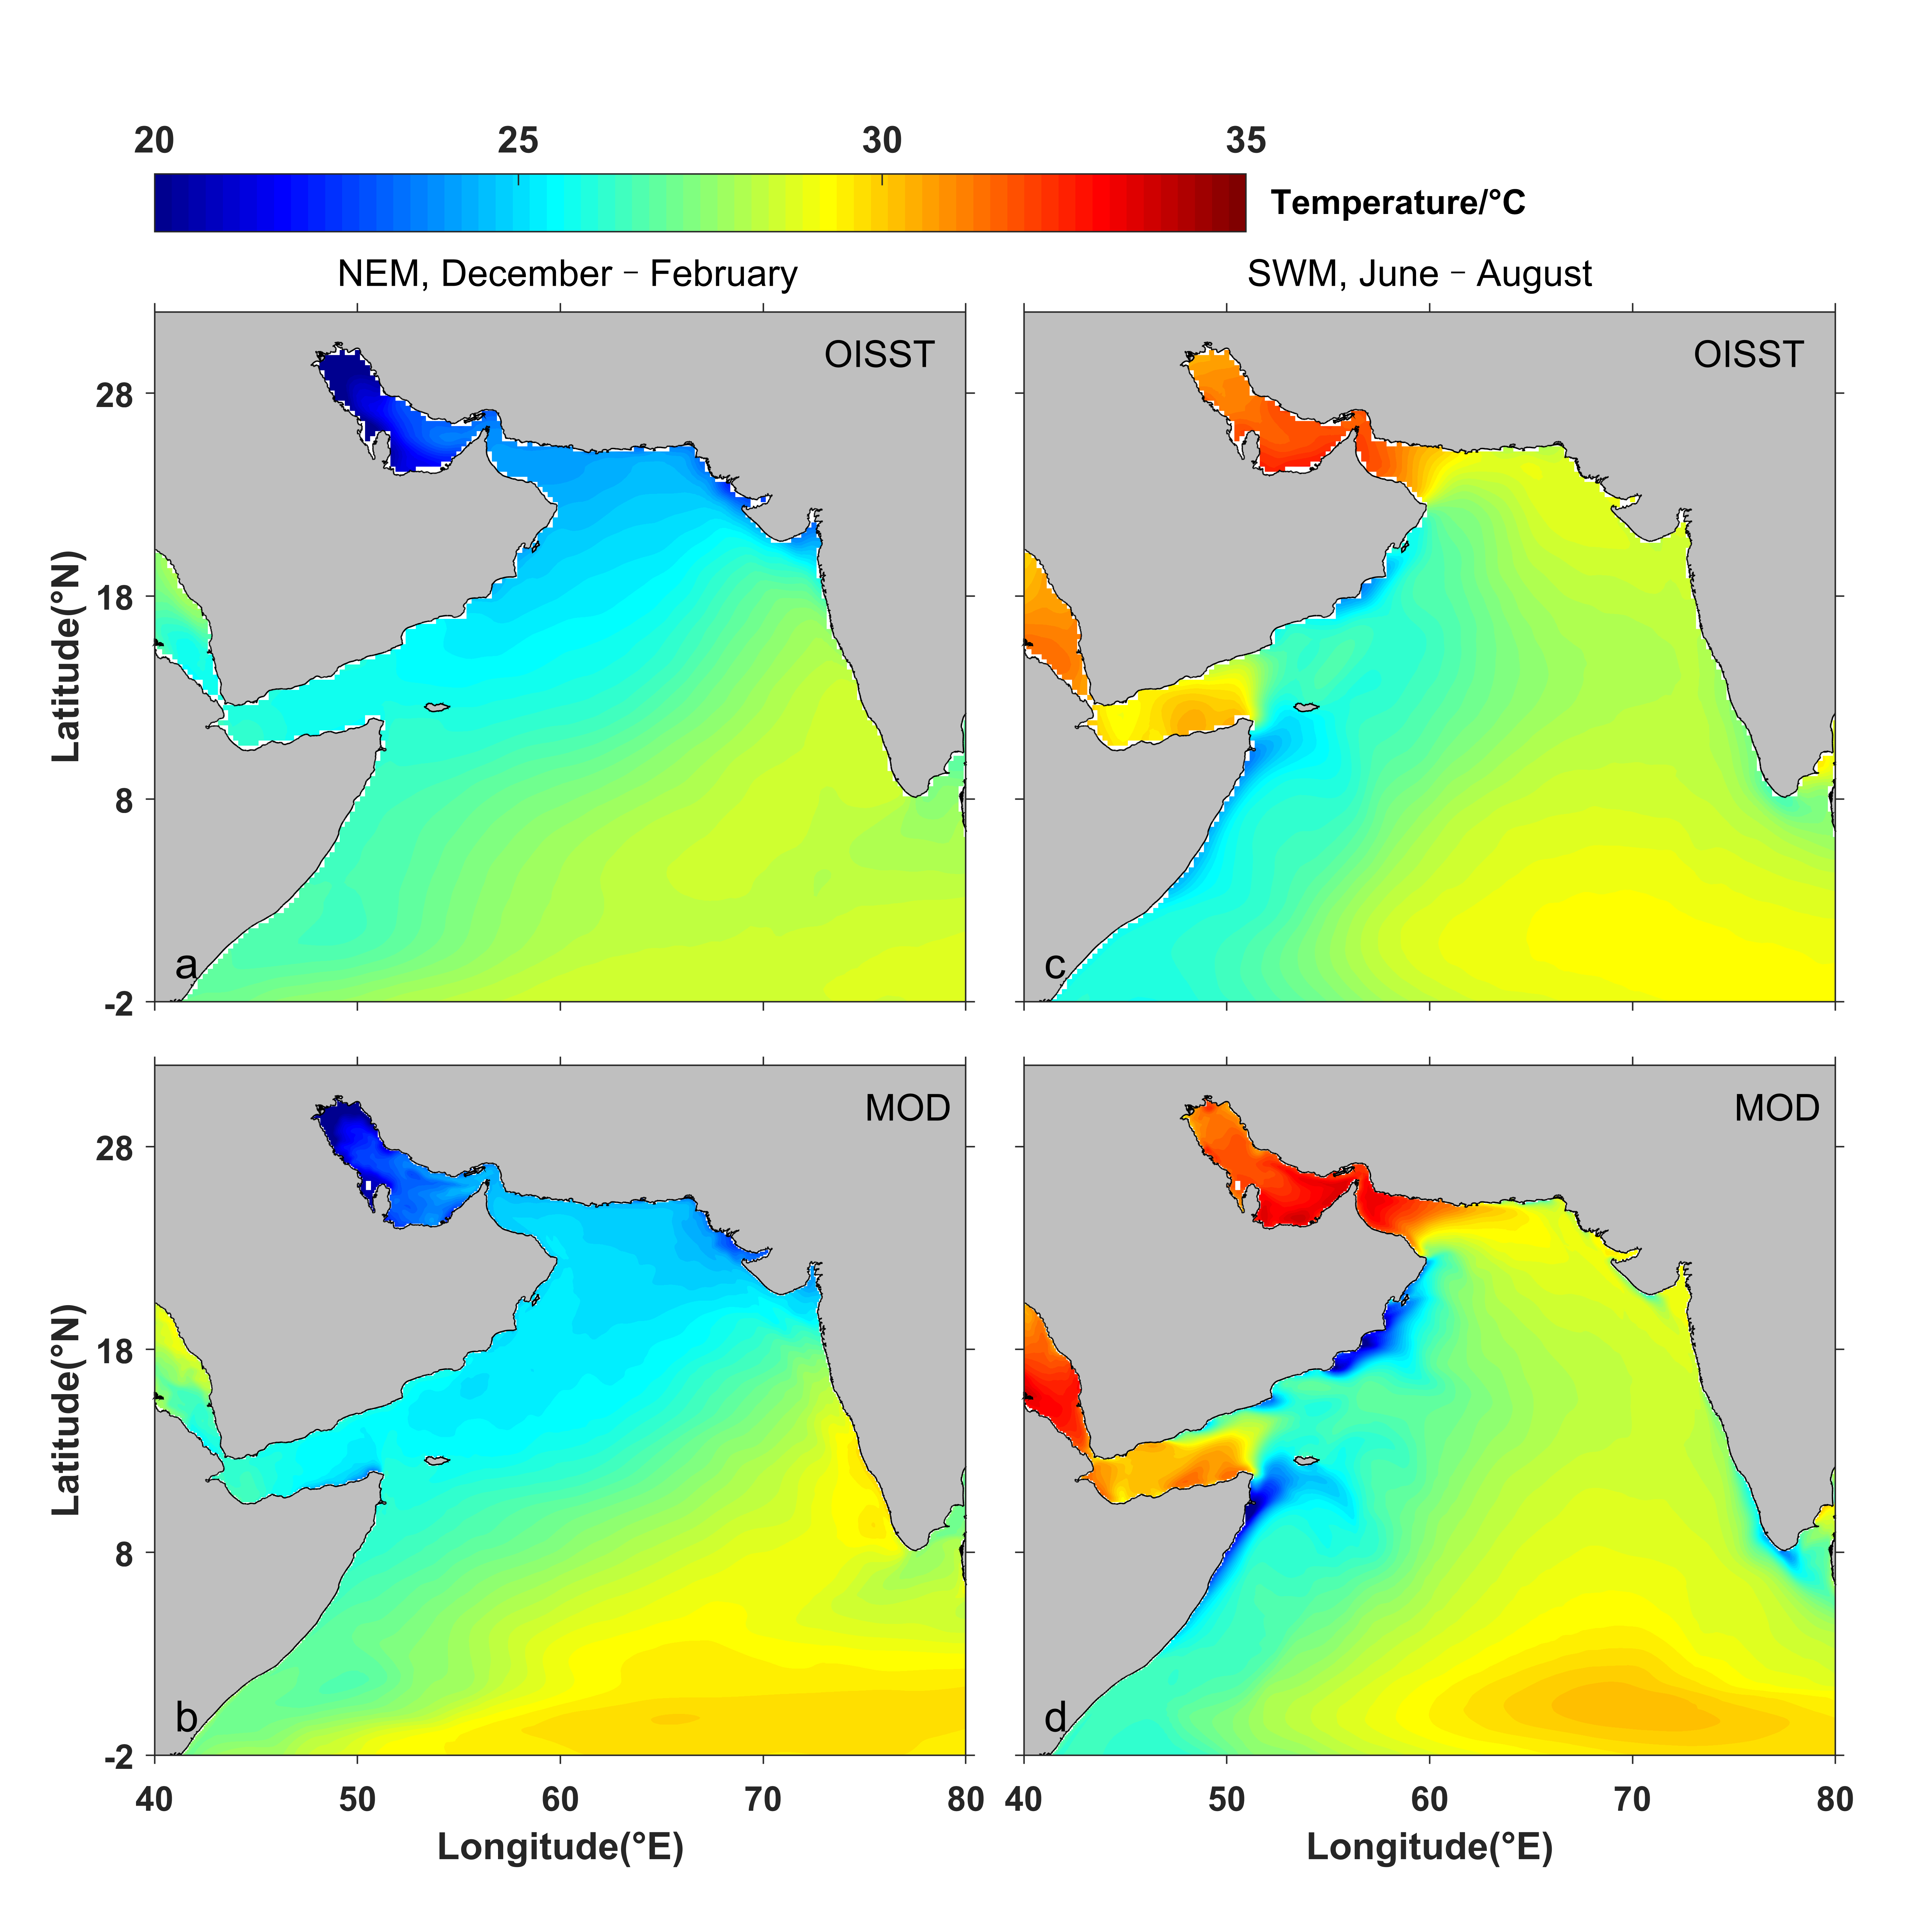
Figure S5. Evaluation of simulated sea-surface temperature (°C) during winter monsoon (a, b) and summer monsoon (c, d). The observation data are the OISST.

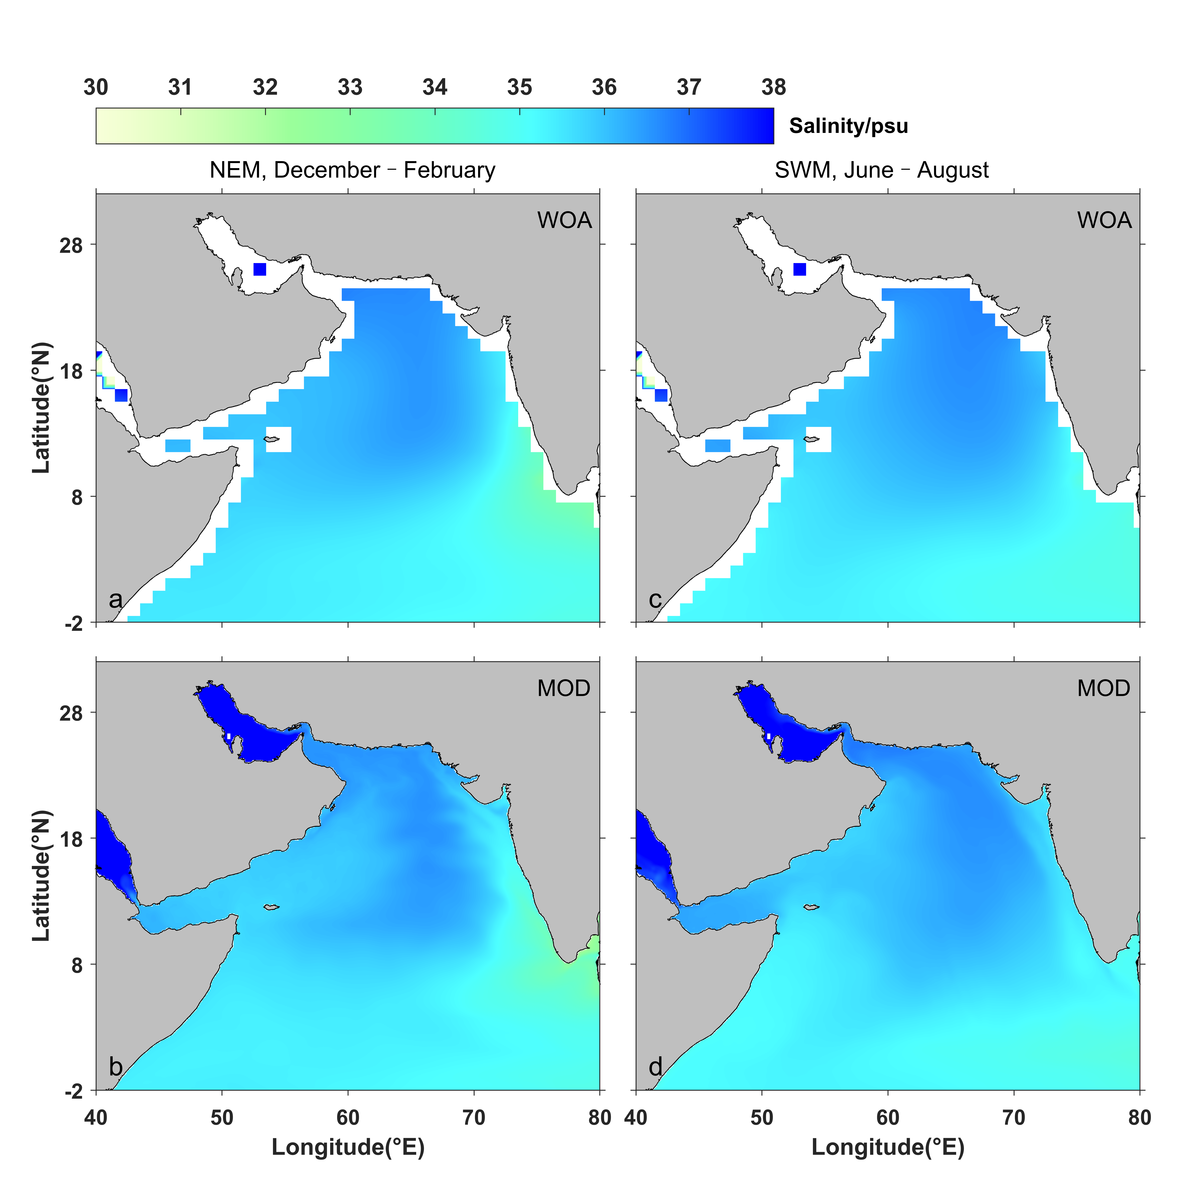
Figure S6. Evaluation of simulated sea-surface salinity (psu) during winter monsoon (a, b) and summer monsoon (c, d). The observation data are from the WOA 2018.

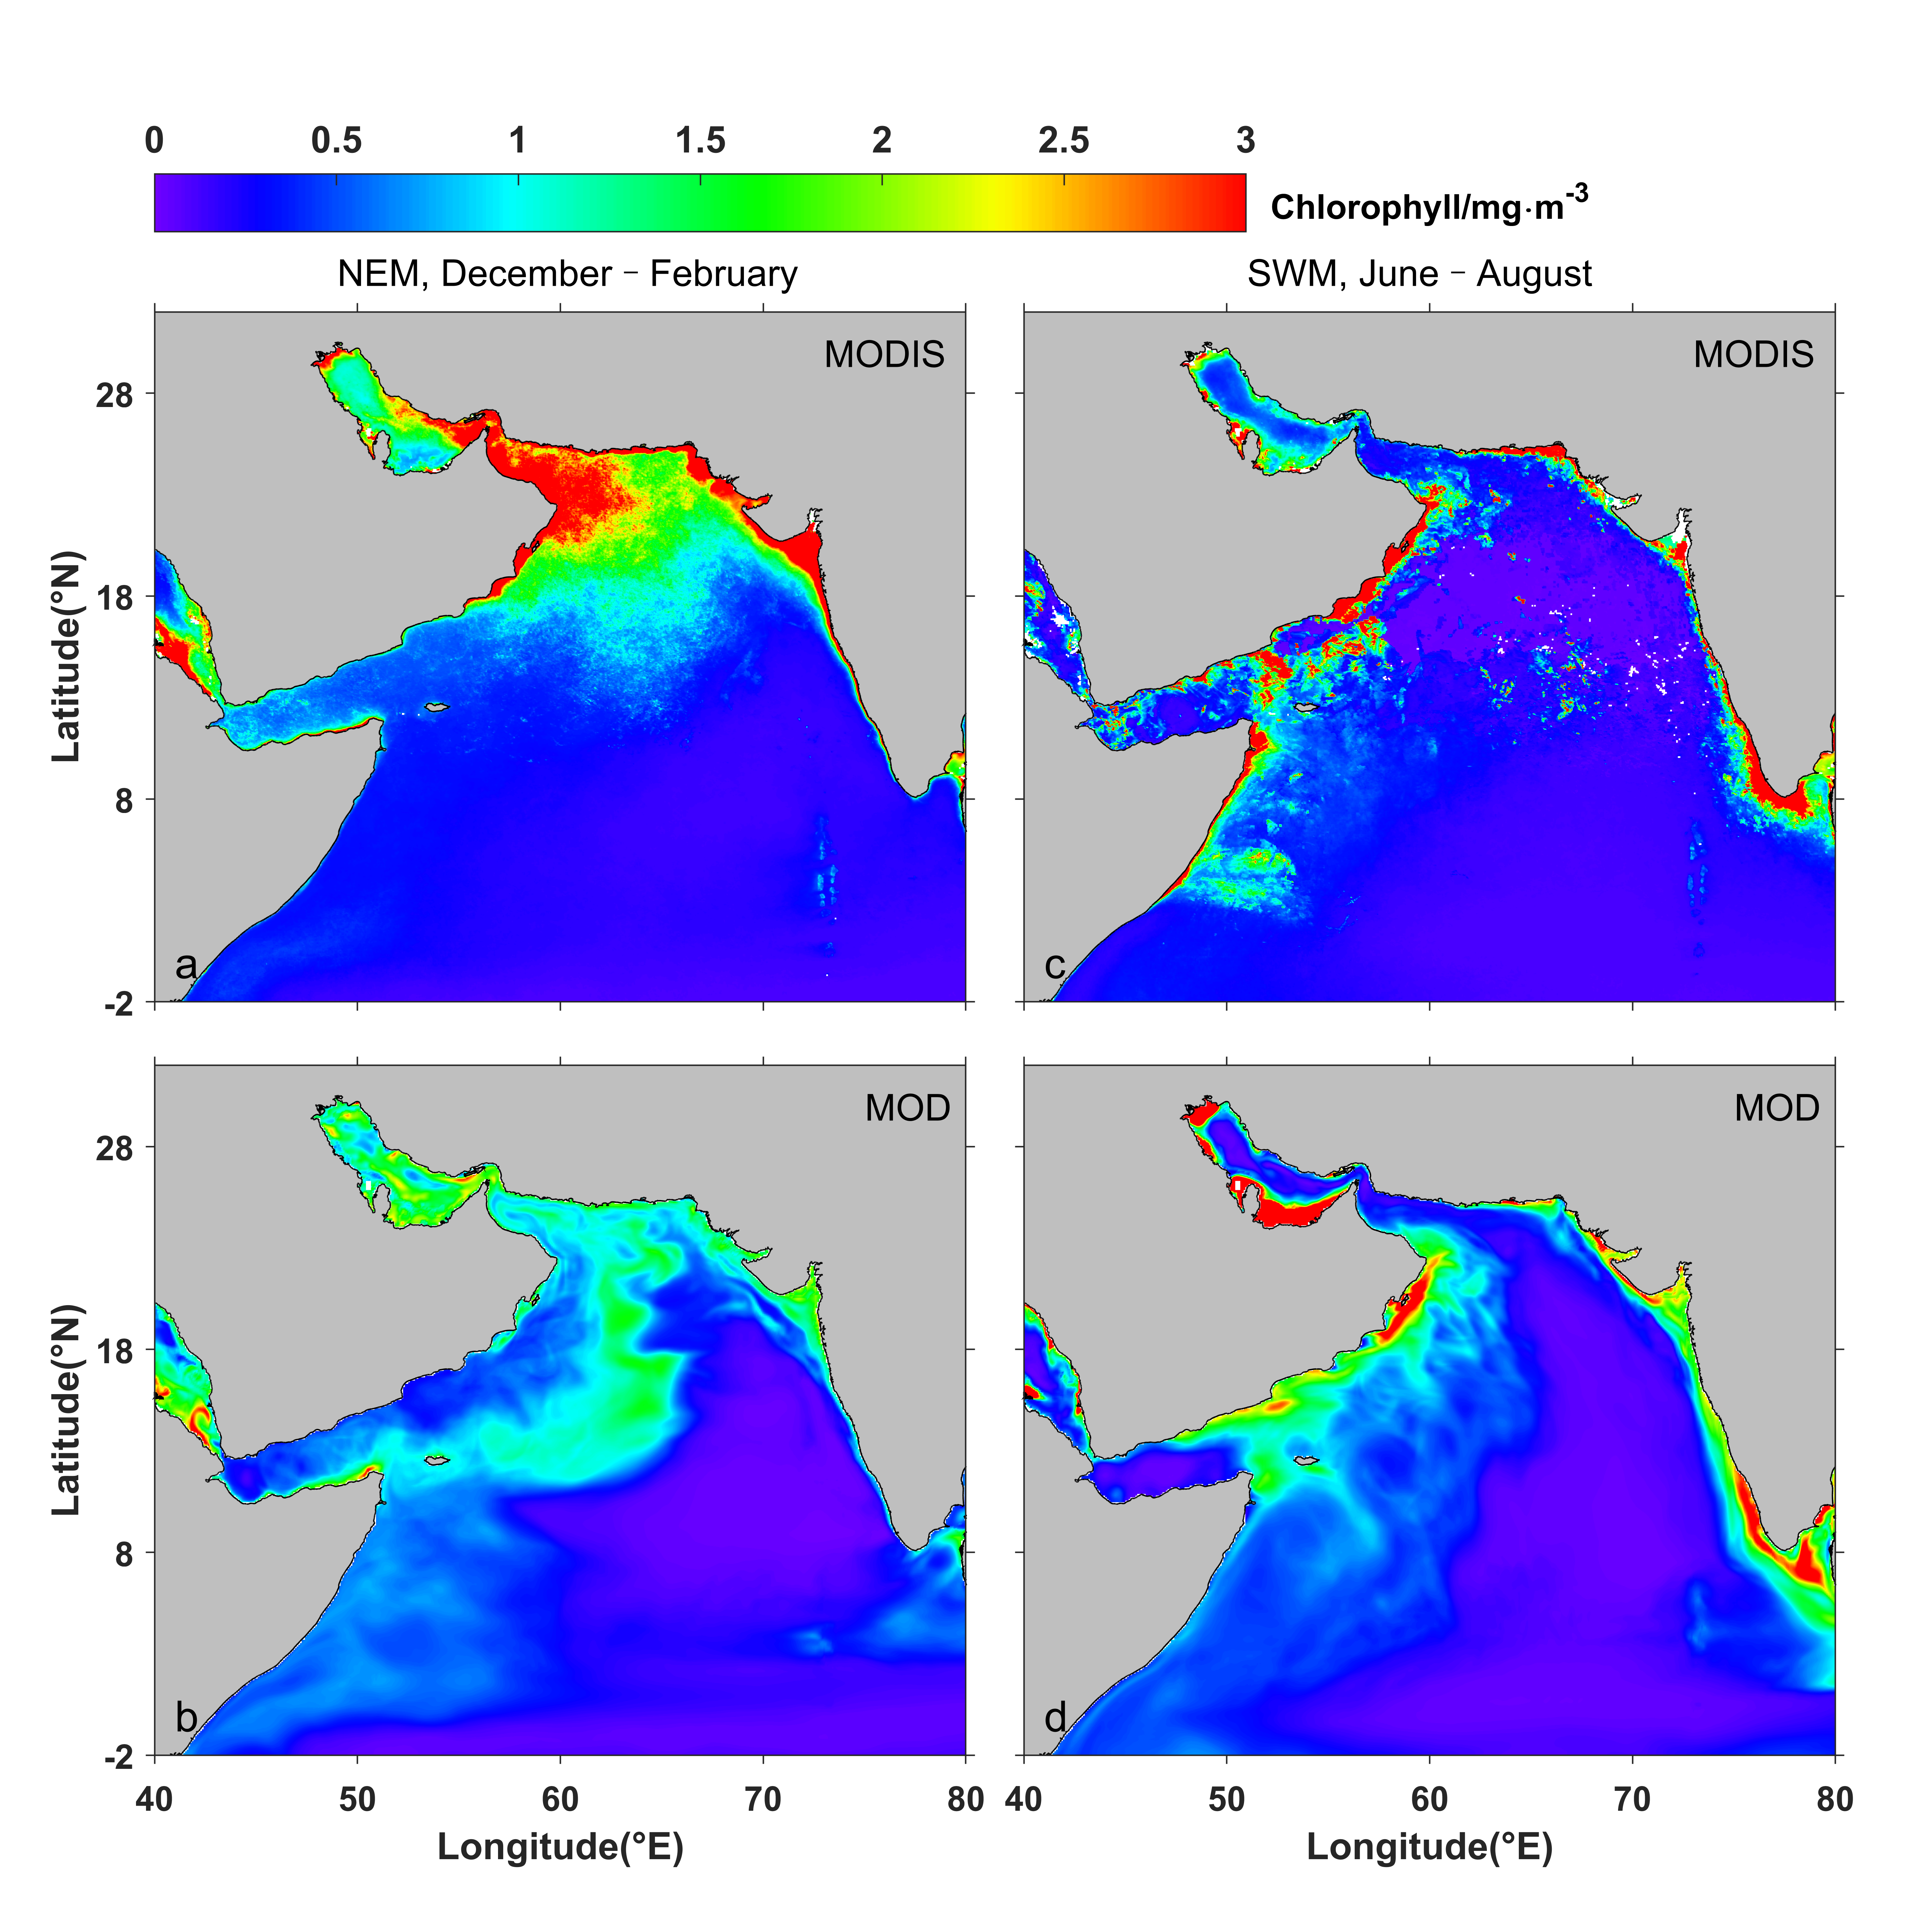
Figure S7. Evaluation of simulated sea-surface chlorophyll (mg·m⁻³) during winter monsoon (a, b) and summer monsoon (c, d). The observation data are from the MODIS.

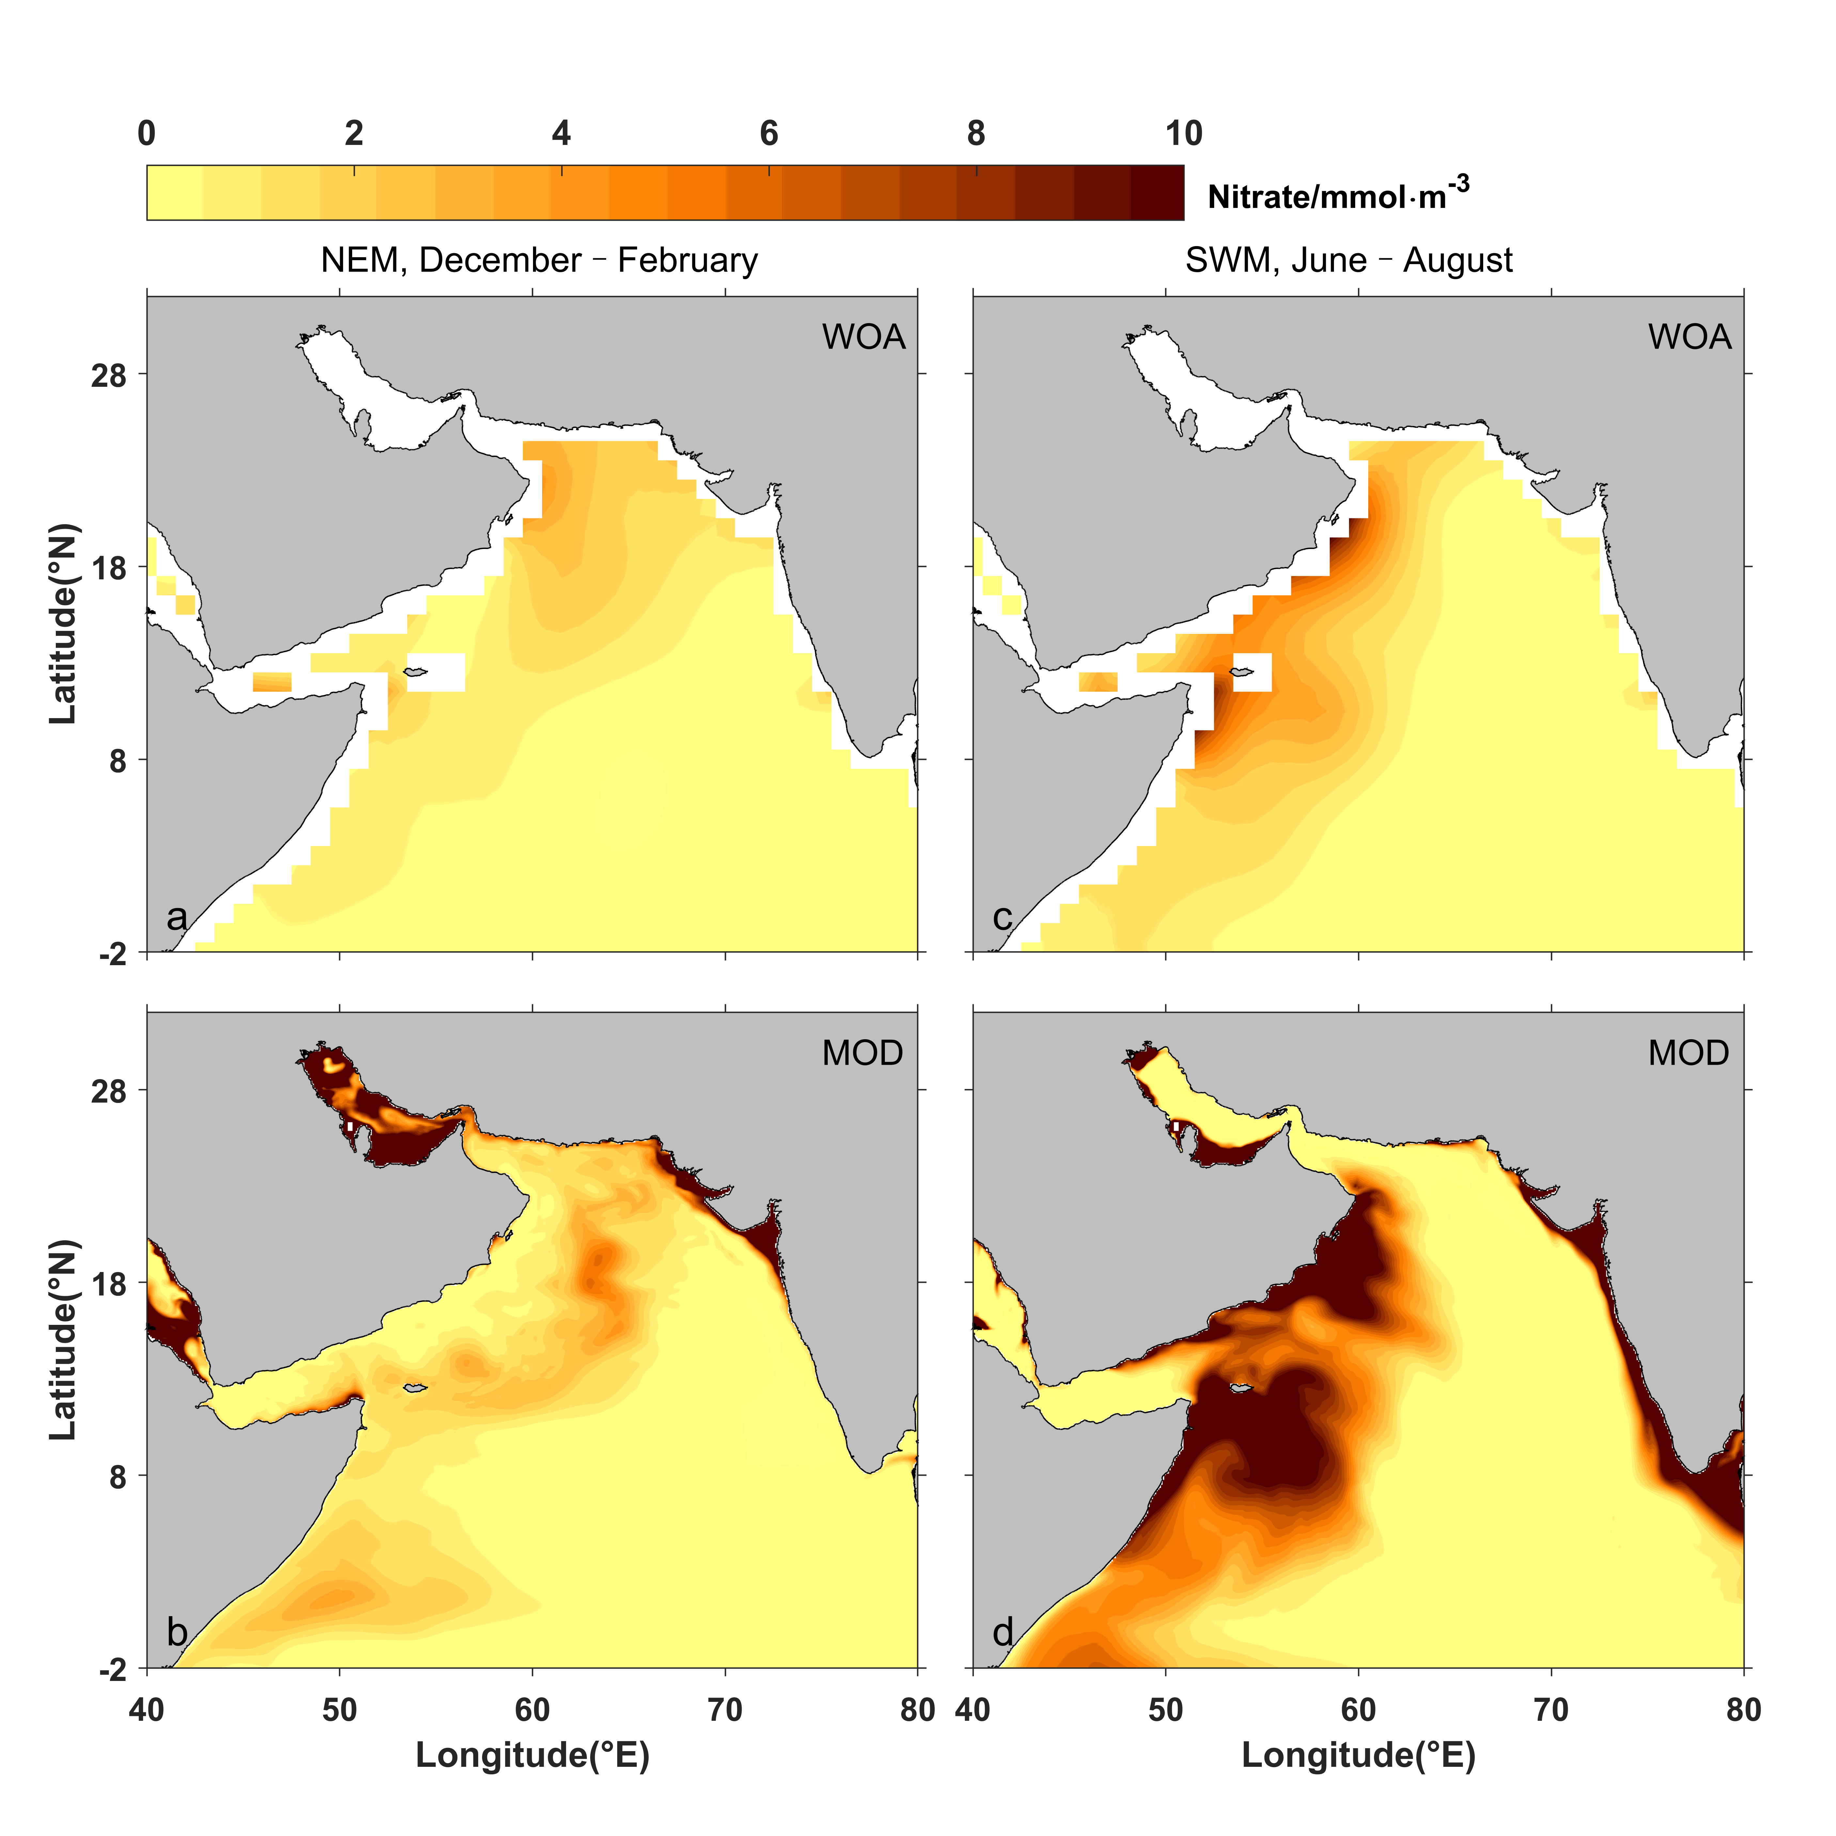
Figure S8. Evaluation of simulated sea-surface nitrate concentration (mmol·m⁻³) during winter monsoon (a, b) and summer monsoon (c, d). The observation data are from the WOA 2018.
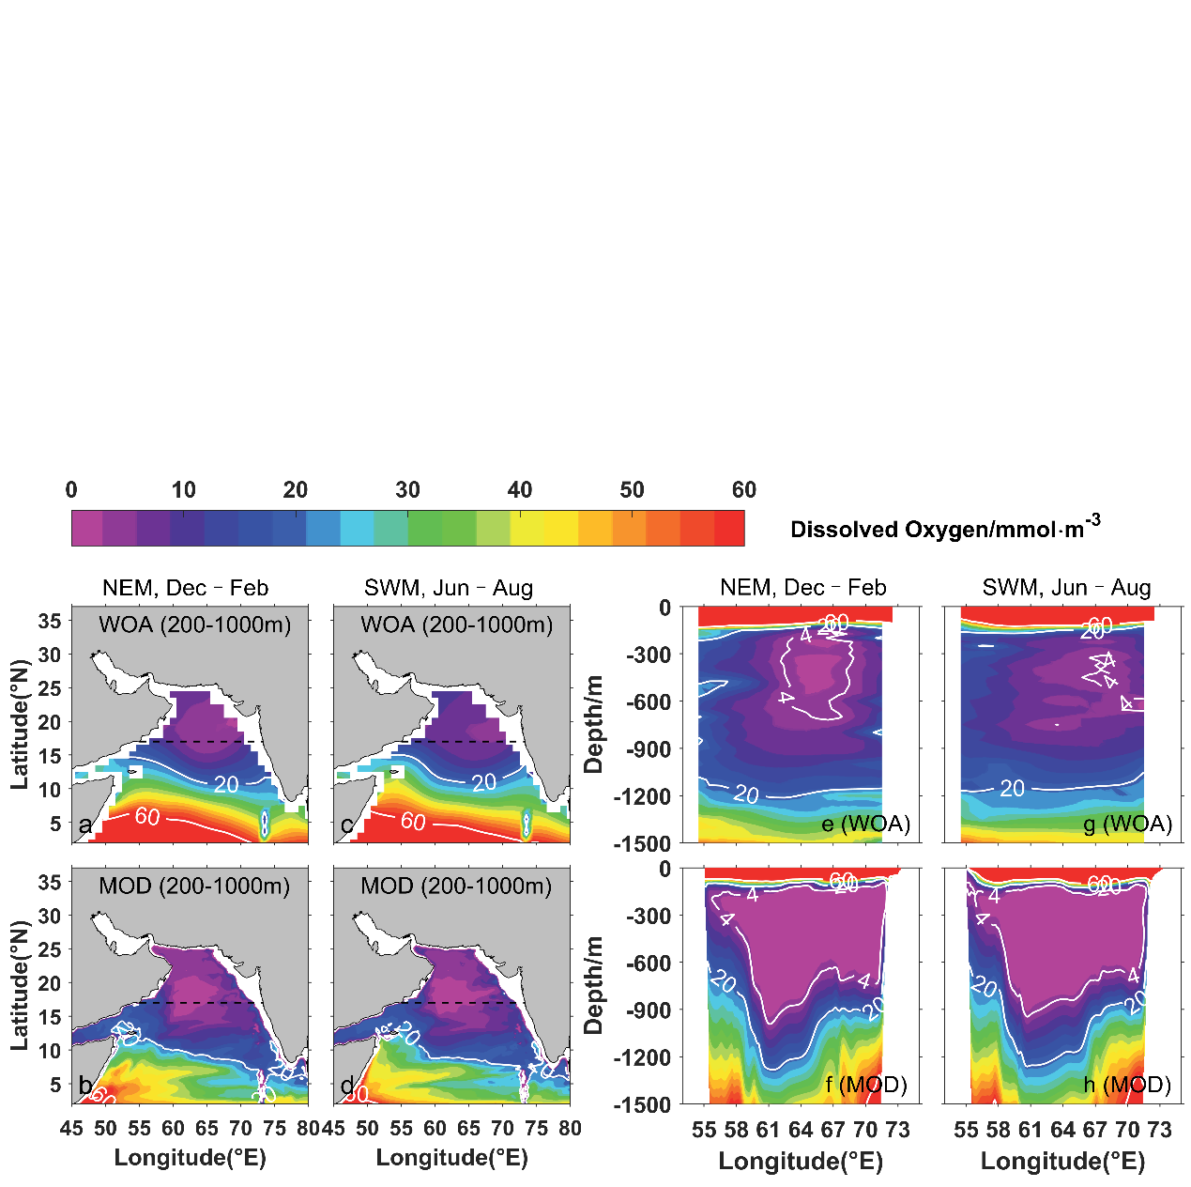
Figure S9. Evaluation of simulated horizontal distribution of dissolved oxygen (mmol·m⁻³) averaged between 200 and 1000 m during winter monsoon (a, b) and summer monsoon (c, d). Evaluation of simulated vertical distribution of dissolved oxygen in the upper 1500 m at 17°N during winter monsoon (e, f) and summer monsoon (g, h).

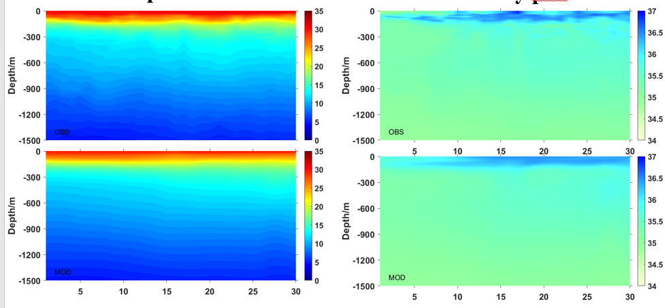
Figure S10. Observed temperature (top left) and salinity (top right) compared to modeled results (bottom) in the upper 1500 m. Observations are from the I07N cruise in 2018.

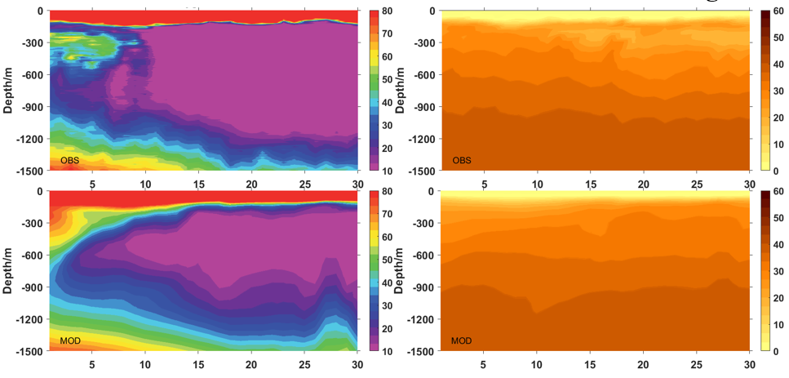

Figure S11. Same as Figure S9, but for dissolved oxygen (left) and nitrate (right).
Table S1 Summary of Quantitative Results
Exp |  | Exp0 | Exp1 | Exp2 | Exp3 | Exp4
Variation | Dissolved Oxygen Flux in Figure 8  (mmol·s⁻¹) | 2.7×10⁷ | -1.1×10⁶ | 9.5×10⁷
 | POM Sinking Velocity  (m·d⁻¹) | 5 |  |  | 2.5 | 10
Dissolved Oxygen Concentration (mmol·m⁻³) | Gulf of Aden | 14.4 | 6.0 | 39.2 | 20 | 10.8
 | Central Arabian Sea | 0.6 | 0.6 | 0.6 | 1.2 | 0.5
Variation of the ASOMZ | Microbial Hypoxic Area (m²) | 2.29×10¹² | 2.31×10¹² (± 0%) | 1.65×10¹² (- 28%) | 2.11×10¹² (- 8%) | 2.31×10¹² (± 0%)
 | Microbial Hypoxic Volume (m³) | 3.43×10¹⁵ | 3.80×10¹⁵ (+ 10%) | 2.68×10¹⁵ (- 22%) | 3.11×10¹⁵ (- 9%) | 3.62×10¹⁵ (+ 5%)
 | Suboxic Area (m²) | 6.79×10¹¹ | 8.09×10¹¹ (+ 19%) | 4.83×10¹¹ (- 29%) | 3.82×10¹¹ (- 44%) | 8.98×10¹¹ (+ 32%)
 | Suboxic Volume (m³) | 1.84×10¹⁵ | 2.33×10¹⁵ (+ 26%) | 1.35×10¹⁵ (- 27%) | 1.59×10¹⁵ (- 14%) | 1.84×10¹⁵ (± 0%)
Percentage of POM from the Local Source Regions (%) | Gulf of Aden Summer | 100% |  |  | 94.4% | 100%
 | Gulf of Aden Winter | 84.5% |  |  | 65.1% | 100%
 | Central Arabian Sea  Summer | 85.3% |  |  | 22.6% | 100%
 | Central Arabian Sea  Winter | 100% |  |  | 100% | 100%

