**Table S1.** Total grain yield in each province and China (Tg) and the accompanied acidification potential (AP) (Tg Acid equiv.), global warming potential (GWP) (Tg CO2 equiv.) and aquatic eutrophication potential (AEP) (Gg PO4 equiv.).

|  |  |  |  |  |  |  |  |  |  |  |  |  |
| --- | --- | --- | --- | --- | --- | --- | --- | --- | --- | --- | --- | --- |
| **Province** | **Grain yield (Tg)** | | | **AP (Tg Acid equiv.)** | | | **GWP (Tg CO2 equiv.)** | | | **AEP (Gg PO4 equiv.)** | | |
| **Beijing** | 0.05 | 0.27 | 0.00 | 0.01 | 0.03 | 0.00 | 0.00 | 0.01 | 0.00 | 0.02 | 0.09 | 0.00 |
| **Tianjin** | 0.57 | 1.11 | 0.37 | 0.08 | 0.12 | 0.06 | 0.04 | 0.04 | 0.01 | 0.21 | 0.38 | 0.01 |
| **Hebei** | 14.51 | 19.41 | 0.53 | 1.91 | 2.11 | 0.08 | 1.08 | 0.63 | 0.02 | 5.37 | 6.60 | 0.02 |
| **Shanxi** | 2.29 | 9.82 | 0.01 | 0.30 | 1.07 | 0.00 | 0.17 | 0.32 | 0.00 | 0.85 | 3.34 | 0.00 |
| **Inner Mongolia** | 2.02 | 27.00 | 1.22 | 0.27 | 2.93 | 0.19 | 0.15 | 0.88 | 0.04 | 0.75 | 9.18 | 0.04 |
| **Liaoning** | 0.01 | 16.63 | 4.18 | 0.00 | 1.81 | 0.64 | 0.00 | 0.54 | 0.15 | 0.01 | 5.65 | 0.13 |
| **Jilin** | 0.00 | 28.00 | 6.46 | 0.00 | 3.04 | 0.99 | 0.00 | 0.91 | 0.23 | 0.00 | 9.52 | 0.19 |
| **Heilongjiang** | 0.36 | 39.82 | 26.86 | 0.05 | 4.33 | 4.10 | 0.03 | 1.30 | 0.94 | 0.13 | 13.54 | 0.81 |
| **Shanghai** | 0.13 | 0.01 | 0.88 | 0.02 | 0.00 | 0.13 | 0.01 | 0.00 | 0.03 | 0.05 | 0.00 | 0.03 |
| **Jiangsu** | 12.89 | 3.00 | 19.58 | 1.69 | 0.33 | 2.99 | 0.96 | 0.10 | 0.69 | 4.77 | 1.02 | 0.59 |
| **Zhejiang** | 0.36 | 0.21 | 4.77 | 0.05 | 0.02 | 0.73 | 0.03 | 0.01 | 0.17 | 0.13 | 0.07 | 0.14 |
| **Anhui** | 16.08 | 5.96 | 16.81 | 2.11 | 0.65 | 2.57 | 1.20 | 0.19 | 0.59 | 5.95 | 2.03 | 0.50 |
| **Fujian** | 0.00 | 0.13 | 3.98 | 0.00 | 0.01 | 0.61 | 0.00 | 0.00 | 0.14 | 0.00 | 0.04 | 0.12 |
| **Jiangxi** | 0.03 | 0.16 | 20.92 | 0.00 | 0.02 | 3.20 | 0.00 | 0.01 | 0.74 | 0.01 | 0.05 | 0.63 |
| **Shandong** | 24.72 | 26.07 | 0.99 | 3.25 | 2.83 | 0.15 | 1.84 | 0.85 | 0.03 | 9.15 | 8.86 | 0.03 |
| **Henan** | 36.03 | 23.51 | 5.01 | 4.74 | 2.55 | 0.77 | 2.68 | 0.77 | 0.18 | 13.33 | 7.99 | 0.15 |
| **Hubei** | 4.10 | 3.23 | 19.66 | 0.54 | 0.35 | 3.00 | 0.31 | 0.11 | 0.69 | 1.52 | 1.10 | 0.59 |
| **Hunan** | 0.08 | 2.03 | 26.74 | 0.01 | 0.22 | 4.09 | 0.01 | 0.07 | 0.94 | 0.03 | 0.69 | 0.80 |
| **Guangdong** | 0.00 | 0.55 | 10.32 | 0.00 | 0.06 | 1.58 | 0.00 | 0.02 | 0.36 | 0.00 | 0.19 | 0.31 |
| **Guangxi** | 0.01 | 2.73 | 10.16 | 0.00 | 0.30 | 1.55 | 0.00 | 0.09 | 0.36 | 0.00 | 0.93 | 0.30 |
| **Hainan** | 0.00 | 0.00 | 1.31 | 0.00 | 0.00 | 0.20 | 0.00 | 0.00 | 0.05 | 0.00 | 0.00 | 0.04 |
| **Chongqing** | 0.08 | 2.51 | 4.87 | 0.01 | 0.27 | 0.74 | 0.01 | 0.08 | 0.17 | 0.03 | 0.85 | 0.15 |
| **Sichuan** | 2.47 | 10.66 | 14.79 | 0.33 | 1.16 | 2.26 | 0.18 | 0.35 | 0.52 | 0.92 | 3.63 | 0.44 |
| **Guizhou** | 0.33 | 2.59 | 4.21 | 0.04 | 0.28 | 0.64 | 0.02 | 0.08 | 0.15 | 0.12 | 0.88 | 0.13 |
| **Yunnan** | 0.74 | 9.26 | 5.28 | 0.10 | 1.01 | 0.81 | 0.06 | 0.30 | 0.19 | 0.27 | 3.15 | 0.16 |
| **Tibet** | 0.20 | 0.03 | 0.01 | 0.03 | 0.00 | 0.00 | 0.01 | 0.00 | 0.00 | 0.07 | 0.01 | 0.00 |
| **Shaanxi** | 4.01 | 5.84 | 0.81 | 0.53 | 0.63 | 0.12 | 0.30 | 0.19 | 0.03 | 1.48 | 1.99 | 0.02 |
| **Gansu** | 2.81 | 5.90 | 0.03 | 0.37 | 0.64 | 0.00 | 0.21 | 0.19 | 0.00 | 1.04 | 2.01 | 0.00 |
| **Qinghai** | 0.43 | 0.12 | 0.00 | 0.06 | 0.01 | 0.00 | 0.03 | 0.00 | 0.00 | 0.16 | 0.04 | 0.00 |
| **Ningxia** | 0.42 | 2.35 | 0.67 | 0.05 | 0.25 | 0.10 | 0.03 | 0.08 | 0.02 | 0.15 | 0.80 | 0.02 |
| **Xinjiang** | 5.72 | 8.28 | 0.73 | 0.75 | 0.90 | 0.11 | 0.43 | 0.27 | 0.03 | 2.12 | 2.81 | 0.02 |
| **China** | 131.44 | 257.18 | 212.13 | 17.28 | 27.94 | 32.42 | 9.78 | 8.37 | 7.45 | 48.63 | 87.44 | 6.36 |

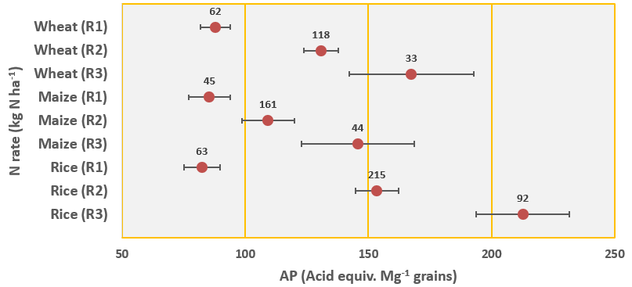

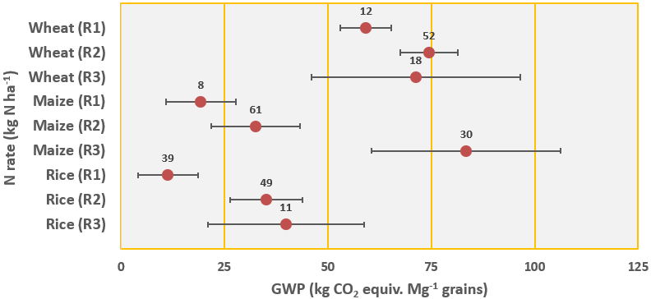

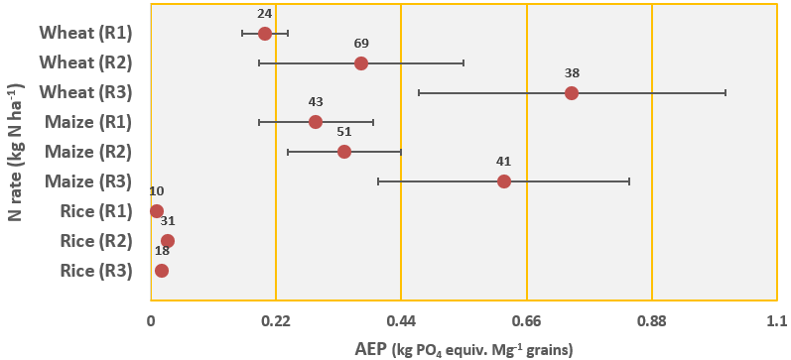

**Fig S1 (A):** The responses of AP, GWP and AEP to the reduced rate strategy in the three crops (wheat, maize and rice). AP is acidification potential (Acid equiv. Mg-1 grains), GWP is global warming potential (kg CO2 equiv. Mg-1 grains) and AEP is aquatic eutrophication potential (kg PO4 equiv. Mg-1 grains). R1 is the reduced rate strategy, R2 is the conventional rate used in China (between 150-250, 200-260 and 170-260 kg N ha-1 for wheat, maize and rice, respectively) and R3 is the increased rate scenario. Numbers above the markers are the number of observations.

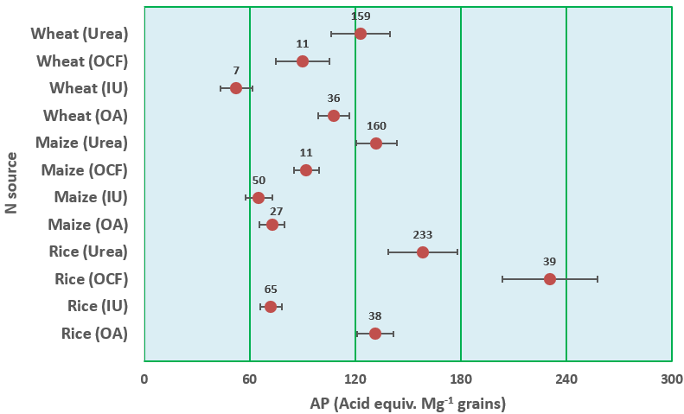

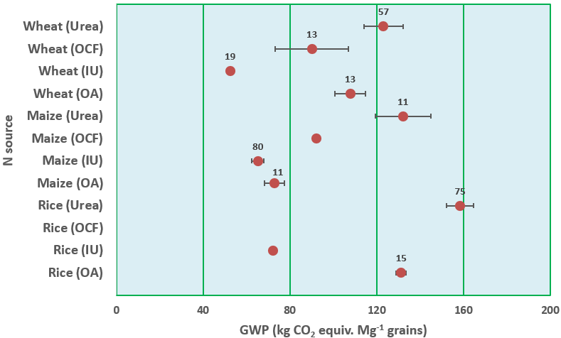

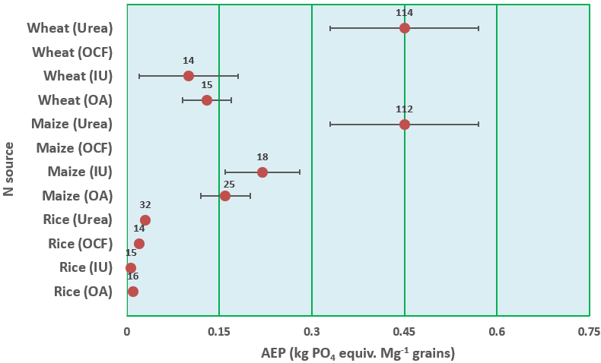

**Fig S1 (B):** The responses of AP, GWP and AEP to the nitrogen (N) source strategy in the three crops (wheat, maize and rice). AP is acidification potential (Acid equiv. Mg-1 grains), GWP is global warming potential (kg CO2 equiv. Mg-1 grains) and AEP is aquatic eutrophication potential (kg PO4 equiv. Mg-1 grains). These N sources are urea, other synthetic fertilizers (OCF), improved urea (IU, slow released fertilizers) and organic sources (OA). Numbers above the markers are the number of observations.

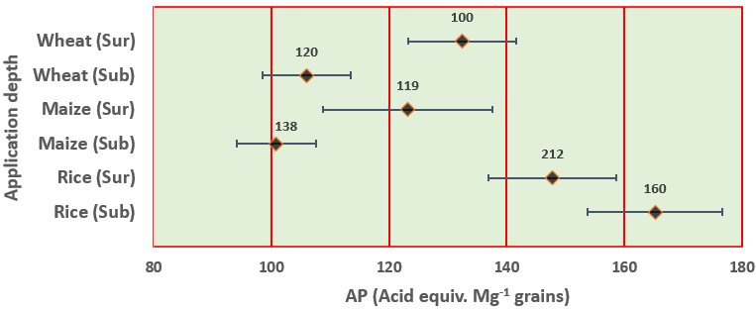

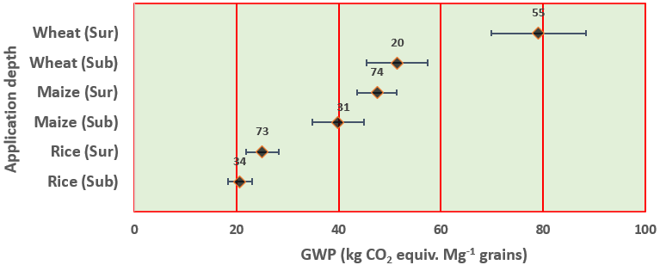

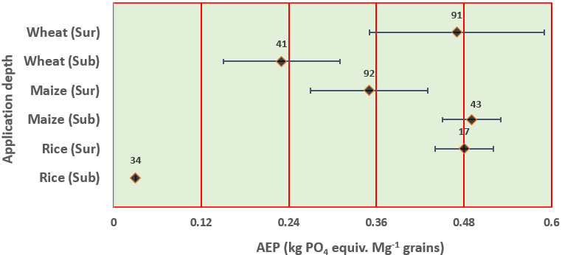

**Fig S1 (C):** The responses of AP, GWP and AEP to the application depth strategy in the three crops (wheat, maize and rice). AP is acidification potential (Acid equiv. Mg-1 grains), GWP is global warming potential (kg CO2 equiv. Mg-1 grains) and AEP is aquatic eutrophication potential (kg PO4 equiv. Mg-1 grains). Sur is the surface application and Sub is the subsurface application. Numbers above the markers are the number of observations.

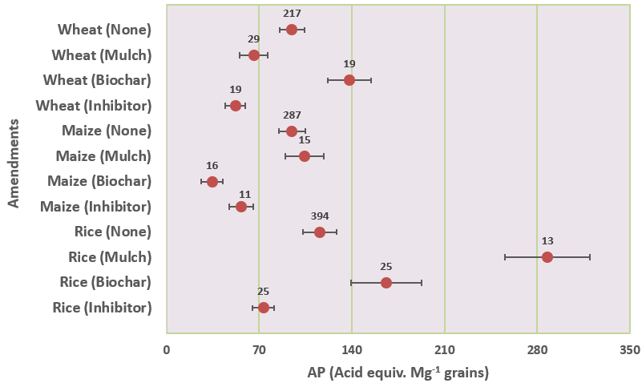

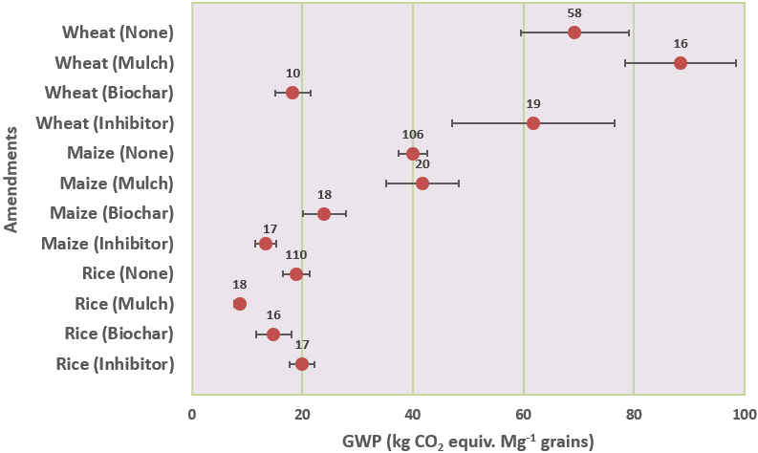

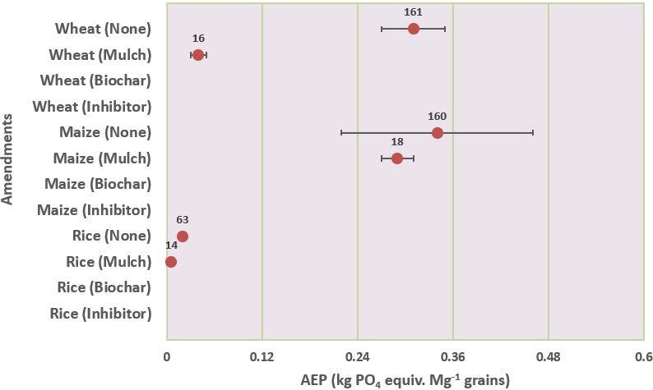

**Fig S1 (D):** The responses of AP, GWP and AEP to the application depth strategy in the three crops (wheat, maize and rice). AP is acidification potential (Acid equiv. Mg-1 grains), GWP is global warming potential (kg CO2 equiv. Mg-1 grains) and AEP is aquatic eutrophication potential (kg PO4 equiv. Mg-1 grains). None means no amendments were applied. Numbers above the markers are the number of observations.