Supplementary Material

# Supplementary Figures and Tables

## Supplementary Figures

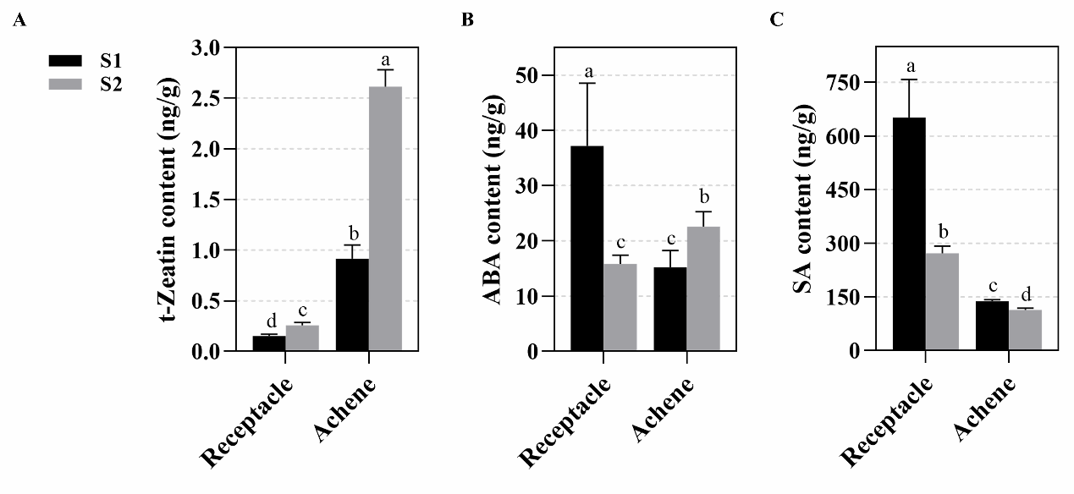

**SUPPLEMENTARY FIGURE S1 |** Changes of phytohormones contents in receptacle and achene during fruit development. The levels of zeatin (**A**), ABA (**B**) and SA (**C**) in achene and receptacle were measured. Error bars represent SD, n = 3. 15 ~ 20 fruits were used for each replicate. The significant different between groups was labeled (*p* < 0.05, one way ANOVA).

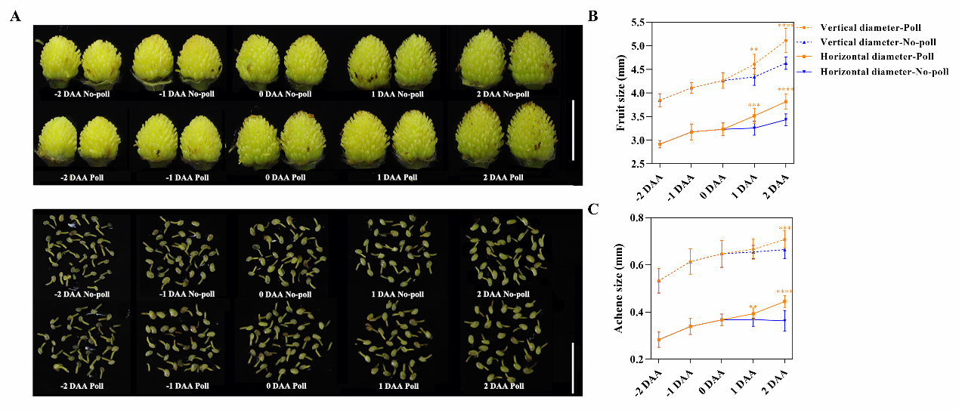

**SUPPLEMENTARY FIGURE S2 |** Fruits showed growth response 1 day after pollination. (**A**) The size of fruits and achenes with (Poll) and without pollination (No-poll). Dimension of fruits and achenes were characterized from -2 to 2 days after anthesis. Bar = 1 cm. (**B** and **C**) Vertical diameter and horizontal diameter quantification of fruits and achenes in **A**. Error bar in (**B)** showed the SD, n = 15 - 20. Error bars in (**C**) represent the SD, n = 60. Statistical analysis showed the significant difference between the groups (*p* < 0.05, one way ANOVA).

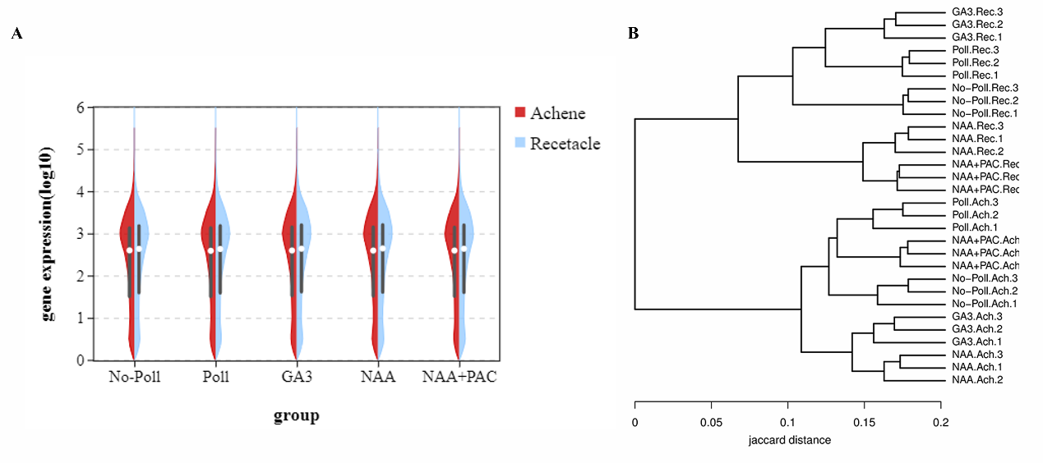

**SUPPLEMENTARY FIGURE S3 |** Transcriptome analysis of achene and receptacle under different conditions. (**A**) Violin figure showed gene expression level for the identified unigenes. (**B**) Similariton for the classified groups basing on hole gene expression profile.

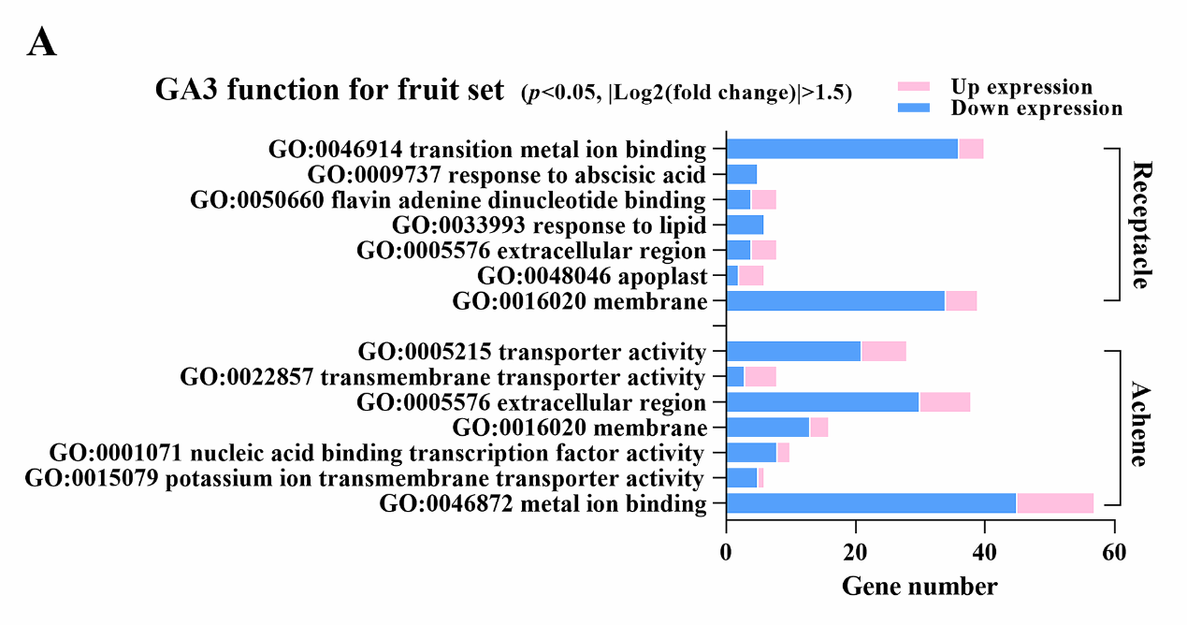

**SUPPLEMENTARY FIGURE S4 |** The enriched GO terms identified in achene and receptacle under GA3 treatment. The up or down-regulated genes were noted in different color. Analysis was performed in receptacle and achene separately. *p* < 0.05, |log2(Fold change)| > 1.5.

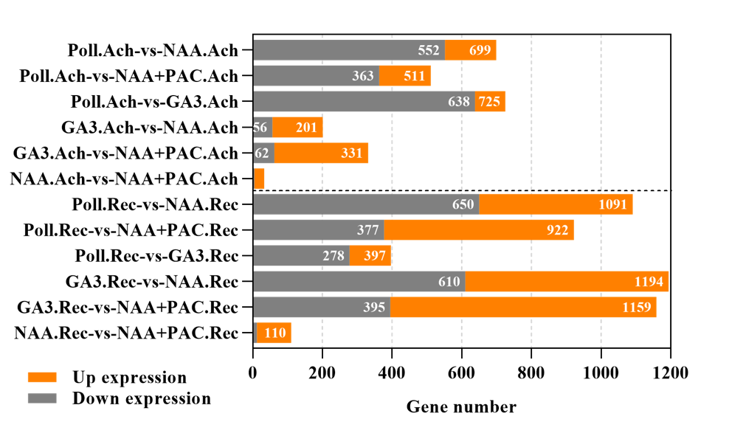

**SUPPLEMENTARY FIGURE S5 |** Statistical analysis of the DEGs identified in different treatment conditions. Numbers of the up-regulated genes (orange) and down-regulated genes (gray) were shown for each group. Poll represents pollination. *p* < 0.05, |log2(Fold change)| > 1.5.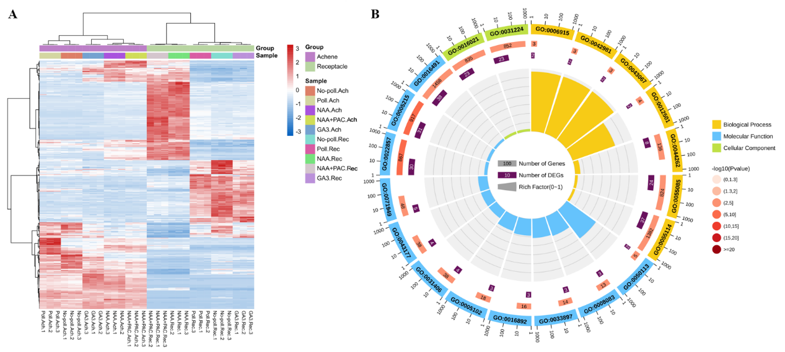

**SUPPLEMENTARY FIGURE S6 |** The DEGs specifically regulated by auxin treatment. (**A**) Expression pattern for genes significantly regulated by NAA treatment in receptacle or achene. (**B**) Functional enrichment of GO terms for genes special responding to NAA. *p* < 0.05, |log2(Fold change)| > 1.5.

## Supplementary Tables

**Supplementary Table S1.** The differentially expressed phytohormone pathways genes under pollination and NAA treatment comparing with no-pollination in achene.

|  |  |  |  |  |
| --- | --- | --- | --- | --- |
| **Pathway** | **Gene ID** | **Description (Ab)** | **No-Poll.Ach-vs-Poll.Ach log2(FC)** | **No-Poll.Ach-vs-NAA.Ach**  **log2(FC)** |
| uxin pathway | FvH4_2g04750 | GH3.1, putative indole-3-acetic acid-amido synthetase GH3.1 | 2.6 | 4.9 |
| FvH4_4g22430 | GH3.17, Indole-3-acetic acid-amido synthetase | - | 3.1 |
| FvH4_1g16980 | GH3.2, indole-3-acetic acid-amido synthetase 3.2 | 2.3 | 5.8 |
| FvH4_2g25330 | GH3.9, indole-3-acetic acid-amido synthetase 3. | - | 3.9 |
| FvH4_2g20500 | IAA12, indoleacetic acid-induced protein 12 | - | 1.8 |
| FvH4_2g35280 | IAA26a, indoleacetic acid-induced protein 26a | - | 1.6 |
| FvH4_6g30860 | IAA6, indoleacetic acid-induced protein 6 | - | 3.6 |
| FvH4_3g23570 | IAMT1, Indole-3-acetate O-methyltransferase 1 | - | 2.6 |
| FvH4_5g22780 | SAUR-like auxin-responsive protein family | - | 2.1 |
| Gibberellin biosynthesis | FvH4_7g28670 | GA20OX1, Gibberellin 20 oxidase 1 | - | 1.8 |
| FvH4_3g16760 | GA2OX1, gibberellin 2-oxidase 1 | - | -3 |
| FvH4_4g36510 | GA2OX8, Gibberellin 2-beta-dioxygenase 8 | 3.1 | 2.7 |
| FvH4_6g30780 | GA3OX1, Gibberellin 3-beta-dioxygenase 1 | - | - |
| FvH4_2g24370 | GID1B, Gibberellin receptor GID1B | - | -2 |
| FvH4_2g33690 | GID2, F-box protein GID2 | - | -2 |
| Cytokinin biosynthesis | FvH4_1g07610 | CKX5, Cytokinin dehydrogenase 5 | 1.6 | - |
| FvH4_4g14440 | IPT; adenylate dimethylallyltransferase (cytokinin synthase) | - | -3 |
| FvH4_6g17030 | UDP-glycosyltransferase 73C1-like | - | -2 |
| Ethylene biosynthesis | FvH4_1g07181 | ACO1, 1-aminocyclopropane-1-carboxylate oxidase 1 | - | 1.9 |
| FvH4_7g15310 | ACS1, 1-aminocyclopropane-1-carboxylate synthase 1 | 3.8 | 2.3 |
| FvH4_7g09550 | ERF034, Ethylene-responsive transcription factor 034 | - | -2 |
| Abscisic acid biosynthesis | FvH4_5g25150 | CYP707A2, Abscisic acid 8'-hydroxylase | 1.7 | - |
| FvH4_3g16730 | NCED1, 9-cis-epoxycarotenoid dioxygenase, chloroplastic | 2.5 | - |

**Supplementary Table S2.** The differentially expressed phytohormone pathways genes under pollination and NAA treatment comparing with no-pollination in receptacle.

|  |  |  |  |  |
| --- | --- | --- | --- | --- |
| **Pathway** | **Gene ID** | **Description (Ab)** | **No-Poll.Rec-vs-Poll.Rec log2(FC)** | **No-Poll.Rec-vs-NAA. Rec log2(FC)** |
| Auxin pathway | FvH4_2g38760 | ARF5, Auxin response factor 5 | - | -1.7 |
| FvH4_2g02300 | ARG7, Indole-3-acetic acid-induced protein 7 | - | 1.52 |
| FvH4_5g22690 | ARG7, Indole-3-acetic acid-induced protein 7 | - | 1.99 |
| FvH4_5g22700 | Auxin-induced protein 15A | - | 1.67 |
| FvH4_2g04750 | GH3.1, putative indole-3-acetic acid-amido synthetase GH3.1 | - | 5.8 |
| FvH4_4g22430 | GH3.17, Indole-3-acetic acid-amido synthetase | 1.76 | 5.65 |
| FvH4_1g16980 | GH3.2, indole-3-acetic acid-amido synthetase 3.2 | - | 6.29 |
| FvH4_2g25330 | GH3.9, indole-3-acetic acid-amido synthetase 3. | - | 4.49 |
| FvH4_2g20500 | IAA12, indoleacetic acid-induced protein 12 | - | 2.75 |
| FvH4_2g22520 | IAA14b, indoleacetic acid-induced protein 14b | - | 3.14 |
| FvH4_6g30850 | IAA17, indoleacetic acid-induced protein 17 | - | 2.89 |
| FvH4_2g22530 | IAA4b, indoleacetic acid-induced protein 4b | - | 2.31 |
| FvH4_6g30860 | IAA6, indoleacetic acid-induced protein 6 | - | 4.92 |
| FvH4_2g27160 | IAA-amino acid hydrolase ILR1-like 6 | - | -1.5 |
| FvH4_3g23570 | IAMT1, Indole-3-acetate O-methyltransferase 1 | - | 4.09 |
| FvH4_5g17310 | PIN1, Auxin efflux carrier component 1 | - | 2.48 |
| FvH4_2g02310 | SAUR23, Auxin-responsive protein 23 | - | 1.64 |
| FvH4_7g17340 | SAUR32, Auxin-responsive protein 32 | - | 1.5 |
| FvH4_7g11280 | SAUR36, Auxin-responsive protein 36 | - | -2.2 |
| FvH4_5g22780 | SAUR-like auxin-responsive protein family | - | 2.25 |
| FvH4_5g22810 | SAUR-like auxin-responsive protein family | - | 4.11 |
| Gibberellin pathway | FvH4_7g28670 | GA20OX1, Gibberellin 20 oxidase 1 | - | 4.08 |
| FvH4_7g12600 | GA20OX2, Gibberellin 20 oxidase 2 | - | 5.01 |
| FvH4_3g16760 | GA2OX1, gibberellin 2-oxidase 1 | -3 | -6.7 |
| FvH4_3g05530 | GA2OX2, Gibberellin 2-beta-dioxygenase 2 | - | -1.6 |
| FvH4_3g38920 | GA2OX9, Gibberellin 2-oxidase 9 | - | -2.3 |
| FvH4_6g30780 | GA3OX1, Gibberellin 3-beta-dioxygenase 1 | - | 2.99 |
| FvH4_5g14950 | Gibberellin-regulated protein 6 | - | 6.33 |
| FvH4_3g11720 | GID1; gibberellin receptor GID1 | - | -4 |
| FvH4_6g04960 | GID1; gibberellin receptor GID1 | - | -2.1 |
| FvH4_2g24370 | GID1B, Gibberellin receptor GID1B | - | -2.4 |
| FvH4_2g33690 | GID2, F-box protein GID2 | - | -1.9 |
| Cytokinin pathway | FvH4_6g04970 | AHP1, Histidine-containing phosphotransferase protein 1 | - | -2.7 |
| FvH4_3g03260 | CKX; cytokinin dehydrogenase | - | 2.39 |
| FvH4_7g02150 | CKX1, Cytokinin dehydrogenase 1 | - | 2.66 |
| FvH4_2g23840 | IPT; adenylate dimethylallyltransferase (cytokinin synthase) | - | -4.8 |
| FvH4_4g14440 | IPT; adenylate dimethylallyl transferase (cytokinin synthase) | -1.5 | -6.6 |
| FvH4_3g31870 | LOG1, Cytokinin riboside 5'-monophosphate phosphoribohydrolase 1 | - | 3.8 |
| FvH4_6g16020 | LOG3, Cytokinin riboside 5'-monophosphate phosphoribohydrol | - | 3.24 |
| FvH4_3g04550 | LOG7, Cytokinin riboside 5'-monophosphate phosphoribohydrolase 7 | - | -2.7 |
| FvH4_2g31610 | LOG8, Cytokinin riboside 5'-monophosphate phosphoribohydrolase 8 | - | -1.8 |
| Ethylene pathway | FvH4_1g07181 | ACO1, 1-aminocyclopropane-1-carboxylate oxidase 1 | - | 1.7 |
| FvH4_3g01280 | ACO2, 1-aminocyclopropane-1-carboxylate oxidase 2 | - | -3 |
| FvH4_6g02270 | Ethylene-responsive transcription factor 1B | 2.23 | 5.4 |
| FvH4_6g08370 | SAMS1, S-adenosylmethionine synthase 1 | - | 1.51 |
| FvH4_4g21340 | SAMS2, S-adenosylmethionine synthase 2 | - | 2.51 |
| Abscisic acid pathway | FvH4_1g08010 | PP2C16, Protein phosphatase 2C 16 | - | 1.56 |
| FvH4_7g31810 | PP2C8, Probable protein phosphatase 2C 8 | -1.5 | -2.9 |
| FvH4_1g20310 | SNRK2; serine/threonine-protein kinase SRK2 | - | -2.3 |

**Supplementary Table S3.** Primers and Accession IDs used for qRT-PCR.

|  |  |  |  |
| --- | --- | --- | --- |
| Gene name | Forward primer (5'-3') | Reverse primer (5'-3') | Gene ID |
| FvACTIN | CAGAAAGATGCTTATGTCGG | TGGGGCAACACGAAGCTCAT |  |
| FvGH3.17 | CGAGCGAATTGCCAATGGAG | GCCACCAAACCAGAAGGAGT | FvH4_4g22430 |
| FvGH3.9 | CCTCGAACGAAACTGGGTCA | GATTTGCGGCAATCAGGGTC | FvH4_2g25330 |
| FvGA20ox1 | GCAATGGCAGTTGAGTGTATG | TGTTTGGGTATGTCAGTTTCGT | FvH4_7g28670 |
| FvGA20ox2 | GGCAGGTTCTCCTCCAAACT | TCTTCACCCATCACATTCACG | FvH4_7g12600 |
| FvGA20ox4 | GTCCCTGCCCTATTGACTCTT | TGGCAGCATTCTCGGTTG | FvH4_2g35050 |
| FvGA20ox5 | GGCTTGGACTAATGGGAGG | TTGTGGCAGAATCAGAGGG | FvH4_5g19970 |
| FvACO1 | GCGTCATCCTTCTGTTCCA | GCCATCTGTCTGGGCAATC | FvH4_6g42090 |
| FvCKX1 | CCACACCCATGGCTCAATCT | TAGGGCCGTTGCTTGTTTCT | FvH4_7g02150 |
| FvCKX6 | AGCTTGAAGTCGTTACGGGG | TCGAGCTCTGGTGATGATGC | FvH4_2g30990 |
| FvCKX8 | CTGGGAAACAAAACCAGCGG | CCGACGGTTCTGATTGGTGA | FvH4_2g39230 |