Supplementary information

Supplementary Table 1: MiRNA identification steps and number of EST derived sequences in C-mii program
MiRNA identification steps | Number of sequences at each step
Sequence loading | 16503
Homolog search | 9278
Primary miRNA folding | 3068
Precursor miRNA folding | 1167

Supplementary Table 2: Predicted functions of EST Ids in which miRNA families are present against cDNA library of cluster bean
Input sequence | Description | Function
GLE045_H05_017 | Structural constituent of ribosome [Arabidopsis thaliana | Translation
GLL02_E10_036 | LEXYL1 [Lycopersicon esculentum] | Carbohydrate
GLL02_C09_038 | ARA12; subtilase [Arabidopsis thaliana] | Chaperones and protease
GLL010_F06_019 | Host specificity protein [Methanococcoides burtonii DSM 6242 | Non classified
GLL031_C04_014 | Sucrose-binding protein 2 [Glycine max | Carbohydrate
GLE094_C01_006 | Unknown [Arabidopsis thaliana] | Non classified
GLE021_H04_009 | PPF-1 protein [Pisum sativum] | Structure and development cycle
GLL054_A10_040 | Putative 1-deoxy-D-xylulose 5-phosphate reductoisomerase [Zea mays] | Energy
GLL094_D08_029 | Protein binding [Arabidopsis thaliana] | Non classified
GLE062_E02_004 | Putative 50S ribosomal protein L20 [Oryza sativa (japonica cultivar-group) | Translation
GLE016_B04_015 | RNA binding [Arabidopsis thaliana] | Transcription
GLE094_G01_002 | Protein binding / ubiquitin-protein ligase/ zinc ion binding [Arabidopsis thaliana] | Chaperones and protease
GLL057_D04_013 | ER lumen protein-retaining receptor-like [Oryza sativa (japonica cultivar-group)] | Signal transduction
GLE057_B04_015 | 60S acidic ribosomal protein P0 | Translation
GLE041_B08_031 | Structural constituent of ribosome [Arabidopsis thaliana] | Translation
GLE047_E04_012 | Unknown protein [Arabidopsis thaliana] | Non classified
GLE032_F06_019 | Unknown protein [Arabidopsis thaliana] | Non classified
GLE041_B08_031 | Structural constituent of ribosome [Arabidopsis thaliana] | Translation
GLE041_E10_036 | Putative Ruv DNA-helicase [Cicer arietinum] | Replication

Supplementary Table 3: The length of the mature miRNAs in cluster bean
Group I  (19 nucleotide long) | Group II  (20 nucleotide long) | Group III  (21nucleotide long)
miR1132, miR1533,miR1535, miR2919, miR399, miR5565 | miR1044, miR1167, miR1527, miR156, miR168, miR2098, miR2105, miR2628, miR2866, miR3979, miR4413, miR5021, miR5265, miR5662 | miR1109, miR1313, miR1439, miR169, miR172, miR1852, miR1857, miR2082, miR2275, miR2606, miR2634, miR393, miR396, miR397, miR414, miR437, miR444, miR4995, miR5015, miR5338, miR537, miR5489, miR5542, miR5641, miR5658, miR773, miR779, miR781, miR837, miR838, miR863, miR865, miR867

Supplementary Table 4: Calculated A/U and C/G ratios in predicted miRNA families of cluster bean
Predicted miRNA Family | A/U | C/G
miR1044 | 0.565217 | 0.769231
miR1109 | 0.722222 | 0.73913
miR1132 | 0.833333 | 0.625
miR1134 | 1.176471 | 1.111111
miR1167 | 1.076923 | 0.727273
miR1313 | 0.742857 | 0.941176
miR1439 | 1.030043 | 1.36
miR1527 | 1.636364 | 1.428571
miR1533 | 1.206897 | 0.625
miR1535 | 0.564103 | 1.04878
miR156 | 1.263158 | 1.096774
miR168 | 1.090909 | 0.923077
miR169 | 1.0625 | 0.923077
miR172 | 1.1875 | 1.333333
miR1852 | 0.730769 | 0.636364
miR1857 | 0.529412 | 0.461538
miR2082 | 0.666667 | 0.421053
miR2098 | 0.5 | 0.5
miR2105 | 0.810811 | 0.727273
miR2275 | 1.066667 | 1.125
miR2606 | 0.769231 | 0.888889
miR2628 | 0.954545 | 0.428571
miR2634 | 0.625 | 0.8
miR2866 | 0.44186 | 1
miR2919 | 0.954545 | 0.5625
miR393 | 0.647059 | 0.846154
miR396 | 0.5 | 0.9
miR397 | 0.444444 | 1.2
miR3979 | 0.6875 | 1.25
miR399 | 1.4 | 0.8
miR414 | 1.619048 | 0.965517
miR437 | 0.947368 | 0.625
miR4413 | 0.677419 | 0.411765
miR444 | 0.363636 | 0.7
miR4995 | 0.928571 | 1
miR5015 | 0.391304 | 0.8
miR5021 | 1.090909 | 0.642857
miR5079 | 0.714286 | 1.25
miR5265 | 1.411765 | 0.818182
miR5267 | 0.913043 | 0.904762
miR5338 | 1.058824 | 0.703125
miR537 | 0.666667 | 0.2
miR5489 | 1.125 | 0.722222
miR5542 | 0.75 | 0.366667
miR5565 | 0.76087 | 0.606061
miR5641 | 0.733333 | 0.571429
miR5658 | 0.636364 | 0.142857
miR5662 | 1.44 | 0.879121
miR773 | 0.375 | 0.583333
miR779 | 0.707317 | 0.545455
miR781 | 0.428571 | 0.555556
miR837 | 0.659091 | 1
miR838 | 0.958333 | 0.926667
miR863 | 0.866667 | 0.777778
miR865 | 1.222222 | 2
miR867 | 1.285714 | 1
miR902 | 0.909091 | 0.727273

Supplementary Table 5: GO IDs and their annotated functions in different categories
GO ID | Biotic stress/  Function | GO ID | Abiotic stress/  function | GO ID | Defense related/function | GO ID | Carbohydrate related function
GO:0009615 | response to virus | GO:0006950 | response to stress | GO:0009867 | jasmonic acid-mediated signalling pathway | GO:0004560 | alpha-L-fucosidase activity
GO:0009616 | virus-induced gene silencing | GO:0009408 | response to heat | GO:0009862 | systemic acquired resistance, salicylic acid mediated signaling pathway | GO:0004575 | sucrose alpha-glucosidase activity
GO:0009617 | response to bacterium | GO:0009414 | response to water deprivation | GO:0009870 | defense response signaling pathway, resistance gene-dependent | GO:0004615 | phosphomannomutase activity
GO:0009624 | response to nematode | GO:0009615 | response to virus | GO:0009626 | plant-type hypersensitive response | GO:0004634 | phosphopyruvate hydratase activity
GO:0009816 | defense response to bacterium, incompatible interaction | GO:0009631 | cold acclimation | GO:0009751 | response to salicylic acid stimulus | GO:0005975 | carbohydrate metabolic process
GO:0009817 | defense response to fungus, incompatible interaction | GO:0009651 | response to salt stress |  |  | GO:0019307 | mannose biosynthetic process
GO:0035195 | gene silencing by miRNA | GO:0006979 | response to oxidative stress
GO:0042742 | defense response to bacterium | GO:0009409 | response to cold

Supplementary Table 6: Description of target genes involved in the regulatory network using GENEMANIA software
Gene name | Description of gene and its function
STO | B-box zinc finger family protein; Acts as a negative regulator of seedling photomorphogenesis and light-regulated inhibition of hypocotyl elongation.
AT1G12310 | Calcium-binding EF-hand family protein; Potential calcium sensor
MIOX1 | Myo-inositol oxygenase 1; Involved in the biosynthesis of UDP-glucuronic acid (UDP-GlcA)
SCL1 | Encodes a scarecrow-like protein (SCL1). Member of GRAS gene family (593 aa)
RD21A | Granulin repeat cysteine protease family protein; Cysteine protease that plays a role in immunity, senescence, and biotic and abiotic stresses (Probable).
AGO1 | Stabilizer of iron transporter SufD / Polynucleotidyl transferase; Involved in RNA-mediated post-transcriptional gene silencing (PTGS).
PGSIP4 | Putative UDP-glucuronate-xylan alpha-glucuronosyltransferase 4; May be involved in the substitutions of the xylan backbone in stem glucuronoxylan (557 aa)
A/N-InvA | Alkaline/neutral invertase A, mitochondrial; Mitochondrial invertase that cleaves sucrose into glucose and fructose and is involved in the regulation of multiple tissue development and floral transition. May generate glucose as a substrate for mitochondria-associated hexokinase, contributing to mitochondrial reactive oxygen species homeostasis (616 aa)
AT1G60420 | DC1 domain-containing protein; Probable thiol-disulfide oxidoreductase required for pollen tube growth and pollen function in the pistil.
TIM13 | Mitochondrial import inner membrane translocase subunit TIM13;
PTR6 | Major facilitator superfamily protein; Its function is described as transporter activity
ADH1 | Alcohol dehydrogenase class-P;
LACS9 | Long chain acyl-CoA synthetase 9, chloroplastic; Activation of long-chain fatty acids for both synthesis of cellular lipids, and degradation via beta-oxidation.
SQN | Peptidyl-prolyl cis-trans isomerase / cyclophilin-40 (CYP40) / rotamase; PPIases accelerate the folding of proteins.
MIOX2 | Myo-inositol oxygenase 2; Involved in the biosynthesis of UDP-glucuronic acid (UDP-GlcA), providing nucleotide sugars for cell-wall polymers.
AGO4 | Argonaute family protein;
CKS1 | Catalytic subunit of cyclin dependent kinase 1
AR17 | Probable E3 ubiquitin-protein ligase ARI7;
CRK1 | CDPK-related kinase 1; May play a role in signal transduction pathways that involve calcium as a second messenger (By similarity). Serine/threonine kinase that phosphorylates histone H3.)
AT2G41410 | Calcium-binding EF-hand family protein; Potential calcium sensor.
PMM | Phosphomannomutase; Involved in ascorbic acid biosynthesis
ASD1 | Alpha-L-arabinofuranosidase 1; May be involved in the coordinated dissolution of the cell wall matrix during abscission and in the secondary cell wall formation in xylem vessels.
EBP | Ethylene-responsive transcription factor RAP2-3;
ADF2 | Actin-depolymerizing factor 2. Required for normal cell growth, plant development, cell organ expansion and flowering. Essential for root-knot nematode infection.
AT3G49810 | U-box domain-containing protein 30; Functions as an E3 ubiquitin ligase.
EXPA17 | Putative expansin-A17; Causes loosening and extension of plant cell walls by disrupting non-covalent bonding between cellulose microfibrils and matrix glucans.
CUL1 | Cullin-1; Involved in ubiquitination and subsequent proteasomal degradation of target proteins.
MSRB3 | Peptide methionine sulfoxide reductase B3; Catalyzes the reduction of methionine sulfoxide (MetSO) to methionine in proteins. Plays a protective role against oxidative stress by restoring activity to proteins that have been inactivated by methionine oxidation. Involved in cold tolerance.
CLA1 | 1-deoxy-D-xylulose-5-phosphate synthase, chloroplastic; Catalyzes the acyloin condensation reaction between C atoms 2 and 3 of pyruvate and glyceraldehyde 3-phosphate to yield 1-deoxy-D-xylulose-5-phosphate (DXP). Is a limiting enzyme for plastidic isoprenoid biosynthesis and essential for chloroplast development
AG | K-box region and MADS-box transcription factor family protein; Probable transcription factor involved in the control of organ identity during the early development of flowers. Is required for normal development of stamens and carpels in the wild-type flower. Plays a role in maintaining the determinacy of the floral meristem.
NRPB2 | DNA-directed RNA polymerase family protein
Tic32-IVa | NAD(P)-binding Rossmann-fold superfamily protein; Involved in protein precursor import into chloroplasts.
LRE | GPI-anchored protein LORELEI; Female gametophyte-specific component of the signaling pathway required for fertilization. Required for the reception of the pollen tube by the female gametophyte.
PCK1 | Encodes a putative phosphoenolpyruvate carboxykinase (ATP-dependent) (671 aa)
SNX1 | Sorting nexin 1; Plays a role in vesicular protein sorting.
ASD2 | Alpha-L-arabinofuranosidase 2; May be involved in the coordinated dissolution of the cell wall matrix during abscission and in the secondary cell wall formation in xylem vessels;
CKS3 | Cytokinin dehydrogenase 3; Catalyzes the oxidation of cytokinins
YKT61 | SNARE-like superfamily protein; Member of YKT6 Gene Family

Supplementary Table 7: List of different transcription factor identified from cluster bean ESTs
Transcription  factor symbol | EST ID | Arabidopsis  thaliana ID | E-value | Transcription factor description
AP2 | EG978135.1 | AT5G10510.1 | 4.00E-35 | AINTEGUMENTA-like 6
B3 | EG988153.1 | AT3G53310.1 | 1.00E-21 | B3 family protein
B3 | EG988477.1 | AT3G53310.1 | 2.00E-13 | B3 family protein
B3 | EG989650.1 | AT3G53310.1 | 3.00E-19 | B3 family protein
BBR-BPC | EG988152.1 | AT5G42520.1 | 5.00E-35 | basic pentacysteine 6
BBR-BPC | EG989811.1 | AT2G21240.1 | 4.00E-37 | basic pentacysteine 4
bHLH | EG976672.1 | AT4G36930.1 | 8.00E-43 | bHLH family protein
bHLH | EG979132.1 | AT4G02590.3 | 1.00E-81 | bHLH family protein
bHLH | EG982170.1 | AT4G36930.1 | 1.00E-37 | bHLH family protein
bHLH | EG985083.1 | AT5G62610.1 | 2.00E-48 | bHLH family protein
bZIP | EG984194.1 | AT5G60830.1 | 2.00E-31 | basic leucine-zipper 70
bZIP | EG984645.1 | AT1G75390.2 | 2.00E-20 | basic leucine-zipper 44
bZIP | EG985556.1 | AT5G60830.1 | 3.00E-31 | basic leucine-zipper 70
bZIP | EG985629.1 | AT5G60830.1 | 3.00E-31 | basic leucine-zipper 70
bZIP | EG986305.1 | AT5G60830.1 | 1.00E-29 | basic leucine-zipper 70
bZIP | EG986350.1 | AT5G60830.1 | 3.00E-31 | basic leucine-zipper 70
bZIP | EG986645.1 | AT3G12250.1 | 3.00E-27 | TGACG motif-binding factor 6
bZIP | EG986785.1 | AT5G60830.1 | 5.00E-29 | basic leucine-zipper 70
bZIP | EG987094.1 | AT5G60830.1 | 2.00E-31 | basic leucine-zipper 70
bZIP | EG987745.1 | AT3G12250.1 | 5.00E-32 | TGACG motif-binding factor 6
bZIP | EG987841.1 | AT5G60830.1 | 3.00E-31 | basic leucine-zipper 70
bZIP | EG989634.1 | AT3G62420.1 | 3.00E-30 | basic region/leucine zipper motif 53
bZIP | EG990212.1 | AT2G40620.1 | 7.00E-54 | bZIP family protein
C2H2 | EG986248.1 | AT1G72050.2 | 3.00E-58 | transcription factor IIIA
C3H | EG982280.1 | AT2G19810.1 | 2.00E-42 | C3H family protein
C3H | EG983965.1 | AT4G29190.1 | 2.00E-91 | C3H family protein
C3H | EG984169.1 | AT2G19810.1 | 2.00E-80 | C3H family protein
C3H | EG984216.1 | AT3G12130.1 | 1.00E-27 | C3H family protein
C3H | EG986530.1 | AT2G20280.1 | 1.00E-118 | C3H family protein
C3H | EG987165.1 | AT3G48440.1 | 4.00E-55 | C3H family protein
C3H | EG989120.1 | AT3G51120.1 | 2.00E-09 | DNA binding;zinc ion binding;nucleic  acid binding;nucleic acid binding
C3H | EG989906.1 | AT3G12680.1 | 3.00E-69 | floral homeotic protein (HUA1)
C3H | EG990338.1 | AT2G47850.2 | 2.00E-36 | C3H family protein
DBB | EG987192.1 | AT1G06040.1 | 5.00E-80 | DBB family protein
Dof | EG983224.1 | AT3G47500.1 | 3.00E-56 | cycling DOF factor 3
Dof | EG987238.1 | AT5G60200.1 | 2.00E-37 | TARGET OF MONOPTEROS 6
Dof | EG988750.1 | AT3G61850.4 | 2.00E-43 | Dof family protein
ERF | EG979339.1 | AT1G53910.3 | 5.00E-45 | related to AP2 12
ERF | EG987232.1 | AT2G40350.1 | 2.00E-51 | ERF family protein
ERF | EG989710.1 | AT5G25390.2 | 2.00E-66 | ERF family protein
FAR1 | EG987116.1 | AT3G06250.1 | 8.00E-11 | FAR1-related sequence 7
G2-like | EG989991.1 | AT3G24120.1 | 9.00E-46 | G2-like family protein
G2-like | EG990581.1 | AT3G46640.2 | 6.00E-56 | G2-like family protein
GATA | EG984775.1 | AT4G17570.1 | 6.00E-41 | GATA transcription factor 26
GRAS | EG980044.1 | AT1G21450.1 | 1.00E-124 | SCARECROW-like 1
GRAS | EG983395.1 | AT1G66350.1 | 0.001 | RGA-like 1
GRAS | EG986533.1 | AT1G07530.1 | 6.00E-27 | SCARECROW-like 14
GRAS | EG987172.1 | AT1G66350.1 | 7.00E-26 | RGA-like 1
HB-other | EG984544.1 | AT2G22430.1 | 1.00E-36 | homeobox protein 6
HB-other | EG985729.1 | AT3G18380.1 | 2.00E-50 | sequence-specific DNA binding transcription  factors;sequence-specific DNA binding
HB-other | EG986732.1 | AT4G00730.2 | 1.00E-71 | HD-ZIP family protein
HB-other | EG989013.1 | AT4G37790.1 | 2.00E-34 | HD-ZIP family protein
HB-other | EG991072.1 | AT4G37790.1 | 7.00E-34 | HD-ZIP family protein
HSF | EG984522.1 | AT5G62020.1 | 9.00E-64 | heat shock transcription factor B2A
LBD | EG983845.1 | AT4G37540.1 | 3.00E-50 | LOB domain-containing protein 39
LBD | EG984806.1 | AT4G37540.1 | 7.00E-43 | LOB domain-containing protein 39
MIKC_MADS | EG978090.1 | AT3G58780.1 | 1.00E-104 | MIKC_MADS family protein
MIKC_MADS | EG978874.1 | AT3G58780.1 | 1.00E-112 | MIKC_MADS family protein
MIKC_MADS | EG979876.1 | AT3G58780.1 | 1.00E-100 | MIKC_MADS family protein
MIKC_MADS | EG981212.1 | AT3G58780.1 | 1.00E-101 | MIKC_MADS family protein
MIKC_MADS | EG983575.1 | AT2G42830.1 | 1.00E-107 | MIKC_MADS family protein
MIKC_MADS | EG984171.1 | AT5G15800.1 | 3.00E-76 | MIKC_MADS family protein
MIKC_MADS | EG985012.1 | AT3G58780.1 | 1.00E-113 | MIKC_MADS family protein
MIKC_MADS | EG985114.1 | AT3G58780.1 | 1.00E-111 | MIKC_MADS family protein
MIKC_MADS | EG985558.1 | AT5G15800.1 | 6.00E-92 | MIKC_MADS family protein
MIKC_MADS | EG985619.1 | AT3G58780.1 | 1.00E-112 | MIKC_MADS family protein
MIKC_MADS | EG986489.1 | AT4G18960.1 | 1.00E-115 | MIKC_MADS family protein
MIKC_MADS | EG986495.1 | AT3G58780.1 | 1.00E-111 | MIKC_MADS family protein
MIKC_MADS | EG986583.1 | AT3G58780.1 | 1.00E-109 | MIKC_MADS family protein
MIKC_MADS | EG987157.1 | AT4G18960.1 | 1.00E-107 | MIKC_MADS family protein
MIKC_MADS | EG988262.1 | AT2G42830.1 | 1.00E-111 | MIKC_MADS family protein
MIKC_MADS | EG988715.1 | AT3G58780.1 | 1.00E-109 | MIKC_MADS family protein
MIKC_MADS | EG988930.1 | AT3G58780.1 | 1.00E-114 | MIKC_MADS family protein
MIKC_MADS | EG989317.1 | AT3G54340.1 | 1.00E-63 | MIKC_MADS family protein
MIKC_MADS | EG989413.1 | AT1G24260.1 | 1.00E-108 | MIKC_MADS family protein
MIKC_MADS | EG990135.1 | AT3G58780.1 | 1.00E-110 | MIKC_MADS family protein
MIKC_MADS | EG990361.1 | AT4G18960.1 | 1.00E-108 | MIKC_MADS family protein
MIKC_MADS | EG990579.1 | AT2G42830.1 | 1.00E-110 | MIKC_MADS family protein
MIKC_MADS | EG990688.1 | AT1G24260.2 | 1.00E-117 | MIKC_MADS family protein
MIKC_MADS | EG991168.1 | AT3G54340.1 | 7.00E-64 | MIKC_MADS family protein
MIKC_MADS | EG991235.1 | AT5G13790.1 | 4.00E-54 | AGAMOUS-like 15
M-type_MADS | EG988204.1 | AT3G02310.1 | 1.00E-65 | MIKC_MADS family protein
MYB | EG984266.1 | AT5G15310.2 | 1.00E-63 | myb domain protein 16
MYB | EG987098.1 | AT5G35550.1 | 7.00E-65 | MYB family protein
MYB | EG987114.1 | AT2G37630.1 | 8.00E-88 | MYB family protein
MYB | EG988716.1 | AT3G11450.1 | 2.00E-77 | DnaJ domain ;Myb-like DNA-binding domain
MYB_related | EG985219.1 | AT1G01060.3 | 1.00E-63 | MYB_related family protein
NAC | EG975444.1 | AT1G69490.1 | 3.00E-34 | NAC-like, activated by AP3/PI
NAC | EG980141.1 | AT1G69490.1 | 3.00E-34 | NAC-like, activated by AP3/PI
NAC | EG984599.1 | AT3G10480.1 | 8.00E-93 | NAC domain containing protein 50
NAC | EG987989.1 | AT5G04410.1 | 6.00E-92 | NAC domain containing protein 2
NF-YA | EG986414.1 | AT1G30500.2 | 1.00E-61 | nuclear factor Y, subunit A7
NF-YB | EG975780.1 | AT2G27470.1 | 5.00E-15 | nuclear factor Y, subunit B11
NF-YB | EG977168.1 | AT5G47670.2 | 7.00E-26 | nuclear factor Y, subunit B6
NF-YB | EG981498.1 | AT4G14540.1 | 4.00E-64 | nuclear factor Y, subunit B3
NF-YB | EG987836.1 | AT5G23090.2 | 5.00E-94 | nuclear factor Y, subunit B13
NF-YC | EG989948.1 | AT1G56170.1 | 4.00E-52 | nuclear factor Y, subunit C2
Nin-like | EG983635.1 | AT4G24020.1 | 2.00E-28 | NIN like protein 7
S1Fa-like | EG978767.1 | AT2G37120.1 | 9.00E-15 | S1FA-like DNA-binding protein
S1Fa-like | EG987760.1 | AT2G37120.1 | 9.00E-15 | S1FA-like DNA-binding protein
SBP | EG982824.1 | AT1G53160.1 | 1.00E-31 | squamosa promoter binding protein-like 4
TALE | EG978095.1 | AT5G11060.1 | 7.00E-61 | KNOTTED1-like homeobox gene 4
TCP | EG980264.1 | AT5G23280.1 | 1.00E-20 | TCP family protein
TCP | EG986580.1 | AT3G15030.2 | 4.00E-60 | TCP family protein
TCP | EG989929.1 | AT5G08330.1 | 2.00E-26 | TCP family protein
TCP | EG989942.1 | AT5G08330.1 | 2.00E-26 | TCP family protein
Trihelix | EG983255.1 | AT2G44730.1 | 1.00E-54 | Trihelix family protein
WRKY | EG984018.1 | AT2G04880.1 | 3.00E-27 | zinc-dependent activator protein-1
WRKY | EG989703.1 | AT2G23320.1 | 1.00E-68 | WRKY DNA-binding protein 15
YABBY | EG977552.1 | AT1G08465.1 | 6.00E-78 | YABBY family protein
ZF-HD | EG990895.1 | AT3G28917.1 | 8.00E-38 | mini zinc finger 2

Supplementary Figures

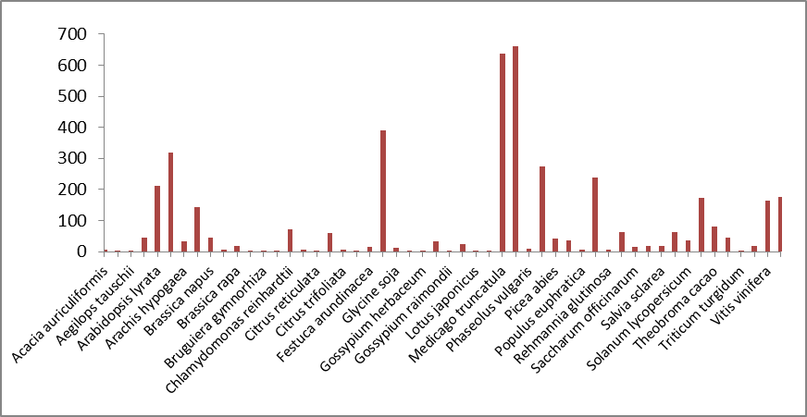
Supplementary Figure 1: Graph showing mature miRNA from various plant species in miRBase

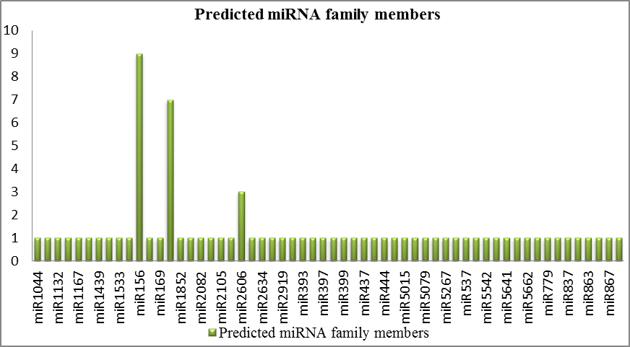
Supplementary Figure 2: Number of members in Predicted miRNA Families of cluster bean

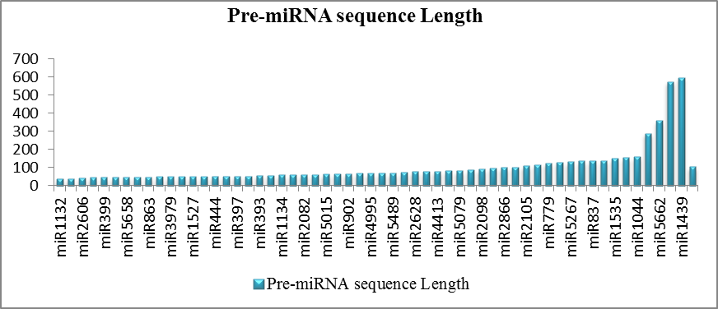
Supplementary Figure 3: Pre-miRNA sequence length of predicted miRNA family members in cluster bean

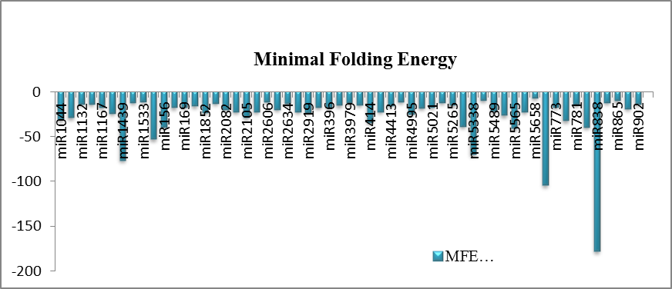
Supplementary Figure 4: Minimal folding free energy range for predicted miRNA families in cluster bean
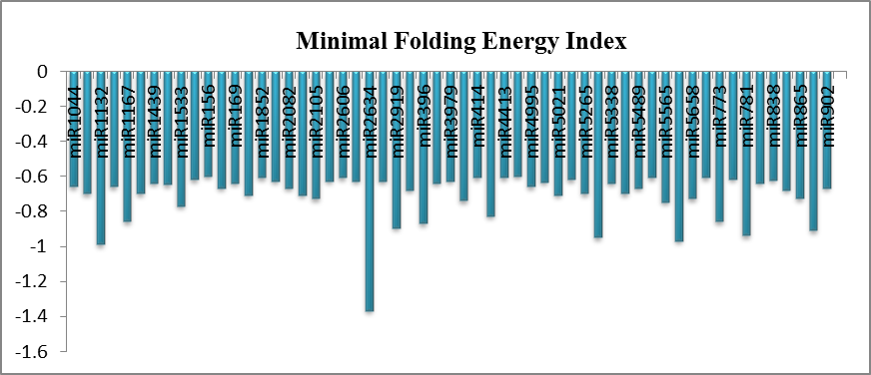

Supplementary Figure 5: Minimal folding free energy index for predicted miRNA families in cluster bean

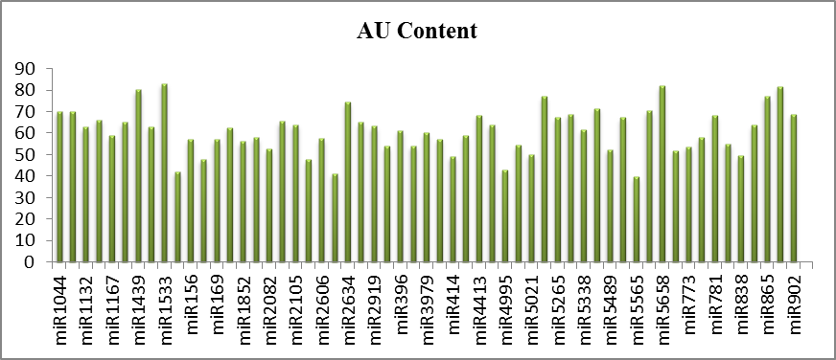
Supplementary Figure 6: AU content of predicted miRNA families in cluster bean

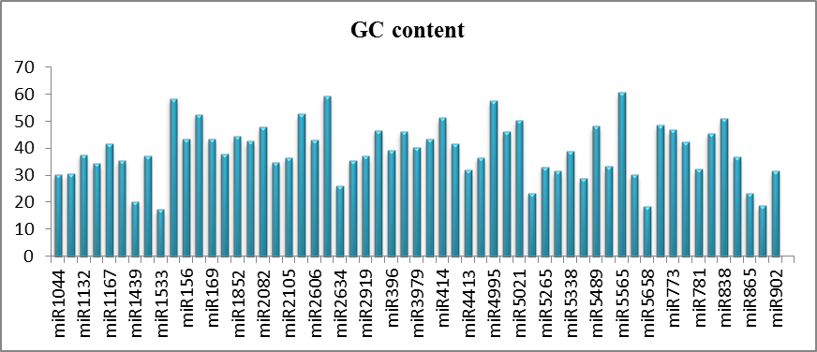
Supplementary Figure 7: GC content of predicted miRNA families in cluster bean

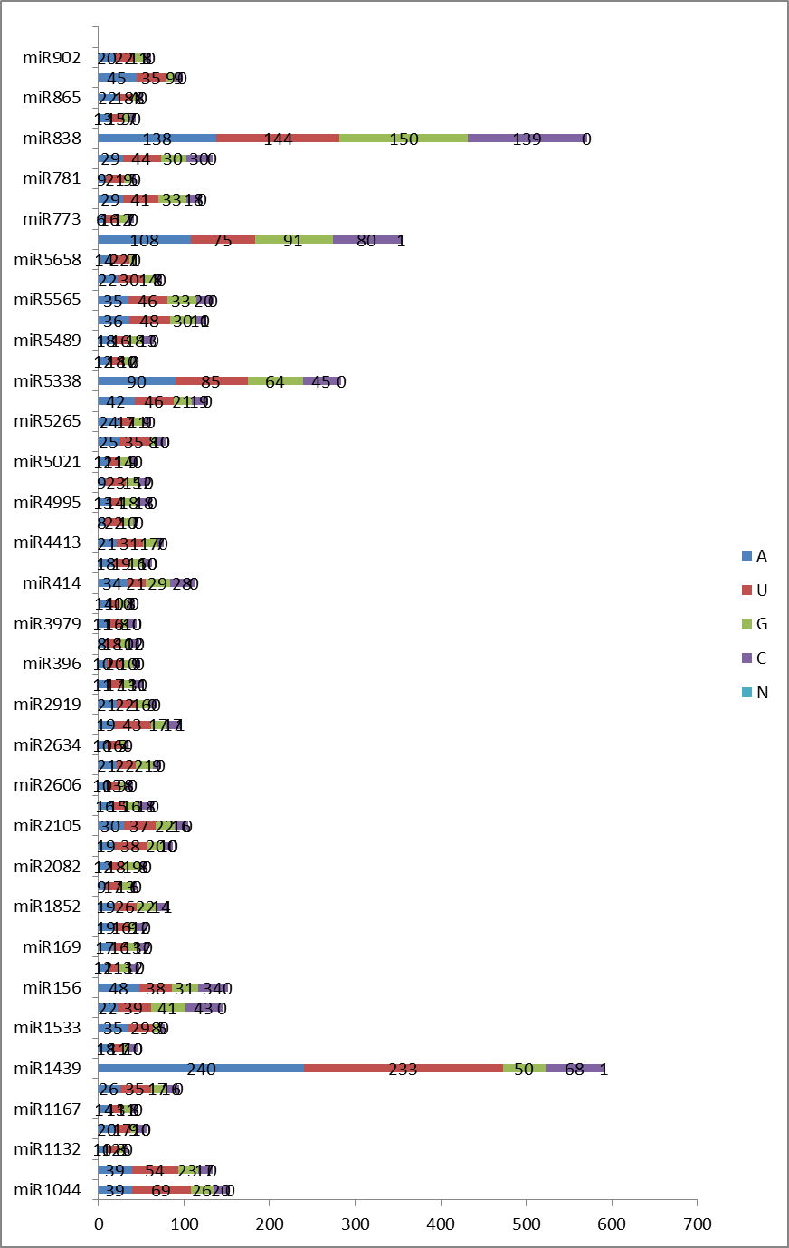Supplementary Figure 8: Nucleotide content for different predicted miRNA families in cluster bean

