Supplementary Information to: Age and origin of Granddad: an iconic Australian lungfish

Benjamin Mayne, Thomas Espinoza, and David Roberts

**Table of Contents**

|  |  |
| --- | --- |
| **Section** | **Page** |
| **Supplementary Methods** | 2 |
| Supplementary Table 1. Multiplex PCR mastermix | 2 |
| Supplementary Table 2. Multiplex PCR cycling conditions | 3 |
| Supplementary Table 3. Barcoding mastermix | 3 |
| Supplementary Table 4. Barcoding PCR cycling conditions | 3 |
| **Supplementary Results** | 4 |
| Supplementary Table 5. Granddad’s DNA methylation | 4 |
| Supplementary Figure 1. River SNP association | 5 |
| Supplementary Figure 2. Random forest modelling | 6 |
| Supplementary Table 6. River SNP coordinates | 7 |
| **References** | 8 |

**Supplementary Methods**

**Supplementary Table 1.**Multiplex PCR mastermix for the Lungfish Clock. The reaction details are for a 50μL reaction. The Combinatorial Enhancer Solution (CES) solution recipe is provided in the second part of the table and originates from a previous study [1].

|  |  |  |  |  |
| --- | --- | --- | --- | --- |
| **Reagent** | **Company** | **Catalogue No.** | **Stock Concentration** | **1x Reaction (μL)** |
| 5X Green GoTaq® Flexi Buffer | Promega | M891A | 5x | 10 |
| GoTaq® Hot Start Polymerase | Promega | M500A | 5U/μL | 0.25 |
| Mg | Promega | A351B | 25mM | 9 |
| Combinatorial Enhancer Solution (CES) | See below | NA | 5x | 5 |
| dNTP | Fisher Biotec | DN-10M-10 | 10mM | 0.5 |
| TMAC | Sigma-Aldrich | T3411-500ML diluted to 1M | 1M | 0.75 |
| Primers | IDT | - | 0.8μM | 12.5 |
| Water | Sigma-Aldrich | W4502-1L | - | 7 |
| DNA | - | - | Final < 2ng/μL | 5 |
| ***Combinatorial Enhancer Solution (CES)*** | | | | |
| **Reagent** | **Company** | **Catalogue No.** | **Stock Units** | **5000μL Stock** |
| Betaine | Sigma-Aldrich | B0300-5VL | 5M | 2700μL |
| DTT | Thermofisher | P2325 | 1M | 33.5μL |
| Dimethyl Sulfoxide (DMSO) | Sigma-Aldrich | D2650-5X5ML | 78.13g/mol | 335μL |
| BSA | New England Biolabs | B9000S | 20mg/mL | 13.75μL |
| Water | Sigma-Aldrich | W4502-1L | - | 1917.75μL |

**Supplementary Table 2.** Multiplex PCR cycling conditions for the Lungfish Clock.

|  |  |  |  |
| --- | --- | --- | --- |
| **Step** | **Temperature (°C)** | **Time (seconds)** | **Cycles** |
| Initial denaturation | 94 | 300 | 1 |
| Denaturation 1 | 94 | 20 | 12 |
| Annealing 1 | 60 | 60 |
| Extension 1 | 72 | 120 |
| Denaturation 2 | 94 | 20 | 16 |
| Annealing 2 | 65 | 60 |
| Extension 2 | 72 | 120 |
| Final extension | 72 | 180 | 1 |
| Hold | 4 | Hold | 1 |

**Supplementary Table 3*.*** Barcoding mastermix. The PCR reaction is carried out in a 30μL reaction.

|  |  |  |  |  |
| --- | --- | --- | --- | --- |
| **Reagent** | **Company** | **Catalogue No.** | **Stock Concentration** | **1x Reaction (μL)** |
| 5X Green GoTaq® Flexi Buffer | Promega | M891A | 5x | 6 |
| GoTaq® Hot Start Polymerase | Promega | M500A | 5U/μL | 0.15 |
| Mg | Promega | A351B | 25mM | 5.4 |
| dNTP | Fisher Biotec | DN-10M-10 | 10mM | 0.3 |
| Water | Sigma-Aldrich | W4502-1L | - | 3.15 |
| Fluidigm Barcode | Fluidigm | 100-4876 | 0.8μM | 5 |
| DNA | - | - | Multiplex PCR Product | 10 |

**Supplementary Table 4.** Barcoding PCR cycling conditions for the marine turtle epigenetic clock.

|  |  |  |  |
| --- | --- | --- | --- |
| **Step** | **Temperature (°C)** | **Time (seconds)** | **Cycles** |
| Initial denaturation | 94 | 300 | 1 |
| Denaturation | 97 | 15 | 12 |
| Annealing | 45 | 30 |
| Extension | 72 | 120 |
| Final extension | 72 | 120 | 1 |
| Hold | 4 | Hold | 1 |

**Supplementary Results**

**Supplementary Table 5.** DNA methylation of CpG sites required to determine the age of Australian lungfish. The methylation values are from a fin clip tissue of Grandad. Genomic locations are analogous to the zebrafish genome (danRer10) which was initially used to develop the Lungfish clock.

|  |  |  |  |  |
| --- | --- | --- | --- | --- |
| **Chromosome** | **Position** | **Coefficient** | **DNA methylation** | **Methylation*Coefficient** |
| Intercept | NA | 2.371135587 | NA | 2.371135587 |
| chr1 | 17053944 | 5.62E-03 | 0.579504447 | 0.003255138 |
| chr1 | 58411664 | -0.009806872 | 0.082486326 | -0.000808933 |
| chr1 | 58529962 | 4.73E-03 | 0.14084507 | 0.000666019 |
| chr4 | 72407427 | -0.000252804 | 0.406058915 | -0.000102653 |
| chr4 | 72407518 | -0.006362557 | 0.14084507 | -0.000896135 |
| chr6 | 57183503 | 0.350160076 | 0.293041145 | 0.10261131 |
| chr7 | 21450653 | -0.009898003 | 0.011684746 | -0.000115656 |
| chr7 | 53689428 | -0.032923816 | 0.684331148 | -0.022530793 |
| chr7 | 69800198 | 6.86E-04 | 0.020123454 | 1.38026E-05 |
| chr7 | 73184405 | 0.181307184 | 0.070197915 | 0.012727386 |
| chr8 | 50244781 | 0.536612254 | 0.599565365 | 0.321734122 |
| chr8 | 50245443 | -9.11E-05 | 0.367716841 | -3.35E-05 |
| chr10 | 11142079 | -0.009645245 | 0.186977932 | -0.001803448 |
| chr10 | 11142129 | 0.309646816 | 0.830198775 | 0.257068407 |
| chr11 | 12533451 | 0.238315509 | 0.118339103 | 0.028202044 |
| chr11 | 16311410 | 0.311810295 | 0.412535426 | 0.128632793 |
| chr11 | 18605931 | 0.238300487 | 0.140996093 | 0.033599438 |
| chr11 | 4718419 | 0.429532312 | 0.426949505 | 0.183388608 |
| chr11 | 4718545 | 0.630979922 | 0.73084507 | 0.461148565 |
| chr11 | 4718873 | 1.81E-05 | 0.328376931 | 5.92783E-06 |
| chr13 | 40742082 | 0.130971722 | 0.156057322 | 0.020439096 |
| chr13 | 40742348 | -0.009898325 | 0.357379016 | -0.003537454 |
| chr14 | 42183036 | -0.013993076 | 0.281690141 | -0.003941712 |
| chr15 | 20939064 | 0.451688769 | 0.633802817 | 0.286281614 |
| chr15 | 20938558 | 0.511590717 | 0.500227075 | 0.255911528 |
| chr16 | 53732412 | -0.009898102 | 0.178896994 | -0.001770741 |
| chr16 | 53732506 | 0.238343018 | 0.424023975 | 0.101063154 |
| chr16 | 8112979 | -0.004591806 | 0.48106342 | -0.00220895 |
| chr17 | 30406809 | 0.356743512 | 0.14084507 | 0.050245565 |
| chr23 | 2856982 | 1.64E-04 | 0.553602061 | 9.09909E-05 |
| chr25 | 5024662 | 0.509516203 | 0.214279462 | 0.109178858 |
|  |  |  | **Raw Summed Methylation Value** | 4.689649989 |
|  |  |  | **Age (Years)** | 108.8150867 |

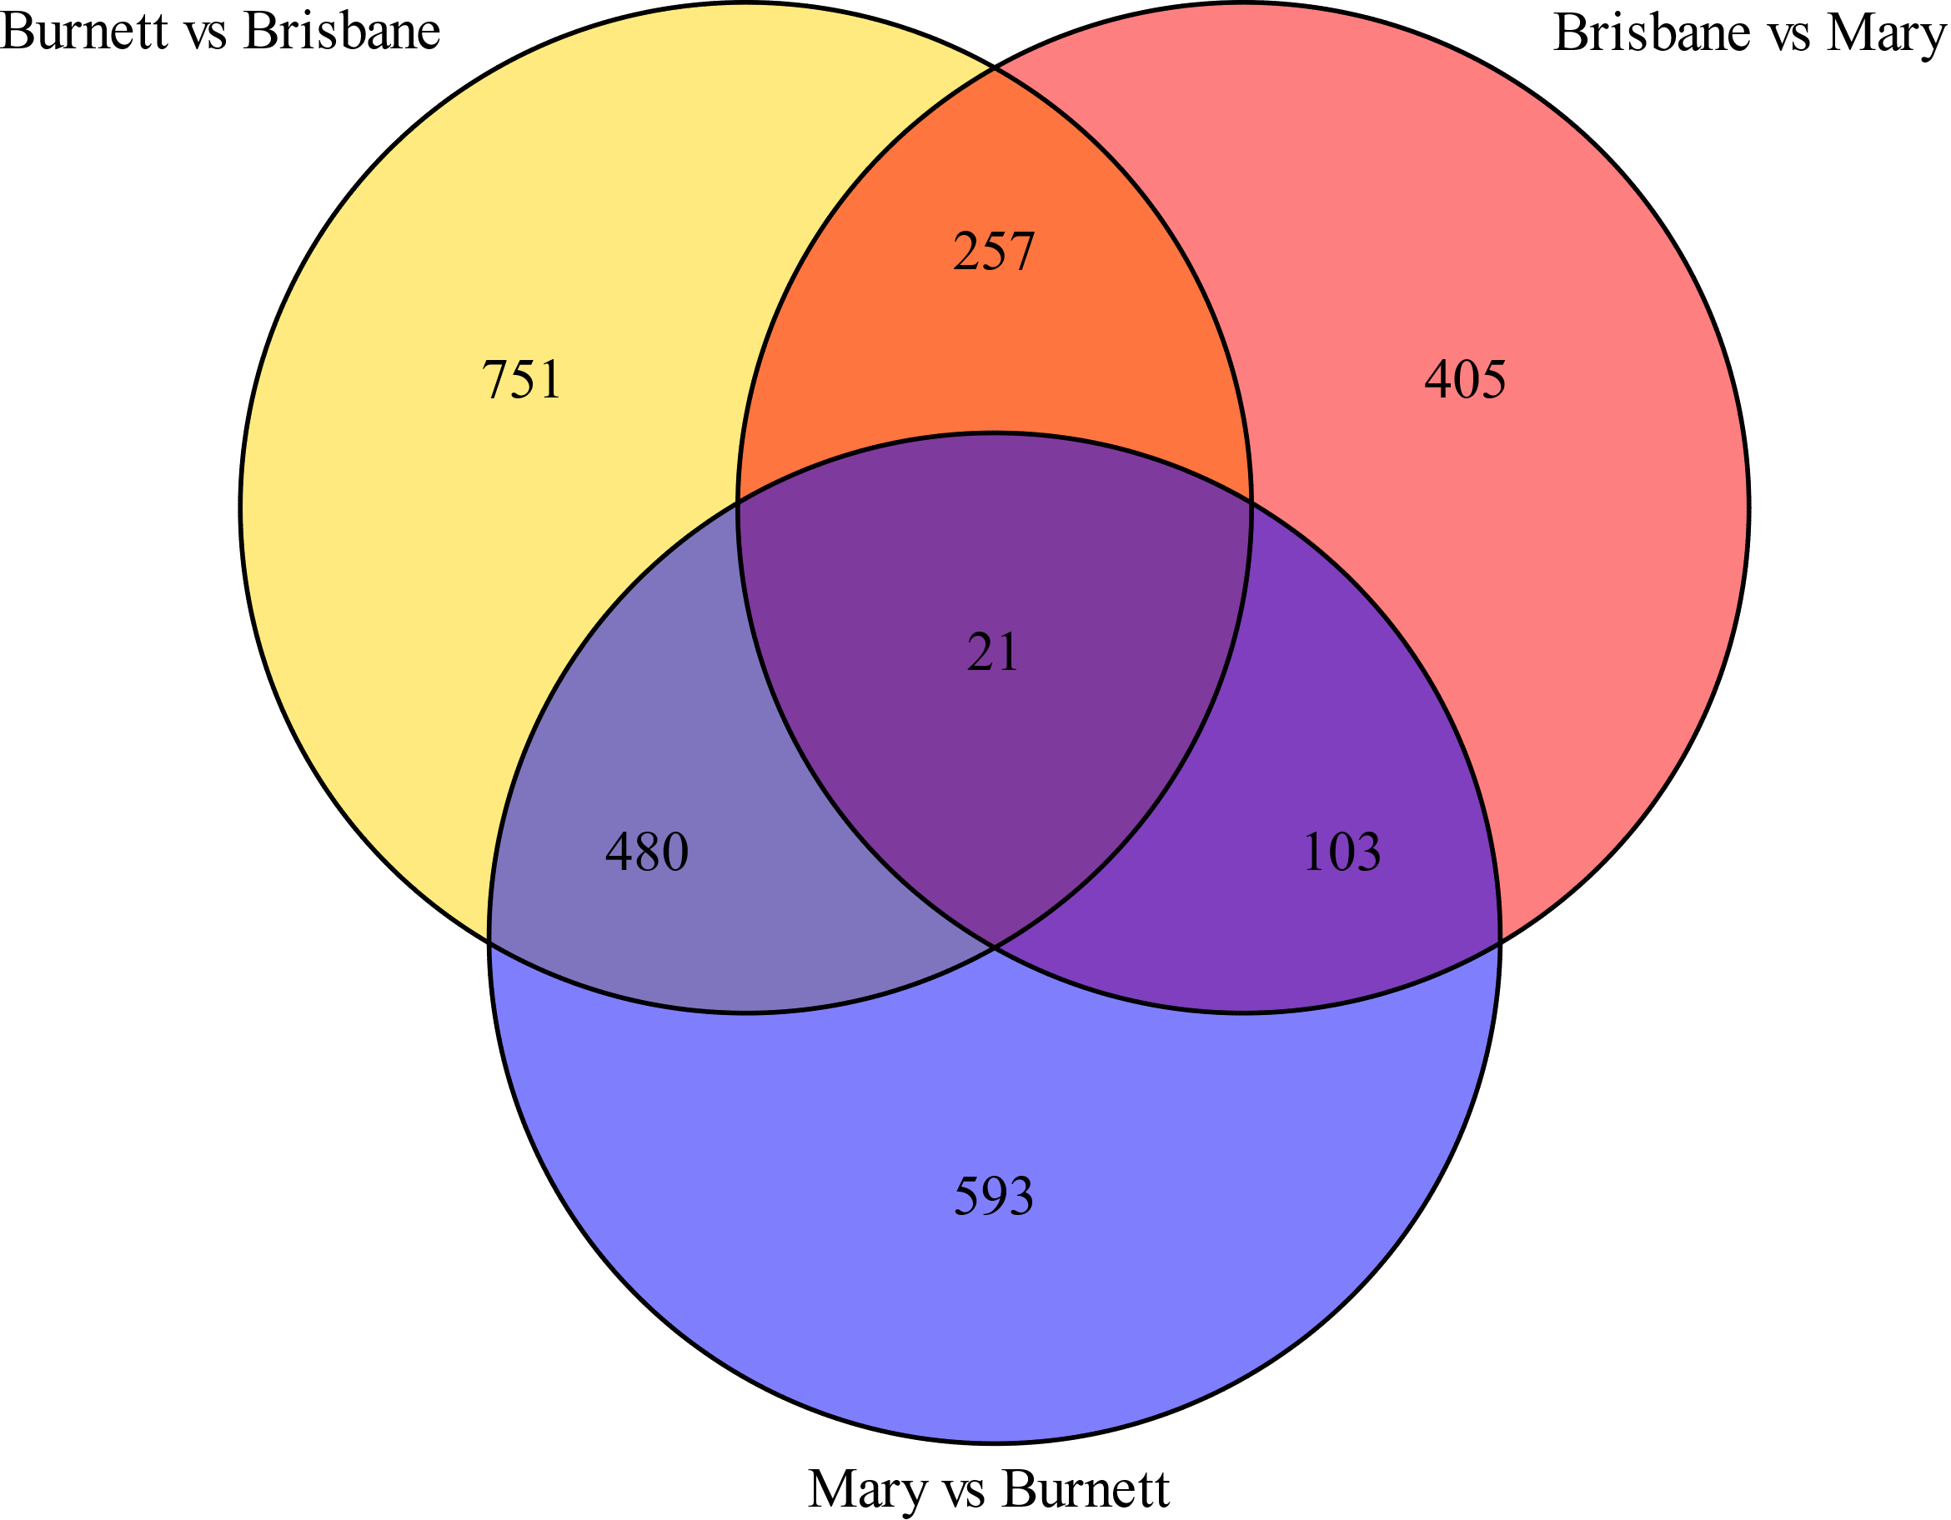

**Supplementary Figure 1.** Association and differentiation of populations by single nucleotide polymorphisms (SNPs). A venn diagram showing the total number of SNPs associated between populations in each comparison. SNPs were considered associated and significant if the adjusted p-value < 0.05.

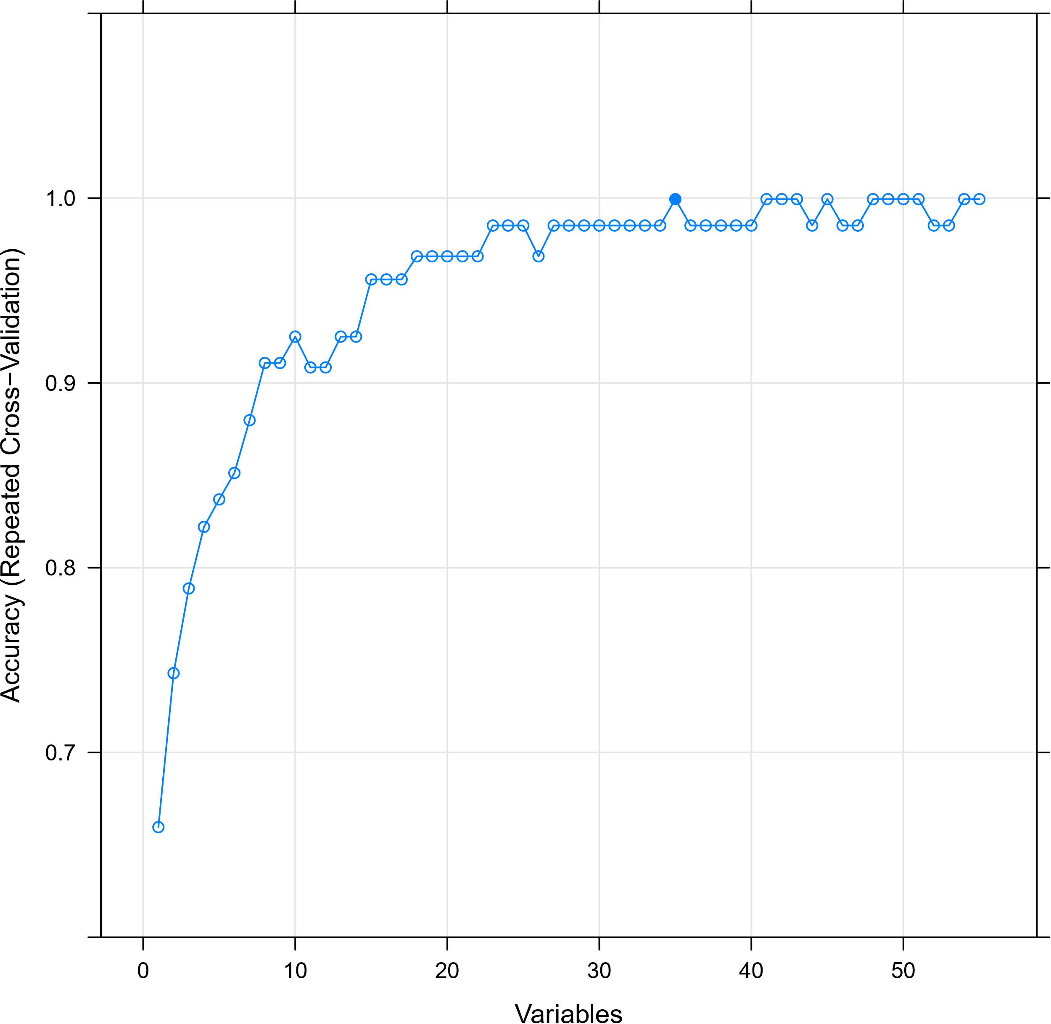

**Supplementary Figure 2.** The accuracy of random forest modelling using 55 SNPs determined by repeated cross validation. A total of 31 SNPs was found to be the minimum number required to accurate predict sample river origin.

**Supplementary Table 6.** Single nucleotide polymorphisms required to predict the river origin of an Australian Lungfish. The coordinates are based on the Australian lungfish reference genome (neoFor_v3).

|  |  |  |  |
| --- | --- | --- | --- |
| **Chromosome** | **Position** | **Allele 1** | **Allele 2** |
| CM028129.1 | 342876387 | T | A |
| CM028132.1 | 37703649 | A | G |
| CM028133.1 | 35820694 | G | T |
| CM028134.1 | 236615718 | C | T |
| CM028134.1 | 349428162 | C | A |
| CM028135.1 | 279036285 | T | C |
| CM028135.1 | 333824606 | C | T |
| CM028136.1 | 601603707 | A | G |
| CM028137.1 | 732234282 | G | A |
| CM028138.1 | 382655230 | C | T |
| JADMNL010000001.1 | 836460112 | C | T |
| JADMNL010000002.1 | 503052344 | C | T |
| JADMNL010000002.1 | 778277220 | T | A |
| JADMNL010000005.1 | 848823039 | G | C |
| JADMNL010000005.1 | 848182798 | C | T |
| JADMNL010000005.1 | 74817460 | T | C |
| JADMNL010000005.1 | 676695080 | A | C |
| JADMNL010000006.1 | 170624399 | G | A |
| JADMNL010000006.1 | 775119743 | A | G |
| JADMNL010000006.1 | 612838386 | T | C |
| JADMNL010000007.1 | 267233483 | T | C |
| JADMNL010000008.1 | 73814279 | A | T |
| JADMNL010000008.1 | 208091041 | A | G |
| JADMNL010000010.1 | 482822909 | T | C |
| JADMNL010000010.1 | 418137764 | C | T |
| JADMNL010000022.1 | 121353545 | G | A |
| JADMNL010000022.1 | 143566706 | G | T |
| JADMNL010000022.1 | 45595794 | C | A |
| JADMNL010000022.1 | 45589672 | T | C |
| JADMNL010000024.1 | 425976767 | C | T |
| JADMNL010000024.1 | 418806048 | G | A |
| JADMNL010000024.1 | 212740981 | C | T |
| JADMNL010000026.1 | 301763637 | T | C |
| JADMNL010000034.1 | 72785034 | T | C |
| JADMNL010000035.1 | 57361080 | G | T |

**References**

1. Ralser, M., Querfurth, R., Warnatz, H.-J., Lehrach, H., Yaspo, M.-L., and Krobitsch, S. (2006). An efficient and economic enhancer mix for PCR. Biochem Biophys Res Commun *347*, 747-751.