**Supporting Document**

**Atmospheric Lamb wave pulse and Volcanic Explosivity Index following the 2022 Hunga Tonga (South Pacific) eruption**

**Prohelika Dalal1, Bhaskar Kundu1*, Jagabandhu Panda1 and Shuanggen Jin2,3**

1Department of Earth and Atmospheric Sciences, National Institute of Technology Rourkela, Odisha 769008, India.

2 School of Surveying and Land Information Engineering, Henan Polytechnic University, Jiaozuo 454000, China.

3 Shanghai Astronomical Observatory, Chinese Academy of Sciences, Shanghai 200030, China.

**\*Corresponding author:** Bhaskar Kundu, Department of Earth and Atmospheric Sciences, National Institute of Technology Rourkela, Odisha 769008, India, (email: [rilbhaskar@gmail.com](mailto:rilbhaskar@gmail.com))

Supplementary document contents

Figure S1 to S3

Table S1 to S6

**Calculation of k1:**

First, the volume of ejected materials of the Hunga Tonga eruption has been calculated from the NOAA eruption column height time series data using the relation proposed by Mastin et al. (2009) as $Hc=2 × v^{0.241}$. Then we consider that value along with other factors (d1 and d2 calculated from Log10P versus Log10S curve (figure 2) as plotted) as considered in the case of Mt. St. Helens and Krakatau to evaluate the k1 value from . Now we have averaged the k1 value for three eruptions (Mt. St. Helens, Krakatau and Hunga Tonga) and reconstructed the equation of Danard and Murty (1988) as ${Log}_{10}{P=4.42+ {Log}_{10}{V}-0.84 {Log}_{10}{S}}$ (see Table S4). Previously k1 was 4.44 according to Danard and Murty (2008), and after including the k1 values of the Hunga Tonga eruption, it becomes 4.42.

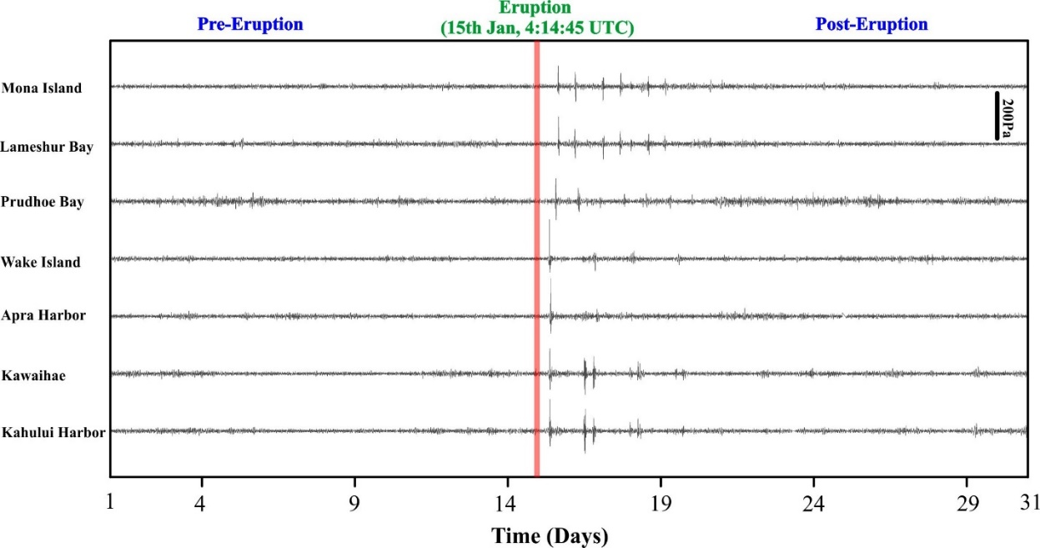

**FIGURE S1** Barograms of representative Seven weather stations from 1st January to 31st January 2022. The red strip represents the time of the Tonga volcanic eruption. Note that before the eruption there is no change in barometric pressure. However, the signatures are observed only after the eruption.

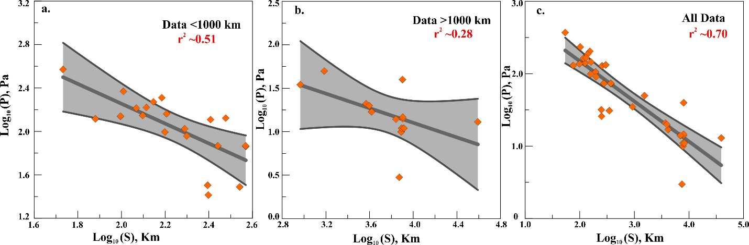

**FIGURE S2** The logarithmic value of pressure change on the arrival of Lamb wave versus the logarithmic value of the distance of the stations from Mt. St. Helens eruption 1980.

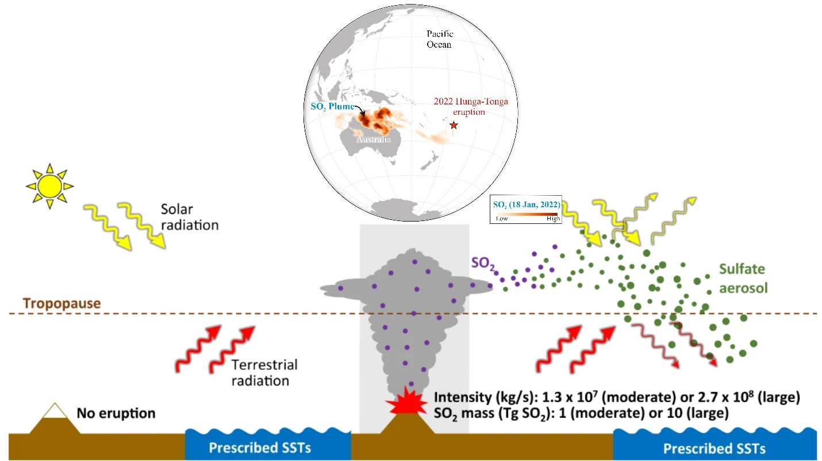

**FIGURE S3** Schematic diagram of emission of SO2 in the stratosphere from a large volcanic eruption (Themens et. al., 2022) The spread of SO2 from Hunga Tonga Volcanic eruption over Australia about 7000 km west of the location on 18th January is shown above(taken from: <https://www.esa.int/ESA_Multimedia/Images/2022/01/Sulphur_dioxide_from_Tonga_eruption_spreads_over_Australia> ).

|  |  |  |  |
| --- | --- | --- | --- |
| **Events** | **Recorder Stations** | **Distance (km)** | **Pressure Amplitude (Pa)** |
| Mount St. Helens (18th May 1990) | Yakima | 125 | 141 |
| Wenatche | 195 | 106 |
| Spokane | 371 | 73 |
| Lewiston | 370 | 74 |
| Walla | 277 | 74 |
| Pendleton | 248 | 32 |
| Dallesport | 99 | 138 |
| Eugene | 250 | 26 |
| Corvallis | 199 | 91 |
| Roseburg | 348 | 31 |
| Salem | 158 | 99 |
| Portland | 76 | 131 |
| Astoria | 117 | 164 |
| Hoquiam | 153 | 205 |
| Toledo | 54 | 373 |
| Quillayute | 256 | 129 |
| Olympia | 102 | 235 |
| Bellingham | 300 | 133 |
| Seattle | 140 | 188 |
| Seattle | 161 | 146 |
| Stampede | 130 | 167 |
| Berkeley | 925 | 35 |
| Honolulu | 4156 | 17 |
| DeBilt | 7982 | 40 |
| Washington | 3700 | 21 |
| Boulder | 1530 | 50 |
| Palisades | 3950 | 20 |
| Hamburg | 8000 | 14.2 |
| Buchholz | 8010 | 14.7 |
| Kushiro | 6945 | 14 |
| Akita | 7453 | 3 |
| Tokyo | 7778 | 10 |
| Wajima | 7833 | 11 |
| Tonago | 8211 | 11 |
| Krakatoa Eruption (1883) | San Francisco | 14000 | 173 |
| Tungsuka Meteor (1908) | Turukhansk | 900 | 120 |
| Khatanga | 1230 | 146 |
| Kirensk | 490 | 146 |
| Sretensk | 1360 | 213 |
| Tulun | 830 | 326 |
| Olkhon | 920 | 200 |
| Irkutsk | 970 | 220 |
| Peshchanaya | 990 | 133 |
| Tunka | 1020 | 193 |
| Kabansk | 1030 | 160 |
| Kultuk | 1030 | 73 |
| Perevalnaya | 1210 | 6.5 |
| Chita | 1210 | 53.2 |
| Slutsk | 3760 | 30 |
| Leningrad | 3740 | 36 |
| Copenhagen | 4900 | 20 |
| Berlin | 5100 | 30 |
| Potsdam | 5100 | 70.7 |
| Schneekoppe | 5100 | 30 |
| Zagreb | 5500 | 27 |
| Greenwich | 5800 | 20 |
| Kew | 5800 | 19.7 |
| England | 5700 | 24.7 |
| USA 15-Mt Test (1954) | Rongerik Island | 247 | 1493 |
| Majuro Island | 845 | 267 |
| Midway Island | 2580 | 80 |
| Wake Island | 850 | 120 |
| Shionomisaki | 3850 | 35 |
| Kyoto | 3950 | 47 |
| USSR 57-Mt Test (1961) | Kyoto | 6110 | 167.2 |
| Stockholm | 2280 | 176 |
| Washington | 6960 | 64.4 |
| Lamont | 6660 | 50 |
| Tappan | 6660 | 27.5 |
| Akron | 33266 | 30 |
| Louisville | 7190 | 200 |
| Rolla | 6230 | 50 |
| New Orleans | 8180 | 169 |
| Mercury | 7730 | 96 |
| Antarctica | 18230 | 30 |

**TABLE S1** Dataset from Reed (1987) used for the derived equation 8.

|  |  |  |
| --- | --- | --- |
| **Events** | **d1** | **d2** |
| Mount St. Helens (s<400 km) | 4.44 | -0.95 |
| Mount St. Helens (s>900 km) | 3.52 | -0.63 |
| Mount St. Helens (all data) | 4.03 | -0.76 |
| Hunga Tonga Eruption (2022) | 5.3 | -0.84 |
| Tungsuka Meteorite | 4.72 | -0.88 |
| USA 15 Mt | 5.93 | -1.21 |
| USSR 57 Mt | 4.88 | -0.75 |

**TABLE S2** Values of d1 and d2in equation 1 from data in Reed (1987) and data of the recent Hunga Tonga eruption (2022).

|  |  |  |
| --- | --- | --- |
| **Events** | **d1** | **k1** |
| Mount St. Helens (all data) | 4.23 | 4.45 |
| Tungsuka Meteorite | 4.57 | * |
| USA 15 Mt | 4.76 | * |
| USSR 57 Mt | 5.2 | * |
| Krakatau Eruption | 5.7 | 4.44 |
| Hunga Tonga Eruption | 5.3 | 4.37 |

**TABLE S3** Values of d1 evaluated from equation (1) considering d2 = -0.84 and values of k1 calculated from equation (6). (* k1 values of these three events are not considered for the present study)

|  |  |  |  |
| --- | --- | --- | --- |
| **Time (UTC)** | **Δtime (min)** | **Δtime (sec)** | **Eruption Column Height (km)** |
| 4:00:00 | 0 | 0 | 0.0 |
| 4:10:00 | 10 | 600 | 18.5 |
| 4:20:00 | 10 | 600 | 30.0 |
| 4:30:00 | 10 | 600 | 56.5 |
| 4:40:00 | 10 | 600 | 44.5 |
| 4:50:00 | 10 | 600 | 50.0 |
| 5:00:00 | 10 | 600 | 46.5 |
| 5:10:00 | 10 | 600 | 47.0 |
| 5:30:00 | 20 | 1200 | 37.0 |
| 5:40:00 | 10 | 600 | 36.5 |
| 5:50:00 | 10 | 600 | 36.5 |
| 6:10:00 | 30 | 1800 | 33.5 |
| 6:20:00 | 10 | 600 | 34.0 |
| 6:30:00 | 10 | 600 | 33.5 |
| 6:50:00 | 20 | 1200 | 34.0 |
| 7:00:00 | 10 | 600 | 31.0 |
| 7:10:00 | 10 | 600 | 31.0 |
| 7:30:00 | 20 | 1200 | 31.0 |
| 7:40:00 | 10 | 600 | 31.0 |
| 7:50:00 | 10 | 600 | 32.0 |
| 8:00:00 | 10 | 600 | 33.0 |
| 8:20:00 | 20 | 1200 | 30.5 |
| 8:40:00 | 20 | 1200 | 34.0 |
| 9:00:00 | 20 | 1200 | 29.5 |
| 9:20:00 | 20 | 1200 | 29.0 |
| 9:40:00 | 20 | 1200 | 28.0 |
| 10:00:00 | 20 | 1200 | 27.0 |
| 10:20:00 | 20 | 1200 | 28.0 |
| 10:40:00 | 20 | 1200 | 27.5 |
| 11:00:00 | 20 | 1200 | 27.5 |
| 11:20:00 | 20 | 1200 | 27.5 |
| 11:40:00 | 20 | 1200 | 27.5 |
| 12:00:00 | 20 | 1200 | 26.0 |
| 12:10:00 | 10 | 600 | 24.5 |
| 12:20:00 | 10 | 600 | 27.0 |
| 12:40:00 | 20 | 1200 | 26.0 |
| 12:50:00 | 10 | 600 | 24.5 |
| 13:00:00 | 10 | 600 | 24.0 |
| 13:20:00 | 20 | 1200 | 26.0 |
| 13:30:00 | 10 | 600 | 26.5 |
| 13:40:00 | 10 | 600 | 25.5 |
| 14:10:00 | 20 | 1200 | 23.0 |
| 15:00:00 | 50 | 3000 | 24.0 |

**TABLE S4** Ash Column height for the main phase of Hunga Tonga eruption

|  |  |  |  |
| --- | --- | --- | --- |
| **Volcano** | **Plume Height(km)** | **Erupted Volume (km3)** | **Mass Eruption Rate (kg/s)** |
| St. Helelns (2005) | 9 | 1.00E-04 | 4.00E+05 |
| St. Helelns (1980) | 10.3 | 0.001 | 1.40E+06 |
| St. Helelns (1980) | 10.2 | 0.016 | 2.00E+07 |
| St. Helelns (2005) | 9.6 | 0.017 | 2.00E+07 |
| Pinatubo (1991) | 17.5 | 0.0056 | 6.00E+06 |
| Ruapehu (1996) | 5.7 | 0.002 | 2.00E+05 |
| Redoubt (1989) | 9 | 0.008 | 4 - 7E+06 |
| Nevado del Ruiz (1985) | 26 | 0.014 | 3.00E+07 |
| Spurr(1992) | 11.3 | 0.012 | 2.00E+06 |
| Spurr(1992) | 10.5 | 0.014 | 3.00E+06 |
| Spurr(1992) | 10.7 | 0.015 | 3.00E+06 |
| Hekla (1970) | 12 - 16 | 0.017 | 6.00E+06 |
| Hekla (1980) | 15 | 0.019 | 2.00E+06 |
| Reventador (2002) | 17 | 0.12 | 1.00E+07 |
| Hekla (1947) | 28 | 0.034 | 4.60E+07 |
| Hekla (1947) | 8 -25 | 0.013 | 1.60E+07 |
| Soufrière (1902) | 14 | 0.14 | 3 - 4E+07 |
| El Chichón(1982) | 20 | 0.3 | 3.50E+07 |
| El Chichón(1982) | 24 | 0.39 | 6.00E+07 |
| El Chichón(1982) | 22 | 0.4 | 4.00E+07 |
| Hudson (1991) | 12 -18 | 3 | 7.00E+07 |
| St. Helelns (1980) | 13.5 | 0.2 | 2.00E+07 |
| Quizapu (1932) | 27 -30 | 4 | 1.50E+08 |
| Novarupta (1912) | 23.5 | 2.94 | 1.20E+08 |
| Novarupta (1912) | 22.5 | 1.96 | 5.20E+07 |
| Novarupta (1912) | 19 | 1.63 | 1.10E+08 |
| Pinatubo (1991) | 35 -40 | 0.8 - 1.6 | 2 - 4E+08 |
| Santa Maria (1902) | 34 | 3.3 | 5 - 7E+07 |
| Etna (2001) | 0.5- 2.5 | 9.00E-04 | 6.00E+03 |
| Cerro Negro (1995) | 2- 2.5 | 1.30E-03 | 9.40E+03 |
| Cerro Negro (1992) | 2.8 -6.8 | 0.0094 | 3.00E+05 |
| Izu - Oshima (1986) | 10 | 0.0045 | 8.00E+05 |
| Fuego (1971) | 10 | 0.03 | 1.70E+06 |
| Miyakejima (2000) | 15.5 | 0.0042 | 1.20E+06 |
| Fuego (1974) | 10 | 0.02 | 3.00E+06 |

**TABLE S5** The list of volcanic eruptions used to determine the relation of volumetric flow rate during the eruption and Ash column height (Mastin et al., 2009).

**References:**

Reed, J. W. (1987). Air Pressure Waves from Mount St. Helens Eruptions. *J. Geophys. Res.* Vol. 92(D10), 11,979-11,992.

Sahagian, D., Tintle, L. and Wygel, C. (2019). Measurement of The Volcanic Explosivity Index (VEI) in Real Time. Lehigh University. *ESSOAr*. <https://doi.org/10.1002/essoar.10500764.1>

Themens, D. R., Watson, C., Žagar, N., Vasylkevych, S., Elvidge, S., Mccaffrey, A., Prikryl, P., Reid, B., Wood, A. and Jayachandran, P. T. (2022). Global propagation of ionospheric disturbances associated with the 2022 Tonga Volcanic Eruption. *ESSOAr*. <https://doi.org/10.1002/essoar.10510350.1>

Mastin, L. G., Guffanti, M., Servranckx, R., Webley, P., Barsotti, S., Dean, K., ... & Waythomas, C. F. (2009). A multidisciplinary effort to assign realistic source parameters to models of volcanic ash-cloud transport and dispersion during eruptions. *J. Volcanol. Geotherm. Res.*, *186*(1-2), 10-21.