Supplementary Material

# Supplementary Figures

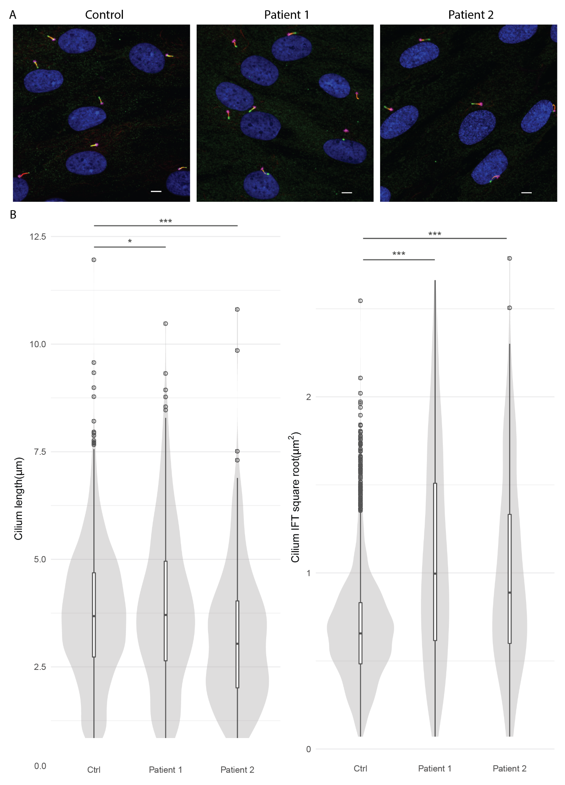

**Supplementary Figure 1.** Cilium phenotype measurements for patients 1 and 2 carrying identical compound heterozygous variants in *IFT140*. (**A**) Representative images of ciliogenesis measured for control (91 ± 1%), patient 1 (90 ± 3%) and patient 2 (93 ± 3%). Cilia were visualized with acetylated-α-tubulin (axoneme, red), pericentrin (basal body, pink), IFT88 (green), and DAPI (nucleus, blue). The scalebar indicates 5µm. (**B**) The cilium length was a combined measurement of acetylated-α-tubulin and ARL13B. The control (Ctrl) value 3.71 ± 0.04 µm is based on the combined measurement of 6 controls (Doornbos et al., 2021). The asterisks represent the statistical significance of the patient measurement compared to the control value using the two-sided Welch’s t-test, i.e. patient 1 p-value 0.049 and patient 2 p-value 2.36 x 10-8. (**C**) The combined control value for the IFT88 measurement is 0.43 ± 0.01 µm2 (Doornbos et al., 2021). Both patients showed a significantly increased IFT88 measurement indicating a defect in retrograde transport, i.e. 0.99 µm2 for patient 1 and 0.79 µm2 for patient 2. The asterisks represent the statistical significance of the patient measurement compared to the control value using the two-sided Welch’s t-test, i.e. patient 1 p-value 6.73 x 10-39 and patient 2 p-value 8.56 x 10-16.

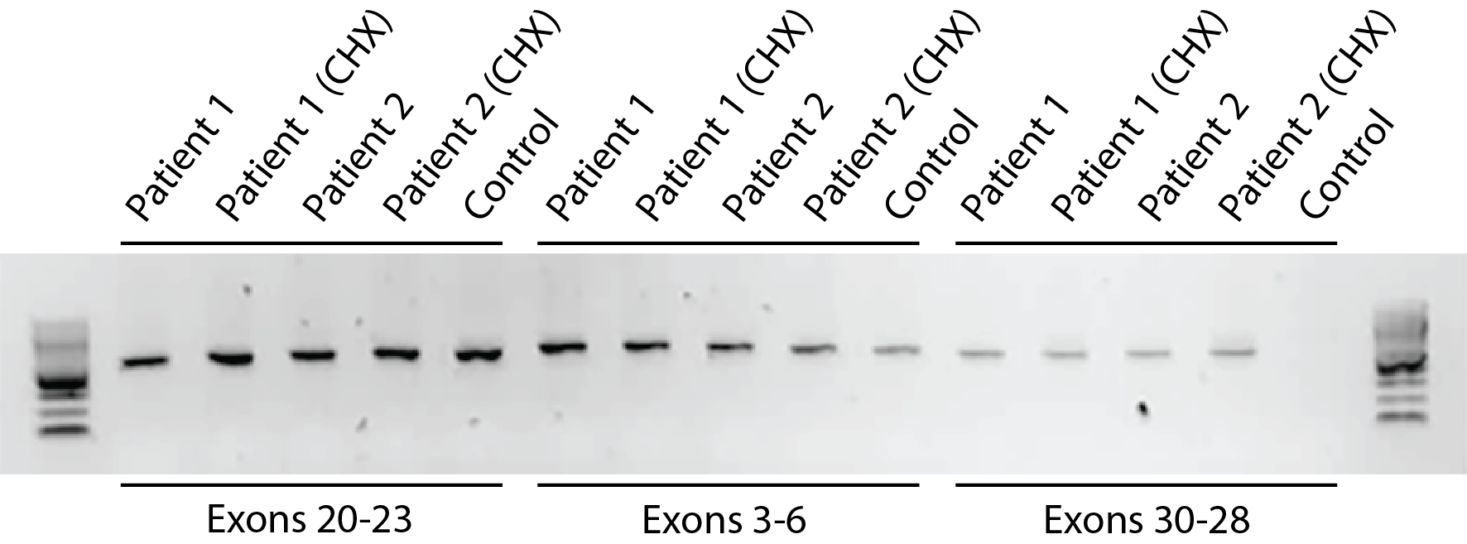

**Supplementary Figure 2.** Gel image of *IFT140* cDNA from control and patient-derived fibroblasts. Three primer sets were used to visualize the effect of variants NM_014714.4: r.2765_2768del; p.(Tyr923Leufs*28) and exon 27-30 duplication; p.(Tyr1152_Thr1349dup) on transcript level. Primers in exon 3 and 6 were used to validate the presence of *IFT140* cDNA. The fragment from exon 20 to 23 covered the 4bp deletion (r.2765_2768del), however, no aberrant transcript is seen due to the minimal size of the deletion. The third fragment with the forward primer in exon 30 and the reverse primer in exon 28 visualized the exon 27-30 duplication variant. Both patients showed a band representing the aberrant transcript and this was absent in the control.

# Supplementary Tables

Supplementary table 1: Exome sequencing SNVs of patient 1

Supplementary table 2: Exome sequencing SNVs of patient 2

Supplementary table 3: Exome sequencing CNVs of patients 1 and 2

**Supplementary table 1**. Exome sequencing SNVs of patient 1. ClinVar interpretation is indicated in C1 = benign, C2 = Likely benign, C3 = Variant of uncertain significance, C4 = Likely pathogenic. The variants marked in grey are shared between patients 1 and 2. NA = not available, Het = heterozygous.

|  |  |  |  |  |  |  |  |  |  |
| --- | --- | --- | --- | --- | --- | --- | --- | --- | --- |
| **Patient 1 (MZSDS)** | |  |  |  |  |  |  |  |  |
| **Gene  name** | **HGVS_Genomic_GRch37** | **HGVS_Transcript** | **HGVS_Predicted_Protein** | **Zygosity** | **gnomAD-G  AF** | **phyloP** | **CADD** | **ClinVar Accession** | **ClinVar Interpretation** |
| *CFAP53* | NC_000018.9:g.47788544T>G | NM_145020.4:c.115A>C | NP_659457.2:p.(Arg39=) | Het | 5.83E-01 | 1.556 | 5.2 | VCV000262550.3 | C1 / C2 |
| *DNAAF1* | NC_000016.9:g.84178972T>C | NM_178452.4:c.-74T>C | NP_848547.4:p.? | Het | 2.23E-02 | -2.610 | 9.6 | NA |  |
| *DNAH1* | NC_000003.11:g.52395717G>A | NM_015512.4:c.4915G>A | NP_056327.4:p.(Asp1639Asn) | Het | -1 | 6.337 | 23.9 | NA |  |
| *GLIS2* | NC_000016.9:g.4387426G>A | NM_032575.2:c.1476G>A | NP_115964.2:p.(Thr492=) | Het | 7.85E-01 | -2.050 | 6.9 | VCV000319225.4 | C1 / C2 |
| *IFT140* | NC_000016.9:g.1575886_1575889del | NM_014714.4:r.2765_2768del | NP_055529.2:p.(Tyr923Leufs*28) | Het | -1 | 7.751 | 34.0 | VCV000863072.2 | C4 |
| *IFT172* | NC_000002.11:g.27670507G>A | NM_015662.2:c.4540-6C>T | NP_056477.1:p.? | Het | 2.58E-01 | 0.031 | 5.6 | VCV000379446 | C1 / C2 |
| *INVS* | NC_000009.11:g.103064336dup | NM_014425.4:c.*1380dup | NP_055240.2:p.? | Het | 5.19E-01 | 0.586 | 6.3 | NA |  |
| *KATNIP* | NC_000016.9:g.27772821C>T | NM_015202.3:c.3719C>T | NP_056017.3:p.(Ala1240Val) | Het | 9.37E-01 | 4.827 | 22.8 | VCV000783064.2 | C1 |
| *KIF14* | NC_000001.10:g.200586908T>C | NM_014875.2:c.944A>G | NP_055690.1:p.(Gln315Arg) | Het | -1 | 0.226 | 7.6 | NA |  |
| *KIF7* | NC_000015.9:g.90177008T>C | NM_198525.2:c.2501A>G | NP_940927.2:p.(Gln834Arg) | Het | 4.01E-01 | 7.931 | 26.6 | VCV000252807.6 | C1 / C2 / C3 |
| *NCAPG2* | NC_000007.13:g.158449369G>A | NM_017760.6:c.2089C>T | NP_060230.5:p.(Arg697Trp) | Het | 5.89E-01 | 2.869 | 25.0 | NA |  |
| *NEK1* | NC_000004.11:g.170322975C>T | NM_012224.2:c.3327G>A | NP_036356.1:p.(Leu1109=) | Het | 1.69E-01 | 0.164 | 2.0 | VCV000283367.5 | C2 / C3 |
| *PKD1* | NC_000016.9:g.2152189G>A | NM_000296.3:c.9270C>T | NP_000287.3:p.(Val3090=) | Het | 7.76E-01 | 0.559 | 0.4 | VCV000257041.6 | C1 |
| *PKD1* | NC_000016.9:g.2160323G>A | NM_000296.3:c.4845C>T | NP_000287.3:p.(Asn1615=) | Het | 3.22E-01 | -0.183 | 0.7 | VCV000256970.3 | C1 |
| *TCTN3* | NC_000010.10:g.97442435C>T | NM_015631.5:c.1425G>A | NP_056446.4:p.(Arg475=) | Het | 5.73E-02 | 0.417 | 5.6 | VCV000383719.3 | C2 |
| *TRAF3IP1* | NC_000002.11:g.239247095A>G | NM_015650.3:c.1156A>G | NP_056465.2:p.(Ile386Val) | Het | 4.46E-02 | -0.090 | 15.2 | VCV000970438.2 | C3 |

**Supplementary table 2**. Exome sequencing SNVs of patient 2. ClinVar interpretation is indicated in C1 = benign, C2 = Likely benign, C3 = Variant of uncertain significance, C4 = Likely pathogenic. The variants marked in grey are shared between patients 1 and 2. NA = not available, Het = heterozygous.

|  |  |  |  |  |  |  |  |  |  |  |
| --- | --- | --- | --- | --- | --- | --- | --- | --- | --- | --- |
| **Patient 2 (CED)** | |  |  |  |  |  |  |  |  |  |
| **Gene  name** | **HGVS_Genomic_GRch37** | **HGVS_Transcript** | **HGVS_Predicted_Protein** | **Zygosity** | **gnomAD-G  AF** | **phyloP** | **CADD** | **ClinVar Accession** | **ClinVar Interpretation** | **Parental  origin** |
| *CC2D2A* | NC_000004.11:g.15534868A>G | NM_001080522.2:c.1519A>G | NP_001073991.2:p.(Lys507Glu) | Het | 5.92E-01 | 6.434 | 25.0 | VCV000126228.4 | C1 / C2/ C3 | MV |
| *ODAD3* | NC_000019.9:g.11545690G>A | NM_145045.4:c.148C>T | NP_659482.3:p.(Pro50Ser) | Het | 5.13E-01 | -0.152 | 6.6 | VCV000241942.3 | C1 | PV |
| *CENPF* | NC_000001.10:g.214814276A>C | NM_016343.3:c.2595A>C | NP_057427.3:p.(Glu865Asp) | Het | 3.18E-03 | 3.017 | 16.6 | VCV000420407.4 | C2 / C3 | PV |
| *CENPF* | NC_000001.10:g.214818775A>G | NM_016343.3:c.5862A>G | NP_057427.3:p.(Ser1954=) | Het | 1.59E-02 | -0.130 | 1.8 | VCV000725062.2 | C1 | PV |
| *DNAH1* | NC_000003.11:g.52431016G>A | NM_015512.4:c.11743G>A | NP_056327.4:p.(Ala3915Thr) | Het | 3.19E-03 | 1.124 | 0.8 | VCV000576226.3 | C3 | MV |
| *DNAH1* | NC_000003.11:g.52431737C>T | NM_015512.4:c.11802C>T | NP_056327.4:p.(Tyr3934=) | Het | 9.56E-03 | 1.413 | 7.8 | VCV000772896.2 | C2 / C3 | MV |
| *DNAH17* | NC_000017.10:g.76419984G>A | NM_173628.3:c.*3C>T | NP_775899.3:p.? | Het | 6.50E-01 | -0.683 | 3.2 | NA |  | PV MV |
| *DYNC2H1* | NC_000011.9:g.102991668C>A | NM_001377.2:c.1263C>A | NP_001368.2:p.(Phe421Leu) | Het | 3.91E-01 | 1.248 | 17.2 | VCV000302011.6 | C1 / C3 | PV |
| *EXTL3* | NC_000008.10:g.28573473C>T | NM_001440.3:c.-104C>T | NP_001431.1:p.? | Het | 7.23E-01 | -0.013 | 4.2 | NA |  | PV |
| *IFT140* | NC_000016.9:g.1575886_1575889del | NM_014714.4:r.2765_2768del | NP_055529.2:p.(Tyr923Leufs*28) | Het | -1 | 7.751 | 34.0 | VCV000863072.2 | C4 | PV |
| *INTU* | NC_000004.11:g.128608927G>A | NM_015693.3:c.1354G>A | NP_056508.2:p.(Ala452Thr) | Het | 1.05E-01 | -0.072 | 2.2 | VCV000504485.2 | C4 | MV |
| *NPHP3* | NC_000003.11:g.132401676del | NM_153240.4:c.3697-7del | NP_694972.3:p.? | Het | 8.95E-02 | -100.000 | 12.9 | VCV000422589.3 | C1 / C2 | PV |
| *PKD1* | NC_000016.9:g.2152189G>A | NM_000296.3:c.9270C>T | NP_000287.3:p.(Val3090=) | Het | 7.76E-01 | 0.559 | 0.4 | VCV000257041.6 | C1 | PV |
| *PKD1* | NC_000016.9:g.2160323G>A | NM_000296.3:c.4845C>T | NP_000287.3:p.(Asn1615=) | Het | 3.22E-01 | -0.183 | 0.7 | VCV000256970.3 | C1 | PV |
| *PKD1* | NC_000016.9:g.2160904C>T | NM_000296.3:c.4264G>A | NP_000287.3:p.(Ala1422Thr) | Het | 3.51E-01 | -0.061 | 0.1 | VCV000256964.6 | C1 / C2 | MV |
| *PKD1* | NC_000016.9:g.2164211G>A | NM_000296.3:c.2813C>T | NP_000287.3:p.(Thr938Met) | Het | -1 | 0.089 | 0.5 | NA |  | PV MV |
| *POC1A* | NC_000003.11:g.52188376A>G | NM_015426.4:c.13T>C | NP_056241.3:p.(Cys5Arg) | Het | 9.56E-03 | -0.216 | 14.5 | NA |  | MV |
| *TMEM237* | NC_000002.11:g.202498081C>T | NM_152388.3:c.324G>A | NP_689601.2:p.(Ala108=) | Het | 1.15E-01 | 0.347 | 7.2 | VCV000198116.4 | C1 / C2/ C3 | MV |
| *DYNC2I2* | NC_000009.11:g.131418941G>A | NM_052844.3:c.65C>T | NP_443076.2:p.(Ala22Val) | Het | 1.85E-01 | 4.090 | 22.6 | VCV000931223.2 | C1 | MV |

**Supplementary table 3**. Exome sequencing CNVs of patient 1 and 2. ClinVar interpretation is indicated in C1 = benign, C2 = Likely benign, C3 = Variant of uncertain significance, C4 = Likely pathogenic. The variants marked in grey are shared between patients 1 and 2. NA = not available

|  |  |  |  |  |  |  |  |  |  |
| --- | --- | --- | --- | --- | --- | --- | --- | --- | --- |
| **Patient 1 (MZSDS)** | |  |  |  |  |  |  |  |  |
| **Chr** | **StartPosition** | **EndPosition** | **Length (bp)** | **Type** | **Value** | **Exons_hg19** | **Gene overlap** | **HGVS** | **ClinVar Accession** |
| chr3 | 129200285 | 129200624 | 340 | DUPLICATION | 1.52 | IFT122_15 | *IFT122* | NC_000003.12:g.129200285(NM_018262.4):c.(1312-88)_(1476+87)dup | NA |
| chr16 | 1568118 | 1570705 | 2588 | DUPLICATION | 1.53 | IFT140_30,IFT140_29, IFT140_28,IFT140_27 | *IFT140* | NC_000016.9:g.1568118(NM_014714.4):c.(4182+99)_(3558)dup | NA |
|  |  |  |  |  |  |  |  |  |  |
| **Patient 2 (CED)** | |  |  |  |  |  |  |  |  |
| **chr** | **StartPosition** | **EndPosition** | **Length (bp)** | **Type** | **Value** | **Exons_hg19** | **Gene overlap** | **HGVS** | **ClinVar Accession** |
| chr16 | 1568118 | 1570705 | 2588 | DUPLICATION | 1.58 | IFT140_30,IFT140_29, IFT140_28,IFT140_27 | *IFT140* | NC_000016.9:g.1568118(NM_014714.4):c.(4182+99)_(3558)dup | NA |

# Supplemental references

Doornbos, C., van Beek, R., Bongers, E., Lugtenberg, D., Klaren, P.H.M., Vissers, L., et al. (2021). Cell-based assay for ciliopathy patients to improve accurate diagnosis using ALPACA. *Eur J Hum Genet* 29(11)**,** 1677-1689. doi: 10.1038/s41431-021-00907-9.