Supplementary Material
Table S1. List of primers.
Experiment | Primer Name | Sequence (5'-3') | Construct | backbone (Vector)
AtC3H18 CDS | AtC3H18-F | ATGAATTTCACAGAATCAATGA | - | -
 | AtC3H18-R | CTATGTAACCGTTGAAATCTCC
AtC3H18 expression pattern | AtC3H18pro-F1 | GACCATGATTACGCCAAGCTTTCAGTTTGTTCTCGGTTCG | AtC3H18pro-GUS | pBI101Δ35S
 | AtC3H18pro-R1 | ACAGGACGTAACATCTCTAAAAAACTTCTTATCTTAAAAA
 | 35S-eGFP-F | GGGACTCTAGAGGATCCATGGTGAGCAAGGGCGA | CaMV35S-eGFP | pBI101ΔGUS
 | 35S-eGFP-R | GTTGTTGATCCCGGGCTAGGATCCCTTGTACAGCTCG
 | AtC3H18pro-F2 | GACCATGATTACGCCAAGCTTTCAGTTTGTTCTCGGTTCG | AtC3H18pro-eGFP | pBI101-eGFP  ΔCaMV35S
 | AtC3H18pro-R2 | CTTGCTCACCATTCTAGACTCTAAAAAACTTCTTATCTTAAAAA
Localization | AtC3H18-N-F | GCTGTACAAGGGATCCATGAATTTCACAGAATCAATGA | eGFP-AtC3H18 | pFGC-eGFP
 | AtC3H18-N-R | TAATTAACTCTCTAGACTATGTAACCGTTGAAATCTCC
 | AtC3H18-C-F | ATTTACAATTACCATGAATTTCACAGAATCAATG | AtC3H18-eGFP
 | AtC3H18-C-R | GCCCTTGCTCACCATTGTAACCGTTGAAATCTCC
 | RFP-F | TACAATTACCATGGTGTCTAAGGGCGAAG | pFGC-RFP | pFGCΔeGFP
 | RFP-R | CCTAGGATCCATTAAGTTTGTGCCCCAGTT
 | DCP2-F | AAACTTAATGGATCCATGTCGGGCCTCCATCGA | RFP-DCP2 | pFGC-RFP
 | DCP2-R | GACTCACCTAAGCTGAATTACCAGATTCCA
 | PABP8-F | AAACTTAATGGATCCATGGCTCAGATTCAGCATCA | RFP-PABP8
 | PABP8-R | GACTCACCTAAGGTACGATGTTGTCTCCAA
 | CCCH-F | GCTGTACAAGGGATCCGTAAAAATCTGCCATTACTTCA | eGFP-CCCH | pFGC-eGFP
 | CCCH-R | TAATTAACTCTCTAGACTACCCGTGGAAGTACCTACAGT
 | LOTUS-F | GCTGTACAAGGGATCCGAGATCATTGAGTTACTCAAGTTAA | eGFP-LOTUS
 | LOTUS-R | TAATTAACTCTCTAGACTAAACTGAATGTTGCCCATGA
 | RRM-F | GCTGTACAAGGGATCCATTTACTTAACGTTTCCGGC | eGFP-RRM
 | RRM-R | TAATTAACTCTCTAGACTACTTGACTAGAACACGTGCAT
 | N-Ter-F | GCTGTACAAGGGATCCATGAATTTCACAGAATCAATGA | eGFP-N-Ter
 | N-Ter-R | TAATTAACTCTCTAGACTACGGGAACTCGGGTAAACT
AtC3H18 Over-Expression | AtC3H18pro-F3 | GACCATGATTACGCCAAGCTTTCAGTTTGTTCTCGGTTCG | pBI121-AtC3H18pro | pBI121Δ35S  ΔGUS
 | AtC3H18pro-R3 | TTGATCCCGGGGATCCCTCTAAAAAACTTCTTATCTTAAAAA
 | AtC3H18pro-CDS-F | AGAAGTTTTTTAGAGATGAATTTCACAGAATCAATGA | pBI121-AtC3H18pro-CDS | pBI121-AtC3H18pro
 | AtC3H18pro-CDS-R | TGATCCCGGGGATCCCTATGTAACCGTTGAAATCTCC
 | eGFP-F | AACGGTTACAATGGTGAGCAAGGGCG | pBI121-AtC3H18pro-CDS-GFP | pBI121-AtC3H18pro-CDS
 | eGFP-R | TGATCCCGGGGATCCCTAGGATCCCTTGTACAGCTC
qRT-PCR | qTUB4-F | AAGGCTTTCCTTCATTGGTACA | - | -
 | qTUB4-R | CTCTCCGGCTGTAGCATCTT
 | qAtC3H18-F | ATTACTCCTACCTCGGCTTCT | - | -
 | qAtC3H18-R | AACCGTTCTGCTTGTTCCT
Knockout of AtC3H18 using CRISPR-Cas9 | sgRNAa-F | GATTGAACGAAAGAGAAGAAGAAGA | AtU6-26-sgRNAa-SK | AtU6-26SK
 | sgRNAa-R | AAACTCTTCTTCTTCTCTTTCGTTC
 | sgRNAb-F | GATTGTGACGGATAATTTTTCACCA | AtU6-26-sgRNAb-SK
 | sgRNAb-R | AAACTGGTGAAAAATTATCCGTCAC
 | sgRNAc-F | GATTGACAACTGTAGGTACTTCCAC | AtU6-26-sgRNAc-SK
 | sgRNAc-R | AAACGTGGAAGTACCTACAGTTGTC
 | U6-b-F | GCCGCTCGAGCGTTGAACAACGGAAACTCGACT | AtU6-26-sgRNAa- AtU6-26-sgRNAb- SK | AtU6-26-sgRNAa-SK
 | U6-b-R | TATCGATACCCGGGCTCGAGCGGCCGCCAGT
 | U6-c-F | GCTCGAGCCCCGTTGAACAACGGAAACTCGACT | AtU6-26-sgRNAa- AtU6-26-sgRNAb-  AtU6-26-sgRNAc- SK | AtU6-26-sgRNAa- AtU6-26-sgRNAb- SK
 | U6-c-R | TGGATCCCCCGGGCTCGAGCGGCCGCCAGT
Gene Editing Test | atc3h18-ko-F | TTGAAATCTGAACCGTCC | - | -
 | atc3h18-ko-R | TTGAAGAGTCCTACCGTATTTT

Note：The underlined nucleotides indicate the homology arm sequences, and bold nucleotides represent cleavage sites.

Supplemental Figure S1. Phylogenetic and sequence analysis of AtC3H18. A, Protein structures of AtC3H18 and other 10 CCCH zinc finger proteins containing RRM domains. Phylogenetic relationships, protein structures (B) and multiple sequence alignment (C) of AtC3H18 and its putative paralogous in Arabidopsis.
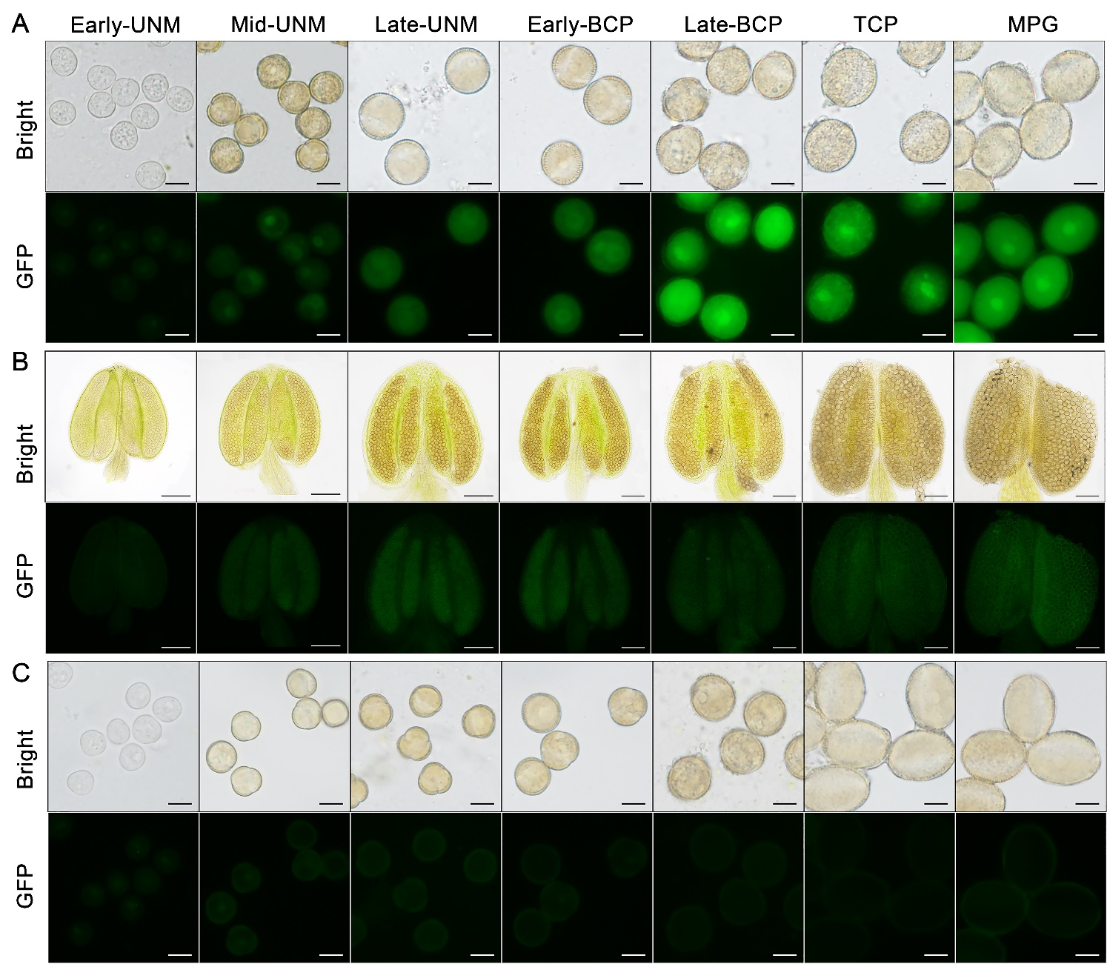
Supplemental Figure S2. AtC3H18 shows the highest expression in late bicellular pollen and tricellular pollen. A, GFP fluorescence intensity of Pro_{AtC3H18}:GFP transgenic pollen at different developmental stages. The weak spontaneous fluorescence of wild-type anthers (B) and pollen (C). Early/Mid/Late-UNM, early/mid/late uninucleate microspore; Early/Late BCP, early/late bicellular pollen; TCP, tricellular pollen; MPG, mature pollen grain. Bars = 10 μm in (A, C), 100 μm in (B).

Supplemental Figure S3. Generation of the atc3h18 mutants using CRISPR/Cas9 technology. A, Genomic location of three guide sequences targeting AtC3H18. B, Schematic diagram of the CRISPR/Cas9 construct containing a Cas9 expression cassette driven by the promoter of AtUBQ and three sgRNA (sgRNAa, sgRNAb and sgRNAc) controlled by the AtU6-26 promoter. C, Large fragment deletions were detected in AtC3H18 genomic DNA of homozygous mutants. A 1-bp insertion, a 719-bp deletion and a 9-bp insertion were detected in AtC3H18 genomic DNA of atc3h18-21. A 1-bp substitution, a 1426-bp deletion and a 1-bp insertion were detected in AtC3H18 genomic DNA of atc3h18-30. A 1-bp substitution and a 1397-bp deletion were detected in AtC3H18 genomic DNA of atc3h18-40.

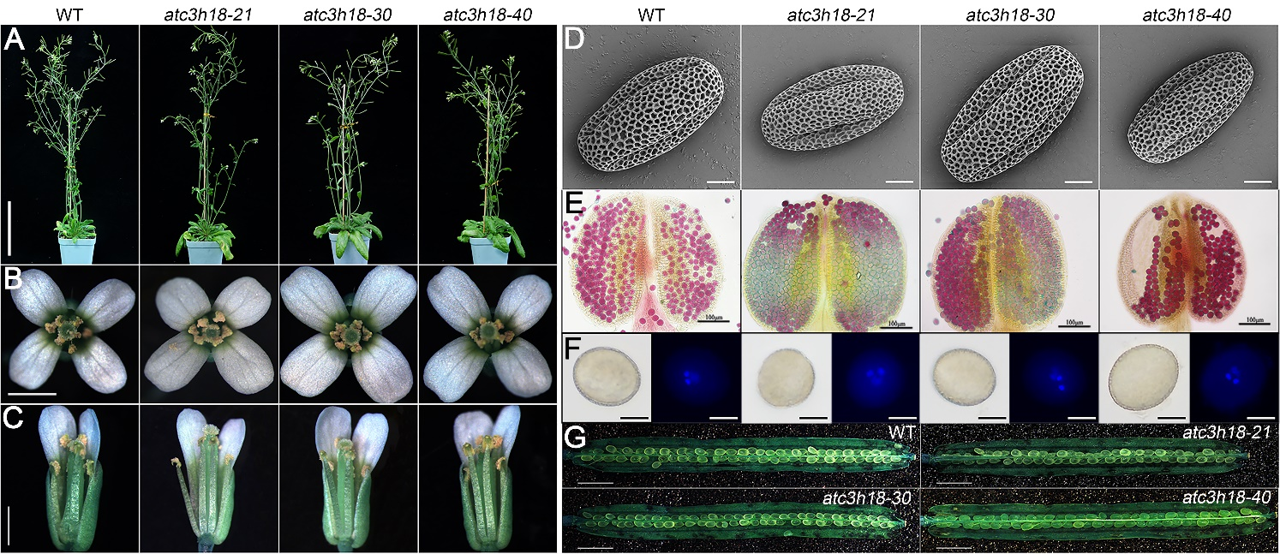
Supplemental Figure S4. The atc3h18 mutants showed no abnormalities during reproductive growth. The plants (A), top (B) and side (C) views of the flowers from wild-type and atc3h18 mutants. Scanning electron micrographs (D), Alexander (E) and DAPI (F) staining test of mature pollen from wild-type and mutants. Siliques (G) from wild-type and mutants. Bars = 10 cm in (A), 1 mm in (B) and (C), 5 μm in (D), 100 μm in (E), 10 μm in (F) and 2 mm in (G).

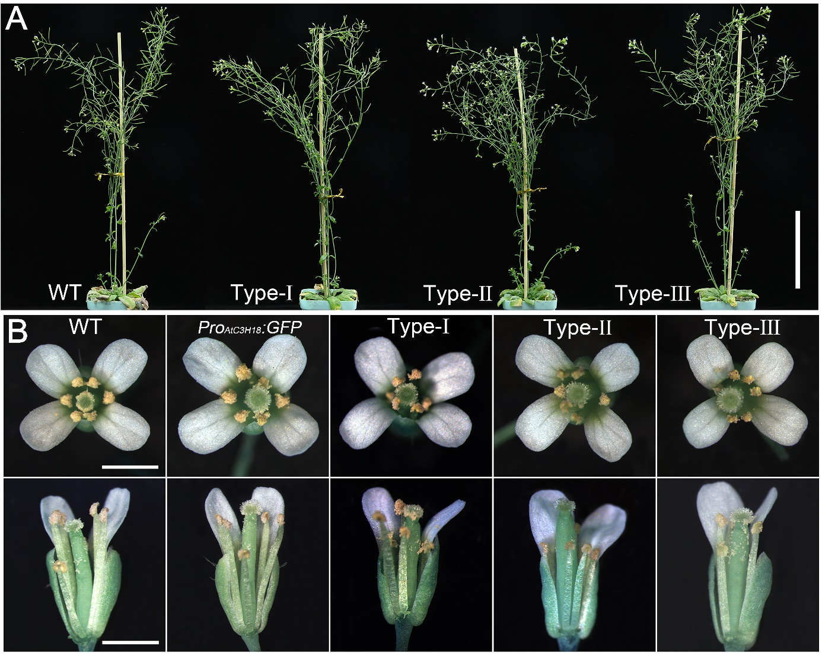
Supplemental Figure S5. AtC3H18 overexpression transgenic plants showed normal morphology. A, Representative plant images of wild-type, Type-Ⅰ, Type-Ⅱ, and Type-Ⅲ Pro_{AtC3H18}:AtC3H18-GFP transgenic plants. Bar = 10 cm. B, Flower top views and side views. Bars = 1 mm.

Supplemental Figure S6. Heat stress induces re-localization of At3H18 into the cytoplasmic foci. The localization images of free-GFP (A and C) and GFP-AtC3H18 fusion protein (B and D) in N. benthamiana leaf epidermal cells at room temperature (RT, A and B) and after heat treatment (C and D), respectively. Pictures represent white field images (Bright), epifluorescence (GFP and RFP) and merged images (Merge). All Images were merged from multiple cutting planes. Bars =25 μm.

Supplemental Figure S7. GFP-AtC3H18 and AtC3H18-GFP fusion proteins can co-localize with PB and SG marker proteins after heat stress. A, Constructs used for the co-localization analyses. Co-localization images of free-GFP and GFP-AtC3H18 fusion protein with RFP-DCP2 (B, C, F and G) or RFP-PABP8 (D, E, H and I) in N. benthamiana leaf epidermal cells at room temperature (RT, B—E) and after heat stress (F—I), respectively. (J—M) Co-localization images of AtC3H18-GFP fusion protein with RFP-DCP2 or RFP-PABP8 in N. benthamiana leaf epidermal cells at RT and after heat stress. Pictures represent white field images (Bright), epifluorescence (GFP and RFP) and merged images (Merge). The areas depicted by the white frames in (B—E and F—I) are shown in Fig. 7. All Images were merged from multiple cutting planes. Bars =25 μm.

Supplemental Figure S8. Cytoplasmic foci cannot be triggered by heat treatment in young roots of CaMV35S:GFP transgenic seedlings. The localization of free-GFP in N. benthamiana leaf epidermal cells at room temperature (RT, A) and after heat stress (B). Pictures represent white field images (Bright) and epifluorescence images (GFP). All Images were merged from multiple cutting planes. Bars = 25 μm.

