Supplementary Material

Supplementary Figures

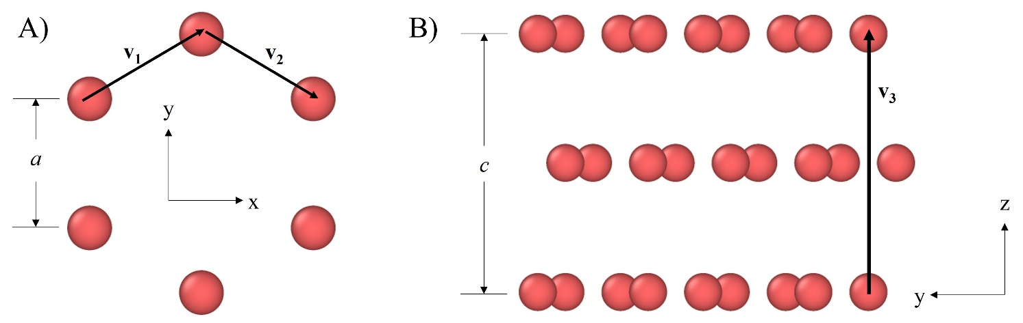
Supplementary Figure 1: A) The lattice vectors v₁ = (a√3/2, -a/2, 0) and v₂ = (a√3/2, -a/2, 0), shown on a single carbon hexagon. B) The vector v₃ = (0, 0, c) shown on multiple graphite layers.
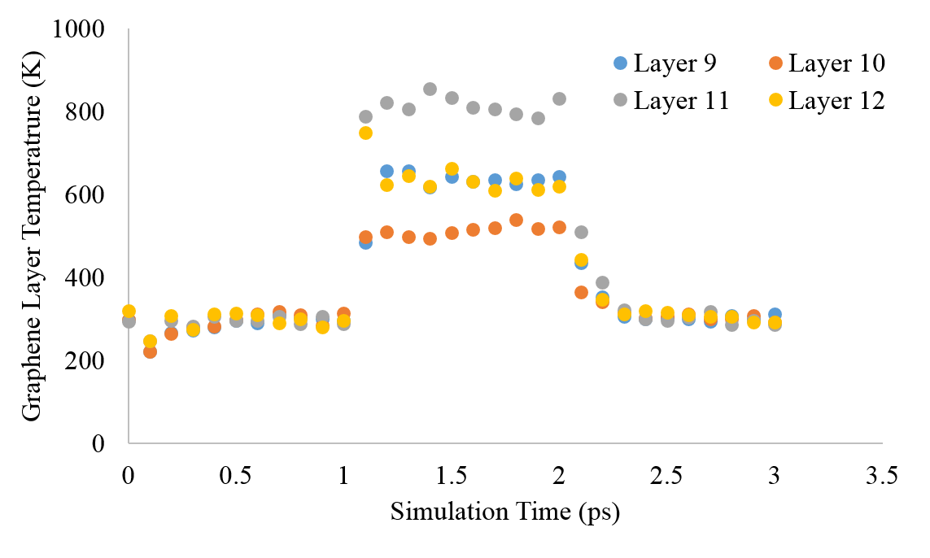
Supplementary Figure 2: The temperature of the top four graphene layers that are under alternating thermostat during the first impact at 250eV at 1 ps of simulation time, showing the increase in temperature, stabilization, then subsequent cool-down after the re-application of the thermostat. The plateaus at each stage indicate that the insertion and thermostat times allow for the collision cascade dynamics to be captured.
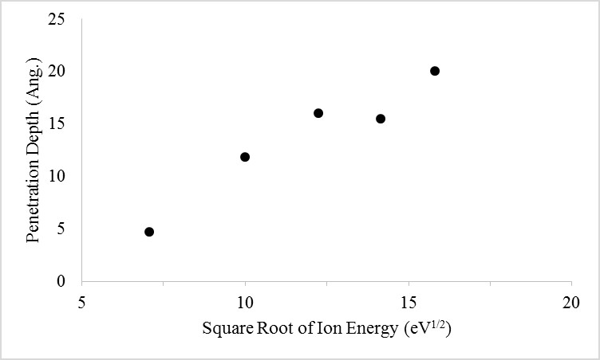
Supplemental Figure 3: The penetration depth (calculated as described in the main text) at the final timestep versus the square root of the ion energy, showing an approximately linear trend that has been noted in previous bombardment studies. We note that additional independent simulations could be used to create error bars for the data, however we do not expect the general trend to change.
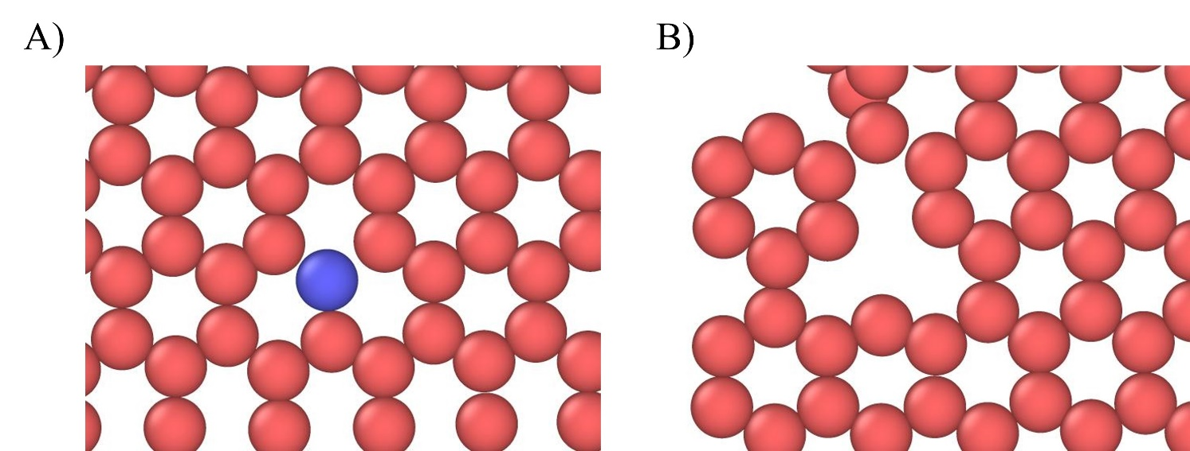
Supplemental Figure 4: A) Substitution defect observed at 150 eV bombardment. B) Vacancy defect observed at 250 eV bombardment.

