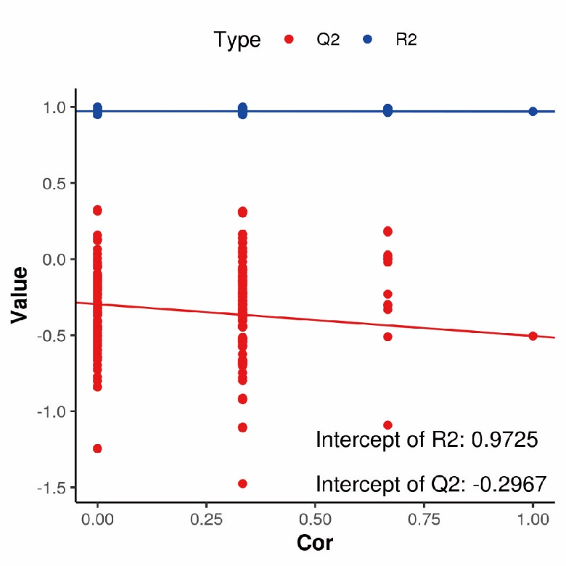

**Figure S1. Validation of PLSDA between the control and depression-like group.**

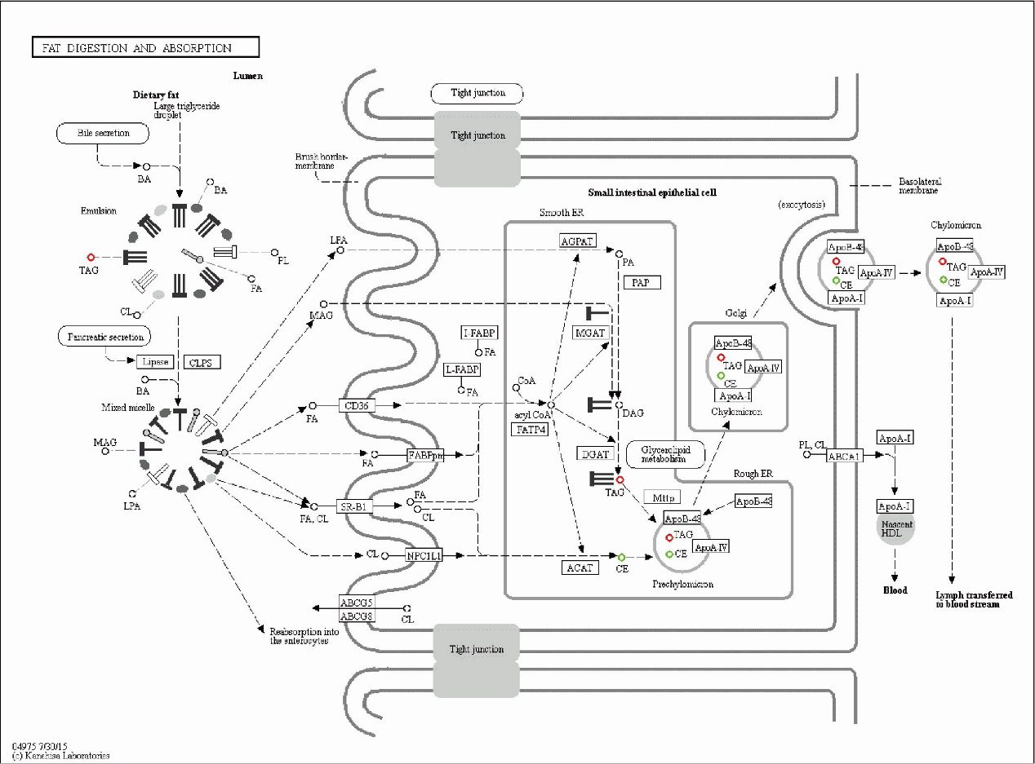

**Figure S2. Details of digestion and absorption pathway. C.** Note of vitamin digestion and absorption pathway. **D.** Note of insulin resistance pathway. **E.** Note of ovarian steroidogenesis pathway.

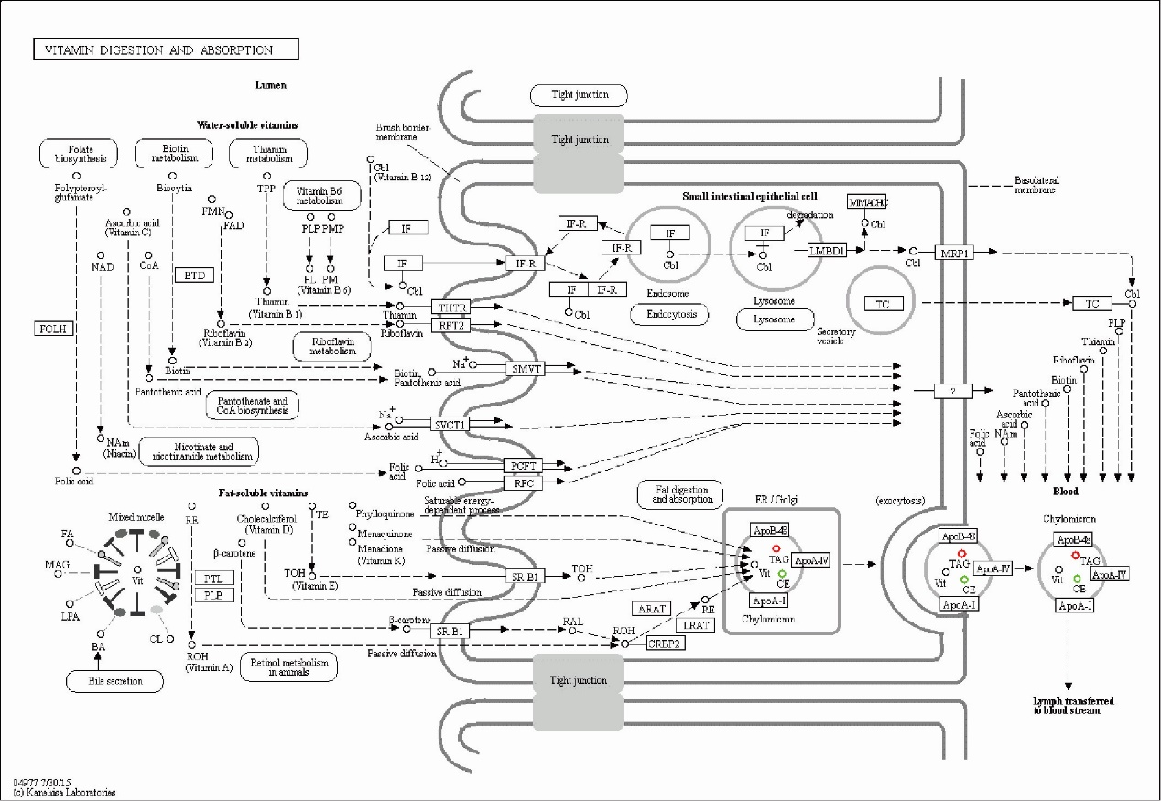

**Figure S3. Details of vitamin digestion and absorption pathway.**

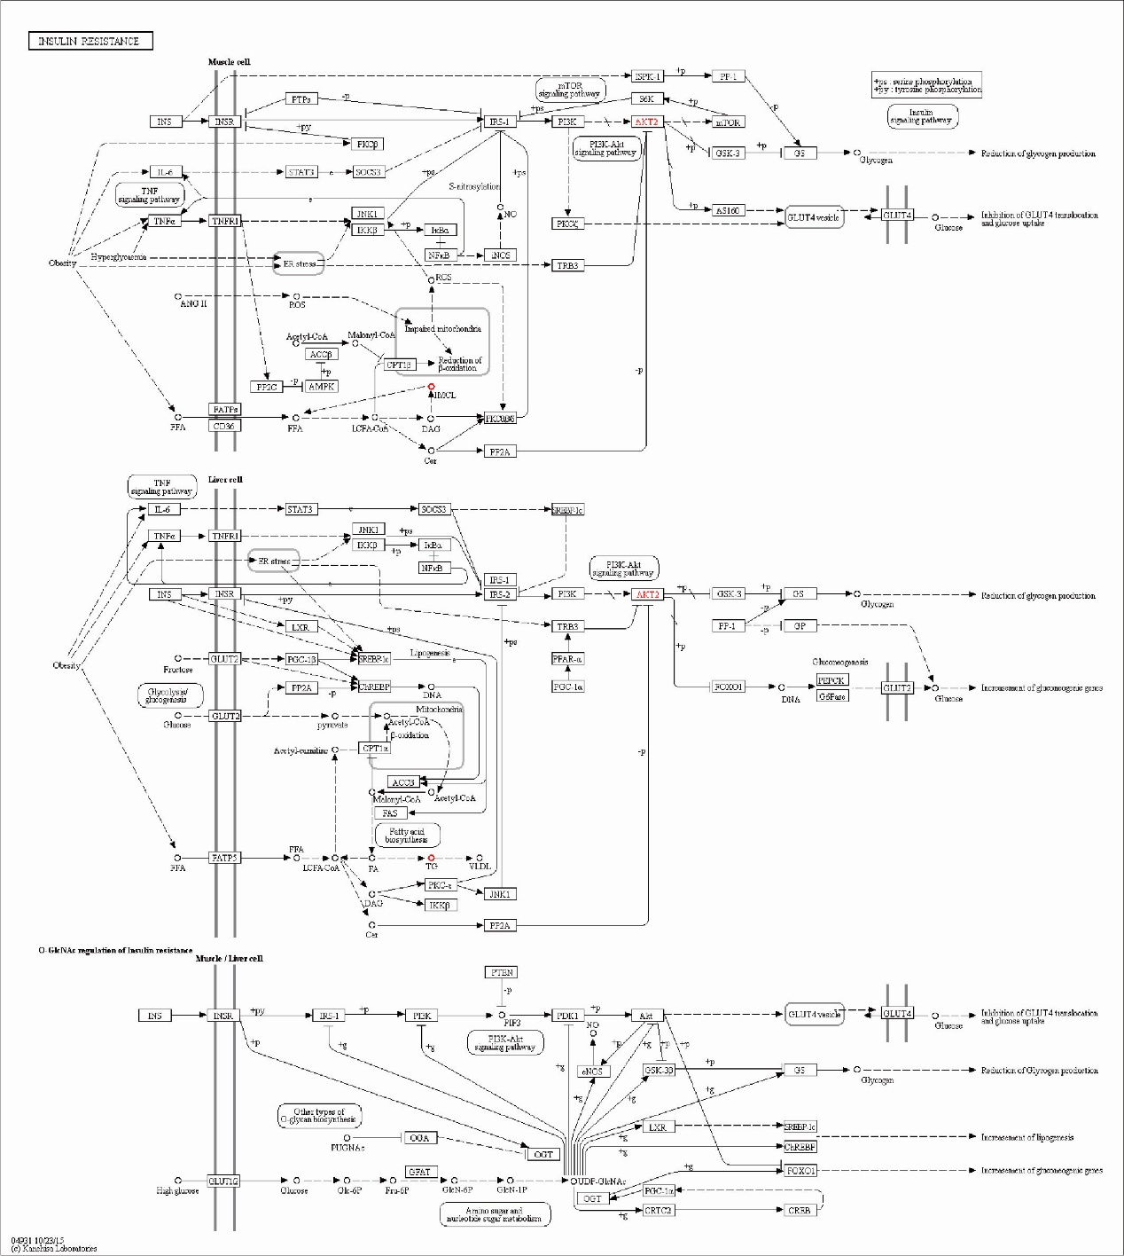

**Figure S4. Details of insulin resistance pathway.**

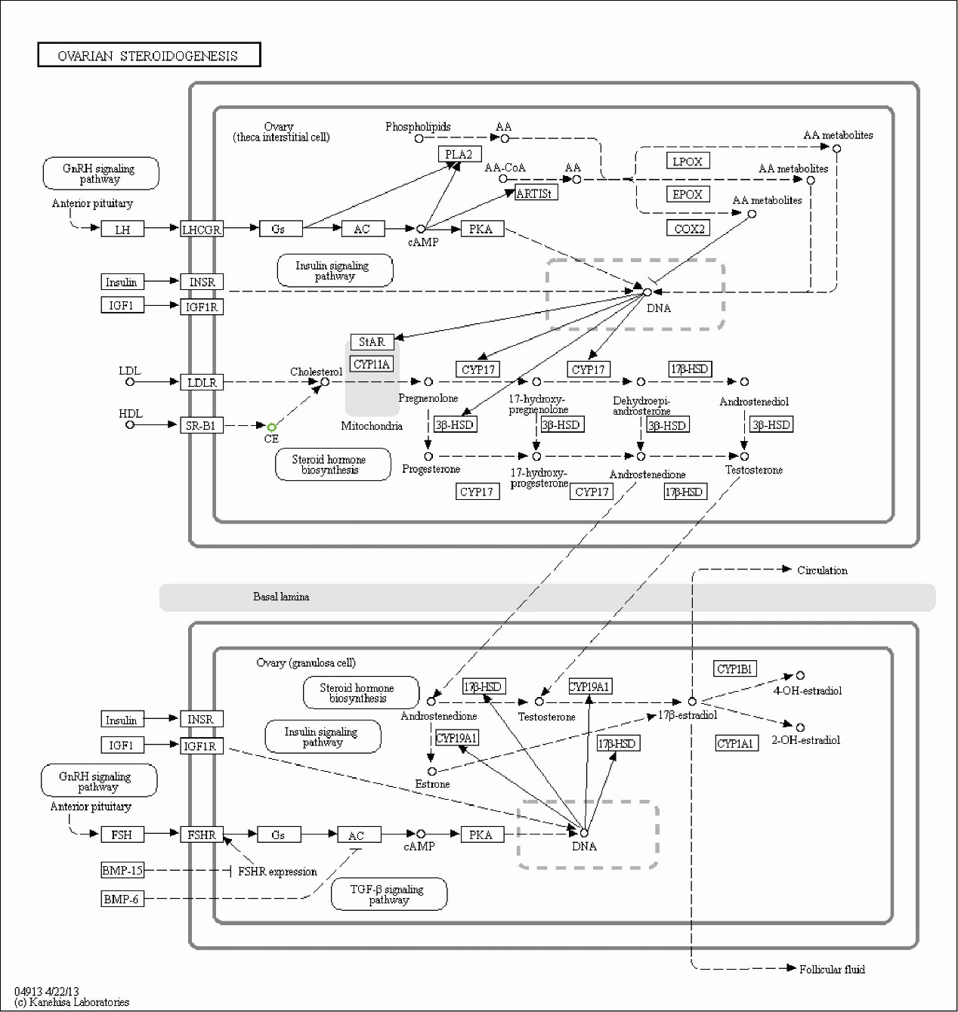

**Figure S5. Details of ovarian steroidogenesis pathway.**

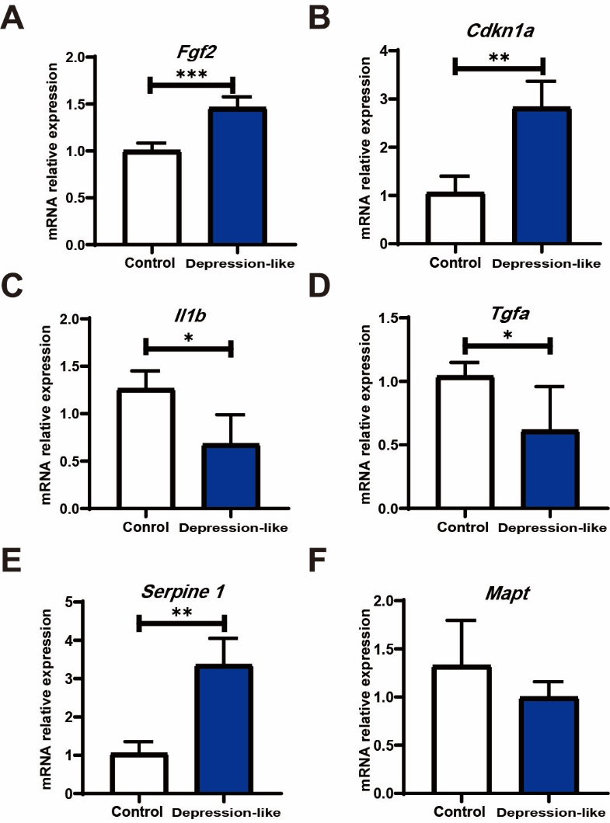

**Figure S6.** **The validation of differentially expressed mRNAs. A-F.** Expression levels of *Fgf2*, *Cdkn1a, Il1b*, *Tgfa*, *Serpine 1* and *Mapt*. The values are presented as the mean±SEM. Paired student t-test was adopted to analyze for significance. *P＜0.05, **P＜0.01.