Supplementary Material

Supplementary Figures and Tables
Figure 1. Directed Acyclic Graph (DAG) of PFAS Exposure and Infant Birthweight
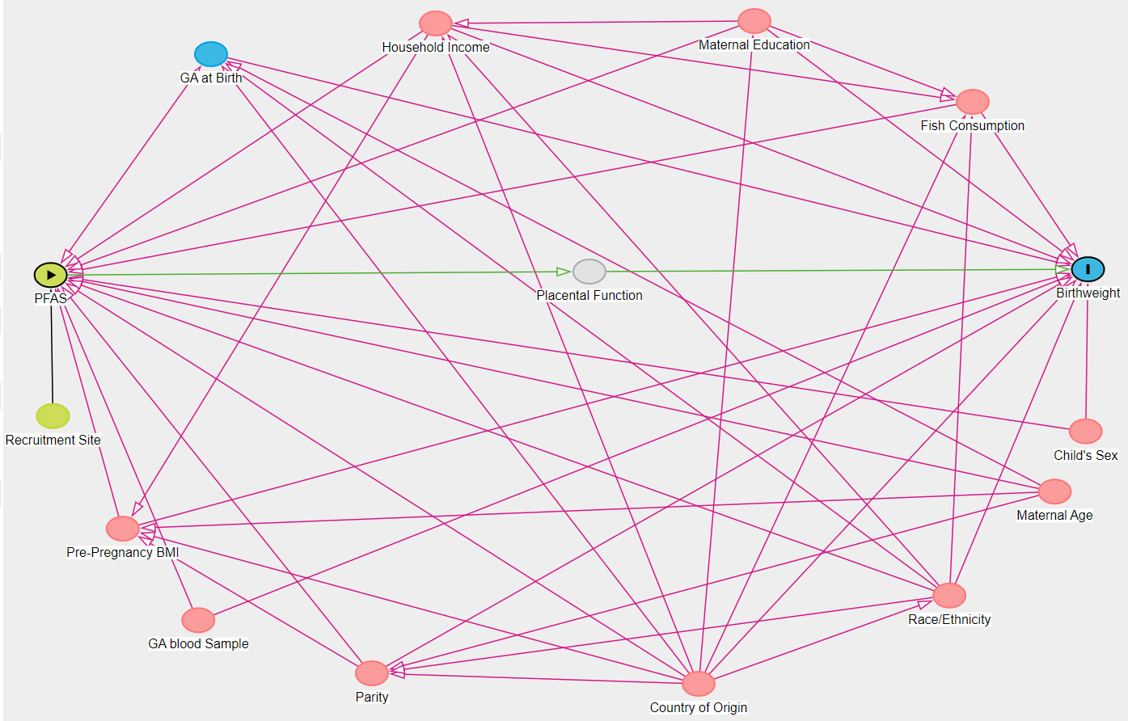
Note: Diagram was visualized using DAGitty software.

Table 1. Median PFAS Analyte Concentrations (ng/mL) by Maternal Demographic Characteristics
 | PFOS | PFHxS | PFOA | PFDA | PFNA
Race/Ethnicity  Hispanic (n=260)  Non-Hispanic Black (n=37)  Non-Hispanic white (n=30)  Non-Hispanic other (n=15) | 1.27**  1.45**  1.95**  1.76** | 1.01**  1.08**  1.81**  1.34** | 0.11**  0.05**  0.52**  0.35** | 0.04  0.04  0.05  0.08 | 0.07*  0.06*  0.16*  0.14*
Household Income  <$50,000 (n=165)  $50,000-$99,999 (n=65)  >$100,000 (n=28)  Reported “Don’t Know” (n=84) | 1.27**  1.48**  1.99**  1.26** | 1.05**  0.98**  1.69**  1.13** | 0.10**  0.19**  0.59**  0.06** | 0.05  0.04  0.07  0.04 | 0.06**  0.11**  0.23**  0.06**
Education  Completed high school or less (n=181)  Some college of completed college (n=133)  Some graduate training (n=28) | 1.26**  1.38**  2.06** | 1.00**  1.15**  1.49** | 0.08**  0.12**  0.53** | 0.04  0.04  0.05 | 0.06**  0.09**  0.21**
Country of Birth  USA (n=175)  Other (n=157)  Unknown (n=10) | 1.44*  1.26*  1.08* | 1.13*  1.01*  1.30* | 1.18  0.09  0.10 | 0.04  0.05  0.03 | 0.09  0.07  0.06
Birth Order of Child  First Born (n=119)  Second or more born (n=212)  Unknown (n=11) | 1.63**  1.25**  1.21** | 1.25**  0.99**  1.30** | 0.35**  0.07**  0.10** | 0.05*  0.04*  0.05* | 0.16**  0.06**  0.07**
Pregnancy Fish Consumption  Never (n=214)  Monthly (n=55)  At least Weekly (n=42)  Unknown (n=31) | 1.26*  1.43*  1.73*  1.38* | 1.07*  1.19*  1.28*  0.90* | 0.09  0.18  0.23  0.22 | 0.04  0.04  0.07  0.02 | 0.06*  0.11*  0.14*  0.07*
*Kruskal-Wallis One Way ANOVA p<0.05
**Kruskal-Wallis One Way ANOVA p<0.0001

Supplemental Table 2. Univariate and Adjusted Models for Independent Prenatal PFAS Compounds and Gestational Age at Birth, in Weeks (N=342)
Compound | Unadjusted  $β$ (95% CI) | Adjusted*  $β$ (95% CI)
PFHxS  < 0.79 ng/mL  0.79- 1.08 ng/mL  1.09-1.46 ng/mL  $≥$1.47 ng/mL | 0.3¹ (-0.1, 0.8)  REF  -0.1 (-0.6, 0.5)  -0.1 (-0.6, 0.5)  0.4 (-0.2, 0.9) | 0.1¹ (-0.5, 0.6)  REF  -0.03 (-0.5, 0.5)  -0.3 (-0.8, 0.3)  0.2 (-0.5, 0.5)
PFOS  <0.97 ng/mL  0.97-1.33 ng/mL  1.34-1.85 ng/mL  $≥$1.86 ng/mL | 0.2¹ (-0.2, 0.5)  REF  0.3 (-0.3, 0.8)  0.003 (-0.5, 0.5)  0.1 (-0.4, 0.7) | -0.3¹ (-0.4, 0.3)  REF  - (-0.3, 0.7)  -0.1 (-0.6, 0.4)  -0.2 (-0.7, 0.4)
PFDA  $≤$LOD  >LOD | REF  0.1 (-0.3, 0.5) | REF  0.02 (-0.3, 0.4)
PFNA  $≤$LOD  >LOD | REF  -0.1 (-0.5, 0.3) | REF  -0.3 (-0.7, 0.1)
PFOA  $≤$LOD  >LOD | REF  0.002 (-0.4, 0.4) | REF  -0.1 (-0.5, 0.3)
Note: CI=confidence interval; PFHxS=Perfluorohexanesulfonic acid; PFOS=Perfluorooctanesulfonic acid; PFNA=Perfluorononanoic acid; PFOA=Perfluorooctanoic acid; PFDA=Perfluorodecanoic acid. Reference group: Samples <LOD PFNA LOD=0.02 ng/mL, PFDA LOD=0.035 ng/mL, PFOA LOD=0.035 ng/mL.
*Adjusted for maternal age, pre-pregnancy BMI, maternal education, country of birth, household income, mother’s race, gestational age at time of blood sample, study recruitment site, parity, infant sex, and fish consumption
¹Beta estimate represents a per natural log increase

Table 3. Maternal Serum PFAS and Birthweight Models Restricted to Participants Without Preeclampsia/Eclampsia, Gestational Hypertension or Gestational Diabetes Mellitus (GDM) (N=261)
Model | Birthweight¹  $β$ (95% CI) | BW-for-GA, sex²  $β$ (95% CI) | BW-for-GA, parity³  $β$ (95% CI)
Single Pollutant Models
PFOS  <0.97 ng/mL  0.97-1.33 ng/mL  1.34-1.85 ng/mL  $≥$1.86 ng/mL | -17.5§ (-120.3, 85.2)  REF  -41.5(-187.9, 104.9)  -24.4 (-169.8, 120.9)  -22.2 (-176.7, 132.3) | -0.1§ (-0.3, 0.2)  REF  -0.1 (-0.5, 0.2)  -0.1 (-0.5, 0.3)  -0.1 (-0.5, 0.3) | -0.1§ (-0.3, 0.2)  REF  -0.2§ (-0.6, 0.2)  -0.1 (-0.5, 0.3)  -0.2 (-05, 0.2)
PFHxS  < 0.79 ng/mL  0.79- 1.08 ng/mL  1.09-1.46 ng/mL  $≥$1.47 ng/mL | 106.6§ (-48.1, 261.2)  REF  93.8 (-50.4, 238.0)  77.4 (-85.5, 240.4)  190.7 (14.6, 366.8)* | 0.3§ (-0.1, 0.7)  REF  0.3 (-0.1, 0.6)  0.2 (-0.2, 0.6)  0.5 (0.02, 0.9)* | 0.3§ (-0.1, 0.7)  REF  0.3 (-0.1, 0.6)  0.2 (-0.2, 0.6)  0.5 (0.01, 0.9)*
PFOA  $≤$LOD  >LOD | REF  -121.9 (-232.9, -10.9)* | REF  -0.3 (-0.6, -0.03)* | REF  -0.3 (-0.6, -0.1)*
PFNA  $≤$LOD  >LOD | REF  -114.7 (-229.2, -0.2)* | REF  -0.3 (-0.6, 0.003) | REF  -0.3 (-0.6, -0.01)*
PFDA  $≤$LOD  >LOD | REF  -34.9 (-138.2, 68.3) | REF  -0.1 (-0.4, 0.1) | REF  -0.2 (-0.4, 0.1)
Multipollutant Model
PFOS  PFHxS  PFOA ($≤$LOD)  PFOA (> LOD)  PFNA ($≤$LOD)  PFNA (>LOD)  PFDA ($≤$LOD)  PFDA (>LOD) | 47.3§ (-78.5, 173.0)  126.3§ (-32.3, 284.9)  REF  -107.2 (-247.8, 33.4)  REF  -81.8 (-230.8, 67.3)  REF  -21.9 (-135.6, 91.8) | 0.1§ (-0.2, 0.4)  0.3§ (-0.1, 0.7)  REF  -0.3 (-0.6, 0.1)  REF  -0.2 (-0.5, 0.2)  REF  -0.1 (-0.4, 0.2) | 0.1§ (-0.2, 0.5)  0.3§ (-0.1, 0.7)  REF  -0.3 (-0.7, 0.02)  REF  -0.2 (-0.6, 0.2)  REF  -0.1 (-0.4, 0.2)
Note: CI= confidence interval; PFHxS=Perfluorohexanesulfonic acid; PFOS=Perfluorooctanesulfonic acid; PFNA=Perfluorononanoic acid; PFOA=Perfluorooctanoic acid; PFDA=Perfluorodecanoic acid. Reference group: Samples <LOD PFNA LOD=0.02 ng/mL, PFDA LOD=0.035 ng/mL, PFOA LOD=0.035 ng/mL. Multipollutant model is mutually adjusted for all five analytes.
¹Adjusted for maternal race, maternal age at study recruitment, maternal education, country of birth, maternal household income, recruitment site, gestational age at time of blood sample, pre-pregnancy BMI, pregnancy fish consumption, infant sex, gestational age at birth, parity
²Adjusted for maternal race, maternal age at study recruitment, maternal education, country of birth, maternal household income, recruitment site, gestational age at time of blood sample, pre-pregnancy BMI, pregnancy fish consumption, and parity
³Adjusted for maternal race, maternal age at study recruitment, maternal education, country of birth, maternal household income, recruitment site, gestational age at time of blood sample, pre-pregnancy BMI, pregnancy fish consumption, and infant sex; N=251
*p<0.05
§Beta estimate interpreted as per natural log increase

Table 4. Maternal Serum PFAS and Birthweight Models Restricted to Samples Collected Prior to 30 Weeks Gestation (N=239)
Model | Birthweight¹  $β$ (95% CI) | BW-for-GA, sex²  $β$ (95% CI) | BW-for- GA, parity³  $β$ (95% CI)
Single Pollutant Models
PFOS  <0.97 ng/mL  0.97-1.33 ng/mL  1.34-1.85 ng/mL  $≥$1.86 ng/mL | -53.3§ (-166.9, 60.2)  REF  -11.1 (-172.4, 150.2)  -48.4 (-212.0, 115.2)  -60.2 (-227.5, 107.1) | -0.1§ (-0.4, 0.1)  REF  -0.06 (-0.5, 0.3)  -0.1 (-0.5, 0.3)  -0.2 (-0.6, 0.3) | -0.2§ (-0.4, 0.1)  REF  -0.1 (-0.5, 0.3)  -0.1 (-0.5, 0.3)  -0.2 (-0.6, 0.2)
PFHxS  < 0.79 ng/mL  0.79- 1.08 ng/mL  1.09-1.46 ng/mL  $≥$1.47 ng/mL | 36.7§ (-125.3, 198.8)  REF  71.7 (-71.7, 215.0)  15.5 (-145.5, 176.5)  119.7 (-81.3, 320.6) | 0.1§ (-0.3, 0.5)  REF  0.2 (-0.2, 0.5)  0.04 (-0.4, 0.4)  0.3 (-0.2, 0.8) | 0.1§ (-0.3, 0.5)  REF  0.2 (-0.1, 0.6)  0.1 (-0.3, 0.5)  0.3 (-0.2, 0.8)
PFOA  $≤$LOD  >LOD | REF  -121.0 (-242.4, 0.3) | REF  -0.3 (-0.6, -0.003)* | REF  -0.3 (-0.6, -0.007)*
PFNA  $≤$LOD  >LOD | REF  -127.7 (-254.2, -1.2)* | REF  -0.3 (-0.6, -0.01)* | REF  -0.3 (-0.7, -0.03)*
PFDA  $≤$LOD  >LOD | REF  -85.9 (-196.4, 24.6) | REF  -0.2 (-0.5, 0.05) | REF  -0.3 (-0.5, 0.02)
Multipollutant Model
PFOS  PFHxS  PFOA ($≤$LOD)  PFOA (> LOD)  PFNA ($≤$LOD)  PFNA (>LOD)  PFDA ($≤$LOD)  PFDA (>LOD) | 44.5§ (-110.1, 199.1)  69.3§ (-103.1, 241.6)  REF  -97.5 (-258.2, 63.3)  REF  -77.9 (-245.3, 89.4)  REF  -67.4 (-192.0, 57.3) | 0.1§ (-0.3, 0.5)  0.2§ (-0.2, 0.6)  REF  -0.2 (-0.6, 0.2)  REF  -0.2 (-0.6, 0.2)  REF  -0.2 (-0.5, 0.1) | 0.1§ (-0.3, 0.5)  0.2§ (-0.2, 0.7)  REF  -0.2 (-0.6, 0.2)  REF  -0.2 (-0.5, 0.1)  REF  -2 (-0.5, 0.1)
Note: CI= confidence interval; PFHxS=Perfluorohexanesulfonic acid; PFOS=Perfluorooctanesulfonic acid; PFNA=Perfluorononanoic acid, PFOA = Perfluorooctanoic acid; PFDA=Perfluorodecanoic acid. Reference group: Samples <LOD PFNA LOD=0.02 ng/mL, PFDA LOD=0.035 ng/mL, PFOA LOD=0.035 ng/mL. Multipollutant model is mutually adjusted for all five analytes.
¹Adjusted for maternal race, maternal age at study recruitment, maternal education, country of birth, maternal household income, recruitment site, gestational age at time of blood sample, pre-pregnancy BMI, pregnancy fish consumption, infant sex, gestational age at birth, parity
²Adjusted for maternal race, maternal age at study recruitment, maternal education, country of birth, maternal household income, recruitment site, gestational age at time of blood sample, pre-pregnancy BMI, pregnancy fish consumption, and parity
³Adjusted for maternal race, maternal age at study recruitment, maternal education, country of birth, maternal household income, recruitment site, gestational age at time of blood sample, pre-pregnancy BMI, pregnancy fish consumption, and infant sex
*p<0.05
§Beta estimate interpreted as per natural log increase

