Influence of saccharides on cryopreserved sperm quality, motility and fertilization associated gene expression of Pacific abalone, Haliotis discus hannai

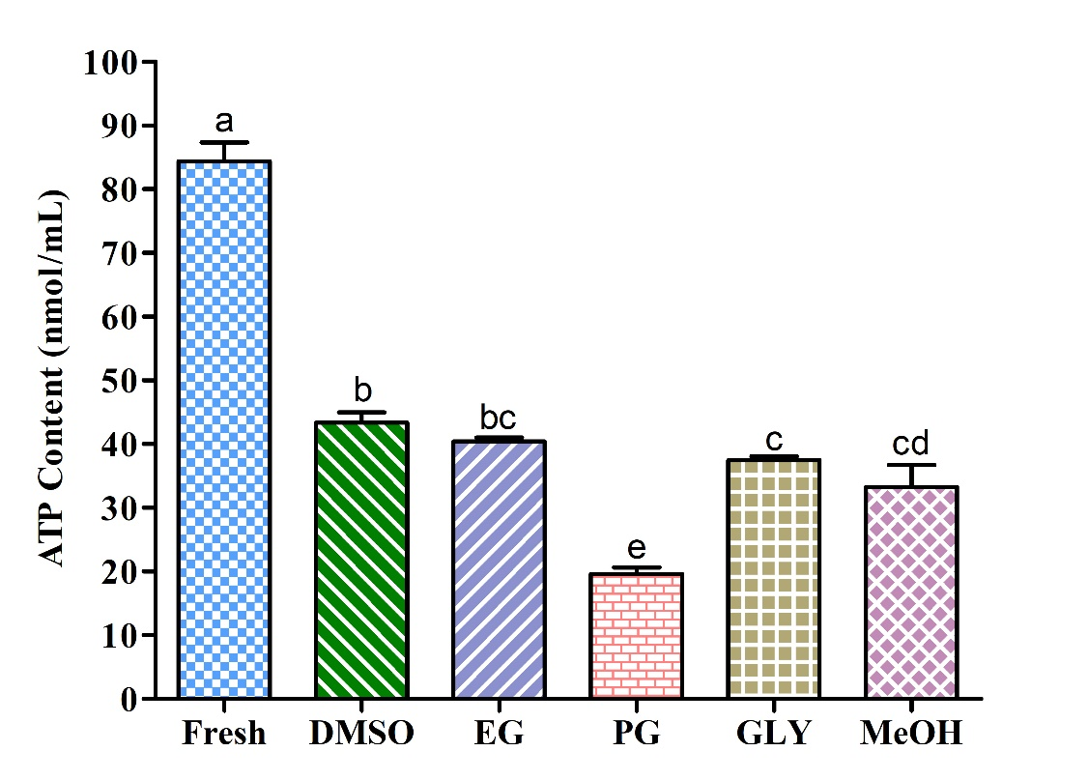

Figure S1. Adenosine triphosphate (ATP) content in different types of post-thaw sperm cryopreserved using P-CPA only.

