Supplementary Material

# Supplementary Figures

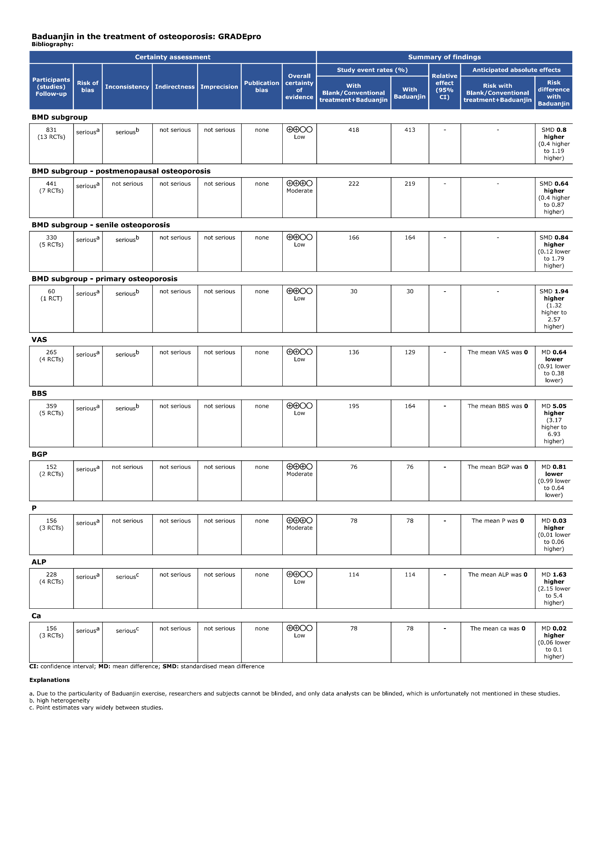

Supplementary Figure 1 Overall quality of evidence by GRADE

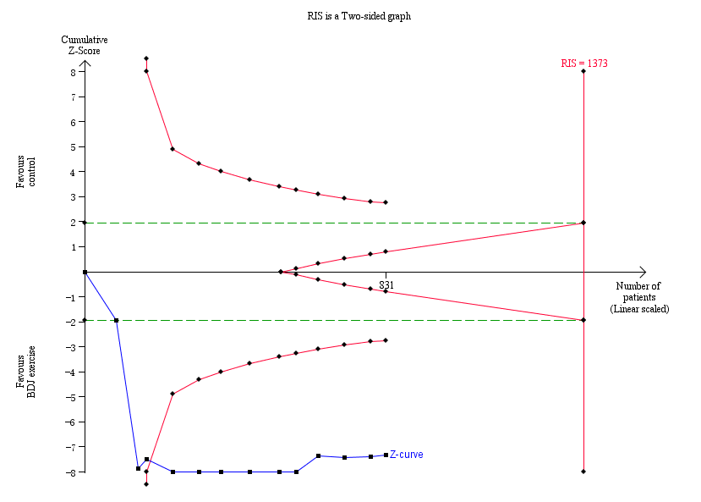

Supplementary Figure 2 TSA for BMD value (all participants) with an α of 5% (two-sided) and β of 20%

**Notes:** The required information size was calculated as 1373. Z curve has across-trial sequential monitoring boundary for benefit (all participants).

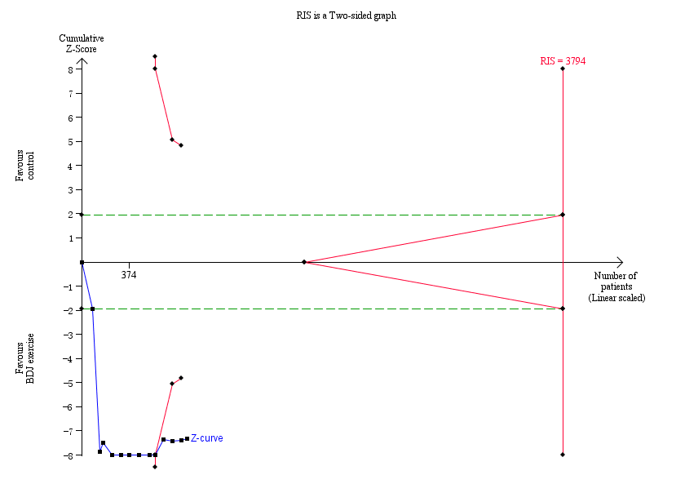

Supplementary Figure 3 TSA for BMD value (blank vs BDJ exercise intervention) with an α of 5% (two-sided) and β of 20%

**Notes:** The required information size was calculated as 3794. Z curve has across-trial sequential monitoring boundary for benefit (blank vs BDJ exercise intervention).

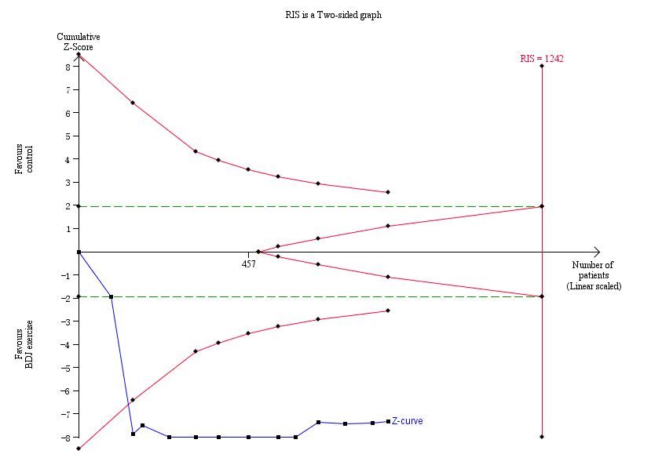

Supplementary Figure 4 TSA for BMD value (conventional treatment vs BDJ exercise combined with conventional treatment) with an α of 5% (two-sided) and β of 20%

**Notes:** The required information size was calculated as 1242. Z curve has across-trial sequential monitoring boundary for benefit (BDJ exercise combined with conventional treatment).