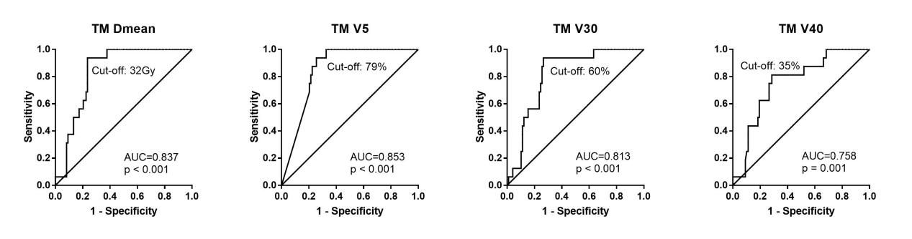

Supplement figure 1. The ROC curves for TM to avoid G4 lymphopenia

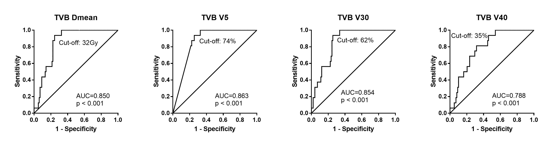

Supplement figure 2. The ROC curves for TVB to avoid G4 lymphopenia

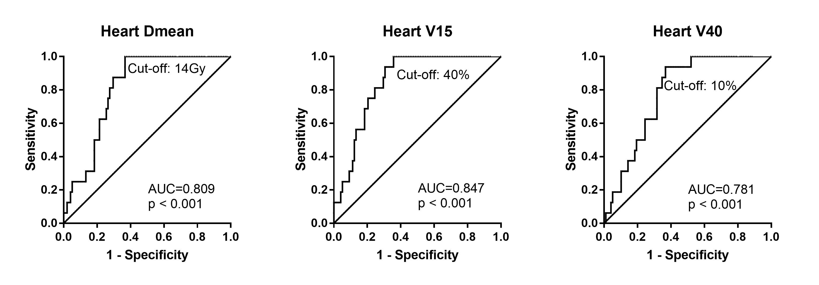

Supplement figure 3. The ROC curves for Heart to avoid G4 lymphopenia

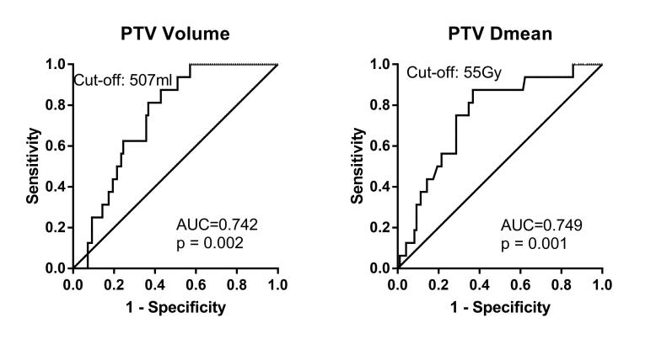

Supplement figure 4. The ROC curves for PTV to avoid G4 lymphopenia