Supplementary Material

Supplementary Data
Supplement: Qualtrics survey
Please note this is a section of a larger survey. The other sections are presented elsewhere.
Introduction and Informed Consent
This survey contains pictures of piglets’ faces in 12 scenarios. We will ask you to apply the grimace scoring system (explained in the survey) based on the position of their nose/cheeks, eyes, and ears. The survey ends with some basic demographic questions and questions about your experience with swine. Experience is not required for this survey. All responses are valuable, no matter the amount of experience!
Identifying pain based on piglet facial expressions can be a useful tool to provide appropriate care to these piglets. A categorical scale to score these pain expressions or grimaces was recently developed. We aim to find out how easy it is for the survey respondents to apply this grimace scale.
The responses will be used to validate the piglet grimace scale and will be published. Your responses will be anonymous. We are extremely grateful that you are willing to participate in this survey and contribute to our data collection.
We thank you for your responses and participation!
Consent to Take Part in a Research Study

Principal Investigator: Leonie Jacobs: jacobsl@vt.edu / [phone number redacted]
Other study contact(s): Jessica Neary jessicaneary@vt.edu / [phone number redacted]
Detailed Information: The following is more detailed information about this study in addition to the information listed above.

Who can I talk to?
- If you have questions, concerns, or complaints, or think the research has hurt you, talk to the lead for the research team at Virginia Tech, Leonie Jacobs (jacobsl@vt.edu / [phone number redacted]
- This research has been reviewed by the Virginia Tech Institutional Review Board (IRB). You may communicate with them at 540-231-3732 or irb@vt.edu if:
- You have questions about your rights as a research subject
- Your questions, concerns, or complaints are not being answered by the research team
- You cannot reach the research team
- You want to talk to someone besides the research team to provide feedback about this research
How many people will be studied?
- We plan to include about 100 people in this research study.
What happens if I say yes, I want to be in this research?
- The length and duration of procedures: This is a one-time online survey that should take about 20 minutes.
What happens if I say yes, but I change my mind later?
- You can leave the research at any time, for any reason, and it will not be held against you.
- If you decide to leave the research, and do not complete the survey, the answers to the questions that you’ve already answered may be used for data collection, but the answers cannot be linked to you in any way. All collected information will be anonymized (any identifiable details removed).
- If you decide to leave the research, you may contact the investigator, but you could also simply do nothing. This is an online survey and you can choose not to complete it.
Is there any way being in this study could be bad for me? (Detailed Risks)
- You may find the images of pig facial expressions emotionally disturbing or they may cause emotional discomfort. There are no physical, privacy, legal, social or economic risks associated with this study (see below for examples of each of these risk categories).
What happens to the information collected for the research?
- No identifiable information will be used for research or publication. All survey responses will be stored without identifiable information. We will use your survey responses to evaluate people’s ability to recognize pain through piglet facial expressions. These outcomes cannot be linked to you personally in any publication.
- Organizations that may inspect your information include the IRB, Human Research Protection Program, and other authorized representatives of Virginia Tech. Data will be retained for 3 years after completion of the project. Identifiable information will be stored separately from survey responses. The results of this research study may be presented in summary form at conferences, in presentations, reports to the sponsor, academic papers, and as part of a thesis/dissertation.
Can I be removed from the research without my OK?
- The research leader can remove you from the research study without your approval. Possible reasons for removal include incomplete entry, late entry, answers that are deemed unreliable.
Signature Block for Capable Adult
- By clicking “I agree to participate” and proceeding to the next part of the survey, you are indicating your permission to take part in this research.
I agree to be a part of this survey and consent to participating
- Yes
- No

Piglet Grimace Scale Explanation and Training
The grimace scale evaluates ears, cheeks and eyes of piglets as an indicator of experienced pain. The scale includes scores between 0 and 3, with 0 meaning piglets are not in pain, and 3 meaning they are in pain.
Ear Position
Ears can be in a normal position (score 0), can be positioned backwards (score 1), further back (score 2), or obviously pulled back (score 3).
- Score 0 = no pain (absent)
- Score 1 = some pain (somewhat present)
- Score 2 = moderate pain (moderately present)
- Score 3 = obvious pain (obviously present)
You can determine the ear position by looking at the base of the ear (the point that connects to the piglet’s head: see red arrows).
Absent (0): The ears are in baseline position (orange dotted line) and ears are both facing forward, seemly relaxed.
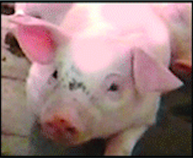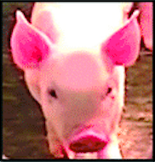

Somewhat present (1): One of the ears is at the baseline and the other is slightly pulled back.
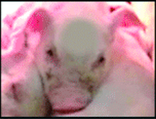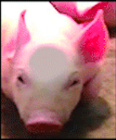

Moderately present (2): Both ears are slightly pulled back, but not pressed against the body.
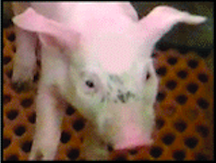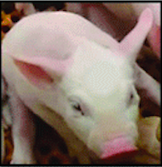

Obviously present (3): Both of the ears are pulled back but are not pressed against the body.

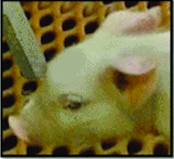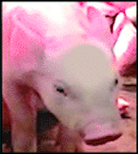

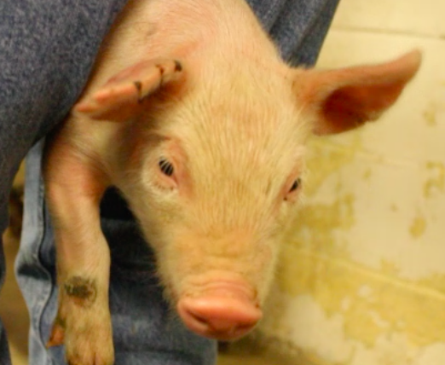
How would you rate this piglet’s ear positioning?
- Absent (0)
- Somewhat Present (1)
- Moderately Present (2)
- Obviously Present (3)

We scored this piglet's ear positioning as somewhat present (1). One ear is slightly relaxed while the other is pulled back slightly away from the base line.
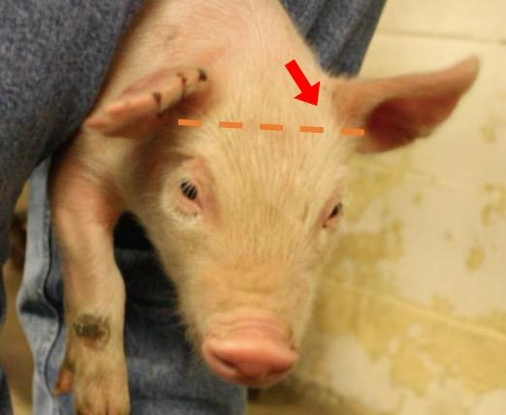
Cheek Tightening
Cheeks can be in a normal position (score 0), can show slight bulging near the snout (score 1), or can show obvious bulging by the snout (score 2).
- Score 0 = no pain (absent)
- Score 1 = some pain (somewhat present)
- Score 2 = moderate pain (moderately present)
You can determine the cheek tightening by looking at a profile view of the piglet and looking at the lip line. The bulging is highlighted by the red lines and circles.
Absent (0): The area right between the nose and cheek is smooth. No bump/bulge is present on the snout (the dotted lines highlight the smooth line and lack of bulge).
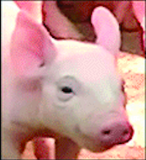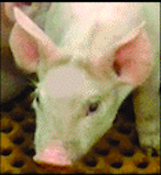

Moderately Present (1): There is a slight bulge on the snout (dotted lines and circle).
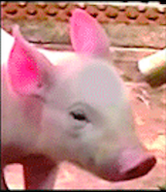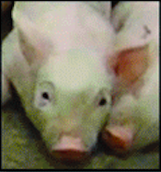

Obviously present (2): There is a clearly noticeable bulge om the snout of the animal (dotted lines and circle).
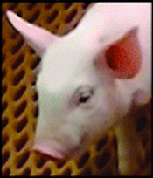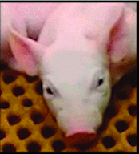

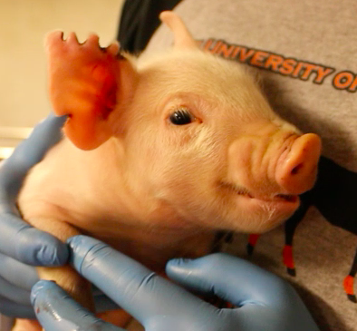
How would you rate this piglet’s cheek tightening?
- Absent (0)
- Moderately Present (1)
- Obviously Present (2)

We scored this piglet's cheek tightening as obviously present (2). There is a clear and noticeable bulge on the animal's snout.
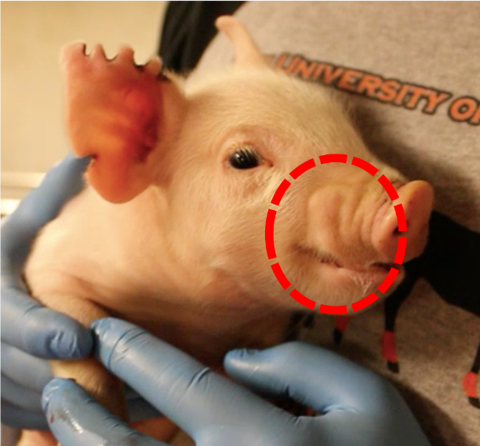
Orbital Tightening
Eyes can be in a normal position, with eyes open similar to human eyes (‘almond shape’) (score 0). When in pain, piglets will squint (orbital tightening) (score 1).
- Score 0 = no pain (absent)
- Score 1 = some pain (squinting/ orbital tightening is present)
Absent (0): Eyes are bright and open (red line)
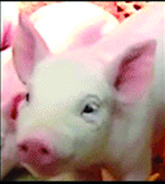

Present (1): Orbital area is narrowed; the eyes are squinting (dotted circle)
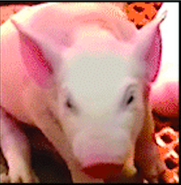

How would you rate this piglet’s orbital tightening?
- Absent (0)
- Present (1)

We scored this piglet's orbital tightening as absent (0). The eye is bright and open without 'squinting'.
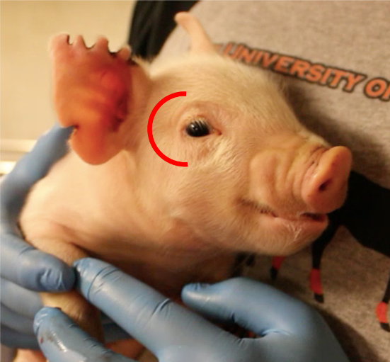
PGS Category Explanations
For this survey, you will be asked to rate 12 pictures of piglets, evaluating the three different areas explained in the grimace scale. A link to the grimace scale scoring sheet is provided at the bottom of each page for your reference.
We recommend you to keep this reference document open during the survey: Piglet grimace scale - reference document.
PGS Questions
Scenario 1: How would you rate the following piglet’s grimace (ears, cheeks and eyes)? This piglet was castrated right before this photo was taken.
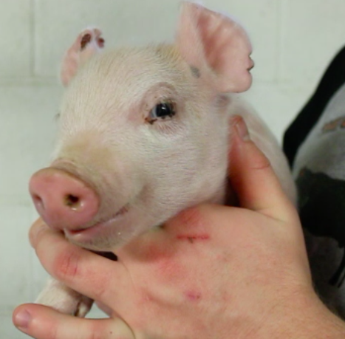
Based on the ear positioning, please score the presence of pain (0-3)
- Absent (0)
- Somewhat Present (1)
- Moderately Present (2)
- Obviously Present (3)
Based on cheek tightening, please score the presence of pain (0-2)
- Absent (0)
- Moderately present (1)
- Obviously present (2)
Based on the orbital tightening, please score the presence of pain (0-1)
- Absent (0)
- Present (1)
How confident are you with your scores (continuous sliding scale)?
Not confident at all slightly confident somewhat confident fairly confident extremely confident
Scenario 2: How would you rate the following piglet’s grimace (ears, cheeks and eyes)? This piglet was castrated right before this photo was taken.
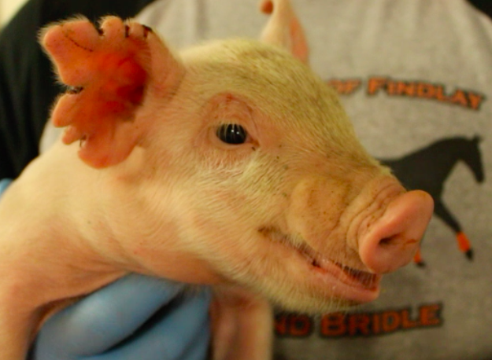

Based on the ear positioning, please score the presence of pain (0-3)
- Absent (0)
- Somewhat Present (1)
- Moderately Present (2)
- Obviously Present (3)
Based on cheek tightening, please score the presence of pain (0-2)
- Absent (0)
- Moderately present (1)
- Obviously present (2)
Based on the orbital tightening, please score the presence of pain (0-1)
- Absent (0)
- Present (1)
How confident are you with your scores (continuous sliding scale)?
Not confident at all slightly confident somewhat confident fairly confident extremely confident

Scenario 3: How would you rate the following piglet’s grimace ears, cheeks and eyes)? This piglet was being castrated while this photo was taken.
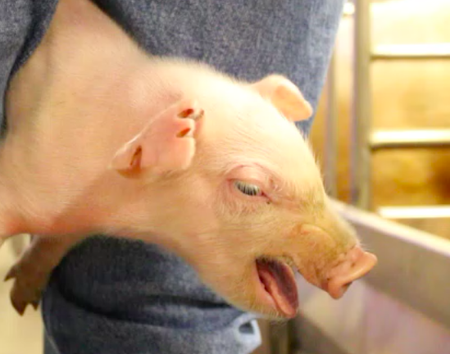

Based on the ear positioning, please score the presence of pain (0-3)
- Absent (0)
- Somewhat Present (1)
- Moderately Present (2)
- Obviously Present (3)
Based on cheek tightening, please score the presence of pain (0-2)
- Absent (0)
- Moderately present (1)
- Obviously present (2)
Based on the orbital tightening, please score the presence of pain (0-1)
- Absent (0)
- Present (1)
How confident are you with your scores (continuous sliding scale)?
Not confident at all slightly confident somewhat confident fairly confident extremely confident

Scenario 4: How would you rate the following piglet’s grimace (ears, cheeks and eyes)? This piglet was castrated right before this photo was taken.
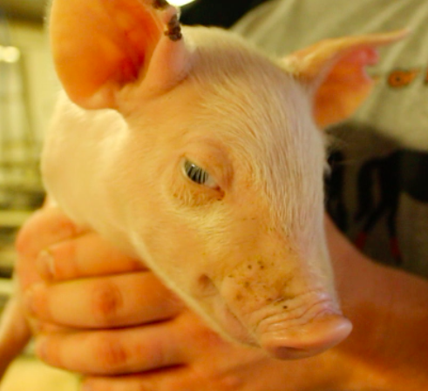
Based on the ear positioning, please score the presence of pain (0-3)
- Absent (0)
- Somewhat Present (1)
- Moderately Present (2)
- Obviously Present (3)
Based on cheek tightening, please score the presence of pain (0-2)
- Absent (0)
- Moderately present (1)
- Obviously present (2)
Based on the orbital tightening, please score the presence of pain (0-1)
- Absent (0)
- Present (1)
How confident are you with your scores (continuous sliding scale)?
Not confident at all slightly confident somewhat confident fairly confident extremely confident

Scenario 5: How would you rate the following piglet’s grimace (ears, cheeks and eyes)? This piglet was not castrated.
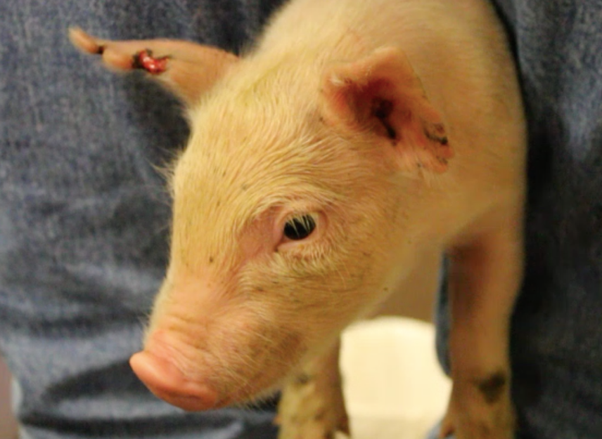
Based on the ear positioning, please score the presence of pain (0-3)
- Absent (0)
- Somewhat Present (1)
- Moderately Present (2)
- Obviously Present (3)
Based on cheek tightening, please score the presence of pain (0-2)
- Absent (0)
- Moderately present (1)
- Obviously present (2)
Based on the orbital tightening, please score the presence of pain (0-1)
- Absent (0)
- Present (1)
How confident are you with your scores (continuous sliding scale)?
Not confident at all slightly confident somewhat confident fairly confident extremely confident

Scenario 6: How would you rate the following piglet’s grimace (ears, cheeks and eyes)? This piglet was not castrated.
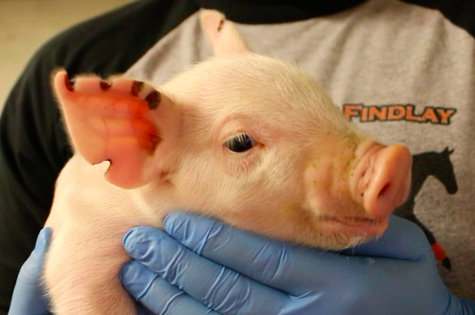
Based on the ear positioning, please score the presence of pain (0-3)
- Absent (0)
- Somewhat Present (1)
- Moderately Present (2)
- Obviously Present (3)
Based on cheek tightening, please score the presence of pain (0-2)
- Absent (0)
- Moderately present (1)
- Obviously present (2)
Based on the orbital tightening, please score the presence of pain (0-1)
- Absent (0)
- Present (1)
How confident are you with your scores (continuous sliding scale)?
Not confident at all slightly confident somewhat confident fairly confident extremely confident

Scenario 7: How would you rate the following piglet’s grimace (ears, cheeks and eyes)? This piglet was castrated right before this photo was taken.

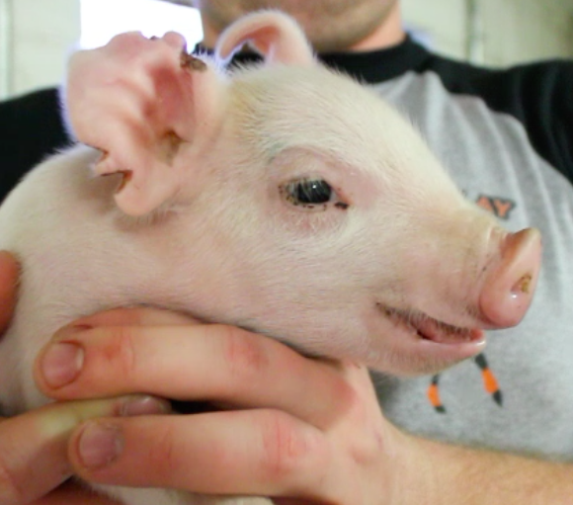
Based on the ear positioning, please score the presence of pain (0-3)
- Absent (0)
- Somewhat Present (1)
- Moderately Present (2)
- Obviously Present (3)
Based on cheek tightening, please score the presence of pain (0-2)
- Absent (0)
- Moderately present (1)
- Obviously present (2)
Based on the orbital tightening, please score the presence of pain (0-1)
- Absent (0)
- Present (1)
How confident are you with your scores (continuous sliding scale)?
Not confident at all slightly confident somewhat confident fairly confident extremely confident

Scenario 8: How would you rate the following piglet’s grimace (ears, cheeks and eyes)? This piglet was not castrated.
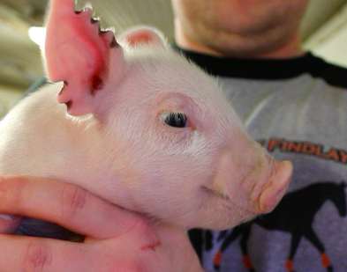
Based on the ear positioning, please score the presence of pain (0-3)
- Absent (0)
- Somewhat Present (1)
- Moderately Present (2)
- Obviously Present (3)
Based on cheek tightening, please score the presence of pain (0-2)
- Absent (0)
- Moderately present (1)
- Obviously present (2)
Based on the orbital tightening, please score the presence of pain (0-1)
- Absent (0)
- Present (1)
How confident are you with your scores (continuous sliding scale)?
Not confident at all slightly confident somewhat confident fairly confident extremely confident
Scenario 9: How would you rate the following piglet’s grimace (ears, cheeks and eyes)? This piglet was being castrated while this photo was taken.
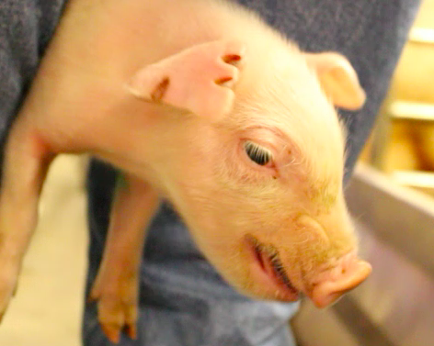
Based on the ear positioning, please score the presence of pain (0-3)
- Absent (0)
- Somewhat Present (1)
- Moderately Present (2)
- Obviously Present (3)
Based on cheek tightening, please score the presence of pain (0-2)
- Absent (0)
- Moderately present (1)
- Obviously present (2)
Based on the orbital tightening, please score the presence of pain (0-1)
- Absent (0)
- Present (1)
How confident are you with your scores (continuous sliding scale)?
Not confident at all slightly confident somewhat confident fairly confident extremely confident

Demographic Questions
What is your gender?

- Female
- Male
- Non-binary/ third gender
- Prefer to self-describe:_________
- Prefer not to say

What is your age range?

- 18-25
- 26-35
- 36-45
- 46-55
- 56-65
- 65+

What state do you currently live in? :_____________________________
What type of community do you currently live in?
- City/urban
- Suburban
- Rural
- Other (self-describe):_____________________________
What is your highest level of education? (If you’re currently enrolled in school, please indicate the highest degree you have received)

- Less than high school
- High school diploma or equivalent (GED)
- Some College (no degree)
- 2-year degree
- 4-year degree (bachelors)
- Master’s degree
- Professional degree (for example MD, DMV)
- Doctorate degree
- Other: (self-describe)

Do you consume meat (beef, pork, chicken, fish, other)?
- Yes
- No
Do you have pets?
- Yes
- No
Do you have any professional work experience with swine and the swine industry?
- Yes
- No

Supplementary Tables
Table S1. Respondents’ demographics (n=119) separated by swine industry experience, with inexperienced respondents (public respondents; n=66) and experienced respondents (industry respondents; n=53). P-values of the main effects on respondents’ Piglet Grimace Scale (PGS) scores are given for the castrated piglet scenarios (CAS) and sham-handled piglet scenarios (SHAM).
Survey question | Response category | Public  respondents (n)¹ | Industry  respondents (n)¹ | Total (n) | Total (%) | Census Data (%) | Effect on PGS scores (P-value)
 |  |  |  |  |  |  | CAS scenarios | SHAM scenarios
Gender | Male | 35 | 27 | 62 | 52 | 49 | 0.472 | 0.950
 | Female | 30 | 26 | 56 | 47 | 51
 | Prefer not to say | 1 | 0 | 1 | 1
Age² | 18-25 | 14 | 12 | 26 | 22 | 9 | 0.830 | 0.131
 | 26-35 | 23 | 19 | 42 | 35 | 14
 | 36-45 | 18 | 15 | 33 | 28 | 13
 | 46-55 | 6 | 4 | 10 | 8 | 12
 | 56-65 | 4 | 3 | 7 | 6 | 13
 | 66+ | 1 | 0 | 1 | 1 | 11
United States region of residency | Northeast | 15 | 4 | 19 | 16 | 17 | 0.700 | 0.712
 | Southeast | 5 | 4 | 9 | 8 | 28
 | Midwest | 21 | 27 | 48 | 40 | 21
 | West | 20 | 16 | 36 | 30 | 21
 | Southwest | 5 | 2 | 7 | 6 | 13
Community Type | City/Urban | 24 | 16 | 40 | 34 | 71 | 0.297 | 0.264
 | Suburban | 29 | 11 | 40 | 34 | 10
 | Rural | 13 | 26 | 39 | 33 | 19
Education Level | Less than a high school degree | 0 | 0 | 0 | 0 | 10 | 0.681 | 0.414
 | High school degree or equivalent (GED) | 4 | 1 | 5 | 4 | 28
 | Some college (no degree) | 14 | 0 | 14 | 12 | 17
 | 2-year degree | 6 | 1 | 7 | 6 | 10
 | 4-year degree (bachelors) | 24 | 26 | 50 | 42 | 22
 | Master's degree | 10 | 11 | 21 | 18 | 9
 | Professional degree | 4 | 4 | 8 | 8 | 1
 | Doctorate (PhD) | 4 | 10 | 14 | 12 | 2
Meat consumption | Yes | 57 | 52 | 109 | 92 |  | 0.443 | 0.109
 | No | 9 | 1 | 10 | 8
Pet ownership | Yes | 49 | 47 | 96 | 81 |  | 0.395 | 0.802
 | No | 17 | 6 | 23 | 19
¹ Respondent categorization into “general public” or “industry” was based on respondent’s answer to the question: Do you have any professional work experience with swine and the swine industry?
² The age ranges for the census data were <18, 18-24, 25-34, 35-44, 45-54, 55-64, and 64+. Census Data from the <18 category is not presented.

Table S2. The full Multi-Trait-Multimethod correlation Matrix between image and component ratings across all raters.
 |  | Ear |  |  |  |  |  |  |  |  | Cheek |  |  |  |  |  |  |  |  | Eye
 |  | 1 | 2 | 3 | 4 | 5 | 6 | 7 | 8 | 9 | 1 | 2 | 3 | 4 | 5 | 6 | 7 | 8 | 9 | 1 | 2 | 3 | 4 | 5 | 6 | 7 | 8 | 9
Ear | 1 | 1.000
 | 2 | 0.330 | 1.000
 | 3 | -0.285 | 0.234 | 1.000
 | 4 | -0.051 | 0.343 | 0.152 | 1.000
 | 5 | -0.348 | 0.318 | 0.248 | 0.571 | 1.000
 | 6 | 0.203 | 0.310 | -0.183 | 0.306 | 0.157 | 1.000
 | 7 | 0.571 | 0.126 | -0.094 | 0.003 | -0.222 | 0.286 | 1.000
 | 8 | 0.197 | 0.271 | -0.103 | 0.512 | 0.359 | 0.449 | 0.322 | 1.000
 | 9 | -0.382 | 0.061 | 0.644 | 0.244 | 0.539 | -0.156 | -0.130 | -0.008 | 1.000
Cheek | 1 | 0.034 | 0.217 | 0.093 | 0.344 | 0.387 | 0.227 | -0.010 | 0.238 | 0.116 | 1.000
 | 2 | 0.363 | 0.243 | -0.192 | -0.151 | -0.144 | 0.092 | 0.336 | -0.001 | -0.127 | -0.048 | 1.000
 | 3 | 0.119 | 0.026 | 0.384 | -0.045 | -0.298 | 0.035 | 0.232 | -0.042 | 0.079 | 0.022 | 0.355 | 1.000
 | 4 | -0.024 | 0.129 | 0.159 | 0.541 | 0.320 | 0.113 | -0.017 | 0.345 | 0.138 | 0.292 | 0.077 | 0.016 | 1.000
 | 5 | -0.048 | 0.119 | 0.034 | 0.216 | 0.312 | 0.238 | 0.008 | 0.225 | 0.081 | 0.196 | 0.222 | 0.024 | 0.415 | 1.000
 | 6 | 0.197 | 0.073 | -0.195 | 0.168 | 0.140 | 0.443 | 0.313 | 0.435 | -0.115 | 0.218 | 0.484 | -0.012 | 0.439 | 0.386 | 1.000
 | 7 | -0.019 | 0.206 | 0.344 | 0.262 | 0.280 | 0.083 | 0.185 | 0.174 | 0.190 | 0.464 | -0.156 | 0.239 | 0.313 | 0.043 | 0.018 | 1.000
 | 8 | 0.165 | 0.220 | -0.097 | 0.210 | 0.248 | 0.352 | 0.046 | 0.473 | -0.139 | 0.403 | 0.141 | 0.100 | 0.287 | 0.432 | 0.570 | 0.117 | 1.000
 | 9 | 0.134 | 0.014 | 0.076 | -0.095 | -0.045 | 0.079 | 0.269 | -0.047 | 0.165 | 0.071 | 0.455 | 0.532 | -0.030 | 0.201 | 0.313 | 0.057 | 0.317 | 1.000
Eye | 1 | 0.264 | 0.191 | -0.097 | 0.143 | 0.038 | 0.078 | 0.058 | 0.139 | -0.126 | 0.129 | -0.112 | -0.104 | 0.160 | -0.024 | 0.018 | 0.344 | 0.044 | -0.165 | 1.000
 | 2 | 0.016 | 0.161 | -0.041 | 0.184 | 0.250 | -0.121 | -0.128 | 0.047 | 0.093 | 0.169 | 0.033 | -0.103 | 0.127 | -0.095 | 0.039 | 0.315 | -0.083 | -0.159 | 0.625 | 1.000
 | 3 | 0.218 | -0.131 | -0.081 | -0.349 | -0.481 | -0.271 | 0.177 | -0.343 | -0.129 | -0.370 | 0.275 | 0.318 | -0.120 | -0.010 | -0.137 | -0.122 | -0.259 | 0.257 | 0.189 | -0.210 | 1.000
 | 4 | 0.275 | 0.045 | -0.209 | 0.242 | -0.355 | 0.286 | 0.145 | 0.191 | -0.357 | -0.148 | 0.144 | 0.258 | 0.448 | 0.201 | 0.411 | -0.172 | 0.287 | 0.049 | 0.071 | -0.076 | 0.196 | 1.000
 | 5 | -0.411 | 0.028 | 0.181 | 0.349 | 0.470 | -0.104 | -0.389 | 0.071 | 0.359 | 0.313 | -0.316 | -0.056 | 0.339 | 0.174 | 0.148 | 0.393 | 0.234 | 0.035 | 0.454 | 0.553 | -0.064 | 0.090 | 1.000
 | 6 | 0.027 | 0.141 | -0.117 | 0.285 | 0.287 | 0.289 | -0.002 | 0.291 | -0.013 | 0.292 | -0.092 | -0.135 | 0.330 | 0.335 | 0.287 | 0.282 | 0.294 | 0.044 | 0.650 | 0.568 | 0.091 | 0.168 | 0.615 | 1.000
 | 7 | 0.076 | -0.076 | 0.005 | 0.055 | -0.007 | -0.076 | 0.130 | 0.079 | 0.106 | 0.000 | 0.019 | 0.185 | 0.094 | -0.130 | 0.111 | 0.422 | 0.017 | 0.097 | 0.711 | 0.563 | 0.411 | 0.143 | 0.552 | 0.602 | 1.000
 | 8 | -0.075 | 0.199 | -0.039 | 0.211 | 0.275 | 0.164 | -0.084 | 0.336 | 0.103 | 0.162 | -0.123 | -0.008 | 0.148 | 0.209 | 0.128 | 0.131 | 0.319 | -0.075 | 0.613 | 0.620 | -0.027 | 0.126 | 0.658 | 0.781 | 0.501 | 1.000
 | 9 | 0.109 | -0.165 | -0.112 | -0.043 | -0.195 | -0.091 | 0.201 | -0.101 | 0.104 | -0.198 | 0.223 | 0.248 | 0.102 | 0.045 | 0.384 | -0.059 | 0.046 | 0.346 | 0.012 | 0.085 | 0.511 | 0.524 | 0.383 | 0.219 | 0.467 | 0.195 | 1.000

