Supplementary Material
Supplementary Figure 1. Generation and verification of Δtom1.
Supplementary Figure 2. 12% SDS-PAGE of purified heterogeneously produced GST-MAT1-1-1 and GST-MAT1-2-1 proteins.
Supplementary Figure 3. Schematic representation of the linear structure of Tom1.
Supplementary Figure 4. Flourescence microscopy.
Supplementary Table 1. Bacterial and fungal strains used in this study.
Supplementary Table 2. Oligonucleotides used in this study.
Supplementary Table 3. Plasmids used in this study.

Supplementary Figures
Supplementary Figure 1

Supplementary Figure 1. Generation and verification of Δtom1. (A) Schematic illustration of the genomic situation of tom1 locus in ΔPcku70 and Δtom1 strains. Gene replacement was reached by integration of a nourseothricin (nat1)-deletion cassette by homologous recombination. Positions of primers used for verification of successful integration of nat1-deletion cassette are marked with black arrows and corresponding names. Sizes of the expected signals (2355 bp for ΔPcku70 and 3816 bp for Δtom1 strain) of Southern hybridization are indicated. The restriction enzyme used for digestion of genomic DNA for Southern blot analysis are displayed in grey letters. Abbreviations: nat1, nourseothricin; PtrpC, Aspergillus nidulans trpC promoter. (B) PCR analysis of the integration of the nat1-deletion cassette at the desired tom1 gene locus in comparison to the ΔPcku70 strain. The positions of primers and corresponding fragments indicated in (A) could be detected. tom1 deletion mutants are numbered T1-4, T1-5, T2-3, T2-4. The mutant T2-3 was used in our study. Genomic DNA from P. chrysogenum ΔPcku70 served as a control. H₂O contains no genomic DNA. (C) Southern hybridization for verification of the Δtom1 strain (transformants T1-1, T1-5, T2-3, T2-4). Region spanning 5’ flank of the tom1 gene was used as a probe for hybridization. successful integration of nat1-deletion cassette in transformants T2-3, T2-4 is indicated by asterisks. Genomic DNA of ΔPcku70 and Δtom1 strains was hydrolysed with NcoI.

Supplementary Figure 2

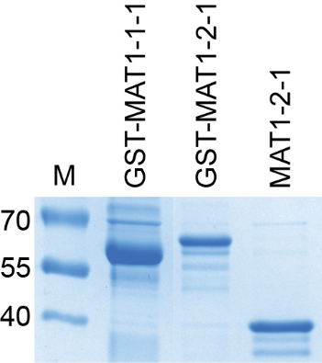
Supplementary Figure 2. 12% SDS-PAGE of purified heterogeneously produced GST-MAT1-1-1 and GST-MAT1-2-1 proteins. MAT1-2-1 was loaded on the gel, after removal of the GST-tag. The predicted molecular weights are: 64.8 kDa (GST-MAT1-1-1), 60 kDa (GST-MAT1-2-1) and 34.5 kDa (MAT1-2-1). Molecular marker (M) is indicated in kDa. Gel was stained with Coomassie blue stain.

Supplementary Figure 3

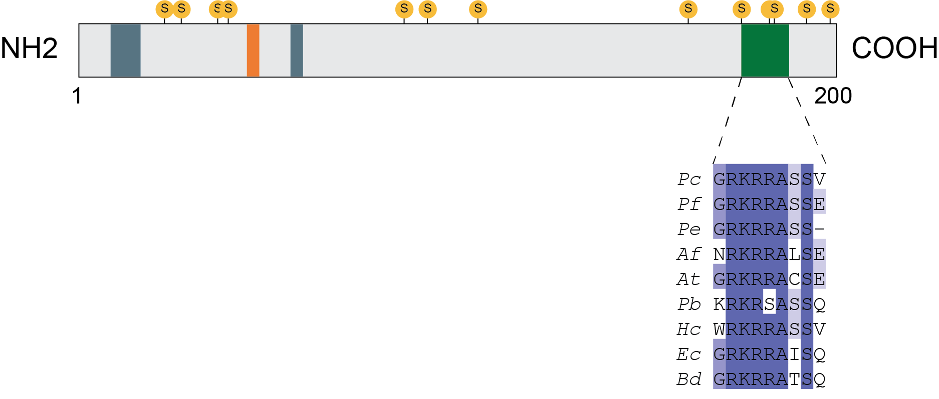

Supplementary Figure 3. Schematic representation of the linear structure of Tom1. The putative protein binding sites (blue), the linear PPxY (x = any amino acid) motif (orange) and putative phosphorylation sites (yellow) are indicated. The cut-value was set as 0.8. The conserved nuclear localization signals (NLS) is shown in green. This motif is conserved in other species belonging to Eurotiomycetes. Tom1 protein sequences from representative species Pc, Penicillium chrysogenum; Pf, P. flavigenum; Pe, P. expansum, Af, Aspergillus fumigatus; At, A. terreus; Pb, Paracoccidioides brasiliensis; Hc, Histoplasma capsulatum; Ec, Emmonsia crescens; Bd, Blastomyces dermatitidis. The putative protein binidng sites were predicted by online tool (https://predictprotein.org/). Putative phosphorylation residues were identified by NetPhos 3.1 server (Blom et al., 1999). The conserved nuclear localization signal (NLS) located at the C-terminus of Tom1 was identified previously (Ramsak et al., 2021).

Supplementary Figure 4

Supplementary Figure 4. Fluorescence microscopic localization of EGFP-Tom1 and EGFP. (A) In Δtom1::EGFP-Tom1 transformants tom1 localizes to the nucleus in conidia. Arrowheads indicate nuclei. (B) P2niaD18::EGFP transformants were used as a negative control. GFP fluorescence shows that enhanced green fluorescence protein (EGFP) is evenly distributed in the cytoplasm. Abbreviations: DIC, differential interference contrast; GFP, green fluorescence protein. Scale bars, 20 μm.

Supplementary Tables
Supplementary Table 1. Bacterial and fungal strains used in this study.
Strain | Genotype | Reference
E.coli
XL1-Blue MRF’ | recA1, endA1, gyrA96, thi1, hsdR17, supE44,relA1, lac-, [F’ proAB, laclqZΔM15, Tn10(tet^{r})] | (Jerpseth et al., 1992)
BL21-Gold (DE3)pLysS | E. coli B F– ompT hsdS(r_{B}– m_{B}–) dcm⁺ Tet^{r} gal λ(DE3) endA Hte [pLysS Cam^{r}] | Agilent Technologies
S. cerevisiae
PJ69-4a | MATa, TRP1-901, LEU2-3, 112, URA3-52, his3-200, gal4Δ, gal80Δ,GAL2UAS-GAL2TATA-ADE2, LYS2::GAL1UAS-GAL1TATA-HIS3, MET2::GAL7UAS GAL7TATA-lacZ | (James et al., 1996)
PJ69-4α | MATα, TRP1-901, LEU2-3, 112, URA3-52, his3-200, gal4Δ, gal80Δ,GAL2UAS-GAL2TATA-ADE2, LYS2::GAL1UAS-GAL1TATA-HIS3, MET2::GAL7UAS GAL7TATA-lacZ | (James et al., 1996)
P. chrysogenum
P2niaD18 | Penicillin producer, niaD⁻ (MAT1-1-1 idiomorph) | (Hoff et al., 2008)
ΔPcku70 | P2niaD18; ΔPcku70::FRT; niaD⁻ | (Kopke et al., 2010)
PC3 | Wild type (MAT1-2-1 idiomorph) | (Böhm et al., 2013)
MAT1-ChIP | P2niaD18; Pgpd::EGFP::MAT1-1-1::TtrpC; nat1; niaD⁻ | (Becker et al., 2015)
P2niaD18::EGFP | P2niaD18; Pgpd::EGFP::TtrpC; ble; niaD⁻ | this study
P2niaD18::EGFP-tom1 | P2niaD18; Pgpd::EGFP-tom1::TtrpC; ble; niaD⁻ | this study
Δtom1 | ΔPcku70; Δtom1::nat1::TtrpC; niaD⁻ | this study
Δtom1::EGFP-tom1 | ΔPcku70; Δtom1::nat1, Pgpd::EGFP-tom1, ble; niaD⁻ | this study
P2niaD18 + Ptom1::DsRed | P2niaD18; Ptom1::DsRed::TtrpC; ble; niaD⁻ | this study
EGFP-MAT1 + Ptom1::DsRed | P2niaD18; Ptom1::DsRed::TtrpC; Pgpd::EGFP::MAT1-1-1::TtrpC; nat1; ble; niaD⁻ | this study
EGFP-MAT1 + Ptom1₍₋₁₄₉₎::DsRed | P2niaD18; Ptom1₍₋₁₄₉₋₉₆₅₎::DsRed::TtrpC; Pgpd::EGFP::MAT1-1-1::TtrpC; nat1; ble; niaD⁻ | this study
EGFP-MAT1 + Ptom1 ₍₋₂₂₂₎::DsRed | P2niaD18; Ptom1₍₋₂₂₂₋₉₆₅₎::DsRed::T_{trpC}; P_{gpd}::EGFP::MAT1-1-1::T_{trpC}; nat1; ble; niaD⁻ | this study

Supplementary Table 2. Oligonucleotides used in this study.
Oligonucleotide | Sequence (5’-3’)
BR-1 | GGAGTTGCAAGGAGTCGATATTGCTC
BR-2 | CCTAACTTTGCCCAAGCAAGGTGGAT
BR-3 | GGCAAGTCGCAATACTTCTT
BR-4 | CCACAGGCTCCTGCATTAAC
PtrpC_seq_r (TD-340) | CTCCACTAGCTCCAGCCAAG
nat1_seq_f (TD-341) | GGCGCTCTACATGAGCATG
5‘-Flanke Pc20g00090_IF_f (KB-306) | CGGTACCACGCATGCTGCAGCGAGATGCAGATGAACTTGC
5‘-Flanke Pc20g00090_IF_r (KB-307) | CACGAATTCTGGATCCGTGATATGACCAGAGTGAAG
3‘-Flanke Pc20g00090_IF_f (KB-308) | ATTCGTCGACAAGCTTCTATGAGCTGTTCCGTGAG
3‘-Flanke Pc20g00090_IF_r (KB-309) | TAGAATACAGCGGCCGCCGATCCACCATATCACATGC
tom1_KpnI_f | CTCAGGTACCATGATGCCTCCATCAGAC
tom1_EcoRI_r | CGCAGAATTCGGATTCATGAGACCAGGG
TtrpC reverse | AGCTGACATCGACACCAACG
BspHI-MAT1-2-1_f | TATATTCATGATGGCGAAAACCCTCTTG
MAT1-2-1-EcoRI_r | ATATAGAATTCTTAGAACACGCTGTTCATAGGG
EMSA
tom1-2 | TCACGTGATCTCTATTGAGAACAATAGAA
kex2-3 | GCTTATTCAAACAGAAGCTAATTCCTTTG
In vivo dsRed expression study
Pc20g00090_dsRed_ApaI_f | ATAGGGCCCCGAGATGCAGATGAACTT
Pc20g00090_dsRed_HindIII | CGACGAAGCTTGTGATATGACCAGAGTGA
Pc20g00090_753_ds Red_HindIII | CCGAAGCTTGCTATTGTTCATGGGG
Pc20g00090_826_ds Red_HindIII | ACGTAAGCTTCGTTACGGGCCATTGAC
Yeast two-hybrid analysis
mat1-2_for_NdeI | ACTGCATATGGGACTTGACCTCGGTGATC
MAT1-2-1_Nt_rev | ATAACATATGATGATGGCGAAAACCCTCTTG
MAT-1-2-1-BD_rev_EcoRI | GATTGAATTCCTAAGAAGGGCGACGAGG
mat1-2_rev_EcoRI | TTGAGAATTCTTAGAACACGCTGTTCATAG
mat1-1-250_rev_STOP | TCACTCGAGCTAGTTGTTATCGATGCAGTGC
mat1-1-109_for | GCTAAGAATTCATGCAGAATGTACTGTCCTCTCCT
mat1-1_rev | CAGACTCGAGCTAGTTGTGCCCAAAGATCC

Supplementary Table 3. Plasmids used in this study.
Plasmid | Characteristics | Reference/Source
pD-NAT1 | PtrpC promoter from A. nidulans, nat1 resistance gene of Streptomyces noursei; used for construction of KO-EN45_061320 | (Kück and Hoff, 2006)
KO-EN45_061320 | Deletion plasmid for tom1 (EN45_061320)  5’ flank tom1, trpC(p)::nat1, 3’ flank, tom1 ura3, bla | this study
Yas1_ptrpC-phleo-egfp | Pgpd of A. nidulans, egfp, TtrpC of A. nidulans, ble resistance gene of Streptoalluteichus hindustanus; used for construction of pGFP-tom1_ble | Mahmoudjanlou  (Unpublished data)
pGFP-Tom1_ble | Pgpd of A. nidulans, egfp, tom1 gene of P. chrysogenum, TtrpC of A. nidulans, ble resistance gene of Streptoalluteichus hindustanus; used for localization and complementation studies | this study
In vivo dsRed expression study
pDsRed | dsRed gene of Discosoma sp., TtrpC of A. nidulans | (Becker et al., 2015)
pDsRed_Ptom1 | P_{tom1} ₍₀₋₁₀₀₀₎ of P. chrysogenum, dsRed gene of Discosoma sp., TtrpC of A. nidulans, ble resistance gene of Streptoalluteichus hindustanus | this study
pDsRed_Ptom1(-149) | P_{tom1(-149-1000)} of P. chrysogenum, dsRed gene of Discosoma sp., TtrpC of A. nidulans, ble resistance gene of Streptoalluteichus hindustanus | this study
pDsRed_Ptom1(-222) | P_{tom1(-222-1000)} of P. chrysogenum, dsRed gene of Discosoma sp., TtrpC of A. nidulans, ble resistance gene of Streptoalluteichus hindustanus | this study
Protein expression
pGEX-MAT1-1-1 | MAT1-1-1 cDNA sequence of P. chrysogenum; used for heterologous expression of a GST-MAT1-1-1 | (Becker et al., 2015)
pGEX-MAT1-2-1 | MAT1-2-1 cDNA sequence of P. chrysogenum; used for heterologous expression of a GST-MAT1-2-1 | this study
Yeast Two-hybrid analysis
pGADT7 | bait vector for yeast one-hybrid analysis,  S. cerevisiae PADH1 and TADH1, gal4-AD (aa 768-881), LEU2, amp^{r} | Clontech
pGBKT7 | pray vector for yeast one-hybrid analysis,  S. cerevisiae PADH1 and TADH1, gal4-BD (aa 1-147), TRP1, kan^{r} | Clontech
pA-RanBPM | ranbpm cDNA (aa 51-654) in pGADT7, LEU2, amp^{r} | (Tucker et al., 2009)
pA-MAT1-NtBD | MAT1-1-1 cDNA (aa 1-220) in pGADT7, LEU2, amp^{r} | this study
pA-MAT1-CtBD | MAT1-1-1 cDNA (aa 109-342) in pGADT7, LEU2, amp^{r} | this study
pA-MAT2 | MAT1-2-1 cDNA (aa 1-303) in pGADT7, LEU2, amp^{r} | this study
pA-MAT2-Nt | MAT1-2-1 cDNA (aa 1-131) in pGADT7, LEU2, amp^{r} | this study
pB-MAT1-Nt | MAT1-1-1 (aa 1-118) in pGBKT7, TRP1, kan^{r} | Wolfers  (unpublished data)
pB-MAT1-NtBD | MAT1-1-1 (aa 1-220) in pGBKT7, TRP1, kan^{r} | this study
pB-MAT2-Nt | MAT1-2-1 (aa 1-131) in pGBKT7, TRP1, kan^{r} | this study
pB-MAT2-NtBD | MAT1-2-1 (aa 1-207) in pGBKT7, TRP1, kan^{r} | this study

References
Becker, K., Beer, C., Freitag, M., and Kück, U. (2015). Genome-wide identification of target genes of a mating-type α-domain transcription factor reveals functions beyond sexual development. Mol Microbiol 96: 1002–1022.
Böhm, J., Hoff, B., O’Gorman, C. M., Wolfers, S., Klix, V., Binger, D., et al. (2013). Sexual reproduction and mating-type–mediated strain development in the penicillin-producing fungus Penicillium chrysogenum. Proc Natl Acad Sci U S A 110: 1476–1481.
Hoff, B., Pöggeler, S., and Kück, U. (2008). Eighty years after its discovery, Fleming’s Penicillium strain discloses the secret of its sex. Eukaryot Cell 7: 465–470.
James, P., Halladay, J., and Craig, E. A. (1996). Genomic libraries and a host strain designed for highly efficient two-hybrid selection in yeast. Genetics 144: 1425–1436.
Jerpseth, B., Greener, A., Short, J., Viola, J., and Kretz, P. (1992). XL1-blue MRF’ E. coli cells: McrA-, McrCB-, mcrF-, Mmr-, HsdR- derivative of XL1-blue cells. Strategies 5, 81–83.
Kopke, K., Hoff, B., and Kück, U. (2010). Application of the Saccharomyces cerevisiae FLP/FRT recombination system in filamentous fungi for marker recycling and construction of knockout strains devoid of heterologous genes. Appl Environ Microbiol 76: 4664–4674.
Kück, U., Hoff, B. (2006). Application of the nourseothricin acetyltransferase gene (nat1) as dominant marker for the transformation of filamentous fungi. Fungal Genet Newsl 53: 9–11.
Tucker, C. L., Peteya, L. A., Pittman, A. M. C., and Jing, Z. (2009). A genetic test for yeast two-hybrid bait competency using RanBPM. Genetics 182: 1377–1379.

