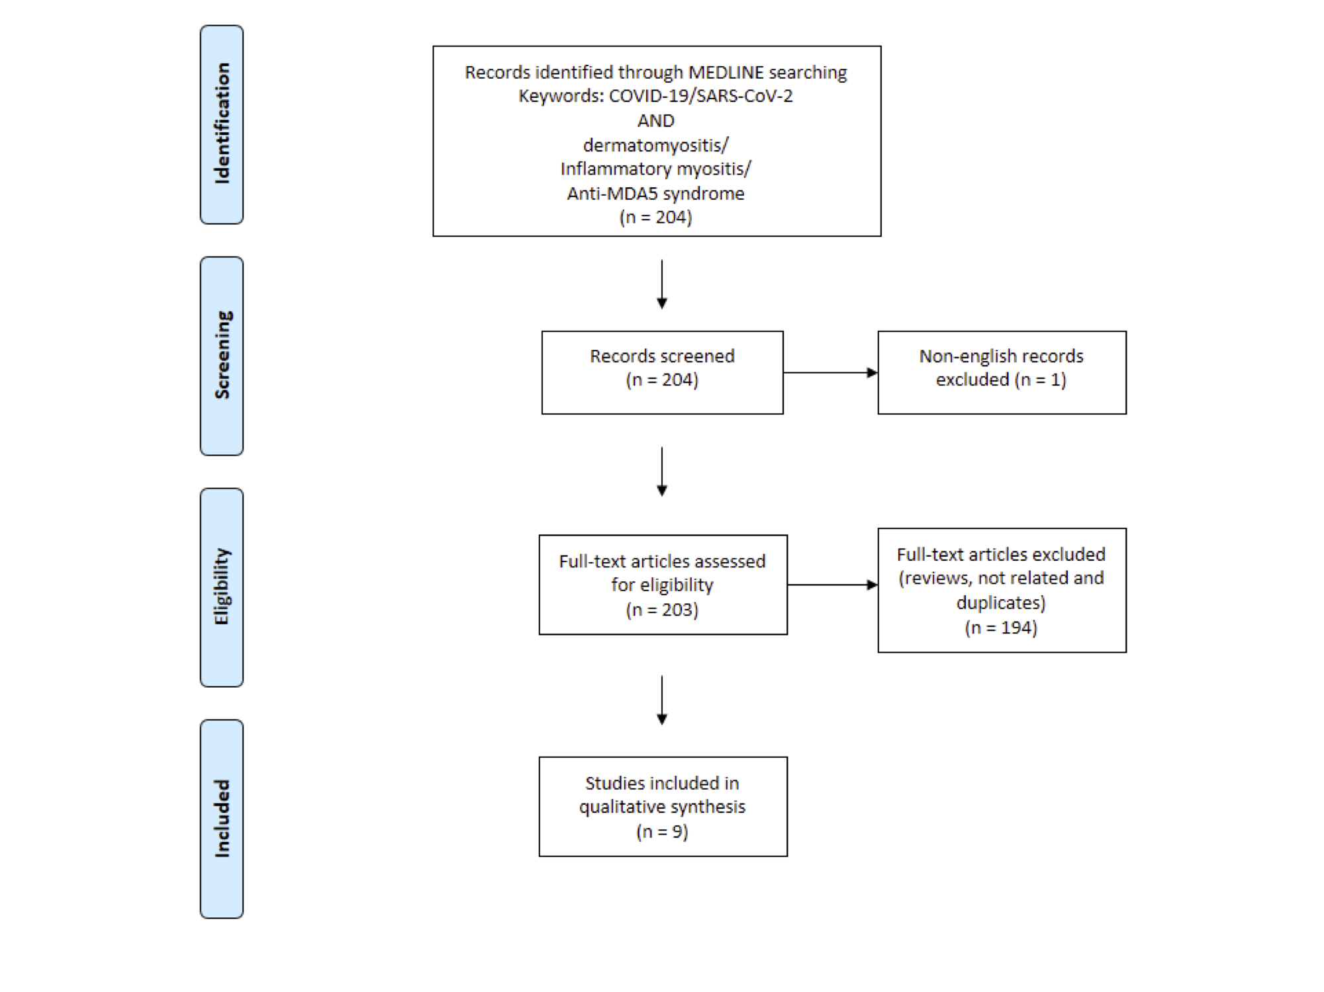**Supplementary Figure 1.** Flowchart showing the study selection process according to preferred reporting items for systematic reviews and meta-analyses (PRISMA).