**Additional file 1**

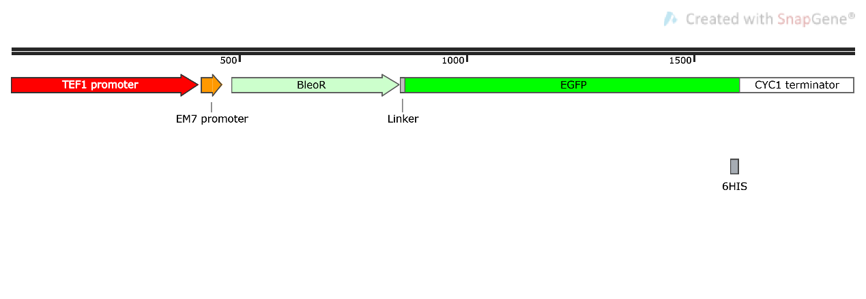

**Figure S1**. Map of basic frame (BF). The total length of BF is 1851 bp. Elements of BF include: TEF1 promoter, EM7 promoter, BleoR, EGFP and CYC1 terminator. BleoR, zeocin resistance gene; EGFP, enhanced green fluorescent protein.

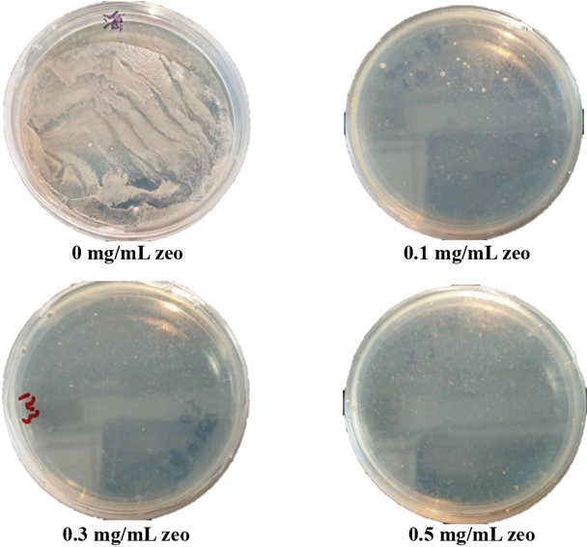

**Figure S2**. The screening of zeocin resistance concentration.

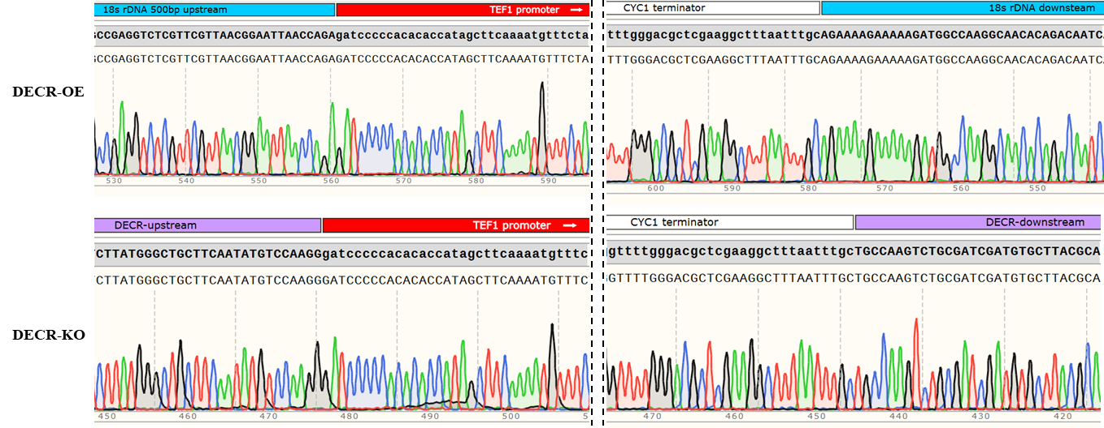

**Figure S3.** Partial fragment alignment of transformants’ genome sequencing peaks. Created with SnapGene software.