Supplementary Figure

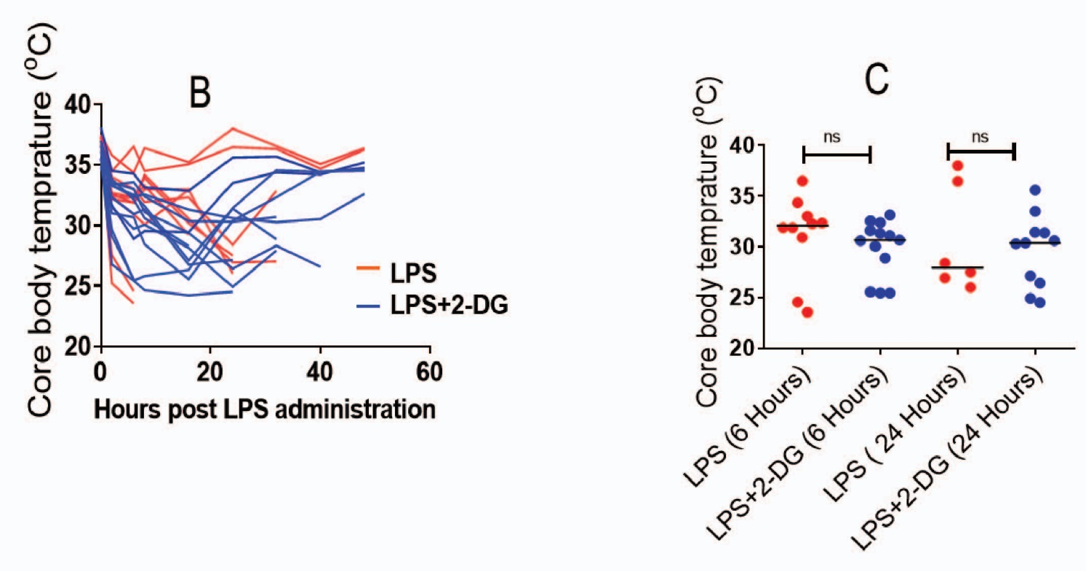
Supplementary Figure 1. Dietary 2-DG enhanced the recovery of mice from LPS induced hypothermia. A. Core body temperature kinetics. B. Core body temperature of mice at 6 hr and 24 hr showing the fall and recovery of temperature during the hypothermic shock.

