**APPENDIX-1**

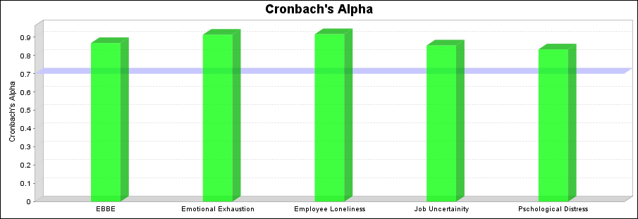

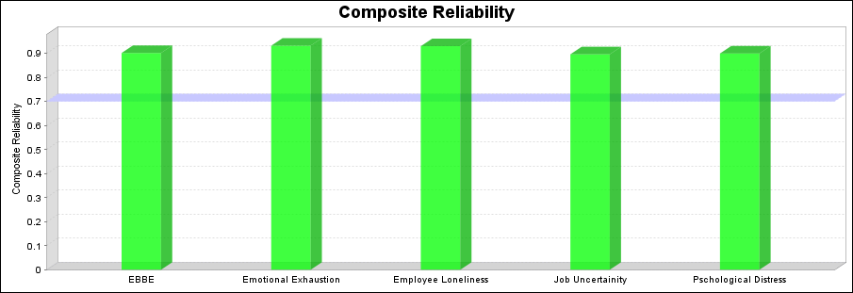

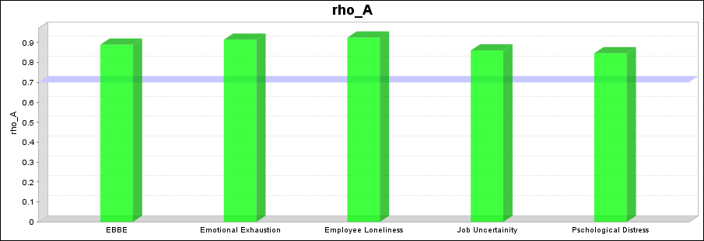

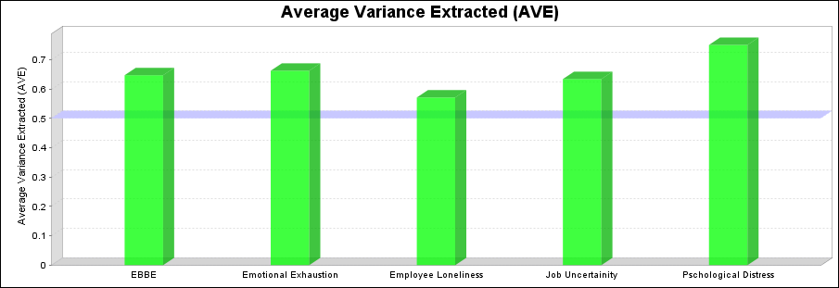

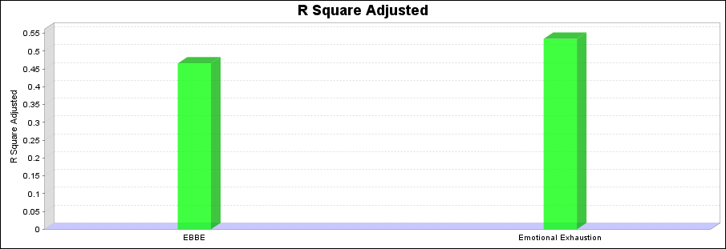

**APPENDIX-2**

**Demographic Information**

|  |  |  |  |
| --- | --- | --- | --- |
| **Categories** | **Subcategories** | **Numbers** | **Percentage** |
| Gender | Male | 263 | 57.3 |
| Female | 196 | 42.7 |
| Age | 26-33 years | 107 | 23.3 |
| 33-40 years | 157 | 34.3 |
| 40-47 years | 118 | 25.7 |
| 48 years or above | 77 | 16.7 |
| Degree | Intermediate | 94 | 20.5 |
| Bachelor | 107 | 23.4 |
| Master | 187 | 40.7 |
| PhD | 18 | 3.9 |
|  | Any other | 53 | 11.5 |