**SUPPLEMENTARY FIGRUES**

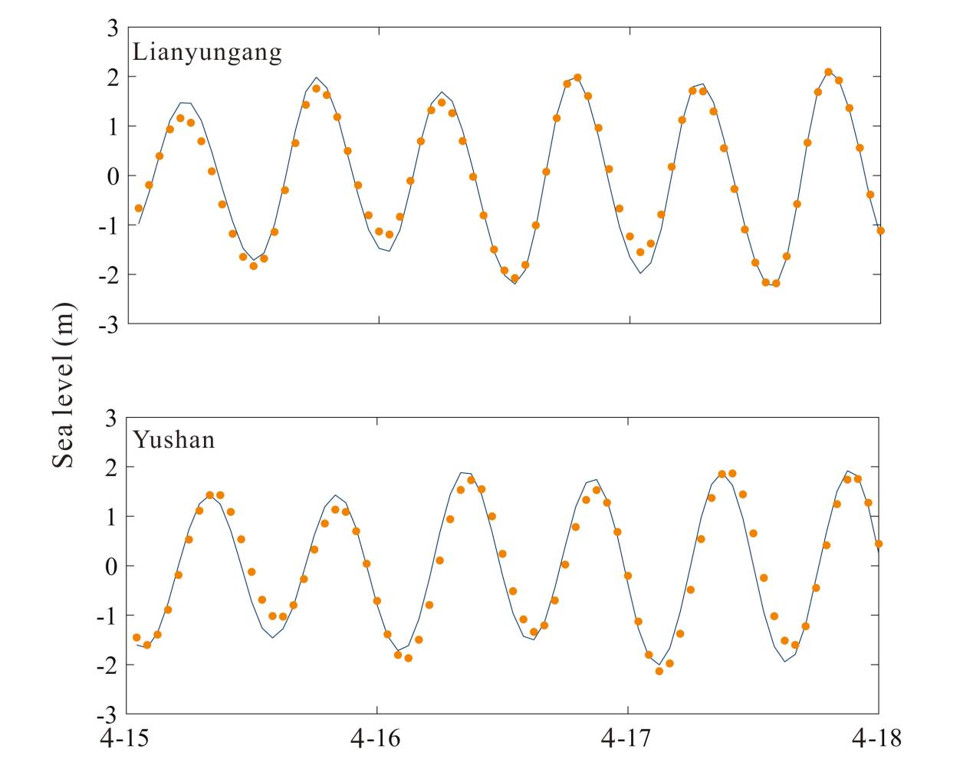

Figure S1 Comparison of sea level height retrieved by simulated values and tide gauge data at Lianyungang station and Yushan station in 2018. Solid line is the output of model, and yellow point is the hourly sea level data of tidal stations.

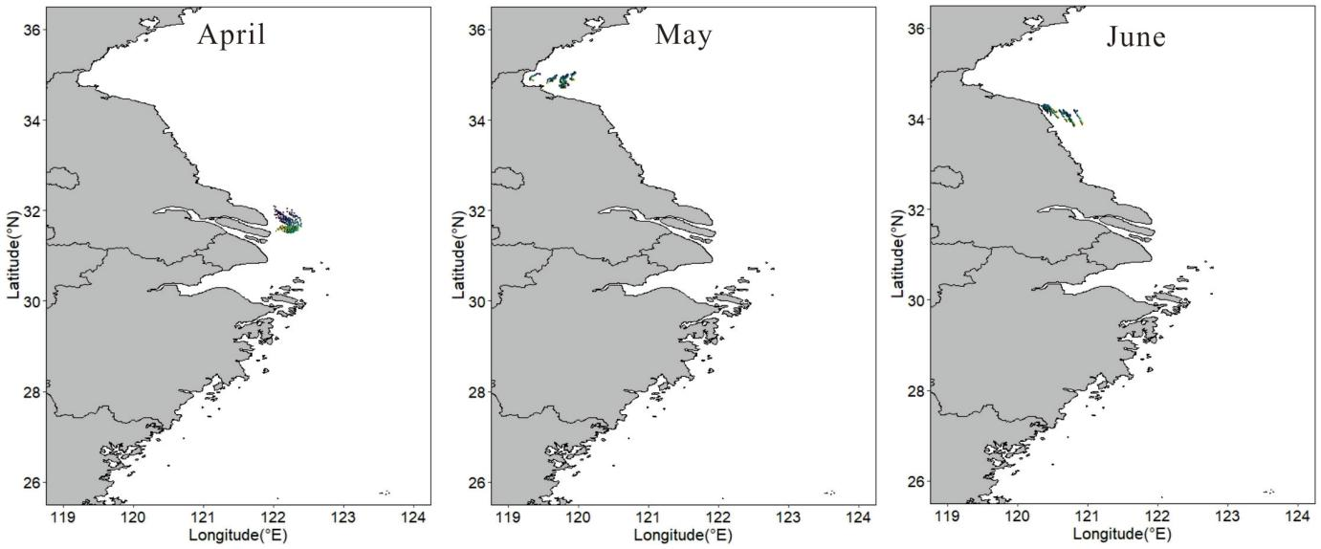

(a)

(b)

(c)

Figure S2. Representative particle trajectories from releasing points (selected based on spawning suitability) in April (a), May (b), and June (c) respectively.

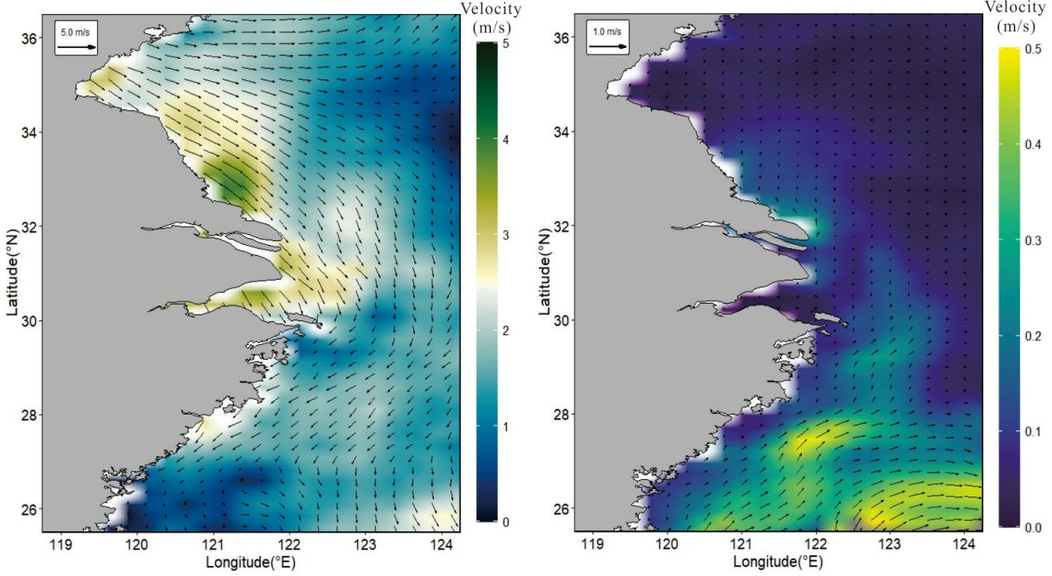

(a)

(b)

Figure S3 Spatial distribution of (a) wind fields, and (b) ocean currents in May 2018. The contour surface color represents their velocities.