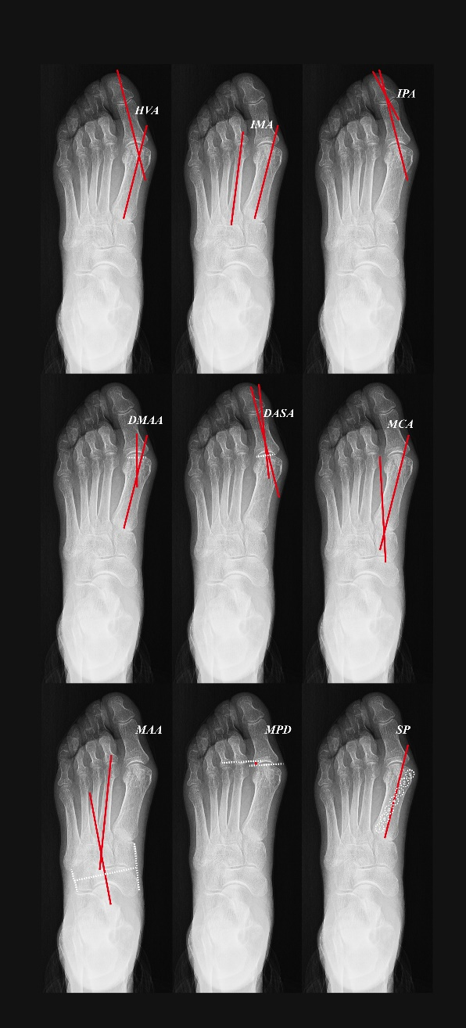

Sup-Fig 1. The radiographic measurements. HVA: Hallux Valgus Angle, IMA: Inter-Metatarsal Angle, IPA: Inter-Phalangeal Angle, DMAA: Distal Metatarsal Articular Angle, DASA: Distal Articular Set Angle, MCA: Metatarsal Cuneiform Angle, MAA: Metatarsal Adducent Angle, MPD: Metatarsal Protrusion Distance, SP: Sesamoid Position



Sup-Fig 2. QQ plots for radiographic data. HVA: Hallux Valgus Angle, IMA: Inter-Metatarsal Angle, IPA: Inter-Phalangeal Angle, DMAA: Distal Metatarsal Articular Angle, DASA: Distal Articular Set Angle, MCA: Metatarsal Cuneiform Angle, MAA: Metatarsal Adducent Angle, MPD: Metatarsal Protrusion Distance, SP: Sesamoid Position