Supplementary Material

**Appendix A.**

**Supplementary Table S1.** Source of reference government documents

|  |  |  |  |
| --- | --- | --- | --- |
| **File name** | **Publishing department** | **Time** | **File sources** |
| Technical Guidelines for the Evaluation of Resource and Environmental Carrying Capacity and Suitability of Territorial Spatial Development | Ministry of Natural Resources, PRC | 2020 | http://gi.mnr.gov.cn/202001/t20200121_2498502.html |
| Ecological Protection Red Line Delineation Guide | Ministry of Ecology and Environment, PRC | 2017 | https://www.mee.gov.cn/gkml/hbb/bgt/201707/t20170728_418679.htm |
| Provincial Territorial Spatial Planning Preparation Guide | Ministry of Natural Resources, PRC | 2020 | http://gi.mnr.gov.cn/202001/t20200120_2498397.html |
| Outline of the Yangtze River Delta Regional Integrated Development Plan | General Office of the State Council, PRC | 2019 | http://www.gov.cn/zhengce/2019-12/01/content_5457442.htm |
| Draft of Overall Planning for National Space of Green Ecological Integration Development Demonstration Zone in Yangtze River Delta (2019-2035) | Municipal Bureau of Planning and Natural Resources of SH, JS and ZJ | 2020 | http://ghzyj.sh.gov.cn/ghgs/20200617/970bdc96c4f8425c8ab0aa57438a6622.html |
| National Nature Reserve List | Ministry of Ecology and Environment, PRC | 2017 | http://www.gov.cn/guoqing/2019-04/09/content_5380702.htm |
| National Ecological Function Zoning (Edited Version) | Ministry of Ecology and Environment, PRC | 2015 | https://www.mee.gov.cn/gkml/hbb/bgg/201511/t20151126_317777.htm |
| List of famous historical and cultural towns and villages in China | Ministry of Housing and Urban-Rural Development, PRC | 2019 | http://www.gov.cn/xinwen/2019-01/31/content_5362691.htm |
| Nature Reserve List of SH, JS and ZJ | Department of Ecology and Environment, JS and ZJ; Environmental Protection Agency, SH | 2014 | <https://lhsr.sh.gov.cn/shszrbhqml/;>https://www.mee.gov.cn/ywgz/zrstbh/zrbhdjg/201309/t20130927_260959.shtml; https://www.mee.gov.cn/ywgz/zrstbh/zrbhdjg/201208/t20120824_235188.shtml |
| List of Wetlands of Provincial Importance in JS | People's Government, JS | 2020 | http://www.jiangsu.gov.cn/ |
| Centralized Drinking Water Source Protection Areas above the County Level to Divide the Program, JS; Drinking Water Source Protection Regulations, ZJ | Department of Ecology and Environment, JS and ZJ | 2018 | <http://www.jiangsu.gov.cn/art/2009/1/6/art_46143_2543889.html;> http://sthjt.zj.gov.cn/art/2021/4/23/art_1201918_58927918.html |
| Qingpu District Statistical Yearbook, SH; Wujiang District Statistical Yearbook, JS; Jiashan County Statistical Yearbook, SZ | SH, Suzhou and Jiaxing People's Government | 2015 | <https://www.shqp.gov.cn/stat/tjzltjnj/;> <http://www.wujiang.gov.cn/zgwj/wjtjnj/2015/index.html;> |
| Jiashan County Ecological Protection Red Line; Jiashan County key areas exceed the standard flood defense plan | Jiashan County People's Government | 2020 | http://www.jiashan.gov.cn/art/2020/7/31/art_1229199806_2948184.html |
| Shanghai Ecological Protection Red Line | People's Government, SH | 2018 | https://www.shanghai.gov.cn/newshanghai/xxgkfj/file3242.pdf |
| Water Resources Bulletin of SH, Jiaxing and Suzhou | Water Authority of SH, Jiaxing and Suzhou | 2015 | <http://swj.sh.gov.cn/szy/;> <http://www.suzhou.gov.cn/szsrmzf/;> http://slj.jiaxing.gov.cn/art/2016/7/12/art_1229147749_49410202.html |

PRC: the People’s Republic of China; SH: Shanghai; JS: Jiangsu Province; ZJ: Zhejiang Province.

**Supplementary Table S2.** Evaluation criteria of aquatic ESs supply assessment

|  |  |  |  |  |  |
| --- | --- | --- | --- | --- | --- |
| **ES Index (unit)** | **Value ranks and descriptions** | | | | |
| Superior (9) | High (7) | Moderate (5) | Low (3) | Lower (1) |
| Soil seepage(%) | 0-0.2 | 0.2-0.4 | 0.4-0.6 | 0.6-0.8 | 0.8-1 |
| Production land types | Forest | Rivers  Lakes | Grassland  Paddy field | Dry land  Unused land | Construction  land |
| Distance from drinking water sources (m) | ≤1000 | 1000-2000 | 2000-3500 | 3500-6000 | ≥6000 |
| Water areas（km2） | ≥60 | 24-60 | 14-24 | 3-14 | 0-3 |
| Areas of impermeable surfaces (km2) | ≤7 | 7-20 | 20-80 | 80-140 | ≥140 |
| Flood inundation scope | Restricted navigable water level | 10-year flood level | 20-year flood level | 50-year flood level | Other areas |
| NDVI (%) | 0-22 | 22-44 | 44-56 | 56-80 | ≥80 |
| Distance from wetland (m) | 0 | 0-1000 | 1000-2000 | 2000-5000 | ≥5000 |
| Habitat quality | Superior | High | Moderate | Low | Lower |
| Distance from biodiversity maintenance areas (m) | 0 | 0-1000 | 1000-2000 | 2000-5000 | ≥5000 |
| Distance from waterside historical sites and traditional villages (m) | ≤200 | 200-500 | 500-1000 | 1000-2000 | ≥2000 |
| Distance from historical waterway recreation (m) | 0 | 0-200 | 200-500 | 500-1000 | ≥1000 |
| Visibility of river and lake landscapes | Superior | High | Moderate | Low | Lower |

In the evaluation model, the individual indicator was transferred to ArcGIS 10.7 and divided into five ranks according to the natural breakpoint method to map the spatial distribution of the assessment results of aquatic ESs in the study area (Shen et al, 2021)[1].

**Supplementary Table S3.** Sources and application methods of aquatic ESs indicators

|  |  |  |  |
| --- | --- | --- | --- |
| **Indicator** | **Index** | **Source** | **Data Processing** |
| Aquatic water supply | Soil seepage | National Tibet Plateau Data Center 1: 1,000,000 China Soil Data Set (http://data.tpdc.ac.cn/) | Selecting the seepage field of China Soil Data Set based on HWSD to characterize the indicator |
| Production land types | LULC Data, Institute of Geographic Sciences and Natural Resources Research, CAS (http://www.igsnrr.ac.cn/) | Dividing the land use type into forest, grassland, paddy field, rivers and lakes, dry land, unused land and construction land to characterize the indicator |
| Distance from drinking water sources | Division Scheme of Centralized Drinking Water Source Protection Areas in Jiangsu Province [(http://sthjt.js.gov.cn/)](http://sthjt.jiangsu.gov.cn/), Regulations of Zhejiang Province on the Protection of Drinking Water Sources [(http://sthjt.zj.gov.cn)](http://sthjt.zj.gov.cn/) | Taking the spatial location of drinking water sources as the center, the buffer zones are analyzed to characterize the indicator. The radius of buffer zones is determined according to the protection scope of each water source. |
| Flood regulation | Water areas | LULC Data, Institute of Geographic Sciences and Natural Resources Research, CAS (http://www.igsnrr.ac.cn/) | Extracting water patches from land use data, calculating the area of water patches and grading it to characterize the indicator |
| Areas of impermeable surfaces | Extracting urban built-up area patches from land use data, calculating the area of these patches and grading it to characterize the indicator |
| Flood inundation scope | Prevention Plan for Excessive flood in Key Areas of Jiashan County (http://www.jiashan.gov.cn), Prevention Plan for Excessive flood of Jiangsu Province(http://jswater.jiangsu.gov.cn/), Prevention Plan for Excessive Flood in Taihu Lake (http://swj.sh.gov.cn/) | Counting the average value of restricted navigation, 10-year, 20-year and 50-year flood water levels in the study area as the threshold, and the space higher than the threshold altitude is successively screened through the raster calculator tool in ArcGIS based on DEM, so as to characterize the indicator |
| Water purification | NDVI | Geospatial Data Cloud (http://www.gscloud.cn/) | classifying by the natural breakpoint method to characterize the indicator |
| Distance from wetland | Jiashan ecological protection red line(http://www.jiashan.gov.cn/), Wujiang ecological protection red line(http://www.wujiang.gov.cn/), Qingpu ecological protection red line(http://www.qingpu.gov.cn/) | Taking the spatial location of wetland as the center, the buffer zones are analyzed to characterize the indicator. The radius of buffer zones is determined according to the protection scope of each wetland patch |
| Aquatic biodiversity maintenance | NPP Maintenance Capability Index | Geospatial Data Cloud (http://www.gscloud.cn/) | $${NPP}_{index}={NPP}_{mean}×F_{pre}×F_{tem}×(1-F_{alt})$$*NPPindex* represents NPP maintenance capability index, ${NPP}_{mean}$ is the mean perennial net primary productivity, $F_{pre}$ is the average annual precipitation factor, $F_{tem}$ is mean perennial temperature factor, and $F_{alt}$ is the altitude factor. |
| Distance from biodiversity maintenance areas | Regional Planning of Ecological Space Management and Control in Jiangsu Province (http://www.jiangsu.gov.cn/), List of Nature Reserves in Shanghai (https://lhsr.sh.gov.cn/) | Taking the spatial location of biodiversity maintenance areas as the center, identifying the buffer zones to characterize the indicator |
| Cultural landscape resources | Distance from waterside historical remains and traditional villages | Draft of Overall Planning for National Space of Green Ecological Integration Development Demonstration Zone in Yangtze River Delta (2019-2035) | Taking the spatial location of waterside historical remains and traditional villages as the center, identifying the buffer zones to characterize the indicator |
| Aquatic recreation potential | Distance from historical waterway recreation | Draft of Overall Planning for National Space of Green Ecological Integration Development Demonstration Zone in Yangtze River Delta (2019-2035) | Taking the spatial location of historical waterway as the center, identifying the buffer zones to characterize the indicator |
| Number of visual river and lake landscapes | LULC Data, Institute of Geographic Sciences and Natural Resources Research, CAS (http://www.igsnrr.ac.cn/) | The distance between each grid and the nearest water area is generated by the Euclidean Distance tool of ArcGIS, and then the Viewshed Analysis tool is used to calculate the number of rivers and lakes landscapes that can be viewed within the visual range of each grid |

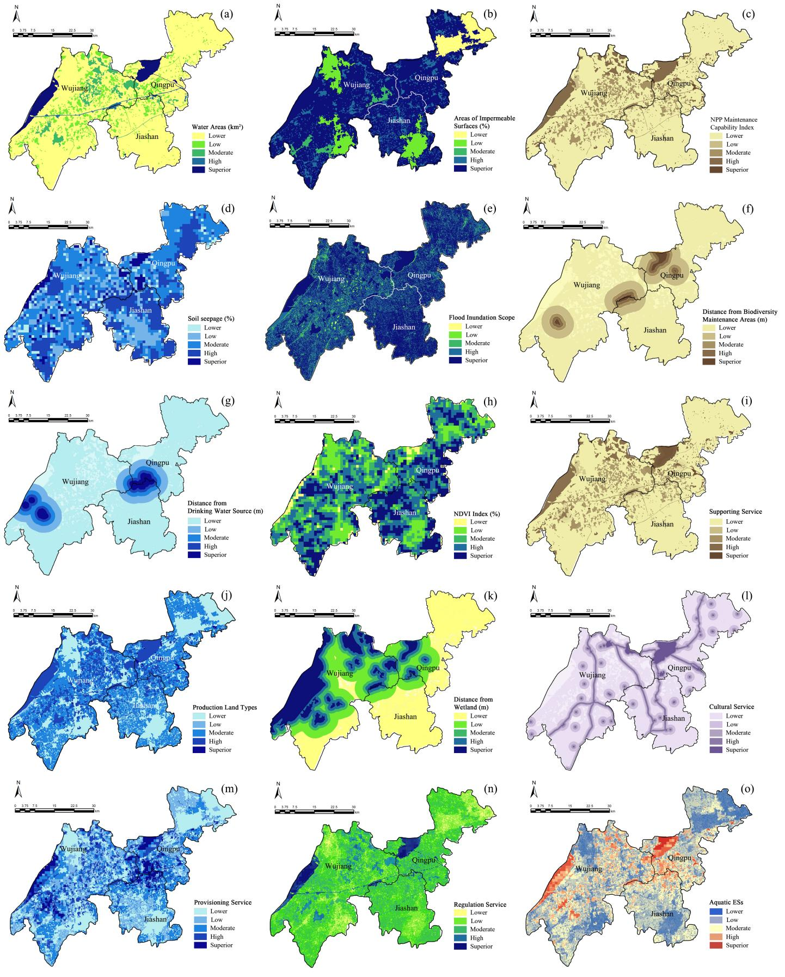

**Supplementary Figure S1**. Detailed results of aquatic ESs supply assessment: (a) Soil seepage; (b) Distance from drinking water source; (c) NPP Maintenance capability index; (d) Provisioning service; (e) Water areas; (f) Distance from wetland; (g) Flood inundation scope; (h) Areas of impermeable surfaces; (i) NDVI index; (j) Regulating service; (k) Distance from biodiversity maintenance areas; (l) Habitat quality; (m) Supporting service; (n) Cultural service; (o) Aquatic ESs

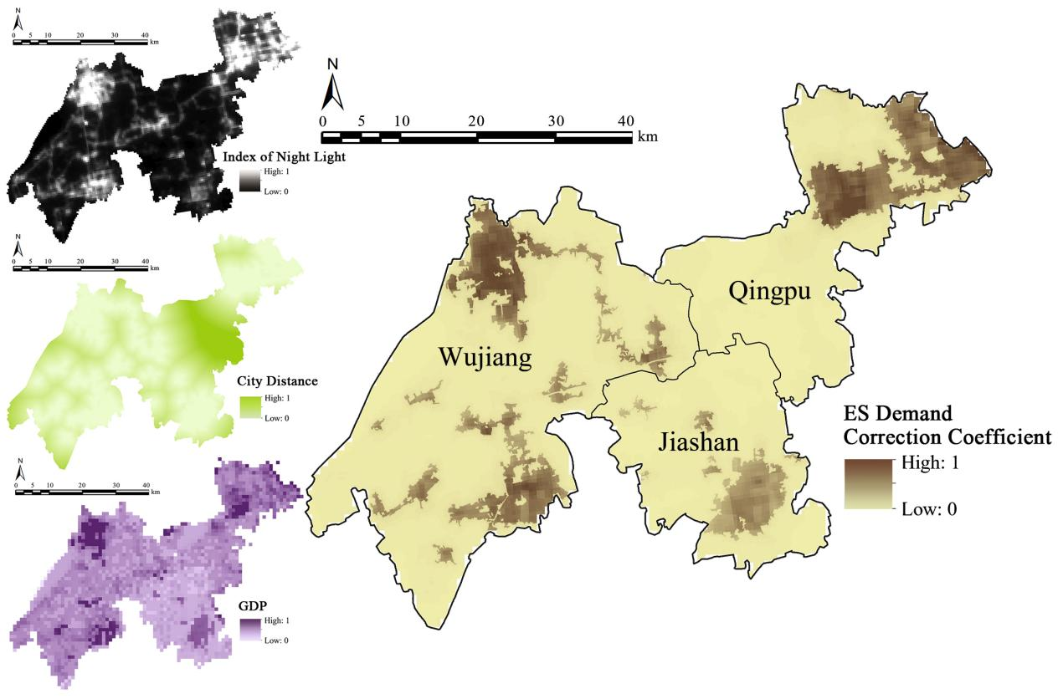

**Supplementary Figure S2**. Spatial heterogeneity correction coefficient of ESs demand

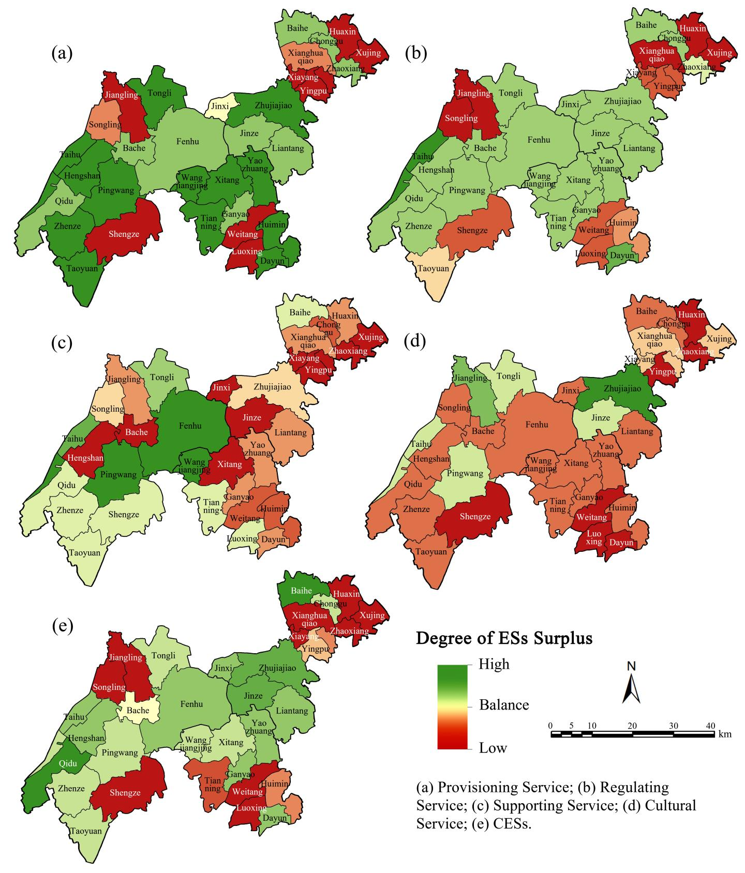

**Supplementary Figure S3**. Degree of individual ESs surplus

**Appendix B.** Design of experts’ questionnaire

Dear expert,

For the past years, rapid urbanization has transformed natural spaces into construction land dramatically, leading to the serious degradation of ecosystem services (ESs) capacity and imbalance between the ESs supply and demand. This circumstance has caused a series of ecological risks, threatening both ecological security and sustainable economic development. Thus, how to effectively and efficiently protect natural spaces and enhance the quantity and quality of ESs are of critical importance for spatial decisions under the background of land scarcity.

The study area is a typical waterside area at the junction of Jiangsu, Zhejiang and Shanghai (30°45'-31°17'E, 120°21'-121°19'N), whose administrative divisions include Qingpu, Wujiang and Jiashan, covering an area of 2143 km2. The study area provides necessary ESs for the Shanghai Metropolitan Area and is an important ecological buffer for the transition from Taihu Lake to rapidly urbanized areas. With the economic reform and opening up and the progress of rapid urbanization, the proportion of construction land in the study area has been increasing from 12.27% to 29.42% over the past 18 years, resulting in the severe loss of the traditional water network, which still accounts for 20.45% of the total area. Meanwhile, typical ecological risks caused by the extensive economic development mode in small town clusters should be mitigated urgently, such as ecological patches fragmentation, lower landscape connectivity, serious flood disasters, increased pollution emission, and wetland environment degradation. These environment problems have become key factors restricting the economic development and destroying the distribution of ecological spaces in the study area.

The purpose of this questionnaire is to determine the relative importance of each indicator in the aquatic ESs assessment to the study area. According to your experience, please take the 9-degree method to score each indicator based on its importance. The purpose of this questionnaire is to obtain more authoritative opinions and information. We guarantee that the data obtained will be used for academic research, and we promise to keep your personal information confidential.

Thank you for your support!

Below, please judge the importance of these ESs types and indicators in the study area, and assign the corresponding weight score:

Scoring description:

—1: i and j are equally important.

—3: i is slightly more important than j.

—5: i is more important than j.

—7: i is much more important than j.

—9: i is absolutely more important than j.

—1/3: i is slightly less important than j.

—1/5: i is less important than j.

—1/7: i is much less important than j.

—1/9: i is absolutely less important than j.

The importance of ecosystem services:

|  |  |  |  |  |  |  |  |  |  |
| --- | --- | --- | --- | --- | --- | --- | --- | --- | --- |
| **i : j** | **9** | **7** | **5** | **3** | **1** | **1/3** | **1/5** | **1/7** | **1/9** |
| Provisioning service : Regulating service |  |  |  |  |  |  |  |  |  |
| Provisioning service : Supporting service |  |  |  |  |  |  |  |  |  |
| Provisioning service : Cultural service |  |  |  |  |  |  |  |  |  |
| Regulating service : Supporting service |  |  |  |  |  |  |  |  |  |
| Regulating service : Cultural service |  |  |  |  |  |  |  |  |  |
| Supporting service : Cultural service |  |  |  |  |  |  |  |  |  |

ESs importance—Regulating service:

Please evaluate the relative importance of the following two indicators for regulating service.

|  |  |  |  |  |  |  |  |  |  |
| --- | --- | --- | --- | --- | --- | --- | --- | --- | --- |
| **i : j** | **9** | **7** | **5** | **3** | **1** | **1/3** | **1/5** | **1/7** | **1/9** |
| Flood regulation: Water purification |  |  |  |  |  |  |  |  |  |

ESs importance—Cultural service:

Please evaluate the relative importance of the following two indicators for cultural service.

|  |  |  |  |  |  |  |  |  |  |
| --- | --- | --- | --- | --- | --- | --- | --- | --- | --- |
| **i : j** | **9** | **7** | **5** | **3** | **1** | **1/3** | **1/5** | **1/7** | **1/9** |
| Cultural landscape resources: Recreation potential |  |  |  |  |  |  |  |  |  |

ESs importance—Provisioning service—Water supply:

Please evaluate the relative importance of the following three indicators for water supply service.

|  |  |  |  |  |  |  |  |  |  |
| --- | --- | --- | --- | --- | --- | --- | --- | --- | --- |
| **i : j** | **9** | **7** | **5** | **3** | **1** | **1/3** | **1/5** | **1/7** | **1/9** |
| Soil seepage : Production land types |  |  |  |  |  |  |  |  |  |
| Soil seepage : Distance from drinking water sources |  |  |  |  |  |  |  |  |  |
| Production land types : Distance from drinking water sources |  |  |  |  |  |  |  |  |  |

ESs importance—Regulating service—Flood regulation:

Please evaluate the relative importance of the following three indicators for flood regulation service.

|  |  |  |  |  |  |  |  |  |  |
| --- | --- | --- | --- | --- | --- | --- | --- | --- | --- |
| **i : j** | **9** | **7** | **5** | **3** | **1** | **1/3** | **1/5** | **1/7** | **1/9** |
| Water areas : Areas of impermeable surfaces |  |  |  |  |  |  |  |  |  |
| Water areas : Flood inundation scope |  |  |  |  |  |  |  |  |  |
| Areas of impermeable surfaces : Flood inundation scope |  |  |  |  |  |  |  |  |  |

ESs importance—Regulating service—Water purification:

Please evaluate the relative importance of the following two indicators for water purification service.

|  |  |  |  |  |  |  |  |  |  |
| --- | --- | --- | --- | --- | --- | --- | --- | --- | --- |
| **i : j** | **9** | **7** | **5** | **3** | **1** | **1/3** | **1/5** | **1/7** | **1/9** |
| NDVI : Distance from wetland |  |  |  |  |  |  |  |  |  |

ESs importance—Supporting service—Aquatic biodiversity maintenance:

Please evaluate the relative importance of the following two indicators for aquatic biodiversity maintenance service.

|  |  |  |  |  |  |  |  |  |  |
| --- | --- | --- | --- | --- | --- | --- | --- | --- | --- |
| **i : j** | **9** | **7** | **5** | **3** | **1** | **1/3** | **1/5** | **1/7** | **1/9** |
| Habitat quality : Distance from biodiversity maintenance areas |  |  |  |  |  |  |  |  |  |

ESs importance—Cultural service—Recreation potential:

Please evaluate the relative importance of the following two indicators for recreation potential service.

|  |  |  |  |  |  |  |  |  |  |
| --- | --- | --- | --- | --- | --- | --- | --- | --- | --- |
| **i : j** | **1** | **3** | **5** | **7** | **9** | **1/3** | **1/5** | **1/7** | **1/9** |
| Distance from historical waterway recreation : Number of visual river and lake landscapes |  |  |  |  |  |  |  |  |  |

Thank you very much for your help! Your valuable comments and suggestions are welcome to help us.

1. Shen, J.K., Guo, X.L., and Wang, Y.C. (2021). Identifying and setting the natural spaces priority based on the multi-ecosystem services capacity index. Ecol Indic 125. doi: ARTN 10747310.1016/j.ecolind.2021.107473.