Supplementary Table 1: The mean (standard deviation) variance and signal-to-noise ratio of white matter regions of interest in RRMS participants from Dataset1 and Dataset2.
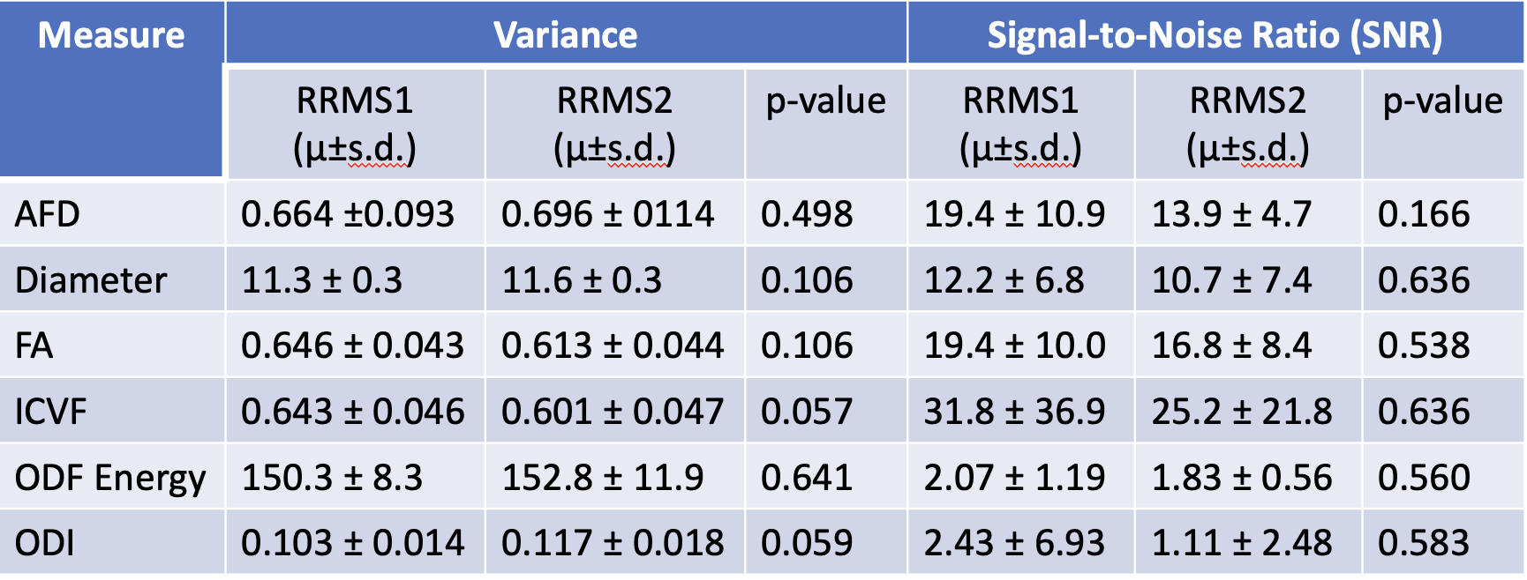
Note: AFD: apparent fiber density; FA: fractional anisotropy; ICVF: intracellular volume fraction; ODF: orientation density function; ODI: orientation dispersion index.

