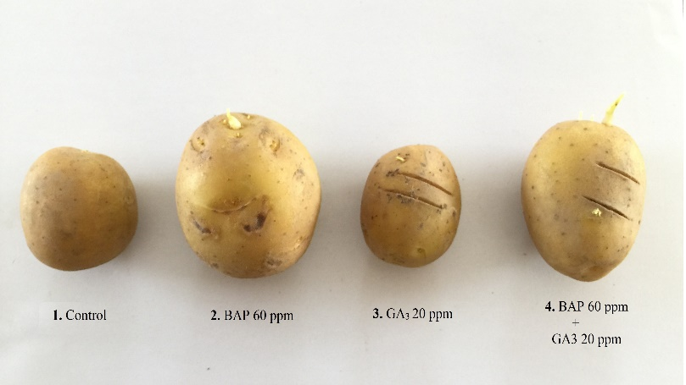 | 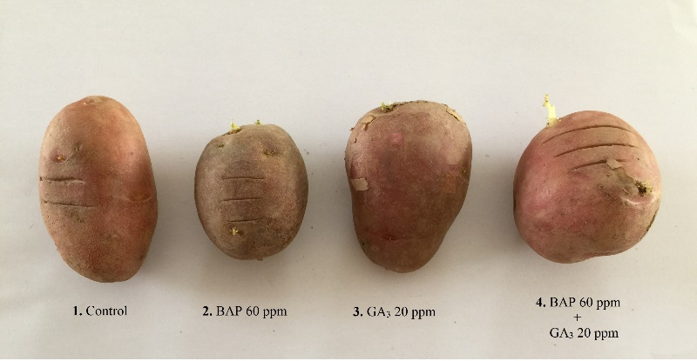
(A) The sprouting behavior of ‘FD51-5’ in response to BAP and GA₃ and their combination | (B) The sprouting behavior of ‘PRI Red’ in response to BAP and GA₃ and their combination
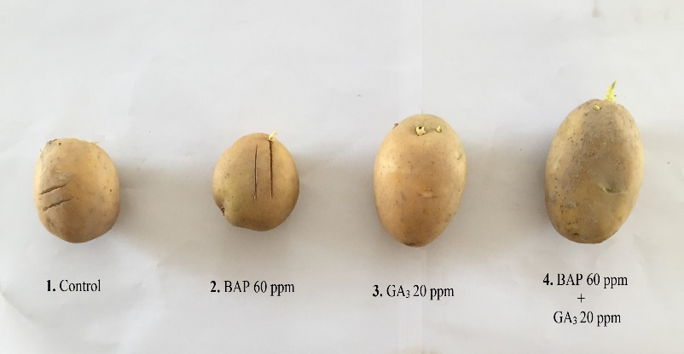 | 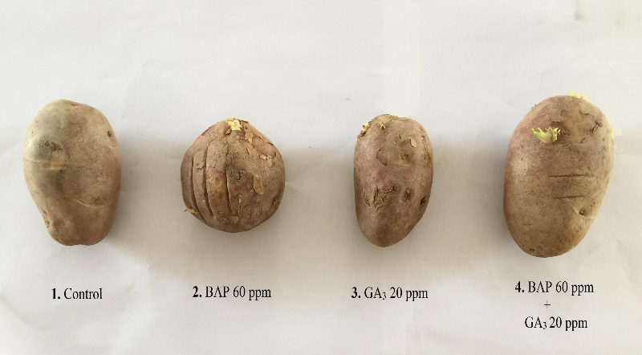
(C) The sprouting behavior of ‘Sante’ in response to BAP and GA₃ and their combination | (D) The sprouting behavior of ‘FD73-49’ in response to BAP and GA₃ and their combination
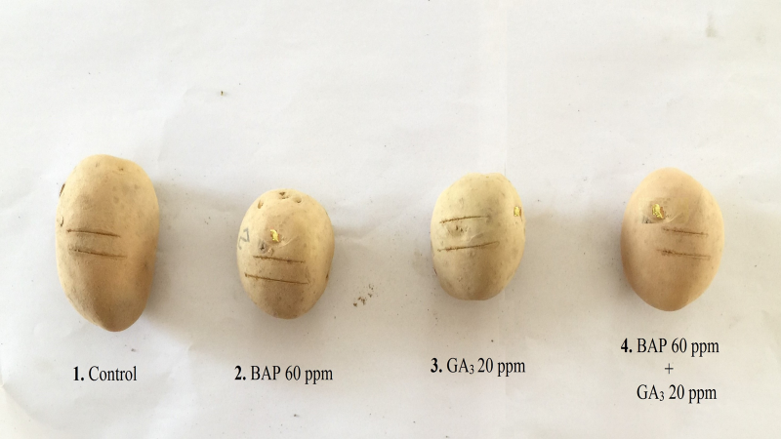 | 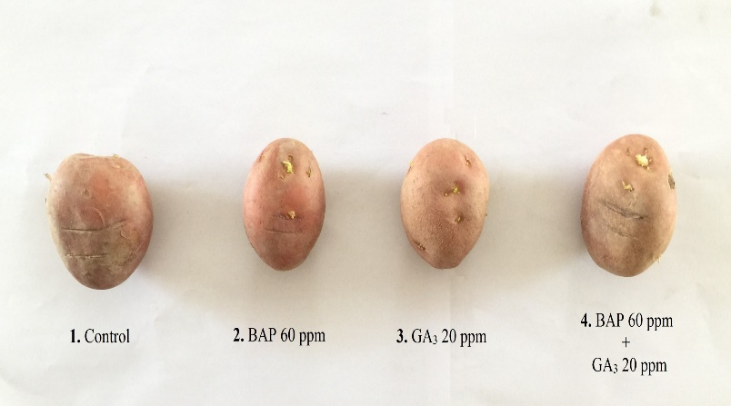
(E) The sprouting behavior of ‘FD69-1’ in response to BAP and GA₃ and their combination | (F) The sprouting behavior of ‘FD8-1’ in response to BAP and GA₃ and their combination
Supplementary data
Figure 1. Alone and Combined effect of BAP and GA₃ on sprouting behavior of six potato genotypes.

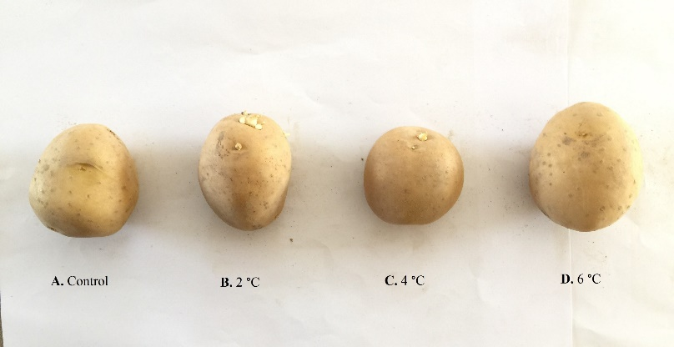 | 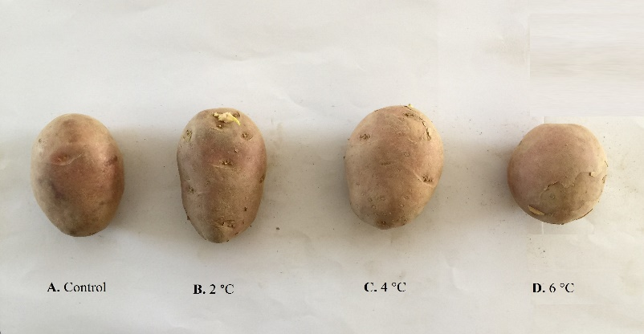
(A) The sprouting behavior of ‘FD51-5’ in response to low temperature shock | (B) The sprouting behavior of ‘PRI Red’ in response to low temperature shock
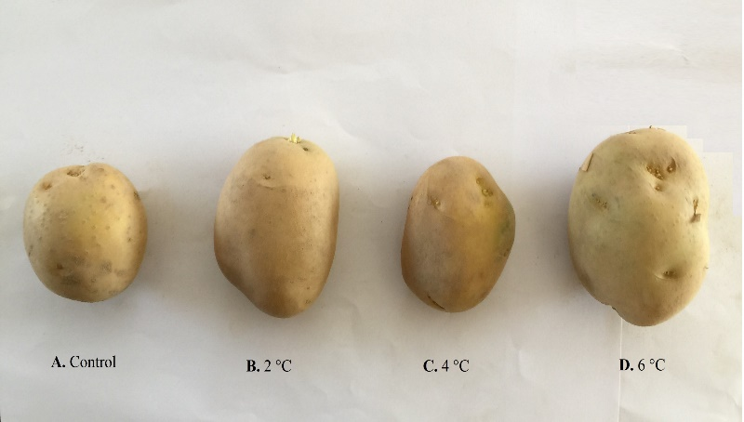 | 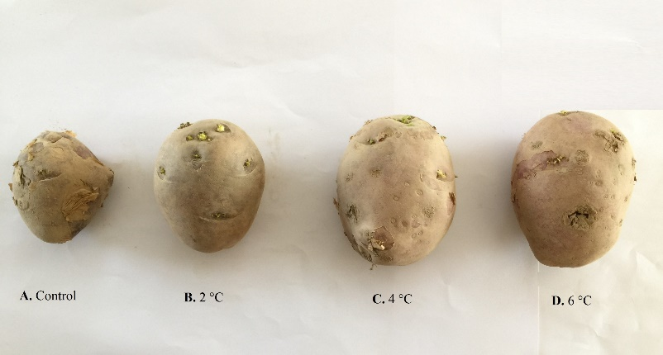
(C) The sprouting behavior of ‘Sante’ in response to low temperature shock | (D) The sprouting behavior of ‘FD73-49’ in response to low temperature shock
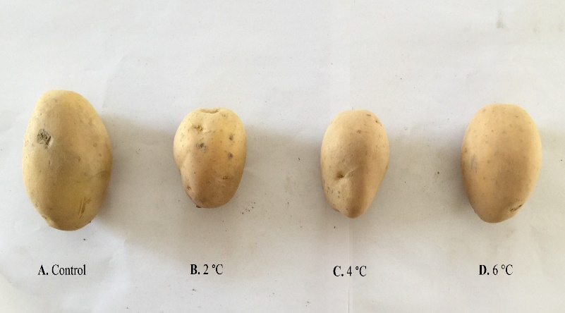 | 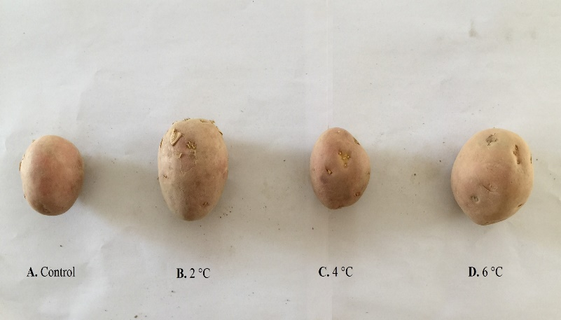
(E) The sprouting behavior of ‘FD69-1’ in response to low temperature shock | (F) The sprouting behavior of ‘FD8-1’ in response to low temperature shock

Figure 2. Effect of low temperature cold storage on sprouting behaviour of six potato genotypes.

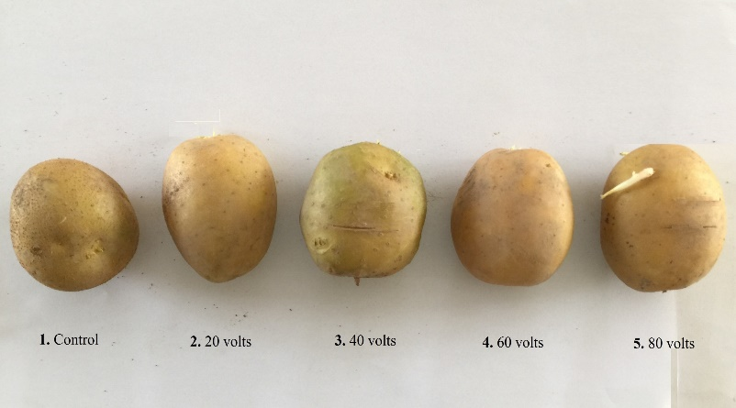
(A) The sprouting behavior of ‘FD51-5’ in response to BAP and GA₃ and their combination | (B) The sprouting behavior of ‘PRI Red’ in response to BAP and GA₃ and their combination
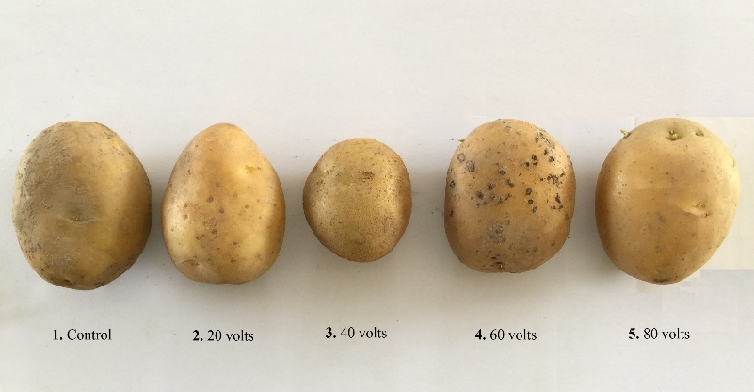 | 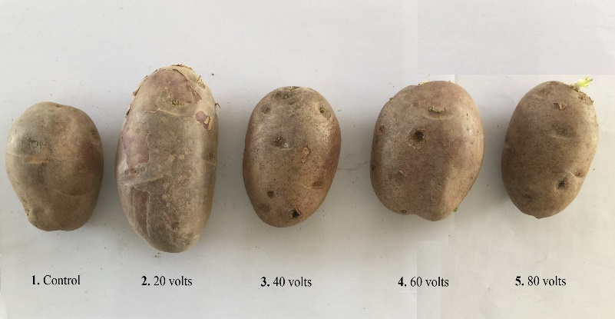
(C) The sprouting behavior of ‘Sante’ in response to BAP and GA₃ and their combination | (D) The sprouting behavior of ‘FD73-49’ in response to BAP and GA₃ and their combination
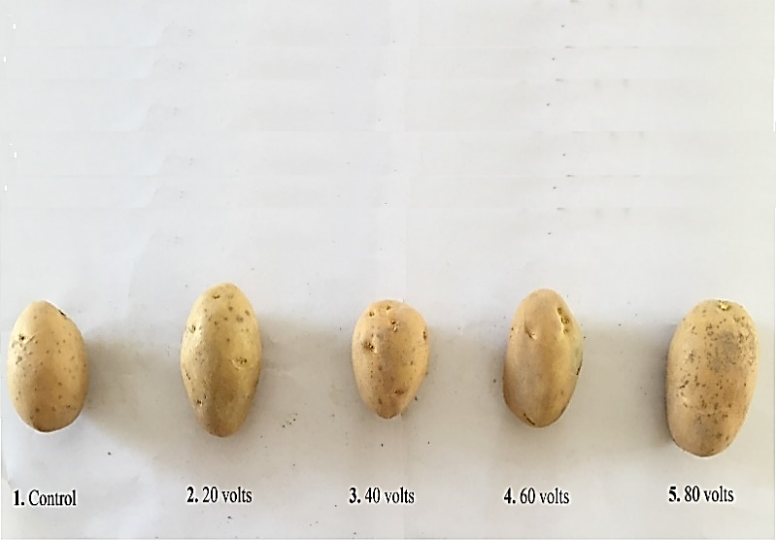 | 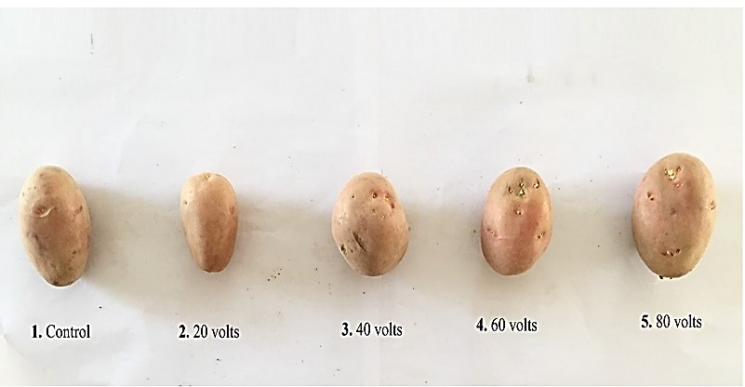
(E) The sprouting behavior of ‘FD69-1’ in response to BAP and GA₃ and their combination | (F) The sprouting behavior of ‘FD8-1’ in response to BAP and GA₃ and their combination
Figure 3. Effect of direct electric current on sprouting behavior of six potato genotypes.
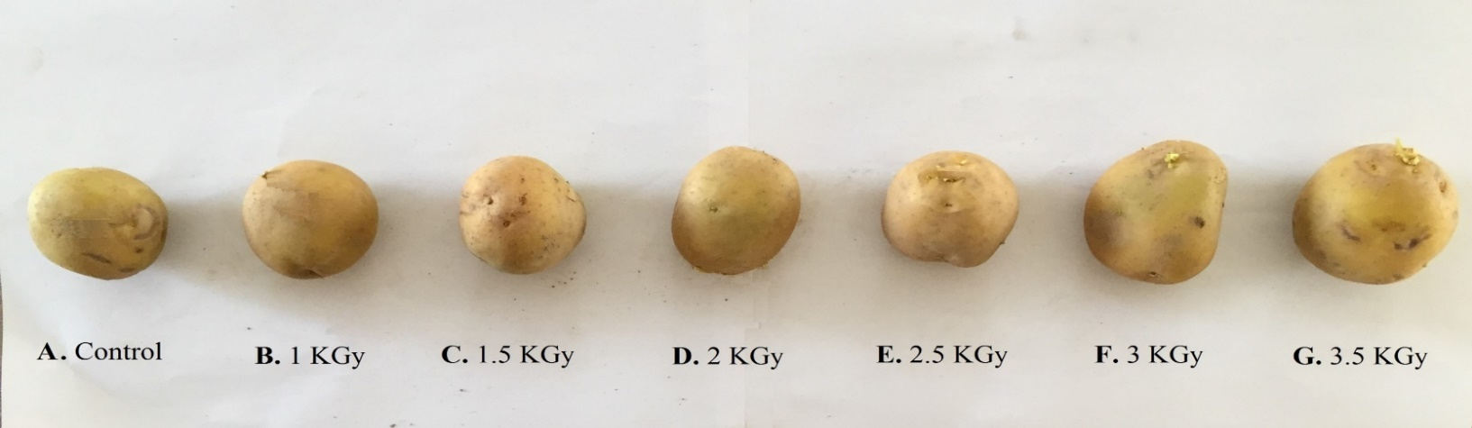
(A) The sprouting behavior of ‘FD51-5’ in response to irradiation
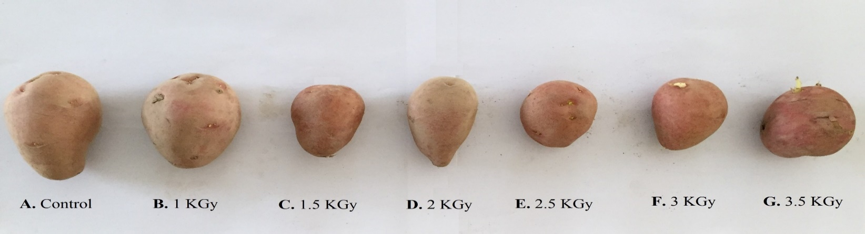
(B) The sprouting behavior of ‘PRI Red’ in response to irradiation
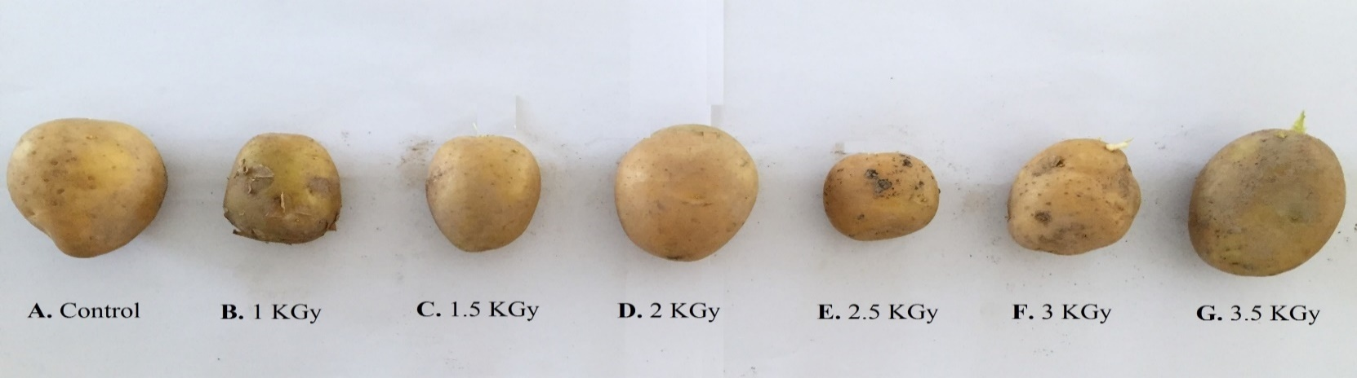
(C) The sprouting behavior of ‘Sante’ in response to irradiation
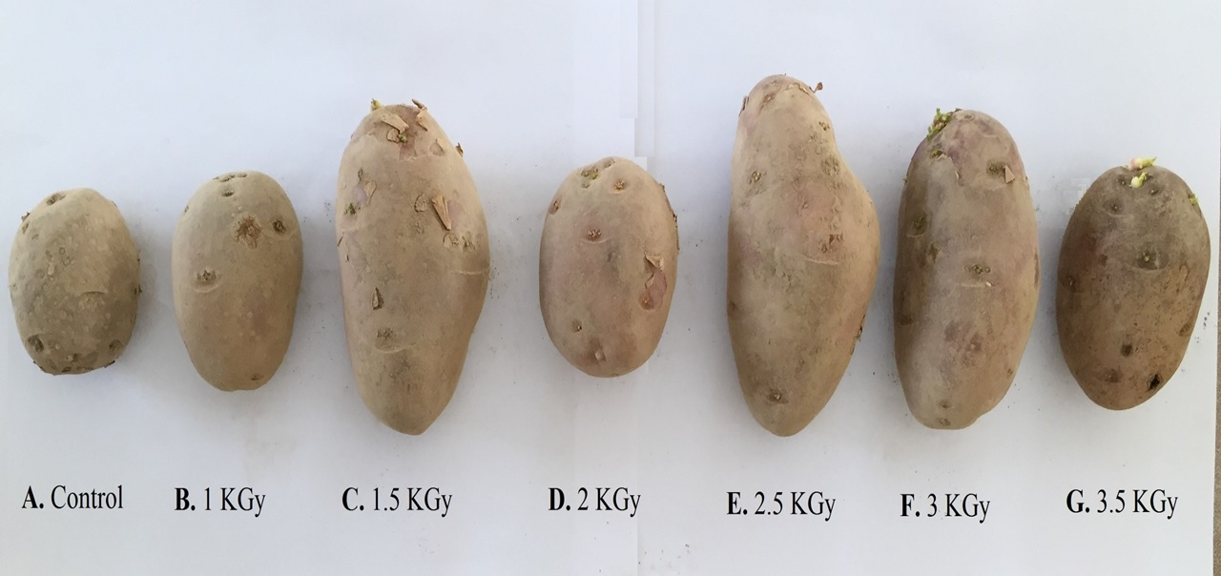
(D) The sprouting behavior of ‘FD73-49’ in response to irradiation
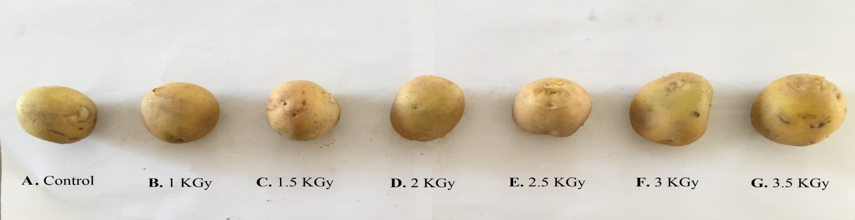
(E) The sprouting behavior of ‘FD69-1’ in response to irradiation
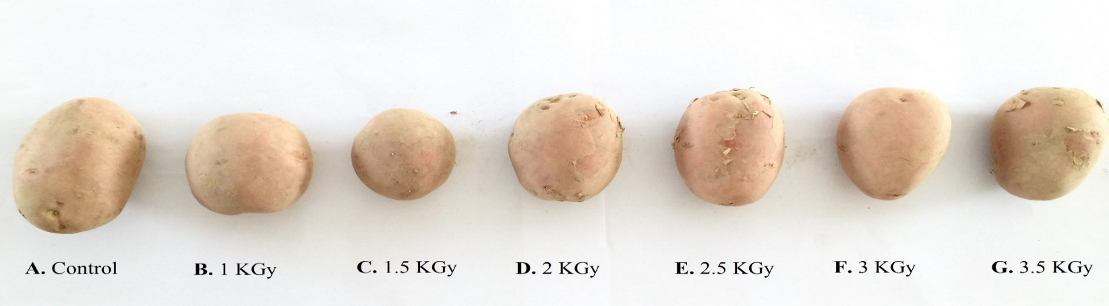
(F) The sprouting behavior of ‘FD8-1’ in response to irradiation
Figure 4. Effect of γ-radiations on sprouting behavior of six potato genotypes.

