Supplementary Material

## Supplementary Figures

## Figure S1.tif

## Supplementary Figure 1. Dolomite Saturation Index vs Calcite Saturation Index

HCO3-Na vs Ca-Na.tif

Mg-Na vs Ca-Na article.tif

Supplementary Figure 2- Mixing diagrams **(A)** Ca2+/Mg2+ versus HCO3−/Na+; **(B)** Ca2+/Mg2+ versus Mg2+/Na+ molar ratios in thermal and cold spring of Calabria region. End-members values from Liu & Hann, 2020.

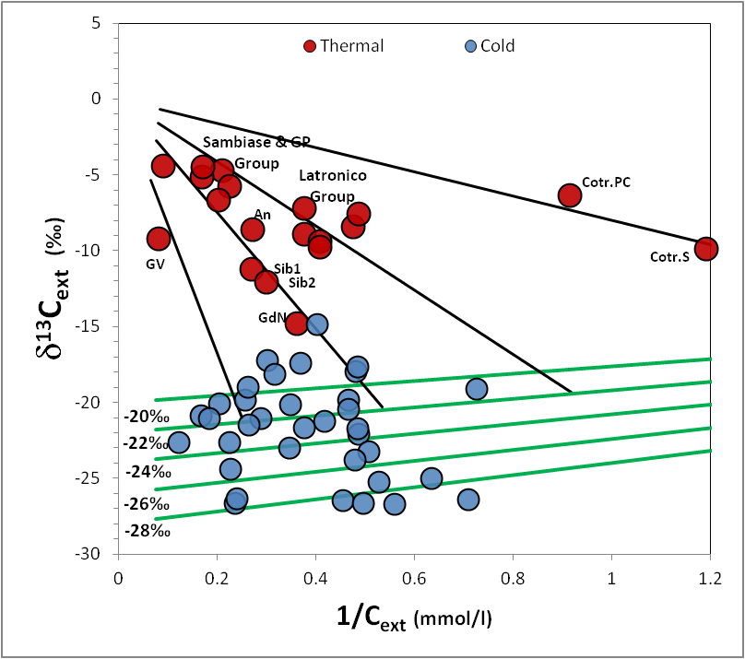

Supplementary Figure 3- 1/Cext versus δ13Cext diagram. The diagram allows the estimation of the infiltrating water end members with Cinf that is determined for different group of samples at the interception of the mixing lines connecting a defined deep end-member (1/Cext=0 and δ13Cdeep= 0.13 mean value for metamorphic CO2; Dai et al.,1996; Hunt, 1996; Clark and Fritz, 1997; Evans et al., 2008) with the infiltrating water line computed at δ13C= -22‰ (green line). This computations gives different Cinf values from 0.55 to 3.5 mmol/l on the base of hypothetical trend lines (black lines).