Supplementary Material

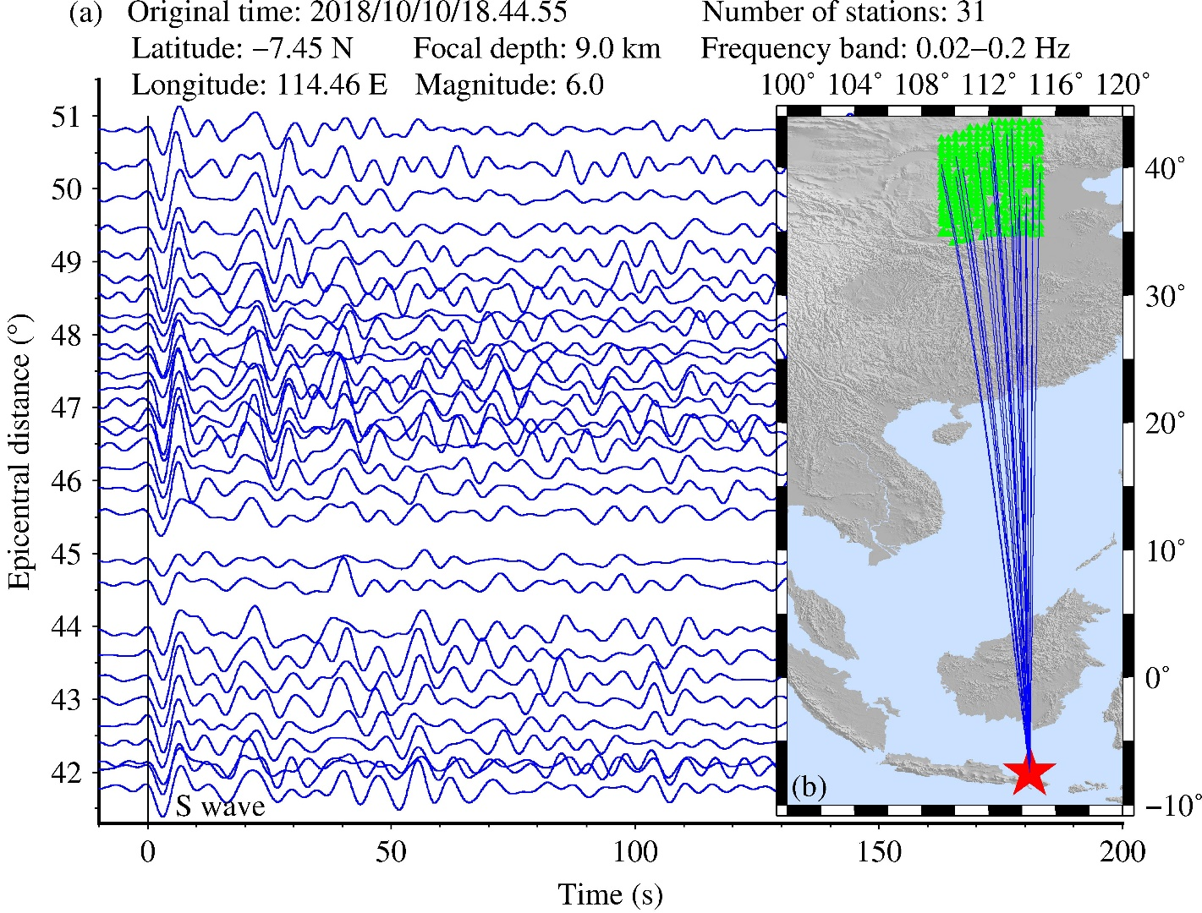

Supplementary Figure 1. (a) Waveforms of a selected earthquake recorded by 31 seismic stations. The focal parameters are labeled on the top of figure. These waveforms are filtered with the frequency band of 0.02-0.2 Hz. The arriveltimes of S wave are shifted to 0 s. (b) Ray paths of the waveforms shown in (a). The red star shows the epicenter. The blue lines indicate the ray paths of the waveform shown in (a). The green triangles are the seismic stations used in this study.

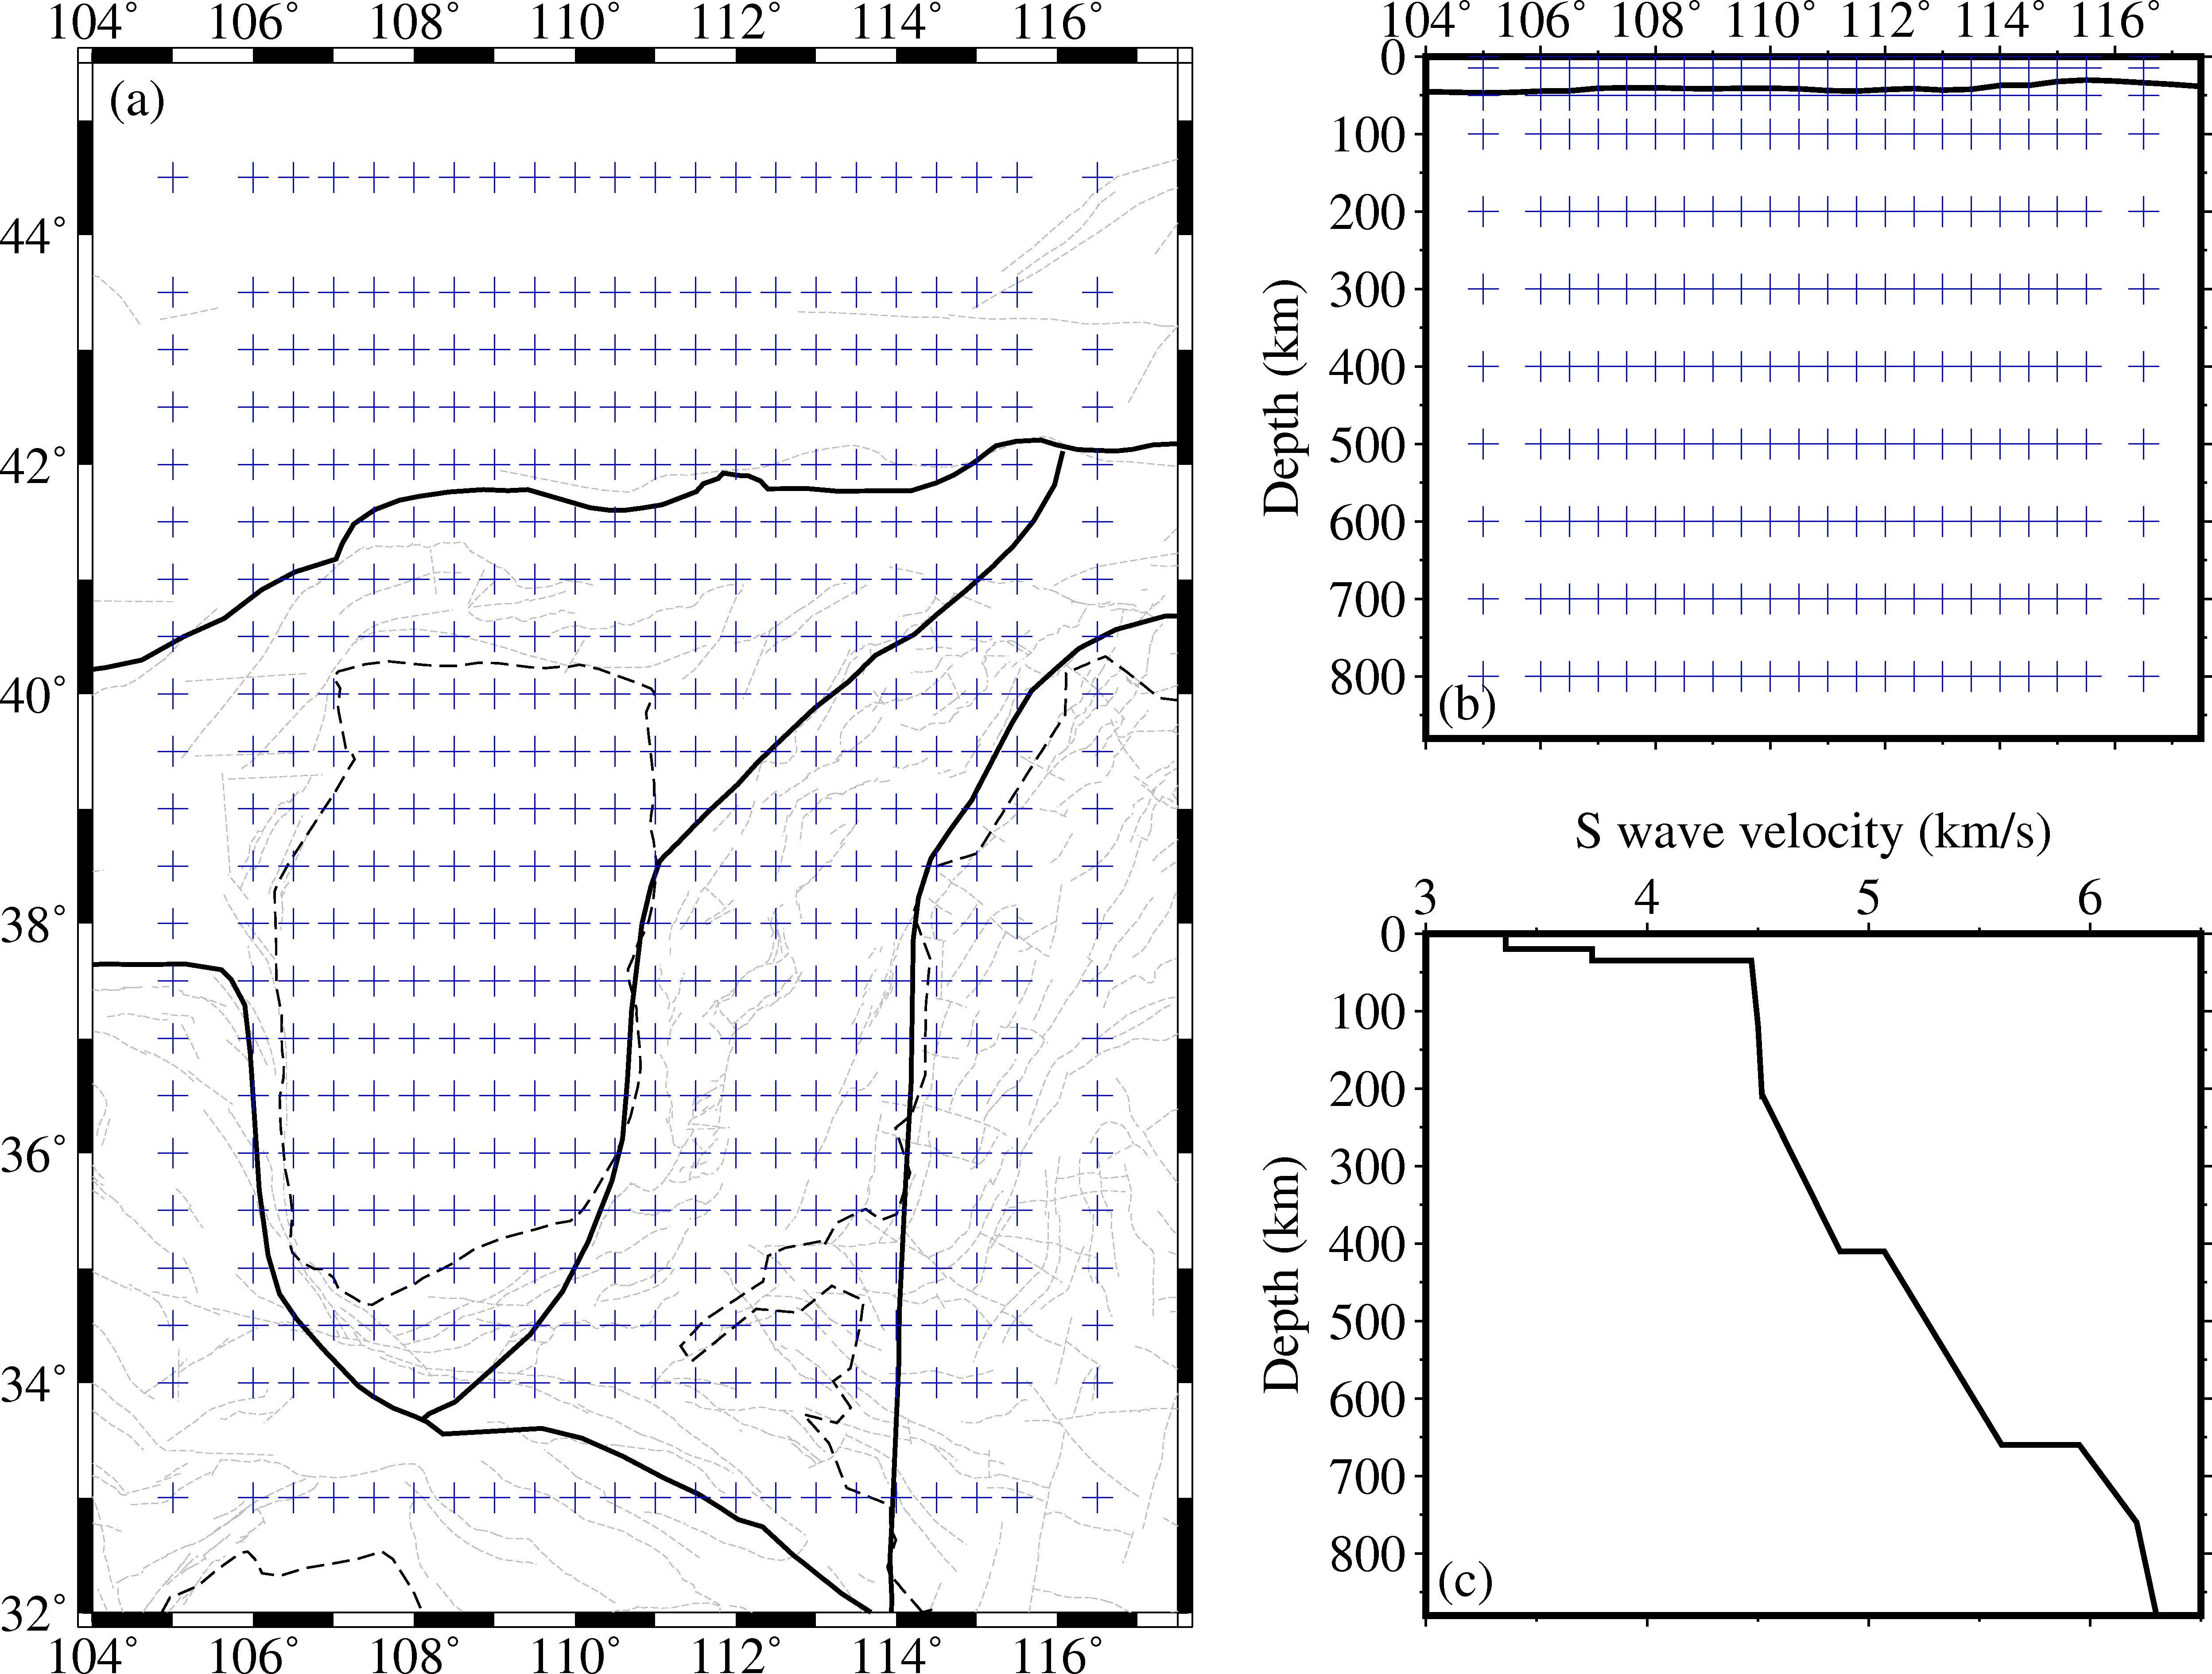
Supplementary Figure 2. (a-b) Configuration of the grid nodes adopted for tomographic inversion. (c) The initial velocity model modified slightly from the IASP91 model.

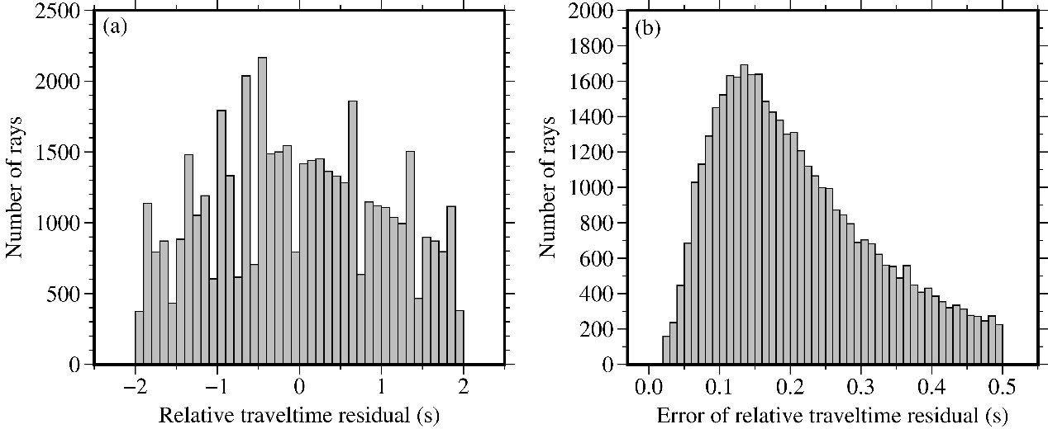
Supplementary Figure 3. Histograms of S wave relative traveltime residuals (a) and their error estimates (b).

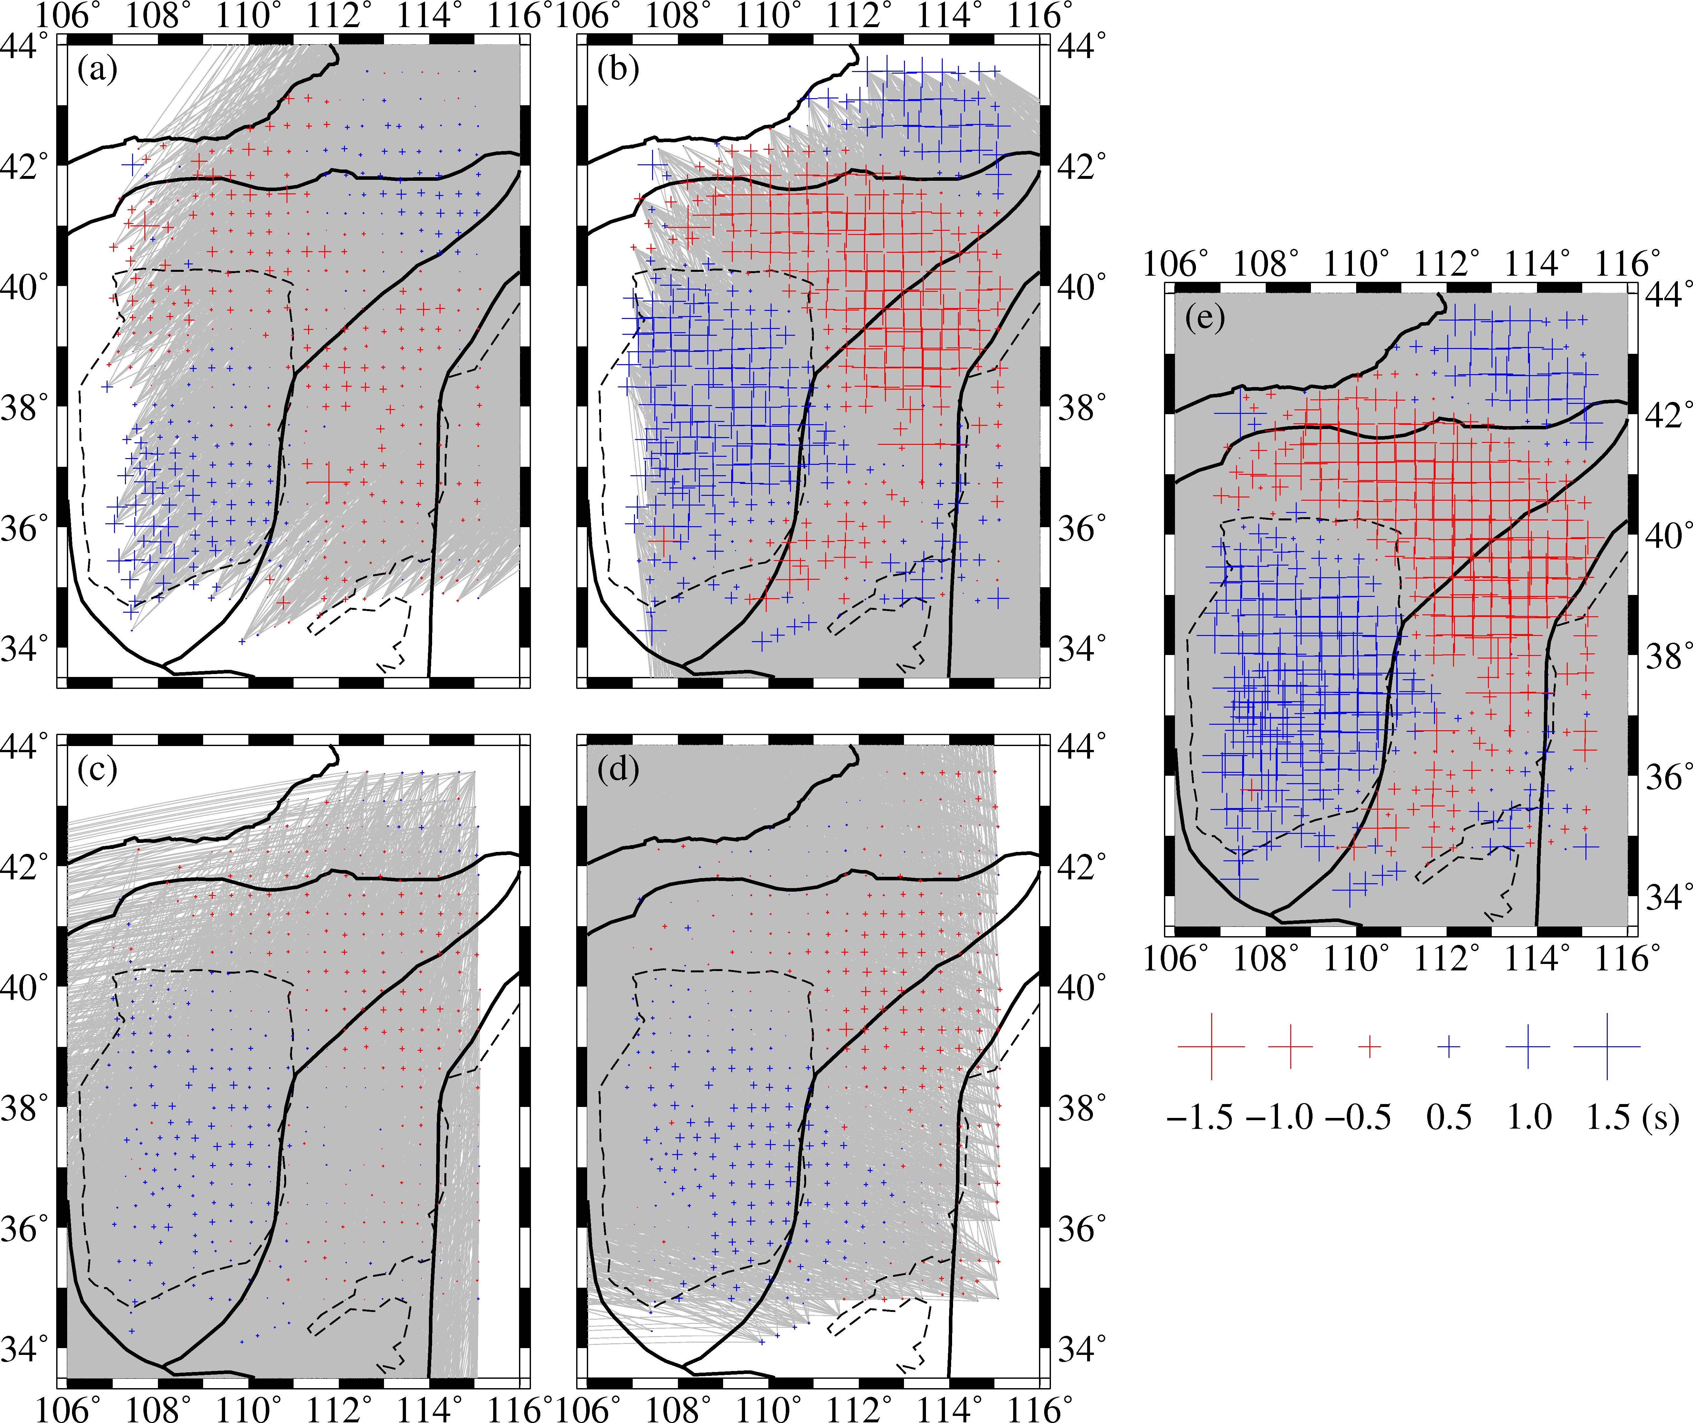
Supplementary Figure 4. Distributions of the average traveltime residuals at each seismic station. The blue and red crosses indicate the early and delayed arrivals, respectively. (a-d) The distributions of the average traveltime residuals from the NE, SE, SW and NW directions. (e) The distributions of the all average traveltime residuals.

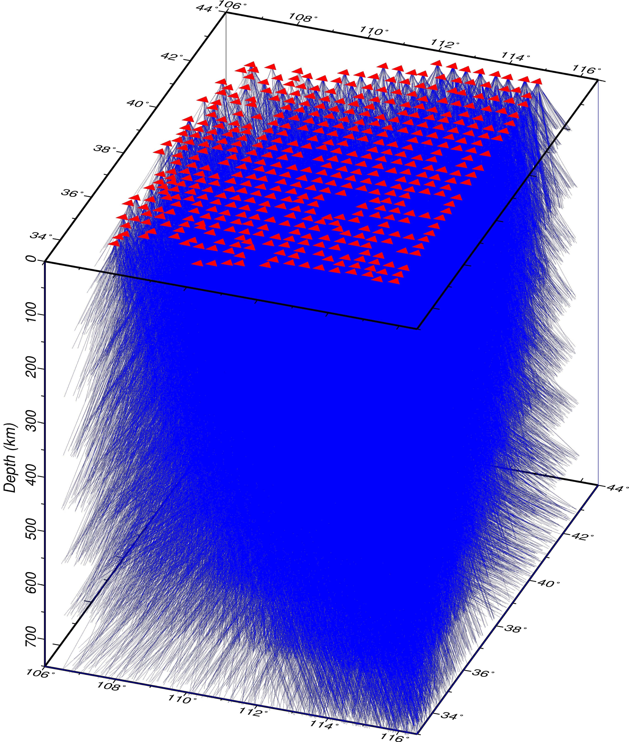
Supplementary Figure 5. 3-D distribution of ray paths used in this study. The red triangles are the seismic stations. The blue lines denote the ray paths.

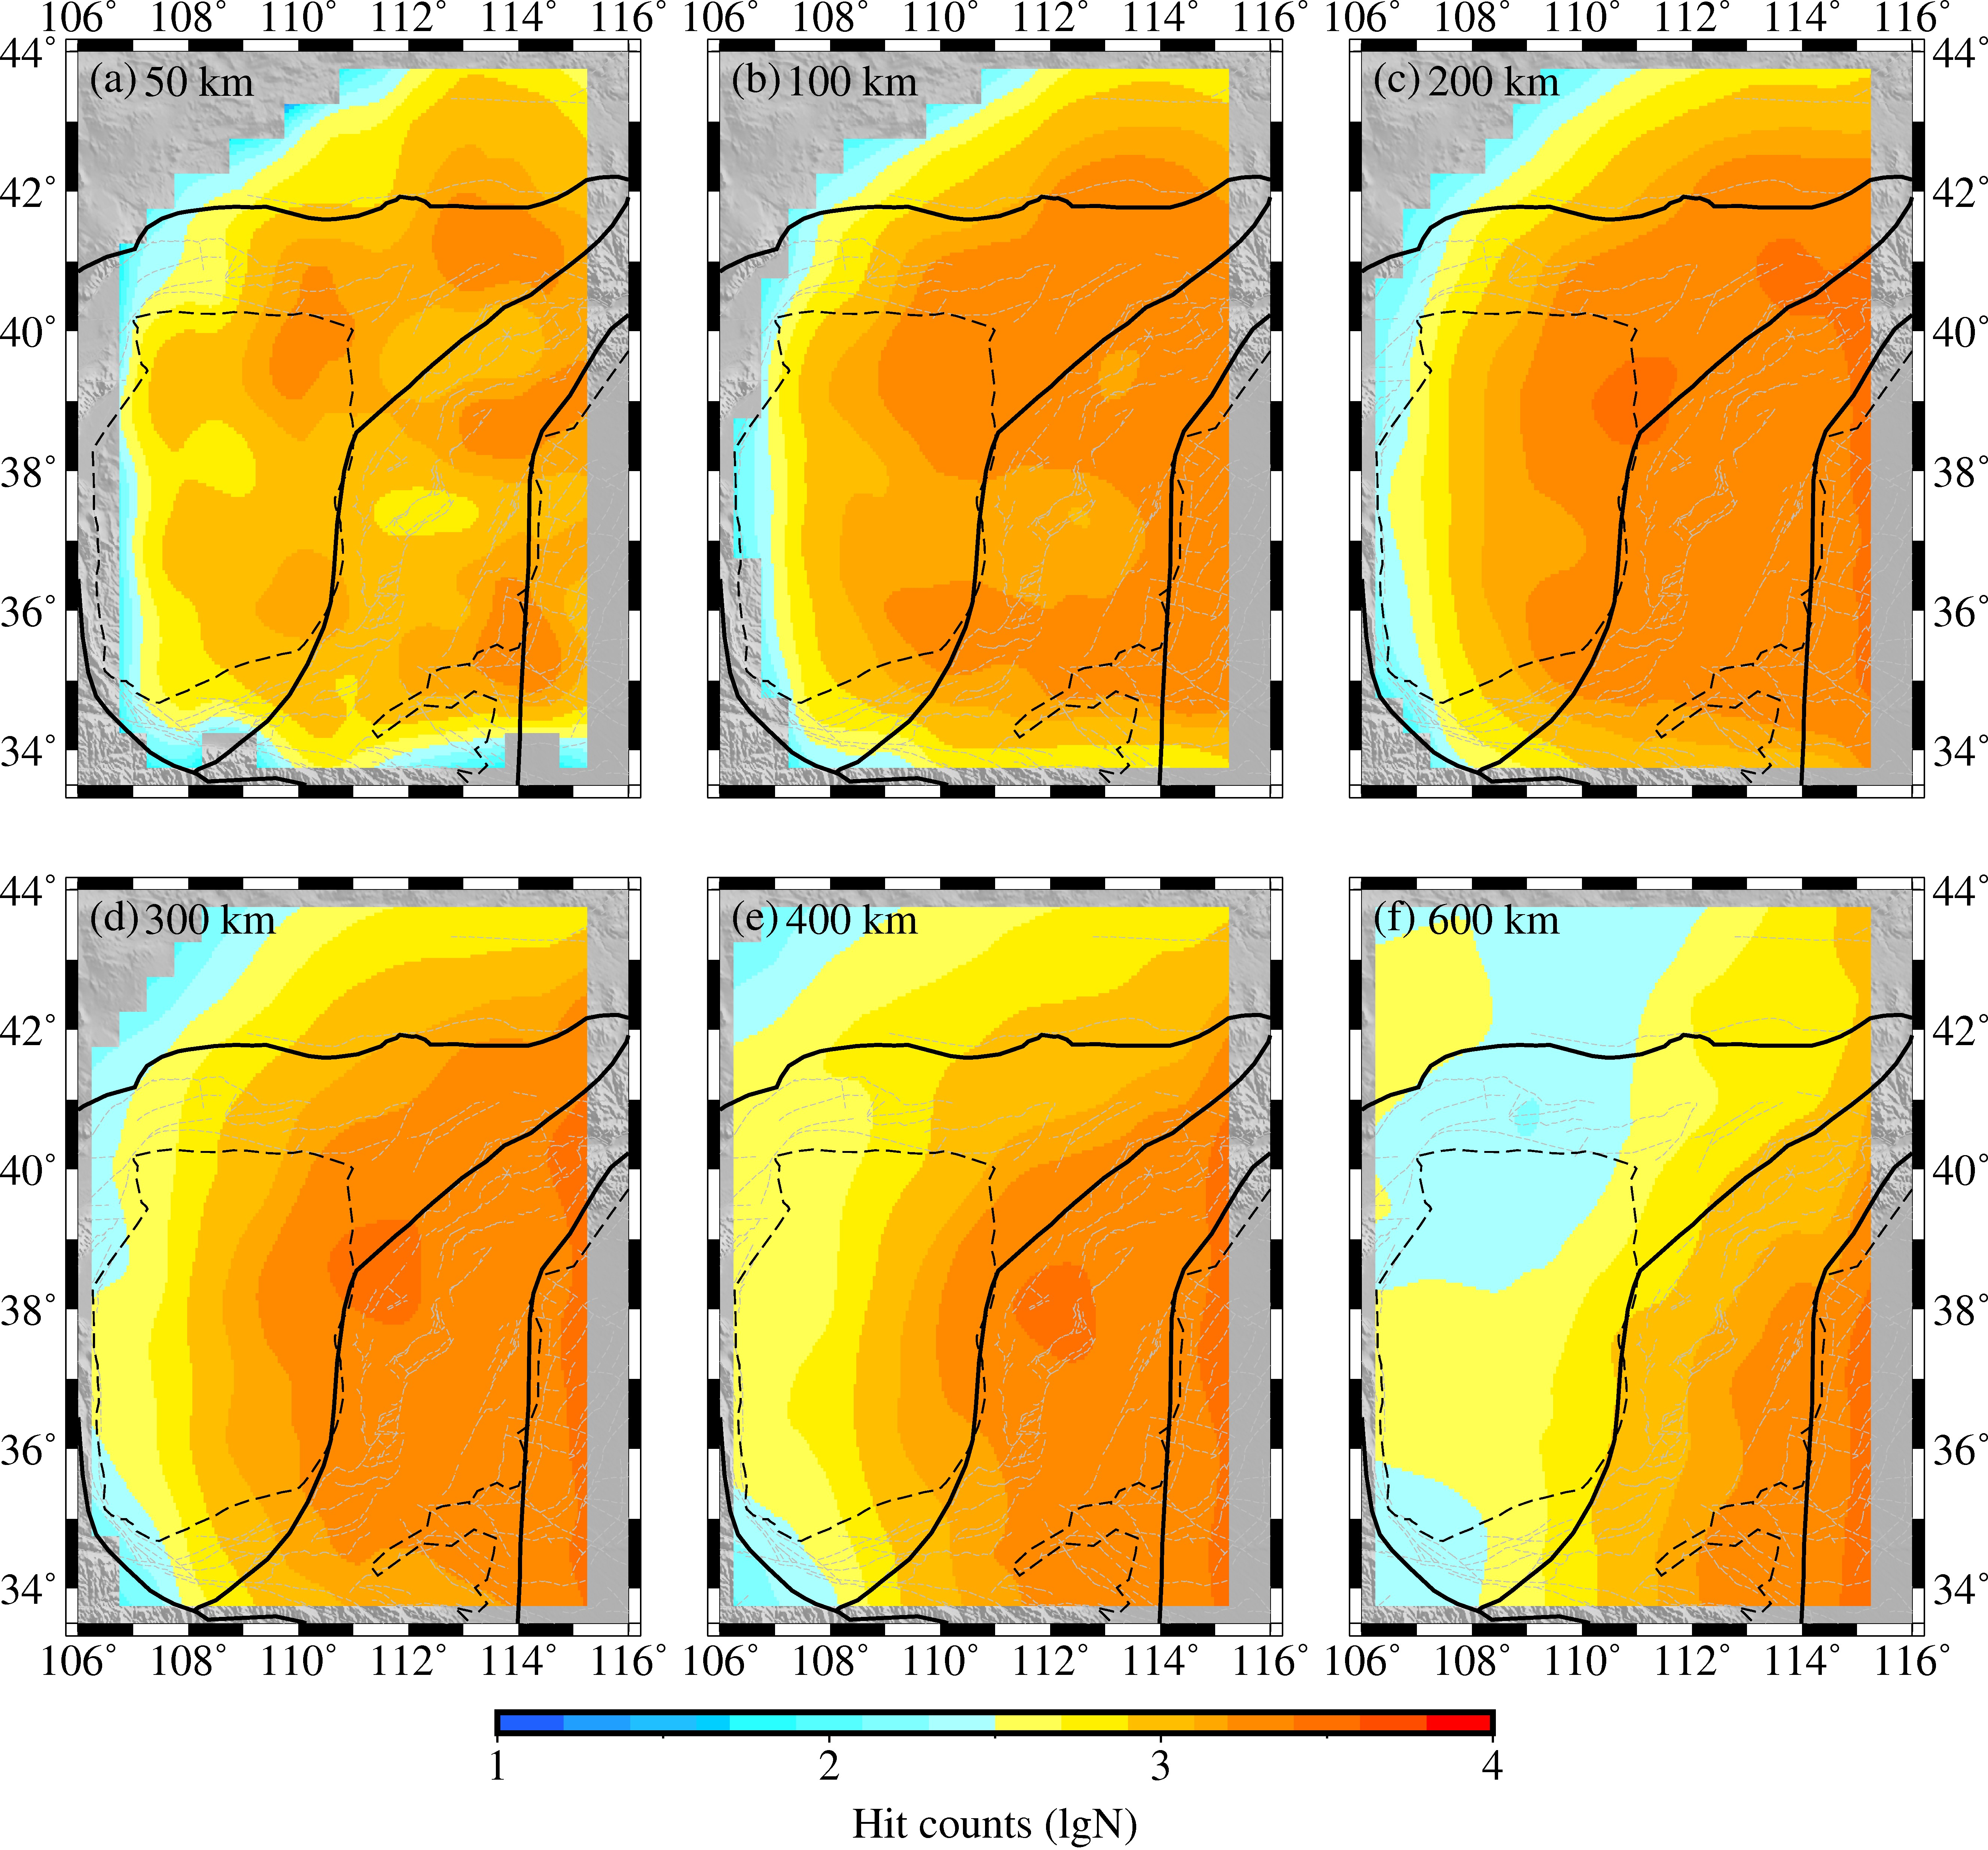
Supplementary Figure 6. (a-f) Ray density distribution in a logarithmic scale at depths of 50, 100, 200, 300, 400 and 600 km.

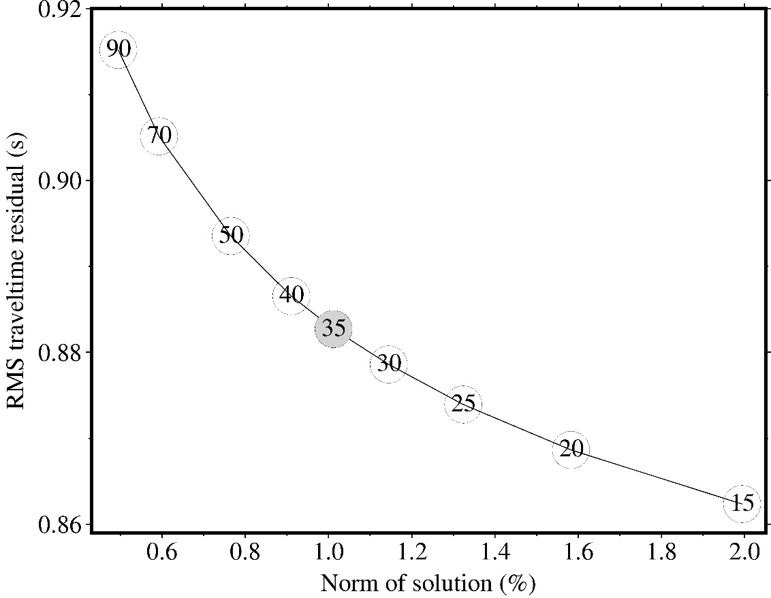
Supplementary Figure 7. Trade-off curve for the model smoothness and RMS traveltime residual. The numbers inside the circles are the damping factors. The optimal value of 35 is used in this study.

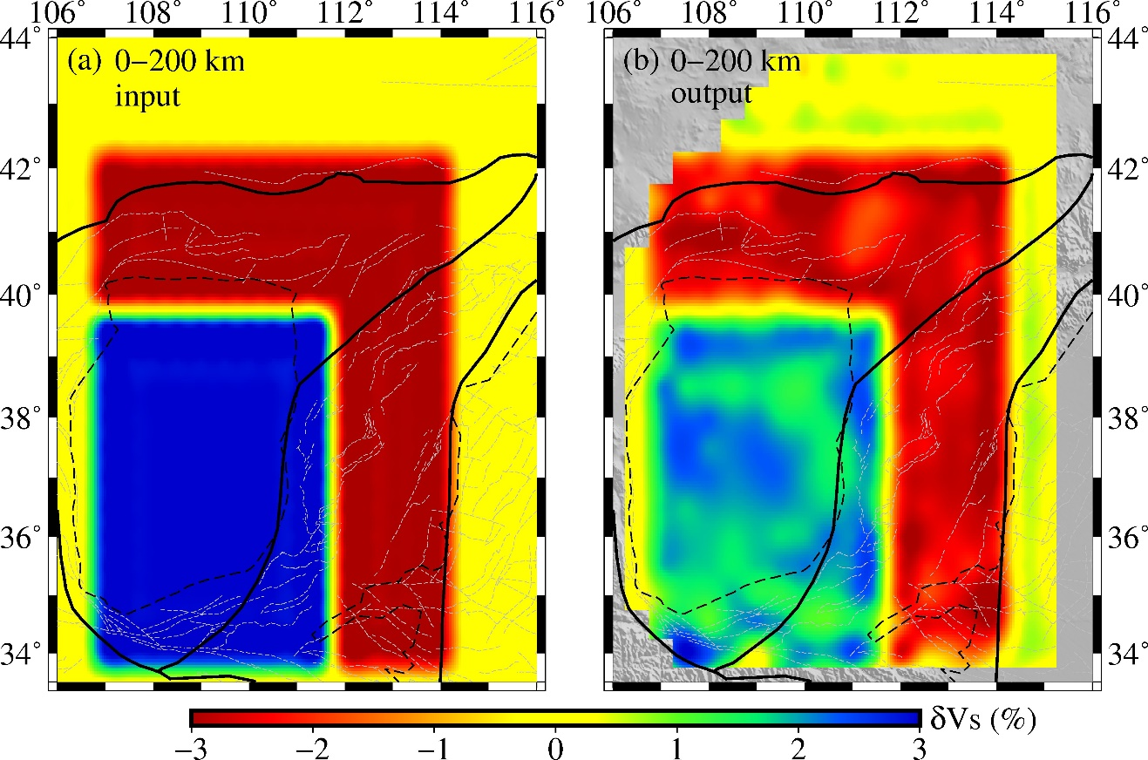
Supplementary Figure 8. The synthetic test for the low and high velocity anomalies in the study area. (a) Map of the input model with the velocity perturbation of -3% and 3% within the depth of 0-200 km. (b) Result of the recovered velocity anomalies.

